FAITH IN PICTURES: 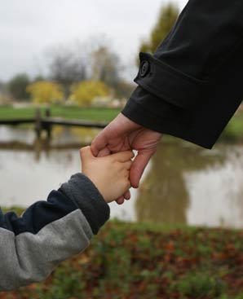
FAITH simply means “holding Abba’s hand.” TOTAL LOVE, total SECURITY! Our highest privilege!

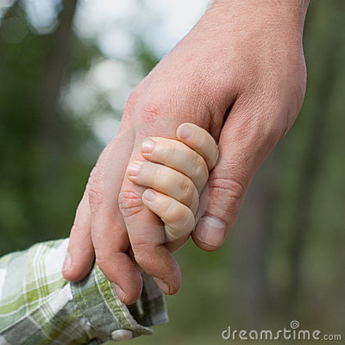
Oh the joy of having His hand to hold!

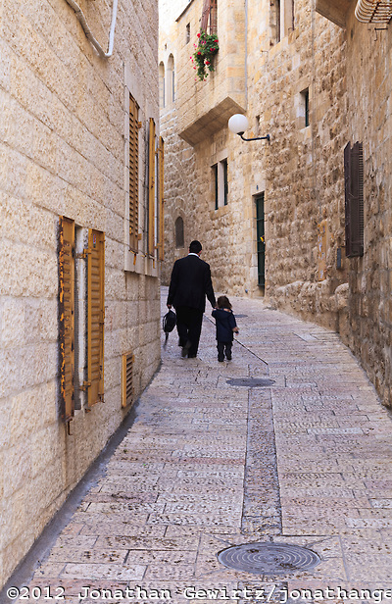
Posted on September 22, 2013 by Jonathan Gewirtz Father and Son: A timeless scene in the Old City’s Jewish Quarter. How familiar these walkways are to me! This picture is one of my favorites! Holding Abba’s hand on our journey home! at he will take care of us, so we do not have to be afraid of anything!

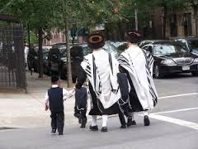
Orthodox father with his little sons: Hanging onto Daddy for protection. This is “emunah”--“FAITH!” There is no fear when we’re holding Abba’s hand! Faith and fear are opposites, yet both are powerful magnets! Faith draws Abba Yahuweh to our side! (Psalm 91) Fear draws demonic spirits who will lead us into destruction!

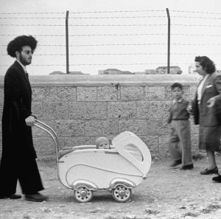
Security and protection by a loving father for his little one…Another sweet find from the archives of Life magazine: John Phillips' 1949 picture from Israel of an Orthodox Jewish dad out for a walk with his child. Matthew 28:20: “Behold, I am with you always…”

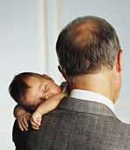
Could there be any greater peace?

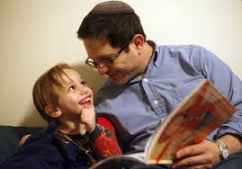
Oh the beauty of being able to share our lives with our loving, kind Abba Yahuweh!

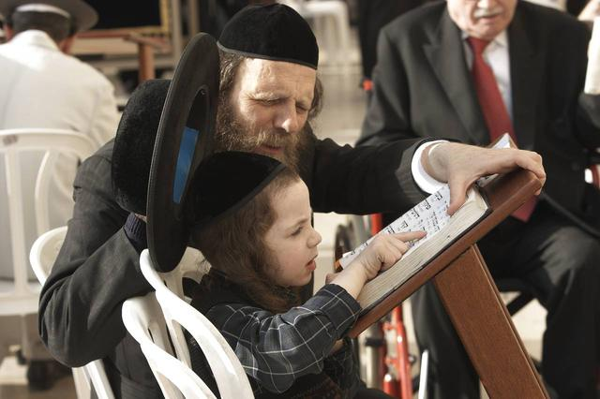
Abba Yahuweh patiently teaches us His Word – one-on-one – so that we understand!

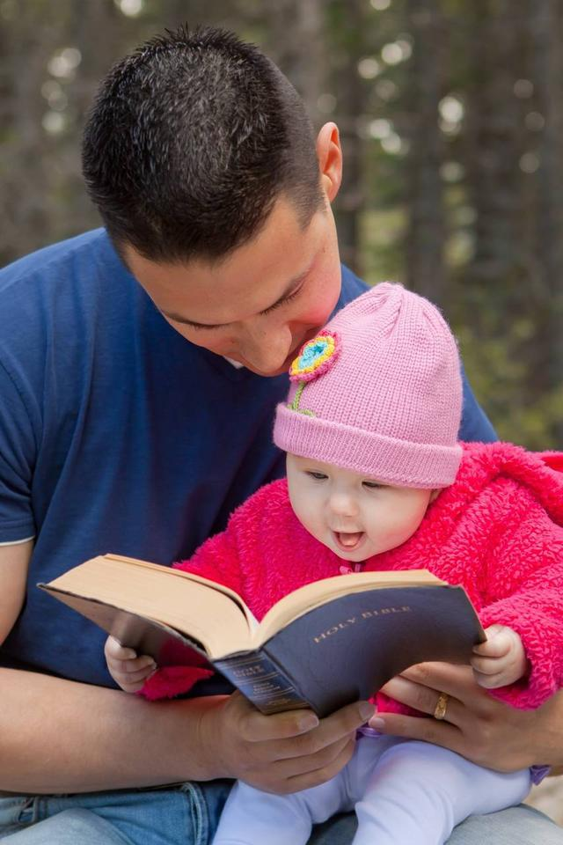
I love this one! Precious!


Oh the security of being held close and snuggled by Abba!

Abba is our “esteem, and the lifter of our head,” Psalm 3:3.
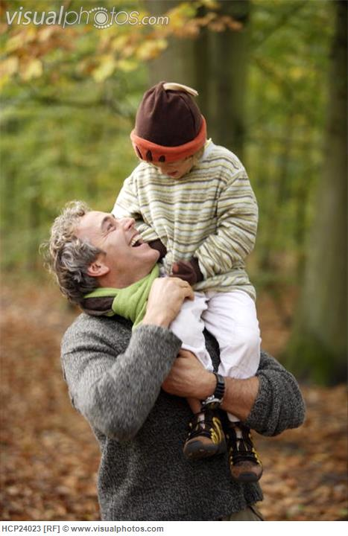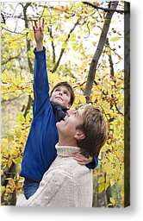
He lifts us up, so that we might triumph over all our enemies. Oh how wonderful is His love! He raises us up to sit with Him in heavenly places!

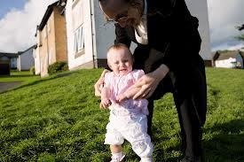
A Haredi father helps his little daughter to walk. Our Abba helps us walk in the ways of Truth, so that we do not fall into error and hurt ourselves!

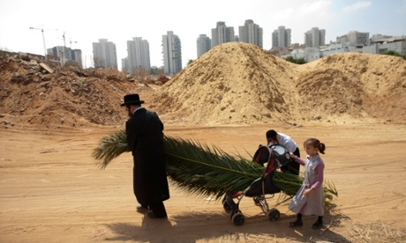
From The Guardian “Best pictures of the day” page, September 12, 2012, just before Sukkot…A Jewish man and his children push a baby stroller with palm fronds to be used to build a Sukka in Bnei Brak, Israel. Photograph: Ariel Schalit/AP – This is a wonderful picture of our Father working with His children to accomplish His goals! I love this! Partners together!

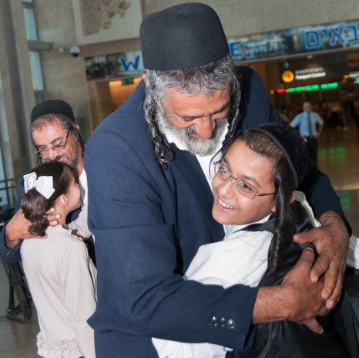
Yemeni Jews secretly airlifted to Israel: A Father and son are reunited at Ben Gurion Airport following an airlift that brought 17 Yemeni Jews to Israel, Aug. 14, 2013. (The Jewish Agency) Oh the joy when we are united in person with our Abba! Is this the passionate longing of your heart?

Abba may ask us to take a “leap of faith,” trusting Him totally to not let us fall. If we really know our loving Abba, we will trust Him to catch us! He will never fail us!

FAITH means “HOLDING ABBA’S HAND”--as a little child--submitting to, and trusting Abba’s wisdom and loving care. Total security!
Isaiah 41:10, 13: “Do not fear, for I am with you! Do not be dismayed, for I am your Elohim! Yes, I will strengthen you! Yes, I will help you! Yes, I will uphold you with the right hand of My righteousness! For I, Yahuweh, your Elohim, am holding your right hand, saying to you, `Do not fear! I will help you!’ ”
Matthew 18:1-4: “And His disciples came to Yahushua asking: `Who is greatest in the Kingdom of heaven?’ Yahushua called a little child to Him, and set him in their midst, and said, `Truly, I say to you, unless you turn and become as little children, you shall by no means enter the Kingdom of heaven. Whoever humbles himself as this little child is the greatest in the Kingdom of heaven.’ ”
Habakkuk 2:4b: “The just shall live by his faith.”
March 28, 2014 by Yedidah

