Geoengineered Wildfires, Destruction of Green Things,
Oceans and Waterways Dying, Earth Overheating
Revelation 7, 8, and 9

A Study of the Destruction of Earth, Oceans, and Trees--giving us timing of Messiah’s return… This heat wave world-over has been geoengineered.
The heart of Elohim: A Father’s Grief and Fury and a Bridegroom’s Longing: They must destroy those that destroy Their Creation! (Revelation 11:18)

***Please visit: Geoengineering Watch | Exposing the climate engineering cover-up: https://www.geoengineeringwatch.org/ and Please watch the YouTube update with Dane Wigington: “Geoengineering Watch Global Alert News, #156,” August 4, 2018. You must have this information!

***For foundational understanding please read my article: “70 YEARS OF WEATHER GEOENGINEERING - 70 YEARS of MAN’S DESTROYING EARTH’S LIFE SUPPORT SYSTEMS”/Mikvah of Present Reality. This article documents of the geoengineering from 1947 to present, with quotes from Dane Wigington about the urgency, for our planet’s life support systems are dying.
Have you ever read Revelation 7, 8, and 9, and wondered about the timing of the destruction of the “green things,” like the trees, grass, which includes green young grain and vegetable shoots? Are you aware that America is importing billions of dollars worth of food from other countries to keep the stores stocked, and hide from the American citizens that we are in famine conditions. And all due to the geoengineering of the Planet, holding back the rain so that the fires can rage? I’ve been reporting for a long time that America is 9 days away from famine. American farmers are committing suicide in large numbers because they either their produce is dying, or they are held back in their produce production by the edicts of new laws. In other words, they cannot produce too much, and always must use Monsanto GMO seeds.
The destruction of the trees and green things has been held back by edict of the Highest Law-Giver until the Daniel 11:32 Bridal remnant is marked in her forehead, sealed unto her Bridegroom. Has this happened?
Something has been loosed that is destroying trees and “grass,” which includes the “grass” of young wheat and barley, and other food crop grains) and other “green things.” The trees of the world are being targeted. Volcano eruptions have increased sky high worldwide! The Earth and the seas are burning, the waterways being polluted with radiation, aka “wormwood,” Russian: Chernobyl. The poison, Fluoride, and aluminums are in hundreds of American products, plus the water.
Have you noticed in all the prophecies throughout the Word having to do with our day, that there is one particular sign that was not part of the “days of Noah,” but was a part of the destruction of Earth in Genesis 1:2?
All around us we see evidence of the return of the “days of Noah,” even in astronomy. But, also we are seeing signs that were NOT in “days of Noah,” but more geared to the goal of Genesis 1:2 and Jeremiah 4:23-28.
As in the “days of Noah,” we are watching a worldwide increase in violence. We are watching the rise of cannibalism. We are watching the increase in threats of war. We are watching gross immorality abounding, and the targeted slaughter of the people of Yahuwah. We are watching the DNA changing of human beings, so that not only their nature is changed, but their physiology and psyche so that they are no longer fully human, and the creation of hybrids. These things went on before the flood. But, now, we watch it over again, plus some new things.
We are seeing incredible technology of the transhumanist-transgenics Movement to be produce what is not human, mixing humans with machines, military’s “enhancement” of soldiers to make them supermen soldiers, the use of DNA-changing substances on the world’s population, biological and chemical warfare on the world’s people, the “genetically modifying” of our food crops, the targeted destruction of food crops, trees, green things, oceans, and waterways, the LGBT movement made to be sacred, the rise in cannibalism for power and sacrifice to Satan, thus the rise of Satanism, the hideous murder of the unborn, the sacrifice of human beings to Satan, the creation of hybrids, plus famine, disease, economic collapse, wars and rumors of wars, great deception from the enemy to the minds of mankind, and the “great falling away” from faith of the once “saved.”
We are watching the results of 70 years of mind programming, and the technology used to destroy Planet Earth. Of course, we could go on and on. Today the worship of the gods of old has returned, as it was “in the days of Noah.” Therefore, as it was “in the days of Noah,” the returned Nephilim and fallen angels from 1896 is evident. Mankind did not get where we are now by himself. He has been guided or 120 years by the returned ones, according to the prophecy of Enoch and Genesis 6:2-4.
This time, the destruction of earth is the highest thing on the agenda of the fallen ones – the return of the earth to its “without form and void” state of Genesis 1:2 and Jeremiah 4:23-27. They want to totally destroy the creation of Yahuwah and Yahushua. They want to show their hate of His life anywhere in the universe, especially on His specially created and chosen planet for His children – Earth. The 120 years of the Spirit’s “striving with those who are also man” ended in the spring of 2016. That year began the final agenda for the ruination of all the beauty that Yahuwah and Yahushua re-created from Genesis 1:3 to 31. It is their attempt to stop Yahuwah from Revelation 19-21! They can’t stop it, but they’re trying.
Today we see prophetic Scripture fulfilled in the Globalist’s pushing for a world government under a single world ruler, with a single world economy, and a single world religion. We see ALL the prophetic signs from the entire Bible happening right before our eyes. They are all pointing to the return of Messiah.
But, what is the one main sign that the Scriptures reveal besides war, nuclear bombs, pandemics, famine, with the deaths of billions of people, and mighty deceptions that would cause a “great falling away?” Notice that deception is at the top of Messiah’s warning list. The warnings have gone out for over 2,500 years about what we are seeing right now that is destroying and will destroy His people and His Creation. (Matthew 24, Luke 21)
There are 223 prophecies of our day in the Word, and most contain some form of destruction of Yahuwah’s people.
Thus the main sign is all-inclusive: The attempt at another Genesis 1:2 by Satan and other fallen angels and their hybrid children--the destruction of Yahuwah’s children along with the destruction of His children’s life-sustaining planet – Earth. The return to Genesis 1:2 was not part of the “days of Noah.”
The judgment in Noah’s day was by Flood. The last destruction allowed by Yahuwah is judgment by Fire!
Today, the fallen ones are using human lackeys to “terraform” the earth to where nothing that is in the image of Yahuwah can live on it--nothing left that would remind them of Yahuwah and Yahushua.
[Refer to the recent “Terraforming the Earth,” also “Noah: Human DNA and the Human Spirit,” and “Noah Days Are Nowadays”/all Mikvah of the Heart of Elohim]
This planned destruction began to be executed at least openly by 1947. It coincided with the entrance into America of what would be thousands of Nazis scientists of varying sorts until the 1990s, experts in chemical and biological warfare, weaponry, space flight, mind control, medicines/drugs, and technology that would change the DNA of human beings and other species.

I also encourage you also to read: “Geo-Engineering – Severe Climate Changes by Human Manipulation”/Mikvah of Present Reality, and “Shields of the Earth.”]
Here I begin an UPDATE that should wake up the coldest and most apathetic of heart: As of today: …”there are currently 2,032 active wildfires going on across America at this moment, nearly all of them in the Western half of the country.” [Refer to: “Wildfires and Geoengineering” ANP, featuring quotes from Dane Wigington Aug. 5, 2018]
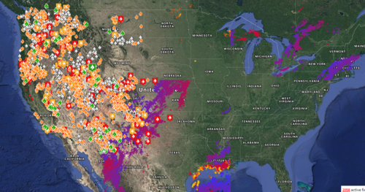
Wildfires going on now in America – ANP August 5, 2018
The present Redding, California, fire is the worst fire in California’s history

Refer to: “Mysterious and Definitely Not Natural California Wildfires”/Mikvah of Present Reality” to note the strange targeting fires that are now worldwide.
Greece is experiencing these targeting fires - by drones, or other means. The article above mentions how it is done, and how firefighters know it is not natural but targeted. While homes are reduced to ash, trees and grass are not touched. Look at these pictures from Greece recently, more below:
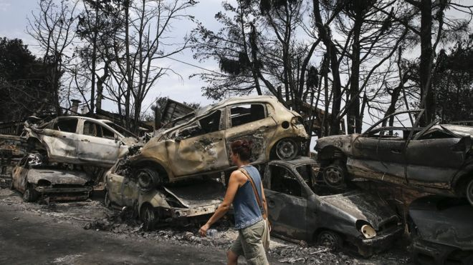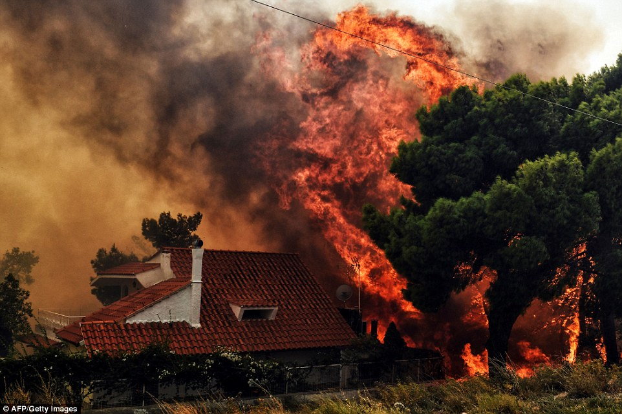
A 'biblical disaster': Greek official on wildfires that have killed at least 74
By Justin Doom - July 24, 2018 ABC News

“Wildfires rage across Europe as countries battle intense heat wave” by Strange Sounds - Jul 31, 2018: “As a scorching heat wave engulfs large parts of Europe this summer, fires have torn through dozens of countries across the European Union. From Germany to France to Sweden, countries in Western Europe are set for another intense heat wave this week with temperatures soaring above 90 degrees. As firefighters continue to battle treacherous blazes that have killed scores of people, here’s a look at what some European countries face as wildfires continue to scorch large swaths of land.”
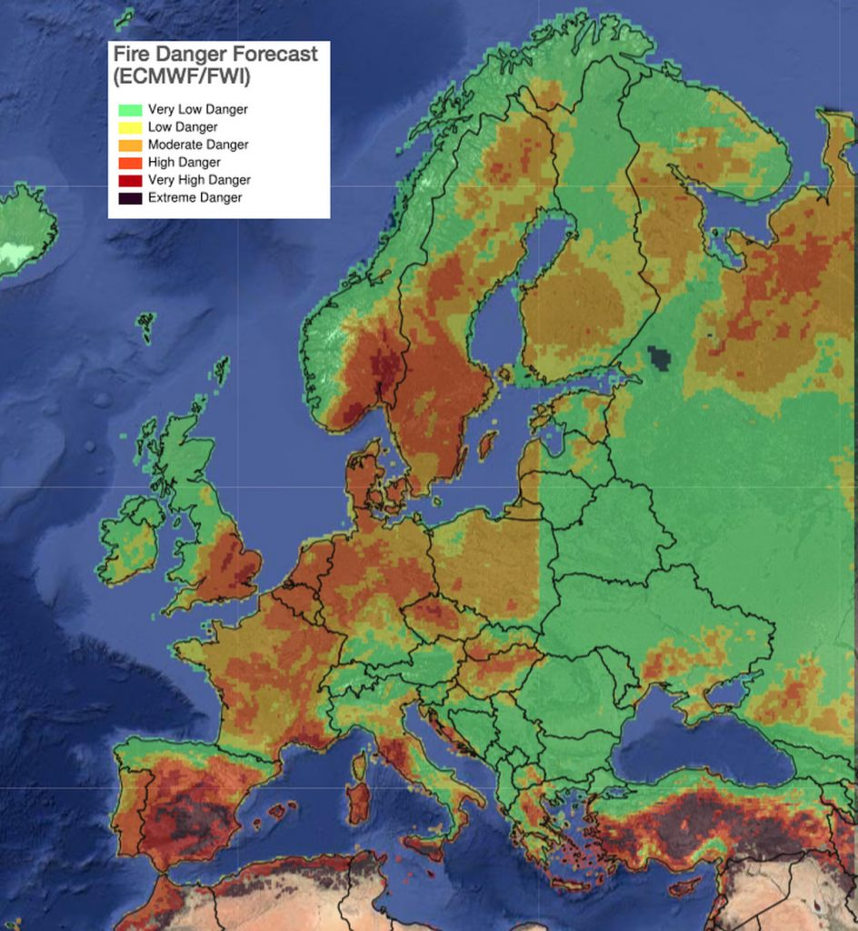
Fires raging in Europe, even to the Arctic Circle

The Millennium Report “Videos and photos document a similar type of `Arson from the Sky’ that occurred during the last series of catastrophic firestorms in California” – July 24, 2018 -TMR Editor’s Note: The photos again tell a story of geoengineered
“The striking similarities to the geoengineered firestorms in California are simply too many and too conclusive to ignore. The same advanced fire-starting technology seems to have been used in both cases. See FIREGEDDON: Geoengineered California Firestorms Propagated to Terrorize and Manufacture Consent. The conflagration in Greece has all the hallmarks of arson via drones in the sky and arsonists on the ground…
… KEY POINTS: What else could have produced the extremely unusual damage of streets filled with burned out automobiles right next to trees and buildings that remained unscathed but DEWs (Directed Energy Weapons)? This DEW and arson attack on Greece, then, appears to be an act of sheer intimidation so that the government in Athens does not join Italy in rebelling against the European Union. Even more significant is the necessity of the EU keeping Greece in line regarding immigration. Greece is the key link in the chain for war refugees and economic immigrants traveling from the Middle East and North Africa now that Italy has shut down the Italian peninsula route. Greeks are now protesting the influx of migrants like never before: Violence flares at Greek island protest over migrants. Consequently, the greater Athens area was sent a message via geoengineered wildfires as the subsequent firestorm destruction and chaos make it much harder to organize protests.”
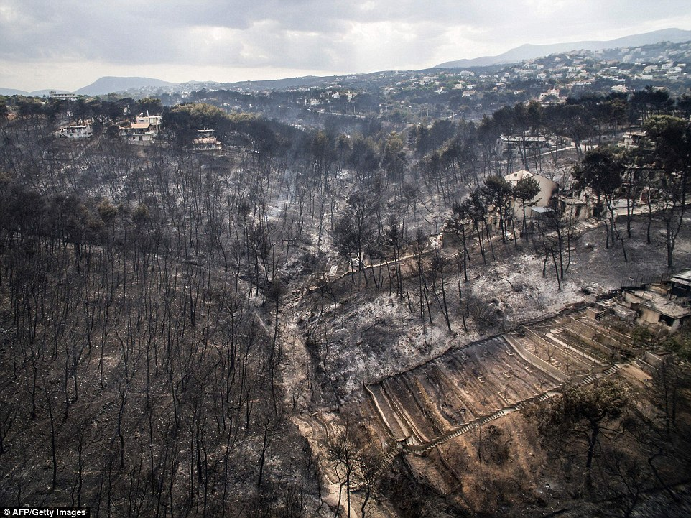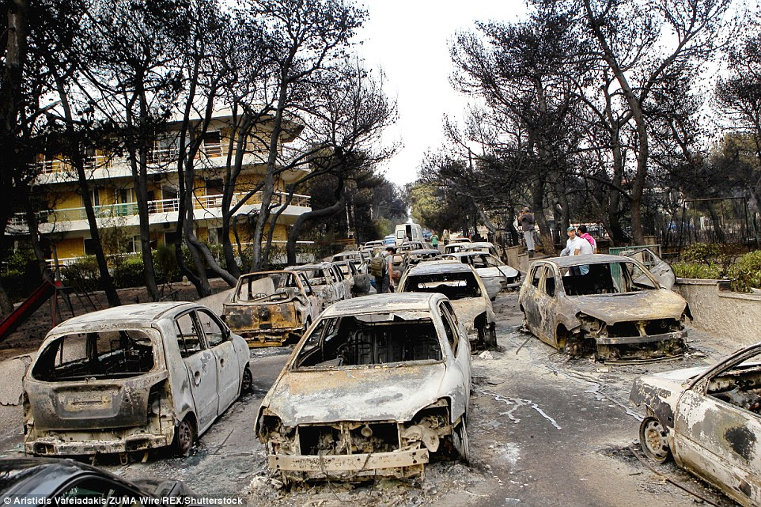
Greece: Notice similarity to California targeted fires – photo on right: Weird!
***Compare with the article and pictures of “Mysterious and Definitely Not Natural California Wildfires”/Mivkah of Present Reality (2017)
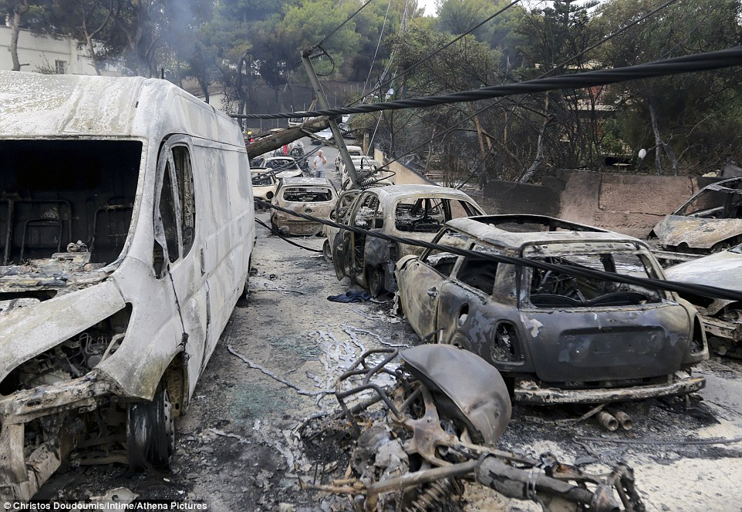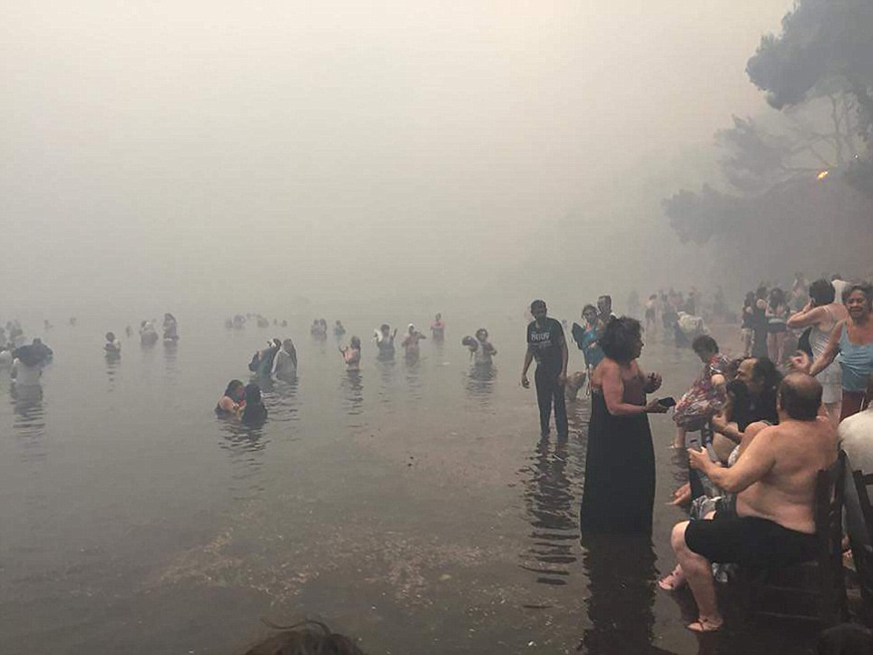
Notice anything strange?
Right: People in Greece fled to the sea for safety, but some drowned…

“Wildfire Greece Athens to Corinth” July 24 2018 – Fortune – “What to Know About the Deadly Wildfires in Greece That Are Forcing Residents to Flee Into the Sea”

“Heat Wave Scorches Sweden as Wildfires Rage in the Arctic Circle” - By Christina Anderson and Alan Cowell - July 19, 2018 - The New York Times

“2018's Global Heat Wave Is So Pervasive It's Surprising Scientists” by Sarah Grillo/Axios August 9, 2018: This article tells of the heat wave from Asia to the Middle East, across Europe, across North America, in strange places. It talks about climate change, but not that it is geoengineered. Heat records are being broken: “According to the U.N., Sodankyla, Finland hit 89.2°F, or 31.8°C, on July 17, which was an all-time record for that location. On Sunday, in far northern Norway, saw the temperature reach 87.8°F, or 31.0°C, which was an all-time high for any month at that location, according to meteorologist Etienne Kapikian. July 27 was the hottest temperature on record in Amsterdam, at 34.8°C, or 94.6°F. … According to the U.N., Sodankyla, Finland hit 89.2°F, or 31.8°C, on July 17, which was an all-time record for that location…
In Asia, Chinese media is reporting that "22 counties and cities" have had their hottest July on record. South Korea set its all-time high temperature record on Aug. 1, when the temperature soared to 40.7°C, or 105.2°F …
In Africa: Ouargla, Algeria, may have set Africa's all-time highest temperature on July 5, with a reading of 124.3°F, or 51.3°C. In Asia: Japan set a national temperature record of 106°F, or 41.1°C, in a heat wave that followed deadly floods…"We found that for the weather station in the far north, in the Arctic Circle, the current heat wave is just extraordinary – unprecedented in the historical record,” said Geert Jan van Oldenborgh, senior researcher at the Royal Netherlands Meteorological Institute (KNMI).
The study found that climate change has boosted the odds of record-breaking heat across more than 80% of the surface area of the globe for which reliable observations were available.”
Revelation 16:8-9: “And the fourth messenger poured out his bowl on the sun, and it was given to him to burn men with fire. And men burned with great heat and they blasphemed the Name of Elohim who possesses authority over these plagues. And they did not repent to give Him esteem.”
There comes a time when man and devils cannot do anymore, and then the wrath of Yahuwah takes over and His plagues end it all!
Few people even care, let alone are applying this information to their lives and making changes to align to Abba’s will for them! I hope you are paying attention and seeing the “handwriting on the wall.” Our planet cannot last much longer under this incredible planet-destroying sin of mankind joined with fallen angels. Of course the wicked ones say that the heat is due to too many humans on the planet, thus it feeds their population reduction agenda.
On top of that, add to his the volcano eruptions, tornadoes, floods, drought, and earthquakes, and the earth’s food supply is diminishing rapidly, water supplies are short, too. Famine is covering the earth. Read Ezekiel 14:12-23!
“Geoengineering Sardinia Switching from Heat Wave to Snow, Hail, and Flooding” - “Rare hail storm hits Sardinia, Italy, amid Europe’s heat wave”

From Strange Sounds - Aug 6, 2018: “A sudden and powerful ice blast covered Sardinia, an Italian island in the Mediterranean Sea, in a 30cm-deep ‘snow blanket’ after the temperatures suddenly plunged from 35C [95F) to 12C [5.6F] despite a record-breaking heat wave across the continent on August 2, 2018. Temperatures plummeted to just 12C, while a 30cm-deep blanket of hailstones caused havoc on the busy roads. Witnesses described a “snow blanket” on the roads, just minutes after a sweltering 35C heat wave… The sudden hailstorm caused transport chaos for some motorists, including an accident between two cars.
The cold temperature blast was also felt in nearby towns, including Mamoiada, Sorgono and Tonara. Flash flooding struck the nearby region of Nuorese, with emergency services called out to empty water from flooded basements.
Mayors and traffic wardens have been at work since to restore road conditions in the affected zones. Viewers online describe the weather videos in Sardinia as “unbelievable” while others claimed “the end was near” due to the bizarre weather. Despite this week’s ice blast, the Italian Island is back to scorching temperatures right now…”
“Massive Flotillas of Putrid Seaweed Wash Up in Caribbean and S. Florida, Threatening Beaches” By Paula Bolyard August 3, 2018 PJ Media
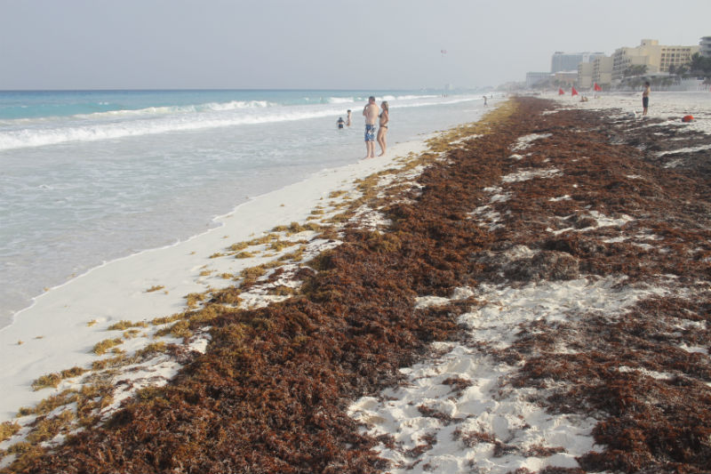
Florida Cancun

“Florida Red Tide Kills Hundreds of Marine Mammals August 2018
Worst red tide bloom in over a decade kills hundreds of marine mammals along Florida's west coast - By Chaffin Mitchell, AccuWeather: “A toxic 'red tide' is devastating Florida's most beautiful beaches…” Also washing up with the Red Tide algae are sea turtles and other marine life - The Telegraph August 1 2018

Fukushima Has Now Contaminated 1/3rd of the World’s Oceans
by Daisy Magnum - May 30, 2018: “It was established after the Fukushima catastrophe when a tsunami triggered was by a significant earthquake on 11 March 2011. The nuclear meltdown occurred when the power supply of the power plant failed and disabled cooling of three Fukushima Daiichi reactors. Fukushima has now Contaminated one-third of all sea life. 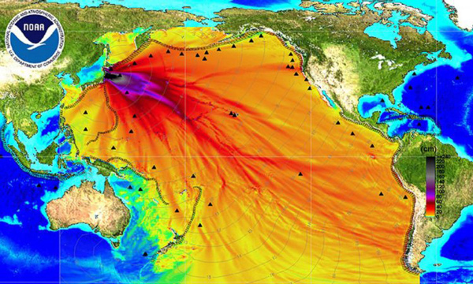
As an outcome a huge amount of radioactive waste was dumped into the Pacific Ocean. Of no surprise, this triggered great issue to countries based around the Pacific Ocean due to the possible economic and ecological ramifications. After leaking into the Pacific Ocean and spreading, scientists say that Fukushima has now contaminated one-third of Earth’s oceans.”

Let’s talk about the Heat! Right now, people in many countries are dying from extreme and unnatural Heat. The earth and seas are being purposely heated. Diseases are being purposely created, and violence is being purposely provoked. It’s all unnatural!
THE HEAT: As Dane Wigington reported in his recent YouTube Update, #156, August 4, 2018, the earth is much hotter than the public news is reporting. Earth is literally burning up, and so are the trees, the crops, the oceans, and the green things – not from geoengineered wildfires, but from the heating of the Ionosphere by the 70 world-encircling Ionosphere heaters that are bouncing the heat into the oceans and onto the Earth.
Wigington is a diver. He has seen the death of the barrier reefs and of the food supply of our sea life first hand. He has swum with seals and dolphins and other sea life, and now he sees them dead from radiation poisoning done by the US military, and the military use of the Ionosphere heaters to beam heat into the Arctic and the Antarctic, and into the oceans. The ice is melting. Luke 21:24-25: The seas are roaring.
Messiah is holding our planet, our universe, together, as Physics seeks the “gluon,” (Colossians 1; Hebrews 1). Yet, He is also letting the destruction happen, so that when He comes He can rightfully destroy those that destroy the Earth and “recreate a new heaven and a new earth wherein dwells righteousness.”
Wigington: “Aerosols are dispersed over the ocean constantly now. It is killing the oceans. He says: “Aerosol spraying is tearing apart the life support system of the planet.” Aerosols contain toxic chemicals and also heavy metals.”
…“This is the greatest assault on the planet and on the human race.” “The goal is to exterminate life on this planet”…“Those that control the weather control the world.”
“National media is giving us bread and circus.” “Life support systems are dying.” “Mainstream media will not cover the climate agenda.” “Northern California broadcasting is full of lies and deceptions.” “Criminal cover-up is distracting the population.” “Chemical ice used to seed clouds to create storms – chemical cool-downs.” “Life support systems crumbling by the day…We’re nearly done.”
“A massive high pressure dome is over west – climate engineering.” “The Jet stream pattern is seeded--Jet aircraft patents using chemical ice…” “HAARP – maybe now a 100 like them, cause the western US to be a `sacrifice zone.’ ”
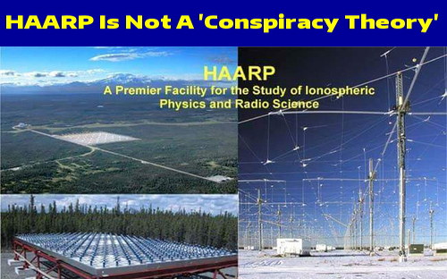
ANP
Wigington: “Unusual wildfires with unusual behavior are continuing to destroy earth’s wildfires all over the globe…unprecedented fire behavior.” “…the firestorms are NOT an act of nature – not natural in any way or form.” ““Global changing of climate behavior is a reality.” “Afoot are: Climate intervention operations, … Climate aka weather warfare …Only the beginning now… All of the forms of climate damage and the greatest threat we face except for nuclear cataclysm…Climate engineering.”
Wigington said: “Technically, `chem.-trails’ do not exist since it is not a scientific term, but few know scientific terms to use--like Hydrological cycle disruption, Climate engineering, geoengineering.”
[Our ozone layer is being destroyed, the radiation protection shields of earth-- Van Allen belts--are being destroyed, our Ionosphere is being destroyed, our magnetic fields are being destroyed, so oceans, forests, land areas, animals, bees, and humans are being destroyed.]
Dr. Kieff of MIT proposed putting 20 million tons a year of aluminum in the atmosphere with incendiary dust into the atmosphere … Wiginton confronted him. When Wiginton asked if they’d done any studies as to the effects of doing this, he said “no, they had done no studies.” (15 minute interview YouTube video from geoengineeringwatch.org) “Climate change” a term used to mask what they are doing to our earth.” “We are now in what is scientifically called “an abrupt climate collapse.” “It is unfolding at blinding speed…” “We have devastated our planet” “We are in total meltdown.” “Scientifically speaking, if the current rate of warming continues we won’t reach 2040 as a planet.”
“50C temperatures in our major cities like Melbourne, Australia right now
Thermal energy rating is like 3-4 Heroshima bombs per second are going off in our protection zones – like Van Allen Belts.” “Oceans are super heating … By 2025, we’re gone. Our crops are dying.”
Interesting that the Deagle Report puts most Americans dead by 2025: “Deagel Makes Mysterious Changes to 2025 Population Forecast for America as Bill Gates Launches 'Grand Challenge': The 'Holy Grail of Influenza Research' And 'Bridging the Valley Of Death'” – Stefan Sanford ANP May 2, 2018
Wigington: “165 degrees heat index in the Middle East …China, Japan, North Korea…” “Survival chances will decrease because of climate engineering,” says Noam Chromsky of MIT.
UK Guardian: “Heat Wave Pushes up Fruit and Vegetable Prices.” “The trend of disappearing fruits and vegetables on store shelves will continue worldwide …”
Yedidah: The heating of the planet by geoengineering of our Ionosphere, purposely beaming heat into the earth, is killing crops, killing trees, killing sea life, killing animals, birds, insects, and killing humans.
Wigington: The US right now is importing around 40 billion dollars worth of fruit, vegetables, and fish products a year, in order to keep stores stocked, but our own produce and sea life is dying …This is to pacify the US population – but most of the world is starving in some way...“ Photo synthesis stops at 104 degrees… Precipitation can be shut off--geoengineering creates drought.” Speaking of public news, scientists, etc.: “They continually say this has happened before – NO it has not – and not on this scale.”
“People are dying from the heat, animals, and other life forms. This is increasing so the death will happen faster. Are those perpetrating this being told that Mars awaits, or some other “paradise” for them to escape to? This is NOT a cycle!”
“Crops without irrigation are struggling” – a UK headline from Cardiff.ACU and other sources in the UK: this is “Ocean destruction not seen in 14 million years…The arctic is melting.” “…if it doesn’t happen this year, it will happen before the end of the next year. Arctic ice is so important because it has been the temperature regulator of the planet. With the ice gone, oceans super heat. We are on track for the “Venus syndrome.” “Sea animals is dissolving already in the acidic sea water.”
“If the oceans die, we die – simple.”… “Kelp forests are dying all over the globe. The barrier reefs are dying. Wigington said he has seen this first hand.” [He saw the dying barrier reefs off Australia and New Zealand.] He said: “…it is far worse than what we’ve been told, far worse.”
“The world’s largest colony of King Penguins has crashed, the population fallen by 90%.” “Technology is not saving us. It is pounding the final nails into our collective coffins.” [Wigington has swum with these penguins]
“The complete collapse of the web of life is underway.” “The U.S. military is using Depleted Uranium munitions, `for practice.’ Our military conducted operations to kill the sea life…using highly radioactive munitions off the North American coast …”
“Our military has stated on the environmental impact reports that they would kill millions of mammals…they state this on their environmental impact reports as a matter of fact.” “That is just business as usual for the Military Industrial Complex.” “We live in an asylum.”
Refer to: “The Oceans and Their Sea Life Are Being Purposely Murdered”/Mikvah of Present Reality. This reinforces what Wigington says here. Also refer to: “Earth is Cracking Like an Egg – Historic Earthquakes and Volcano Eruptions, Plus Chunks of Earth’s Mantle Are Peeling Off”/Mikvah of Present Reality. Earthquakes and volcano eruptions are increasing by the day.
Wigington: “Ocean warming by sea-bed gassing, and the military is putting radiation into the water. It’s 90 degrees in the Arctic Circle this week.” (August 1 Headline) “The temperature in the Arctic Circle reached 95 this week” He said he’s had the joy of swimming with seals, sea lions, dolphins, and turtles, off American islands, as well as with the king penguins in New Zealand. “Eco systems are collapsing all over the globe.”
Ocean out-gassing … (headline) “Ocean out-gassing causes strong odor off coast of California.” “What’s behind the out-gassing is that the oceans are super heating.” This heating is causing formerly frozen methane deposits to melt.” Methane deposits are called “FIRE ICE!” To heat it releases hydrogen sulfide. It is highly toxic.”
I wrote many articles after the BP explosion in the Gulf, and reported my findings in several Word Fellowship News Updates. One in particular is about “Fire Ice.” It is entitled: Word Fellowship Report Fire Ice” July 20, 2010. Here is a picture from that article: Fire Ice is found all around America’s sea coasts and Gulf of Mexico. “Methane hydrate, also called methane ice or methane clathrate, consists of methane, which is enclosed in frozen water. The water molecules completely surround the methane.” It is a gas and highly flammable.
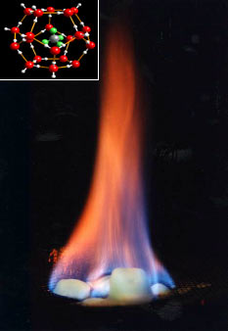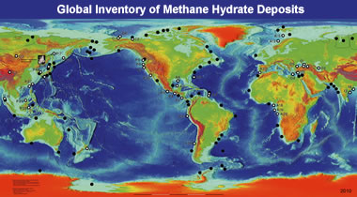
Wigington: “The geoengineering is blocking the natural moist air that brings rain and cooling…They’re talking about releasing methane deposits around the globe – releasing FIRE ICE. Methane hydrate released into the atmosphere would be 120 X more potent in the atmosphere than greenhouse gasses. Releasing methane would damage the whole earth’s atmosphere and be deadly to life on earth. They are talking about releasing methane globally...” “Methane death trap:” the heat cannot get out, it is earth-bound, and no cool air can get in. In other words they want to turn our planet into a Venus or Mercury ... a fiery desert, a total hell, a total lake of fire.”
“We are well past the point of no return.” Temperatures are being falsified, so as not to tell how hot it really is. “It’s much, much hotter than we’re being told.”
“For scientists to say they don’t know where this methane is coming from is a blatant, blatant lie.” “The wildfires are directly related to climate engineering.”
Wigington said: “The spraying of chemicals is blocking any inflow of moist cool air – especially over the West Coast where these fires are raging.”
“N. Korea: Temperatures may hit 124 degrees F. Heat wave sears crops there …This is happening all over the world…Livestock being moved out of Missouri and Montana because of heat there.
Europe is burning … British Columbia is burning…”

***“Wildfires rage across Europe as countries battle intense heat wave” By Strange Sounds - Jul 31, 2018 – map of fires across the world…
Folks listen to reality: The heat produced by beaming off of the Ironosphere into the seas and onto the earth is increasing the heat of earth to staggering proportions. Recently Death Valley had the highest sustained temperatures day and night in their history. Death Valley is the hottest place on earth at least it has been, but now, all over the earth people are suffering and dying from extreme heat, while weather is changing so fast that it goes from extreme heat to snow and hail, as in Italy recently.
“Death Valley just set an all-time sizzling heat record” August 3, 2018
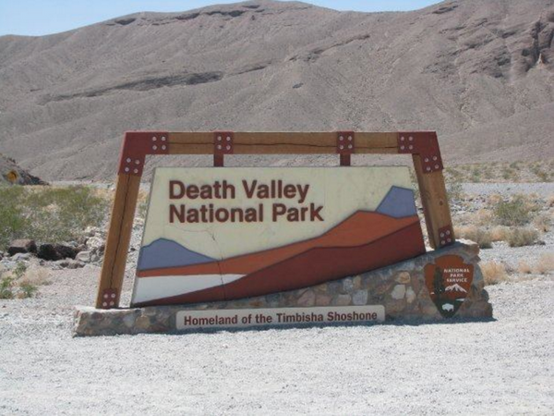
(Photo courtesy NOAA/National Weather Service - Las Vegas, NV)
By Mark Torregrossa - mtorregr@mlive.com
“Death Valley, CA set an all-time record for July. The average temperature for July 2018 was the hottest ever recorded at Death Valley. This July temperature record was also an all-time record for any month at Death Valley. And it's a hot number. The average monthly temperature was 108.1 degrees. The average monthly temperature is the average of the all the high temperatures and low temperatures for the month. If the average daily temperature was 108.1 degrees, the afternoon high temperatures were even hotter.
Every day in July topped out over 110 degrees at the Death Valley observation site. The coolest two days had high temperatures of 113 degrees. 21 days had high temperatures of 120 degrees or higher. Four days in a row had high temperatures of 127 degrees.”
It’s a depopulation agenda at work, too. But, it is far more than that. Forces, whether human, fallen angel, hybrid, or Nephilim, are working through man to terraform the Earth into an uninhabitable planet for life created by Yahuwah and Yahushua.
Folks, we don’t have much time to prepare for our stand before the Master, Yahushua Messiah at His coming! I strongly believe in 7-year cycles, as does the Word. He emphasizes throughout the Word His 7-year time frames. Four hundred years ago, Jewish sages traced the 7-year cycles from the time Joshua and the Hebrews entered the Land. It was in a Shmittah year. From their calculations, they were able to prophesy details of the last 3 cycles before the final one of Daniel’s 70th week, giving exact dating and events. In my article “The Shmittah Year Prophecy” I show how all Israel understood this, and how the final cycle of the 3 ended on Yom Teruah 2015/2016. Every new cycle of 49 years, ends with a Shmittah year and begins with a Jubilee year.
I suggest strongly that you read Tom Horn’s Zenith 2016. It wasn’t just Jewish sages that prophesied of our day, but also many others from over 1000 years ago, hitting details right on the mark! In 2016, the end of the 120 years given to the Nephilim ended also. Please for the update on “The Shmittah Year Prophecy”/Mikvah of Preparation, read my recent article “The Shmittah Year Prophecy Revisited”/Mikvah of Preparation. We are in a finality that you must prepare for.
NO I am not setting dates! Yet, Abba is the one who made sure I knew about the 3 final cycles of the sages from 400 years ago. He made sure I knew about 70-generation prophecy of Enoch, and the year of the return of the Nephilim. This all became very personal to me, and I prophesied at the Wall in Jerusalem from that information, along with Ezekiel 4 and Leviticus 26 information, the exact timing of the end of Ephraim’s punishment. Fascinating enough, the Jews in Jerusalem on that date, Yom Teruah 2007, knew it exactly that Ephraim’s punishment was over and so rejoiced that now Messiah can come. That was September 13, 2007/2008 on the Creator’s Calendar. The 3 prophesied final 3 cycles of 7 years were 1993/1994 to 2000/2001, from 2001 to 2007/2008. Do your own homework! I’ve given you a lot of research links, videos, and articles to search out. Again, review “The Shmittah Year Prophecy Revisited”/Mikvah of Preparation.
Continuing on: Revelation 11:14-19: “The second woe is past, and see, the third woe is coming speedily. And the seventh messenger sounded, and there came to be loud voices in the heaven, saying, `The reign of this world has become the reign of our Master, and of His Messiah, and He shall reign forever and ever!’ And the twenty-four elders sitting before Elohim on their thrones fell on their faces and worshipped Elohim, saying, `We give You thanks, O יהוה Ěl Shaddai, the One who is and who was and who is coming, because You have taken Your great power and reigned. And the nations were enraged, and Your wrath has come, and the time of the dead to be judged, and to give the reward to Your servants the prophets and to the set-apart ones, and to those who fear Your Name, small and great, and to destroy those who destroy the earth.’ And the Dwelling Place of Elohim was opened in the heaven, and the ark of His covenant was seen in His Dwelling Place. And there came to be lightning, and voices, and thunders, and an earthquake, and great hail.”
Revelation 7:1-4: “And after this I saw four messengers standing at the four corners of the earth, holding the four winds of the earth, that the wind should not blow on the earth, nor on the sea, nor on any tree. And I saw another messenger coming up from the rising of the sun, holding the seal of the living Elohim. And he cried with a loud voice to the four messengers to whom it was given to harm the earth and the sea, saying,`“Do not harm the earth, nor the sea, nor the trees until we have sealed the servants of our Elohim upon their foreheads.’ And I heard the number of those who were sealed, one hundred and forty-four thousand, sealed out of all the tribes of the children of Yisra’ĕl:…’ ”
Revelation 8:6-11: “And the seven messengers who held the seven trumpets prepared themselves to sound. And the first messenger sounded, and there came to be hail and fire mixed with blood, and they were thrown to the earth. And a third of the trees were burned up, and all green grass was burned up. And the second messenger sounded, and what looked like a great mountain burning with fire was thrown into the sea, and a third of the sea became blood, and a third of the living creatures in the sea died, and a third of the ships were destroyed. And the third messenger sounded, and a great star fell from the heaven, burning like a torch, and it fell on a third of the rivers and on the fountains of water, and the name of the star is called Wormwood. And a third of the waters became wormwood, and many men died from the waters, because they were made bitter.” (This is in process of being fulfilled.)
Revelation 9:3-4: “And out of the smoke locusts came upon the earth, and authority was given to them as the scorpions of the earth possess authority. And it was said to them that they shall not harm the grass of the earth, or any green thing, or any tree, but only those men who do not have the seal of Elohim upon their foreheads.”
Between Revelation 7 and 9, the sealing is finalized
HAVE the FOUR WINDS BEEN LOOSED, at LEAST in the BEGINNING STAGES?

Judgment by fire: sample Scriptures
II Thessalonians 1:6-10: “…Elohim shall rightly repay with affliction those who afflict you, and to give you who are afflicted rest with us when the Master יהושע is revealed from heaven with His mighty messengers, in flaming fire taking vengeance on those who do not know Elohim, and on those who do not obey the Good News of our Master יהושע Messiah, who shall be punished with everlasting destruction from the presence of the Master and from the esteem of His strength, when He comes to be esteemed in His set-apart ones and to be admired among all those who believe in that Day, because our witness to you was believed.”
Hebrews 12:28-29: “Therefore, receiving an unshakeable reign, let us hold the favor, through which we serve Elohim pleasingly with reverence and awe, for indeed, our Elohim is a consuming fire.”
II Peter 3:10-14: “But the day of יהוה shall come as a thief in the night, in which the heavens shall pass away with a great noise, and the elements shall melt with intense heat, and the earth and the works that are in it shall be burned up. Seeing all these are to be destroyed in this way, what kind of people ought you to be in set-apart behavior and reverence, looking for and hastening the coming of the day of Elohim, through which the heavens shall be destroyed, being set on fire, and the elements melt with intense heat! But according to His promise we wait for a renewed heavens and a renewed earth in which righteousness dwells. So then, beloved ones, looking forward to this, do your utmost to be found by Him in peace, spotless and blameless,…”
An earthquake will happen that will cause the mountain to fall, i.e. Revelation 6:12-17, Revelation 16:17-21.
***Since the earth will be destroyed totally, beginning before, but also at Messiah’s coming, we see in Isaiah 65 and 66 a new heaven and a new earth will be created as soon as Messiah comes… He will not bring His Family of redeemed ones onto a destroyed earth to live with the dead. It could be that as He comes, He will re-create Earth and also the Cosmos. All He has to say is “the Word,” and Genesis 1:3 will happen again.
The question is: How long will Elohim wait before He stops the destruction of Earth? Will He let it get so bad that even anti-messiah has to build a bunker to protect himself? I think not … Today, Earth and all on it, is literally dying. The Creators won’t wait long! Things have accelerated greatly – the plans of the fallen ones and their leader Satan, and the plans of Yahuwah and Yahushua!
In Revelation 7:1-3, four angels hold back the four winds of the earth so that the winds do not blow on the earth, sea, of on any green tree. These angels are not identified as to who they are – Abba’s or Satan’s. If they are Satan’s, they are commanded by Yahuwah to hold back, and they have to obey. If they are Abba’s the text is more understandable. We see that a “sealing” angel comes from the East, and cries to the four holding back the “winds” that are allowed to harm the earth, sea, or trees. “Do not harm the earth, or the sea, or trees until we have sealed the servants of our Elohim in the forehead.”
Then the “sealing angel” refers to “we.” Evidently he is not the only one who seals, or they are his backups. After the sealing, he then speaks to the four holding back the winds, so perhaps they are the fallen angels of Satan, who are on Abba’s leash as is Satan. They are holding back destruction, but at some point, they are commanded to loose the destruction. Have “they” been told to loose the destruction already? It is surely happening and increasing by no stretch of the imagination. If you listen to Dane Wigington in his #156 YouTube Report, you’ll hear the urgency in his voice because of what he knows.
Earth: Ionosphere heating, ozone depletion, radiation belt damage, oxygen depletion, crop destruction, waterway destruction, food contamination (GMO), air contamination (chem.-trails/geoengineering of “climate change”), disease creation—manmade death and destruction of all types to kill not just humans, but bees and other pollinators, mammals, birds, good insects, reptiles, and good arachnids – destroying the whole balance of nature. Earth and all on it are being destroyed at the pleasure of the Nephilim. The Spirit no longer strives with them but is allowing their plans to go forward, for the Earth is being prepared to be re-created!
Oceans, Gulfs, Seas: Destruction of the food chain at its lowest levels so that the upper life is also destroyed. The U.S. military is releasing radiation into the oceans purposely. Then there was the targeted Fukushima release of radiation that has gone all the way to California. There have been targeted deaths of birds, fish, and crustaceans worldwide, beginning in Arkansas in 2011.
Trees: Our oxygen supply, our fruit supply, our shade – and “green things,” like grass and crops like barley and wheat, soy, and flax, plus food that begins as a shoot of green from the ground, or a tree shoot. The destruction of what brings life to all the earth is being destroyed from our outer atmosphere to the tiniest weed, flower, or blades of grass.
Revelation 8:7: 1/3 of the trees will be burned up and all grass/green shoots/crops
Revelation 8:8: 1/3 of “the seas turn to blood”
Revelation 8:9: 1/3 of all living things in the sea die
Revelation 8:10: 1/3 of the water systems, rivers, waterways, streams, etc. are contaminated with radiation and other pollutants
Revelation 9:4: The pit opens and out of it comes the king of the pit incarnates as the Beast of Revelation 13:1-10. How he incarnates we don’t know, but he becomes visible to the world. He is the 8th Beast who comes out of the 7th empire, and is very well known by face to the world’s people. (The Beast of Revelation 13:1-10 is also Revelation 9:4; 11:7; 17:8, II Thessalonians 2:3)
In Revelation 9, the mandate to the locusts/demons that arise with him is not to harm the grass of the earth (which may include the green shoots of crops like wheat and other grains), or any tree. Harm only those who do not have the seal of Elohim in their foreheads. Therefore, by this time, all the 144,000 of Revelation 3:12, 7:1-9, 14:1-5, and 22:3-5 have been sealed. The principle is in Deuteronomy 15:16-17. Those sealed know their Elohim, are strong, and act in exploits for their Master: Daniel 11:32. This is a company who is on earth at the same time as the Beast/anti-messiah/Apollyon-Abbadon.
The sealing has to be completed before the Beast arises and his demonic locust-like entourage is free to destroy the earth and mankind. The burning of trees and other green things, the pollution of the seas, sea life dying and the harming of crops is a sign that the earth is being destroyed and the only ones to survive will be those marked by the “sealing angels.” So, the sealing has either happened or most likely is in its final stages. There will be many martyrs, as we see now in the slaughtering of Christians worldwide, and laws even in America, England, Canada, and Europe against Christians, the Bible, and the use of the Name Yahweh. So, watch – for right now, we are in a global burning of the trees, houses, buildings, crops, and the seas dying.
The geoengineering of our planet began in 1947 as documented. Make sure you’ve read: “70 YEARS OF WEATHER GEOENGINEERING - 70 YEARS of MAN’S DESTROYING EARTH’S LIFE SUPPORT SYSTEMS”/Mikvah of Present Reality. America and Nazi scientists joined up with Nephilim to learn how to destroy the earth, and they began in 1947. It is also the time when UFOs began to be seen in great numbers, indicating that man and Nephilim had joined forces.
The earth is being heated by man’s bouncing electromagnetic beams off the Ionosphere, and destroying our life support systems. The whole perfect balance set in motion by Yahushua at the Creation is being offset into chaos. The geoengineering of the climate is causing unusual heat worldwide – to the point where crops are burning up, and fires starting, and sea life dying. Humans are also dying of extreme heats in various places. Famine is across the world now, and few places are left with “green things.” Diseases are being created and released by evil men. DNA-changing elements are being dropped on us by chem.-trails.
Why would human beings purposely destroy the Earth? It sounds insane. It is insane! But, it is humans who are puppets of Satan and his forces, totally taken over and changed into their nature, with their ways and thinking. But over all, it is fallen angels and Nephilim who are in control of Earth now? In January 2016 I wrote a trilogy of articles on the Withdrawal of the Spirit of Yahuwah. You might want to review those three.
I believe that the four winds have been loosed, and we are beginning to see the onslaught of destruction manifesting.
In several articles I listed the four winds as 1) political, 2) economic, 3) military, and 4) religion. Out of these four categories all the destructions are emanating, especially the military, but also political Globalists under the authority of the fallen ones, and the fast rising religion of Earth that is occult, pagan, Satanic, and which calls for the ancient gods (fallen angels/Watchers) to return and rule earth. So, I still believe the four winds are these four forces and what goes along with each.
Romans 8:18-23: “For I reckon that the sufferings of this present time are not worth comparing with the esteem that is to be revealed in us. For the intense longing of the creation eagerly waits for the revealing of the sons of Elohim. For the creation was subjected to futility, not from choice, but because of Him who subjected it, in anticipation, that the creation itself also shall be delivered from the bondage to corruption into the esteemed freedom of the children of Elohim. For we know that all the creation groans together, and suffers the pains of childbirth together until now.
And not only so, but even we ourselves who have the first-fruits of the Spirit, we ourselves also groan within ourselves, eagerly waiting for the adoption, the redemption of our body.”
Not only is His bridal remnant calling out: “Come Yahushua Come,” but also all of Earth’s life forms are crying out.
Revelation 22:17: “The Spirit and the Bride say `Come.’ ”
Messiah and Yochanan add their voices voice in Revelation 22:20: “He who bears witness of these things says, `Yes! I am coming speedily, Amen.’ [To which Yochanan replies] `Yes! Come Master Yahushua!”
Like Steve Quayle says of Earth: “…we are a sandwich.” The powers of darkness are coming from outside of earth, from the cosmos, as well as from extra dimensional realities of the kingdom of darkness, and from up under the earth. We are in between – the sandwich meat.
Thus, Fundamentalist eschatology has to give way to reality: Isaiah 65 and Isaiah 66 talk of Messiah’s Kingdom, and the renewal of the Earth, along with Isaiah 35 and other such glorious passages of the earth at peace, and the animals and humans at peace.
Isaiah 65:16b-25: “…he who blesses himself in the earth does bless himself in the Elohim of truth. And he who swears in the earth does swear by the Elohim of truth. Because the former distresses shall be forgotten, and because they shall be hidden from My eyes. `For look, I am creating new heavens and a new earth, and the former shall not be remembered, nor come to heart. But be glad and rejoice forever in what I create; for look, I create Yerushalayim a rejoicing, and her people a joy.
“And I shall rejoice in Yerushalayim, and shall joy in My people, and let the voice of weeping no more be heard in her, nor the voice of crying. No more is an infant from there going to live but a few days, nor an old man who does not complete his days, for the youth dies one hundred years old, but the sinner being one hundred years old shall be lightly esteemed. And they shall build houses and inhabit them, and plant vineyards and eat their fruit. They shall not build and another inhabit; they shall not plant and another eat. For the days of My people are going to be as the days of a tree, and My chosen ones outlive the work of their hands. They shall not labour in vain, nor bring forth children for trouble, for they are the seed of the blessed of יהוה, and their offspring with them. And it shall be that before they call, I answer. And while they are still speaking, I hear. Wolf and lamb feed together, a lion eats straw as an ox, and dust is the snake’s food. They shall do no evil, nor destroy in all My set-apart mountain,’ said יהוה.”
Isaiah 66:15-16, 23-24: “For look, Yahuwah comes with fire and with His chariots, like a whirlwind, to render His fury with burning, and His rebuke with flames of fire. For by fire and by His sword Yahuwah shall judge all flesh, and the slain of Yahuwah shall be many...`For as the new heavens and the new earth that I make stand before Me,’ declares יהוה, `so your seed and your name shall stand. And it shall be that from New Moon to New Moon, and from Sabbath to Sabbath, all flesh shall come to worship before Me,’ declares יהוה.”
(The context here is the Kingdom of Messiah, not the Revelation 21-22 eternity of Yahuwah’s coming with His city to reign over the earth)
Let us prepare as best we can in the natural, but mostly prepare ourselves spiritually so that we are in the Kingdom of Light forever, and walk now as children of Light before a dark and dying world. What is on Abba’s heart right now? Align to that, and you will join with Him in His victory!
In His love, shalom!
Yedidah
August 10, 2018

