HONG KONG, PROTESTING CHINA EXTRADITION,
SHANGHAI AND TYPHOON LEKIMA
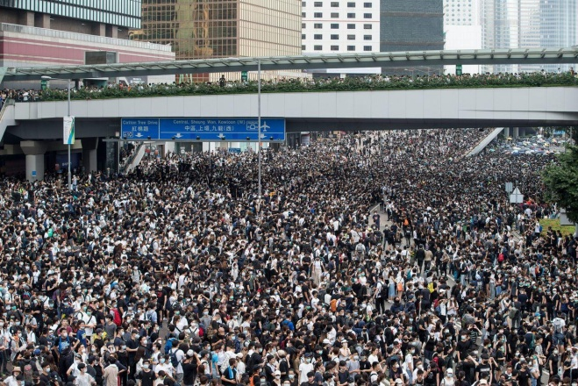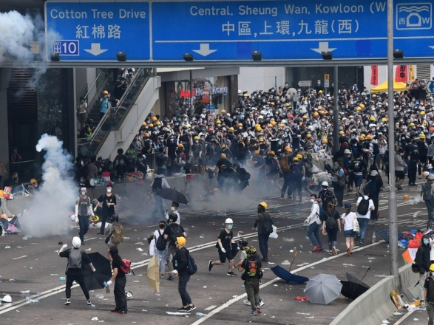

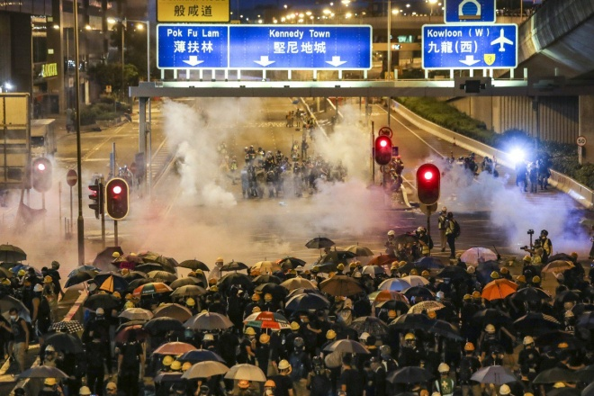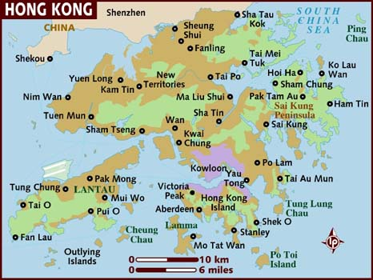
Kowloon: Home base for 40 trips into Mainland China 1994-1995

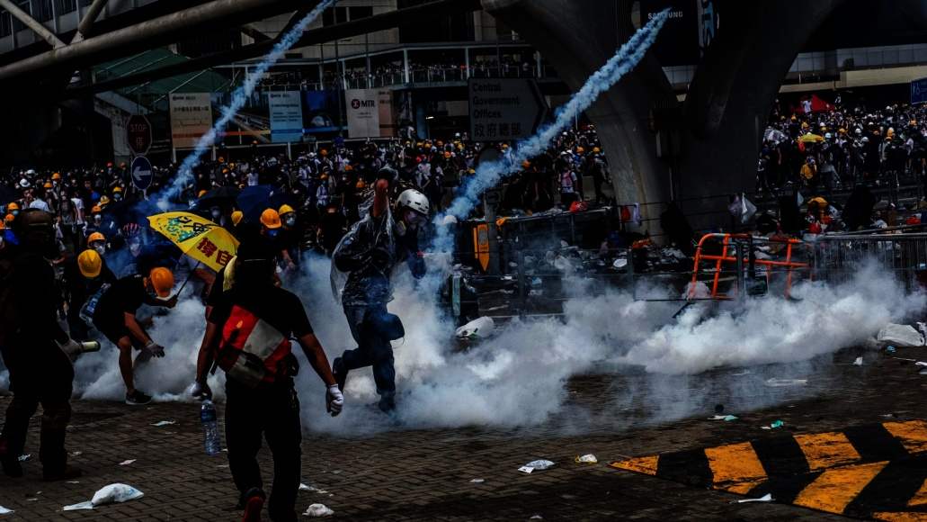
Rioters and police using tear gas, pepper spray, batons to stop the violence

On March 3, 1775 a cousin of mine faced a newly formed Congress of leaders to rally a militia to fight for the rights of Virginia. He made a speech that changed the course of the American colonies and American history as a whole. He is known as “the Voice of the Revolution.”
Here is how Patrick Henry finished his speech that day: “Gentlemen may cry, `Peace, Peace,’ but there is no peace. The war is actually begun! The next gale that sweeps from the north will bring to our ears the clash of resounding arms! Our brethren are already in the field! Why stand we here idle? What is it that gentlemen wish? What would they have? Is life so dear, or peace so sweet, as to be purchased at the price of chains and slavery? Forbid it, Almighty God! I know not what course others may take; but as for me, give me liberty or give me death!”
For several years, I worked for two Parks of Forest Lawn Mortuaries in California for several years. I worked in the office, with family counselors, arranging funerals, sending first-call drivers, and with coroners and police. I often walked into the embalming area. Many bodies lay on gurneys, covered with sheets up to their waist or chest. But, not one of them cried, laughed, or showed any love or compassion for anyone or anything. They were cold and hard as a rock. Their eyes were shut to the sufferings of this world.
The tragedy is that most people today, including most of Yahuwah’s people in the “free” world of affluence, are so dead to Yahuwah’s heart, so dead to Yahushua’s heart, and to the cries of Their people, that they might as well be on a gurney covered with a sheet. Where are today’s voices of a revolution against sin!
I had a dream a few months back in which I saw a hospital full of patients on life-support systems, dying. Then I saw a huge graveyard with graves already dug, waiting for the caskets to be lowered into them. Abba told me that this was a picture of His people--dying spiritually; awaiting burial. What a true picture of reality today! His heart is broken!
I cried until I looked through blurry eyes when I read that portion in red above, spoken so passionately by Patrick Henry. The people of the Virginia Colony were in a desperate life or death situation. His passionate plea became the battle cry for the American Revolution. He said is speech “we must fight.” Those words apply to each born again believer on earth right now. We’re under siege, under attack by an eternal enemy, and we either “fight the good fight of faith,” or we lose the Kingdom. (II Timothy 4)
It takes passionate love with the heart of Elohim to care about those we’ve never met, just because they’re our family! I’ve written so much about the persecuted church of China and the brave believers who “love not their lives even to death,” as they give their testimonies to the lost. But, in all of my writings, even sharing testimonies of the persecuted, I hear no passion out of only a miniscule few who really know how to pray. I am very thankful for the non-religious African Americans I fellowship with who really know how to pray passionately, and lead our assembly to pray in order to touch the heart of Yahuwah!
If you are aligned to the heart of Yahuwah, it is impossible to pray without strong emotion! It is impossible, because Yahuwah is very emotional! He pours His deepest feelings through those whom He trusts with His feelings.
Stand in full spiritual armor (Ephesians 6:10-18) and pray for the freedom fighters in Hong Kong! Many of them are your brothers and sisters in Messiah. It’s coming to your city or town!
Today, Chinese troops sit on the border of ShenZhen ready to break into Hong Kong. Pastor Paul Begley (paulbegley.com YouTube) reported that China is training 12,000 police officers right now in training drills in ShenZhen to combat the rioters. China is already sending in secret police and spies among the people. These China-police, military police, are not using rubber bullets; they’re firing live ammunition, kidnapping people, killing people. Begley said President Xi (pronounced “she”) is getting ready to send in the army across the ShenZhen border. It is nearly the 70th anniversary of ShenZhen’s police force.
The “Extradition” ruling is basically the evil leadership of mainland China trying to take over an independent territory. It is something like America’s coming TAPS law, and the Executive Order signed by Obama that says if anyone is suspected by neighbors, family, work employees, churches, public school teachers, or police, etc., of doing anything that might be considered “criminal,” or “out of line,” they can be reported, arrested, tried without jury, and sent away - forever.
China’s extradition law says that anyone suspected of being “strange,” “criminal,” “weird,” “suspicious,” or Christian, can be turned in. And, without trial or any chance of defense, they can be extradited to Shanghai or Beijing for judgment. They will never be heard from again! America’s Executive Order says that you can be put in prison without trial or defense if you are “suspected” of being a “domestic terrorist.” Well folks, according to China, Christians are enemies of the state, and that’s coming to America, too.
In 1997, when the British turned Hong Kong back over to mainland China as a territory, the deal signed between China and Britain said that Hong Kong was to remain independent, the citizens having their own elections, their own policing, and the privilege of continuing on with their rights as citizens of an independent territory. But, now, all of a sudden China says that they have right to come into Hong Kong and do as they please with the citizens, arrest whom they want, and extradite whom they want into mainland China.
The people of Hong Kong have been rioting for 10 weeks now and the rioting is reaching a desperate and vicious stage. Thousands of Chinese troops are on the border of ShenZhen right now.
Why are the people of Hong Kong fighting so hard? It is because they know what life is like under the Communist dictatorship of China. They know they’ll lose all of their freedoms and rights as slaves to a cruel and inhumane system. They know their property will be confiscated, their beautiful city turned into a trash heap.
Hong Kong is a major world banking center! Just look at pictures of the buildings on Hong Kong Island. It looks like a mini-Manhattan.
Why am I so passionately standing with the citizens of Hong Kong? Why is Paul Begley, and so many other believers, passionately aligned with the protestors?
For one thing there are many Christians in Hong Kong. These people are fighting for their lives. The crack-down on Christians in mainland China is intensifying. Bibles are being confiscated and burned. Christians are being arrested and killed. It’s a mini-picture of the world’s fight for basic human rights, to practice their faith as they see fit, to have good work opportunities, to have freedom and independency from wicked dictatorships, and live in peace.
I take what’s happening in Hong Kong and all of China personally. Three times during 1994 and 1995 I lived in Hong Kong with born again believers from England, Australia, New Zealand, Tasmania, and parts of Europe, in facilities of Open Doors ministry. I was involved deeply with helping the underground “church,” the true believers, get what was almost impossible to get – a Bible. My adventures took me 40 times into mainland China at many points. I saw Abba work miracles for us. See map below: I headquartered in Kowloon and went through the “New Territories” by train or by bus, through ShenZhen to GuangZhou, and by plane to Beijing and Shanghai, and even down to Hainan Island off the coast of North Viet Nam. I was in many places in China, always with the people. I love the Chinese people. Even some of the border police were challenging, but fun to interact with.
I led teams many times and did some daring exploits, adventures that to this day astound me. But, being with the people personally who risked their lives to get a Bible, - well, it changed my life. I met several times with the famed Brother Samuel Lamb. His book Bold As a Lamb is a bok you really should read, along with God’s Smuggler by Brother Andrew and God’s Smuggler to China by Brother David.
So, when I see the rioting in Hong Kong, which is mainly in the New Territories right now, feel strong emotion that leads to prayer. My heart is with the people who are fighting for their freedom. Chinese Christians are some of bravest people I’ve ever met in this world, and the most joyful. They are a passionate people.
In China I worked with believes who faced death at any moment, and their one goal was to win more souls to the Savior before death. They said that when they met together they had no time to talk about problems, or news, or family – they only had time to talk about the Savior.
Please make sure you’ve read these two articles under the Mikvah of the Heart of Elohim or listened to these to two podcasts:
1) “Transcript of Podcast XXXVI Part II: A Letter to the West from Persecuted Believers In China” and 2) “Preparing for Tribulation – Based on a Faith-Building Letter by Corrie Ten Boom in 1974” [Podcasted XXXVII-January 11, 2018]
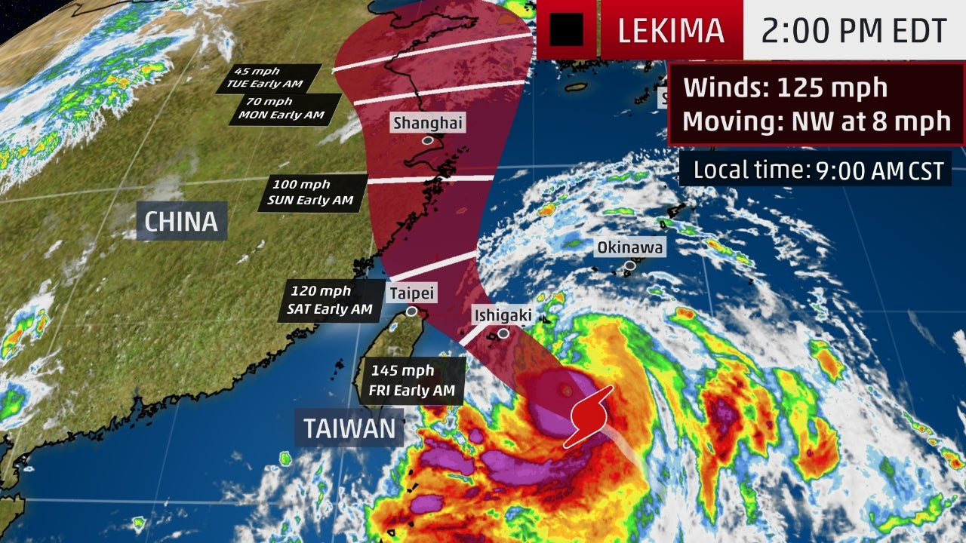
Paul Begley August 7, 2019 Typhoon Lekima
RIGHT NOW Typhoon Lekima is hitting Shanghai full force with high winds, rain, hail, lightning, also northern Taiwan where they had (8/7/2019) a 5.9 earthquake, and Japan.
“Typhoon Lekima Intensifies and Poses a Threat to Japan's Ryukyu Islands, Taiwan and Eastern China” weather.com meteorology (August 8, 2019)
Pastor Begley said that the people of Hong Kong have been protesting China’s intervention to stop their freedoms and extradite anyone they think is doing wrong to SHANGHAI. He asked: “Is this God’s statement to China?”
There are so many praying for the believers in Hong Kong, a shelter-place for Christians. It is very possible that this typhoon is Abba’s doing to let them know He’s fighting for them! This typhoon was categorized as a 4, but had the potential of increasing to a 5 or 6, category typhoon/hurricane before reaching Shanghai.
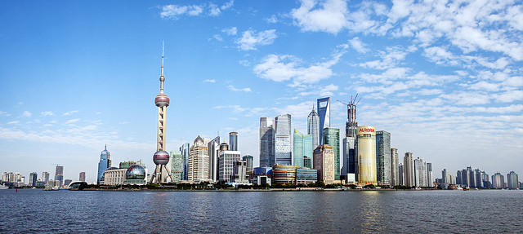
“The Bund” of Shanghai and Shanghai Harbor
I remember my three days in Shanghai. I led a team of three men. We went by bus from Hong Kong to Shanghai. When we got there with about 300 pounds of Bibles in suitcases, we found that out 150,000 police had been added in Shanghai to catch Christians and confiscate Bibles. That was in 1995. I got a call from the main office in Hong Kong telling me not to bring the “books” back to brother Lamb’s because the police had raided his church and taken all the Bibles. Because of the 150,000 police swarming Hong Kong, we couldn’t get a contact to get our Bibles.
I made phone calls trying to find anyone in Shanghai who would come get the Bibles. I prayed, “Oh Father, this is your Word, Your “precious cargo,” please send someone to help us.” That afternoon we heard a knock on the door, and a small Chinese man came in giving us the name of the leader in Hong Kong. He was from the government “Three-Self Church.” Some of them helped the underground church who is opposed to being under government control. He arranged for a man to meet us outside about 7:00 PM after it got dark. So about 6:55, we went downstairs with our suitcases, acting like typical tourists in a hotel, and went outside. Police were everywhere. It was incredible. Then from out of the shadows of a near-by building came a tall thin man, a very scared man. He presented an Open Doors ID card to me, identifying himself. We hailed a taxi. I sent the two Swiss young men with him and with all of our suitcases. The Swiss guys came back later reporting that the Bibles were safely hidden in a warehouse. The next day, we enjoyed Shanghai.
I remember our wonderful day at the Yu Gardens and at The Bund. What a wonderful feeling that amidst all those police, Abba won out!
The next day, we boarded a train for our 36-hour trip back through the countryside of China to Hong Kong. There were bunk beds set 3 high – 6 to a compartment. I loved that trip so much! I loved being with the Chinese people! I had with me a couple of booklets which contained testimonies of Chinese who had become born again. I knew they were “illegal” materials.
In the next compartment over was a lovely young Chinese couple. We got to talking. Abba said to me: “Give them one of the booklets.” Ooooh … I knew it was Abba. I gave the man the booklet. He saw what it was and his face lit up with light and he pressed it to his heart and smiled so big and said “thank you.” He showed it to his wife, she was so happy. We got to know each other. He was an officer in the Chinese military and she was a doctor. I have to laugh. Abba knew them. I loved being with the people so much on that trip. My heart is with them!
If you’re not out walking the Acts 1:8 pattern, you’re the loser. We begin by prayer walking, then sharing where we are, and the next thing we know, we’re on a plane to some remote place filled with joy of the Spirit. He leads all of His children by the Acts 1:8 pattern. It is our commission!
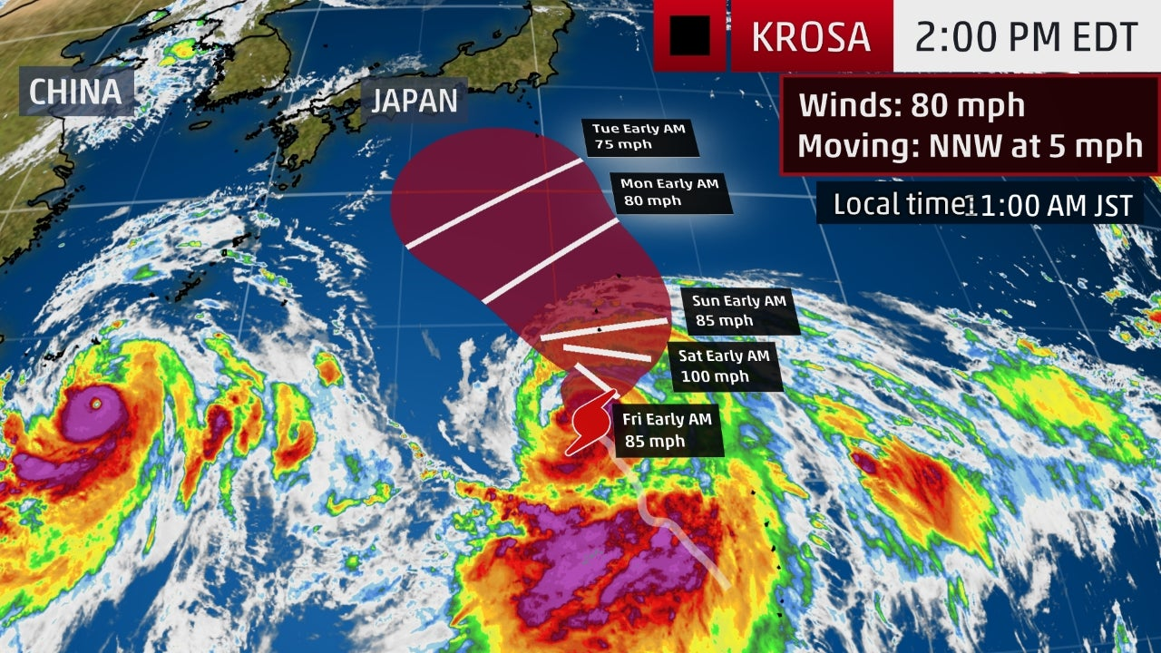
“Tropical Storm Krosa follows Typhoon Lekima and could intensify to a hurricane strength storm…” August 8, 2019
The storm at the bottom right of the map is Lekima headed straight for Shanghai. Krosa could cross Japan further north. Over in the right hand corner is another storm that is forming. The hurricane/typhoon season hits its peak on September 10th. The peak season is just beginning.
I felt led to buy a t-shirt last week with HONG KONG in big letters on it with a Chinese boat on it, like the ones docked at Tsim Sha Tsui, Kowloon.
PRAY WITH ME WITH ABBA’S HEART for Abba’s people in Hong Kong, but also His people in Shanghai, and all over China, for there are many believers in many places in China who are under severe persecution. They don’t need a typhoon! Pray for those in Taiwan and Japan also, for these typhoons are huge!
In His love, Shabbat shalom, Yedidah - August 10, 2019

