HE SETS THE PACE

In around 1992, I had a dream. It was a short dream, but very clear. I saw a first class modern high-speed locomotive barreling down the tracks at full throttle (maximum speed). Obvious it was midnight or after. It was dark, and no one was in the depots. The locomotive ran through all the stop signs, breaking down any barriers that got in its way. Then, I woke up.
As I groggily got up and shuffled into the bathroom, Abba spoke to me regarding what He had shown me in the dream. He said: “From now on, I am going to move at full throttle, and NOTHING is going to stop Me!”
That totally shook me awake! I can still see that locomotive in my mind.
Years later, around 2006, while still living in Jordan, I had a vision. I was in a beautiful country scene with meadows of wildflowers. The meadows were surrounded by towering mountains. I could not see anyone around me. I was riding a racing horse as fast as he would go, and was only focused on what was ahead. All of a sudden, out of the corner of my eye, I saw an old- fashioned stream locomotive pulling a short train. The engineer was keeping the locomotive parallel to me. It was not far away to my right. The train was also going quite fast on a track that was hidden in the meadow grass. It was one of those old trains where the engineer wood and/or coal in the boiler to keep a fire going. (See picture below, page 7) He also had to make sure that the boiler didn’t build up so much pressure that it blew up. The pressure in the boiler made the whistle blow, and the steam come out the smokestack. The engineer was keeping the train directly opposite of me. I glanced over towards the train. The engineer looked out the window and waved. I knew it was Yahushua! I’d seen Him in Jerusalem in 2003 at a dramatic turning point in my life.
Then, my mind questioned what had happened to those I was with when I mounted the horse back in the town. I was concerned because I was out there alone, except for the engineer of course. I had seen a few people getting on their horses, but most of the people didn’t even attempt to mount their horse. They were too busy laughing and talking. I thought that I should stop and wait for those behind me. I knew I could not stop! I had to keep up with the train. The horse was going as fast as he could--straight forward. Others who had mounted their horses had equally as swift a horse as mine. Yet, where were they?
All of a sudden, I saw straight ahead what looked like the main street of an old western town--like the kind in the old American T.V. “westerns” of the 1950s, i.e. “Gunsmoke.” My dad loved watching “westerns,” so I watched them too. This town had wooden stores and other businesses on either side of a wide dirt street. Wooden sidewalks ran along each side. Standing along the sidewalks were opaque-looking human figures like ghosts, dressed in old western garb. I remember the long dresses of the women, and their bonnets with ribbons that tied under their chins. All of them had faces radiant with joy. They were all facing me--cheering me on with great enthusiasm and clapping. I knew who they were. I had seen such a group two times before. They were the Hebrews 12:1 “cloud of witnesses.” I did not break speed, but ran straight down the dirt road towards them. The train I was paralleling had disappeared. I had arrived among my people, Abba’s people.
Hebrews 11 is a fantastic chapter, telling of the faith, endurance, and overcoming of those that have gone before us. It concludes with Hebrews 11:39-40: “And all these, having obtained a good report through faith, yet not having received the promise (of Messiah)--Elohim having provided some better thing for us, so that, without us they should not be complete.”
Hebrews 12:1-3: “We, too, then, having so great a cloud of witnesses all around us, let us lay aside every weight, and the sin which so easily entangles us, and let us run the race with patience, looking unto Yahushua, the Author and Finisher of our faith, Who, for the joy set before Him, endured the stake, despising the shame, and is set down at the right hand of the throne of Elohim.”
I knew th3 vision was a prophetic word from Abba about what lay ahead for me. It was also an exhortation--a “word of knowledge and a “word of wisdom,”--about what is and what will be.” (I Corinthians 12:4-11)
Today, December 3, 2014, while drinking my morning green tea shortly after I got up, Derek pointed out a rainbow that was coming up from the floor of a valley below the mountain where we now temporarily live. I took a couple of pictures of it. It was beautiful. Shortly after that, he and Rivkah went to begin their daily work in their individual rooms. I was not feeling well. It was cold. My bones, and my whole body, were aching. But, also, my spirit was heavy.
I am facing new things in my walk with Yahuweh that require even more resignation of everything to Him--more faith, more resolve to push forward. And, too, I carry His heart of grief for His people. So many of His loved ones are about to go over a cliff to their destruction, because they have allowed themselves to be ensnared by deceptions, and the world.
Through the years, He has shown me quite a bit of my future. But, grabbing hold of it is not easy when part of me longs for a home of my own with a nice recliner rocking chair in the living room, and my own office where I can actually work at a table. Though my health is excellent, still, after nearly 400 airline flights, and challenging hardships in so many countries, the idea of going through more airports is not the great adventure it used to be. I’m more drawn to “Take Me in to the Holy of Holies.” I am also enjoying learning to play my Davidic harp!
I am submitted to Yahuweh to do whatever He wants me to do, and go wherever He wants me to go. And, there are times when the fire begins to burn in the boiler of this old locomotive, and I realize that inside my spirit, I am only about 16 years old. It still does not take much to revive my excitement to go, see, and report! I have always been curious, and so I ask a lot of questions, and I want to see places with my own eyes.
Iyob (Job) writes, in Iyob 19:25-27: “I know that my Redeemer lives, and that He shall stand in the latter days upon the earth. And though after my flesh worms destroy this body, yet in my flesh I will see Elohim--whom I shall see for myself, and my eyes shall behold, and not a stranger…”
He didn’t long to hear about the Kingdom from someone else--he longed to see it for himself, be active in it, and stay close to the King.
After finishing a bowl of cereal, I tackled the project of opening a bottle of Myrrh essential oil, but the sticky resin was holding it closed. Derek was already at work. So, I boiled some water in a tea kettle to pour over the cap. Then, I tried pouring the boiling water over the side of the bottle to loosen the cap, but instead I poured it onto three of my fingers. I felt the pain. But, I tried once again to pour the boiling water over the bottle, and once again burned the same three fingers. I was already crying over things I was wrestling with, so the immediate pain from the boiling water released a flood-gate of tears. However, to my amazement, after the initial feeling of the boiling water, I had no more pain in my fingers--as if it didn’t happen.
I went into my room so I would not disturb them. I was not on a “downer”--no self pity involved, no negative emotions--that’s not me. I was just honestly assessing my situation, and requesting Him not to put me out to pasture, but to fulfill what He has shown me of my future. King David also pleaded with Abba when he was old and grey headed to let him teach the next generation. (Psalm 71:18) Abba kept me in “perfect peace.”
Upon entering the room, I looked out my door which faces the valley below and the mountains on the other side. Instead of a ½-rainbow, I saw a large full-sized rainbow. It arched up from the valley floor into the blue sky above and came down to the valley floor again. It was gorgeous. I got my camera and took some pictures. I love the beauty of His creation! My mother was an artist, and loved bright colors – me too. I “paint” beautiful and unusual scenes with photography. My first thought was that Abba put that rainbow there for me--to show me that His promises will never be withdrawn. As He promised Noah, so He promised me. I took it as a proclamation to me of His faithfulness. I had renewed joy. (See rainbow picture below, page 7)
Lamentations 3:21-24: “This I recall to mind, therefore I have hope. It is of Yahuweh’s mercies that we are not consumed, because His compassions fail not. They are new every morning – great is Your faithfulness! Yahuweh is my portion (my inheritance), says my soul, therefore I will hope in Him.”
I had tried to be quiet with my crying, but it was not long before Derek and Rivkah were by my side to pray for me. For some reason, as Derek prayed and we talked, I remembered that dream from 1992, and the vision from 2006. I told them what I saw.
In response, Derek said, referring to the Engineer, Yahushua, in my vision: “The Engineer sets the pace of the locomotive. It is our job to keep up with Him.” He reminded me of the many promises Yahuweh has given to me about my future. Together, they reminded me of things I needed reminding of. Derek elaborated that in an old coal and/or wood-driven locomotive, the engineer had to keep the fire burning in the boiler, but must not let it get too hot so that it would blow up. He said that the steam vents through the whistle, but also has to be vented through the smokestack. But, the engineer kept the pace and the pressure under his control, all the while the train was taking people to their destination.
Somewhere in our discussion, the tears stopped and the light of day broke through. I had renewed hope, joy, and expectancy. The anointing of the Spirit came, and I began to cry from joy.
I can still see this vision as if it was given to me yesterday. I also clearly see the vision that followed this one, within a couple of days of it. In this vision, I saw the same country scene. But, I was walking up a path that led up a very high and very steep mountain. I was doing all right, but not far from the top, I became exhausted. I reached a point where I could not put one foot in front of the other. I just stood there staring at the top of the mountain, knowing I had to get over it in order to descend to what Yahushua had for me on the other side. But, I could go no further in my own strength. All of a sudden, there He was – Yahushua. He smiled, put His arm around my waste, and together we walked over the top. I remember looking down into a deep valley below the mountain, and was excited about going there.
There are things we must do to the best of our ability in obedience to Him. He wants to toughen us up, not spoil us. Discipline and endurance are necessary to overcome and be ready to meet Him in the air. But, it is He who sets the pace, the goals, and the deadlines--not us! Our job is to stay with Him – not run ahead, or lag behind! He is moving at full throttle now. We must keep our eyes forward and not look back if we want to keep up with Him! Thank goodness we have peripheral vision, so that we also can see the front of the locomotive in order to keep pace with Him! There is no time allotted to us to stop, get off the horse, and lollygag around. But, as we go forward, there are times when He has to rescue us in soul (mind, emotions) and body, to keep us on the straight and narrow path.
Beware of false responsibility! It so often makes us feel guilty if we don’t stop and do what culture or family says we should do. I’ve seen this destroy the lives of several friends who knew that Abba was leading them to specific places to serve Him, but out of false responsibility to family, they did not obey Him. The thoughts in my mind in the vision were to stop and wait for others to catch up, but I knew that if I did, I would not make cross the finish line. (Slowly read Matthew 10:34-39 and Luke 14:25-33)
We should never allow anyone to put us on a pedestal for our achievements, but we must give all esteem to Yahuweh. The old expression goes: “There are no heroes in the service of the Master – just those that have said “yes” to the Master so many times that they give the illusion that they are.”
We’re all frail human beings. Messiah said: “Without Me, you can do nothing.” Sha’ul said: “I can do all things through Him, who strengths me.”
In other words, we can do all that He strengthens us to do within His will. Yet, there is something that He has put in us called our “will.” In order to win this race of life, we must lock our will into His will, look straight forward, and with His strength go forward to the finish line.
I love the movie Iron Will. There is something built into us humans that gives us the determination to overcome, endure hardship, and reach our goals no matter what obstacles come in our path. But, the illusions and deceptions of fallacious goals, fed to us by the Illuminati programming, have left most people spiritually weak. Thus, their will is turned towards making life good, easy, comfortable, and secure, not in learning to endure to the end to receive their reward in the Kingdom of Light.
In the 1st vision, above, most of my friends had not even gotten on their horse, let alone started riding. It is a lonely ride, yes … As the song goes, “though none go with me, still I will follow.” Our Elohim never takes us anywhere but forward! Rewards are only given to those who cross the finish line … “…so run the race with patience, looking unto Yahushua, the Author and Finisher of our faith.” (Hebrews 12:1)
To be in the race, we have to first get moving towards the starting line, then He will come along side to help us. He can’t help us if we do not show Him our faith by acting on what He has told us to do--in the Word, and personally in our spirit. Everyone of His children are called to press forward into that cloud of witnesses, which represents our eternal life-goal.
Daniel 11:32b: “…but the people who know their Elohim will be strong and will act” (do exploits, KJV).
I Corinthians 9:24-25: “Don’t you know that in a race all run, but only one gets the prize. So run that you might obtain it. Everyone who competes controls himself in every way. Now they do it to receive a corruptible crown, but we for an incorruptible crown!” The Spirit of Yahuweh wants to prepare us in every way to win, but He will not have any competition from our self-will! We have to totally submit to Him.
We’re all heading forward in time, and we must do it without looking back. “Remember Lot’s wife.” (Luke 17: 32) Luke 9:62: “No one having put his hand to the plough and looking back is fit for the Kingdom of Yahuweh.” “Tell the children of Israel to go forward.” (Exodus 14:15)
My theme song for many years has been Steven Curtis Chapman’s The Great Adventure: “Saddle up your horses; we’ve got a trail to blaze…”
I remembered that song this morning. Yahuweh gives each one of us his own trail to blaze, and, if we keep going, we arrive to the cheering cloud of witnesses. It’s just that in blazing the trail He has for us, we don’t dare put down tent-pegs in this world. “The path of the righteous is like the light of dawn, it gets brighter to the full day.” (Proverbs 4:18-19) The only way the path can get brighter is if we’ve moving forward towards the full Day of His return. The cloud of witnesses is cheering us on!
Remember! He sets the pace! And, through His strength, we must keep up with Him! Come, ride with me!
In His love,
Yedidah
Written December 3, 2014
Posted December 5, 2014
TWO PICTURES BELOW …

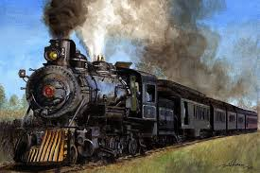
Painting of a steam locomotive by Dale Jackson, fineartamerica.com

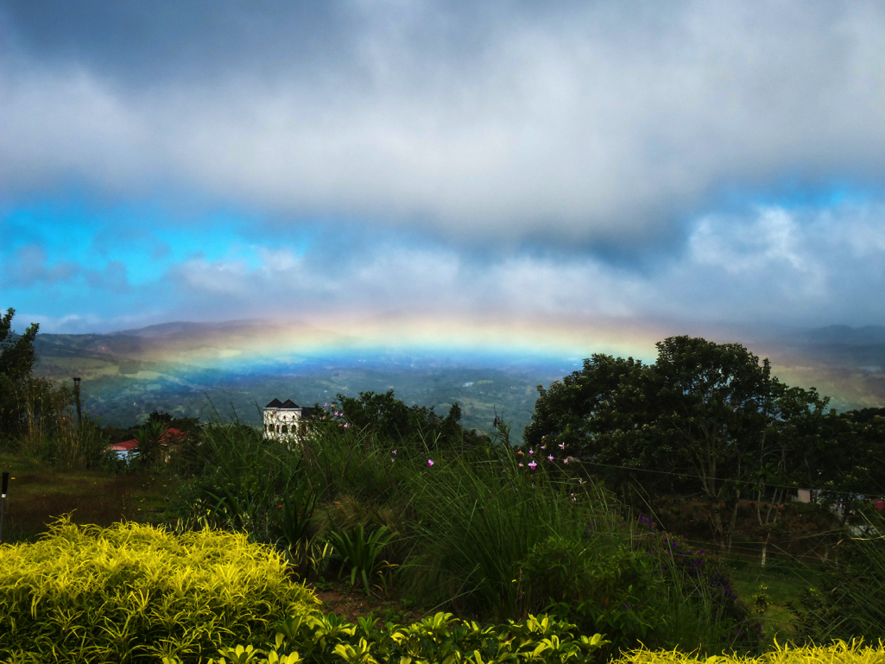
December 3, 2014, Costa Rica morning – Photo by Yedidah

