HISTORIC LOCUST PLAGUE THREATENS FAMINE IN EAST AFRICA

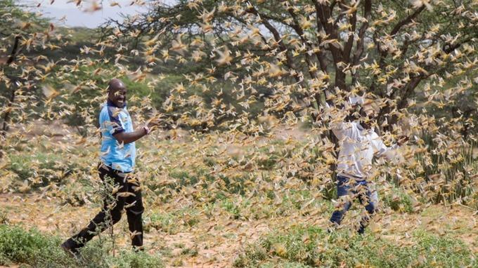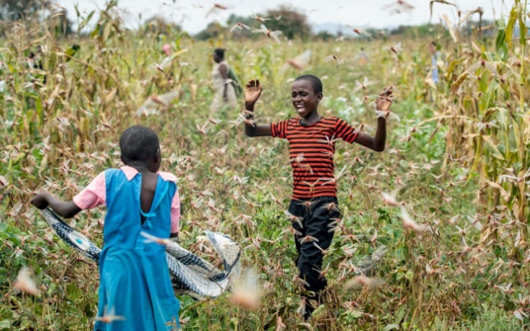

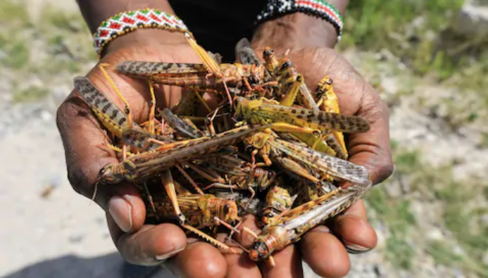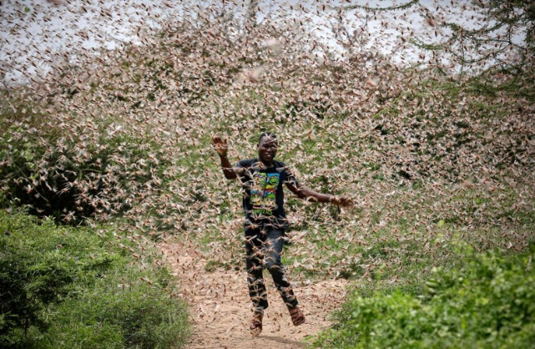

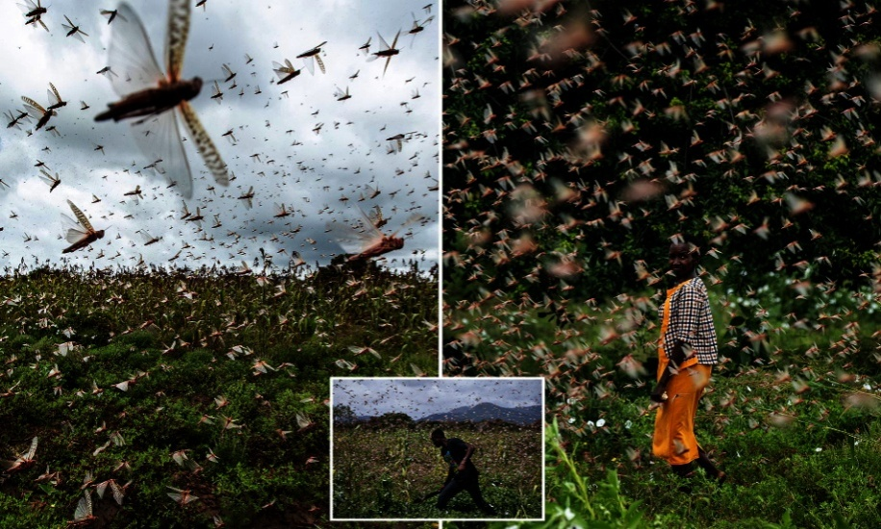
Exodus 10:3-20: “And Mosheh and Aharon came in to Pharaoh and said to him, `Thus said יהוה Elohim of the Heḇrews, “Till when shall you refuse to humble yourself before Me? Let My people go, so that they serve Me. Or else, if you refuse to let My people go, see, tomorrow I am bringing locusts within your borders. And they shall cover the surface of the land, so that no one is able to see the land. And they shall eat the rest of what has escaped, which remains to you from the hail, and they shall eat every tree which grows up for you out of the field. And they shall fill your houses, and the houses of all your servants, and the houses of all the Mitsrites (Egyptians), which neither your fathers nor your fathers’ fathers have seen, since the day that they were on the earth to this day.” ’ ” Then he turned and went out from Pharaoh…
And יהוה said to Mosheh, `Stretch out your hand over the land of Mitsrayim for the locusts to come upon the land of Mitsrayim, and eat every plant of the land – all that the hail has left.’ And Mosheh stretched out his rod over the land of Mitsrayim, and יהוה brought an east wind on the land all that day and all that night. Morning came, and the east wind brought the locusts. And the locusts went up over all the land of Mitsrayim and settled within all the borders of Mitsrayim, very grievous. There had never been locusts like them before, nor would there again be like them. And they covered the surface of all the land, so that the land was darkened. And they ate every plant of the land and all the fruit of the trees which the hail had left, and no greenness was left on the trees or on the plants of the field, in all the land of Mitsrayim. Pharaoh then called for Mosheh and Aharon in haste, and said, `I have sinned against יהוה your Elohim and against you. And now, please forgive my sin only this once, and pray to יהוה your Elohim, that He would only turn away this death from me.’ And he went out from Pharaoh and prayed to יהוה. And יהוה turned a very strong west wind, which took the locusts away and blew them into the Sea of Reeds. Not one locust was left within all the border of Mitsrayim. However, יהוה hardened the heart of Pharaoh, and he did not let the children of Yisra’ĕl go.”
This story is very heavy on my heart, especially regarding Kenya. I was in and out of Africa 7 times in six years. Many times I stayed with my African Director and his precious family in their small mud-hut community, not too far from Bungoma, and worked with several pastors in that area. My heart breaks for the people. The crops are being destroyed, and famine will set in. I also ministered across Uganda and into Tanzania. So far the locusts have not gone into these two countries.
Refer to “Geoengineered Wildfires, Burning of Green Things, Oceans and Waterways Dying, Earth Overheating: Revelation 7, 8, and 9”/Mikvah of the Heart of Elohim. Green things provide us with oxygen and with disease protection.
The sealing of His last-days Daniel 11:32 remnant takes place before the total destruction of green things, i.e. crops of all types, trees, and grass (including young grain crops). (Revelation 7:1-3, Revelation 8:7, and Revelation 9:4)
Note Joel 2 with Revelation 9:1-11! The locusts in these two chapters are Yahuwah’s army of judgment. Reading in context, the locusts are symbolic of demonic hoards. In “The Pale Horse! Separating Yahuwah’s Judgments From His Final Wrath,” published January 28, 2020, and “Yahuwah’s Pattern of Judgment,” the “beasts of the earth” is one of the first four of His 10 judgment patterns. (Ezekiel 14:12-23) His main 4-pattern includes: war/martyrdom, famine, pestilence/disease plagues/pandemics, and the beasts of the earth. (Revelation 6)

'Biblical' Locust Plague With Mega-Swarms The Size Of Cities Descends On East Africa by Tyler Durden - Mon, 1/27/2020 Zero Hedge
“As if the world's facing a looming new global pandemic weren't enough, here's yet another rare occurrence of apocalyptic proportions threatening to devastate the economy and way of life on an entire continent: the worse outbreak of desert locusts in seventy years is ravaging East Africa — specifically Kenya as hundreds of millions have swarmed in from Somolia and Ethiopia, reports the Associated Press. The hum of millions of locusts on the move is broken by the screams of farmers and the clanging of pots and pans. But their noise-making does little to stop the voracious insects from feasting on their crops in this rural community.
… The numbers and immediate destructive force are staggering, according to quotes in the AP: About 70,000 hectares (172,973 acres) of land in Kenya are already infested. A single swarm can contain up to 150 million locusts per square kilometer of farmland, an area the size of almost 250 football fields, regional authorities say. One especially large swarm in northeastern Kenya measured 60 kilometers long by 40 kilometers wide (37 miles long by 25 miles wide).
The UN Food and Agricultural Organization is reportedly mobilizing an emergency response, given even small swarms can wipe out crop fields at sizes constituting enough food that could have fed tens of thousands of people in a single day, which makes it a humanitarian disaster in the making.
It's both the nature of their small size (about a finger's length) and the fact that they swarm in millions at a time that make preventative measures nearly impossible.”

“A Plague of Billions of Locusts Threatens to Create a Horrific End Times Famine All Over Africa” January 27, 2020 by Michael Snyder - The Economic Collapse
“Billions of locusts are eating everything in sight in east Africa right now, and every single day many more farms are being completely wiped out.
Ravenous locust swarms that are `the size of cities’ are consuming crops at a staggering pace, and this could potentially cause famine on the African continent that is unlike anything we have ever seen before.
... The density of some of these locust swarms is absolutely crazy. According to officials, a single locust swarm can have`up to 150 million locusts per square kilometer’‘…`A typical desert locust swarm can contain up to 150 million locusts per square kilometer,’ the East African regional body, the Intergovernmental Authority on Development, has said. `Swarms migrate with the wind and can cover 62 to 93 miles in a day. An average swarm can destroy as much food crops in a day as is sufficient to feed 2,500 people.’ And it is important to note that some of these swarms are many times that size. In fact, one of the largest swarms in northeastern Kenya was measures to be `60 kilometers long by 40 kilometers wide’. In other words, that swarm was far larger than any major city on the entire planet.
If you can believe it, and I know that this sounds absolutely nuts, but UN officials are actually warning that this plague of locusts could get “500 times” larger when warmer weather arrives…When rains arrive in March and bring new vegetation across much of the region, the numbers of the fast-breeding locusts could grow 500 times before drier weather in June curbs their spread.”

In 2018-2019, locusts covered Mecca, Saudi Arabia, and devastated several countries east of the Red Sea. Now locust swarms are moving across the African nations West of the Red Sea. In Aqaba, Jordan, I could see 4 countries on two continents from my kitchen window--Israel and Egypt to the West, and Jordan and Saudi Arabia on the East. The African Continent and the Asian Continent are separated by the Red Sea.
One year, while looking out my kitchen window, I saw huge swarms of locusts coming across the Egypt border, flying straight ahead into Israel. I wrote an article about them. Evidently, not one had a Jordanian passport (smile), so none entered Jordan. They flew along the border of Israel and Jordan, but stayed inside Israel.
So many wonderful believers are in extreme danger zones, in Africa, the Middle East and the Far East/Asia. So many wonderful believers in China are starving under lockdown in quarantined cities. Many risk their lives to share the Good News of salvation. What a mission field!
Don’t just pray - intercede for the believers – “stand in the gap.”
Proclaim their protection using the Word. Speak in the tongues of angels the will of Yahuwah by the Spirit. Don’t just think it’s over there. It’s coming to your neighborhood too. Unless you move to Mars and live underground (smile). Every truly born again believer who is heaven-bound is our brother or sister. Pray as if they were your family, because they are! Abba loves His children!
I Peter 4:7-8: “…the end of all has drawn near. Therefore be sober-minded, and be attentive to prayers. And above all have fervent love for one another…”
In His love, Yedidah
January 29, 2020

