Hong Kong Christians Join Protesters with
Bibles, Prayer, and “Singing Hallelujah to the Lord”

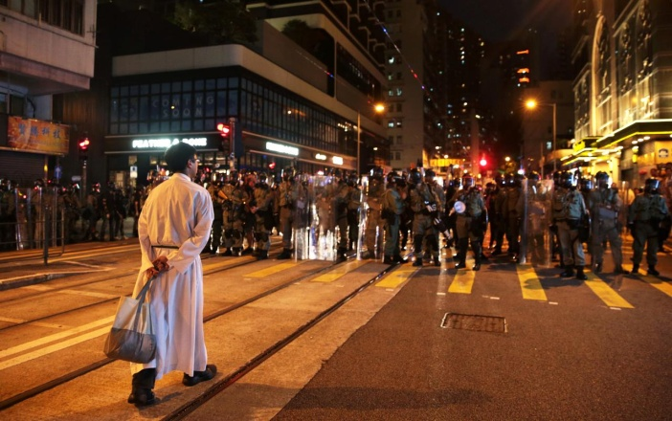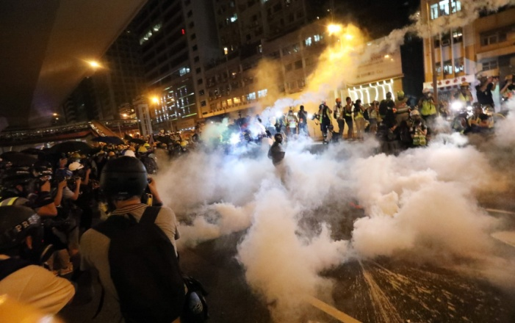
Left: “Stoic priest faces down a wall of riot police – Chinese troops mixed into Hong Kong Police” Right: The police broke past the priest and began spraying pepper spray and tear gas on the protestors.
Christians are protesting with dignity, going into the streets carrying Bibles and singing praises to Jesus. The song “Sing Hallelujah to the Lord” has become an unofficial anthem for the protestors. This is the 14th week of pro-freedom protests in Hong Kong against the Chinese law of forcing Extradition to China.
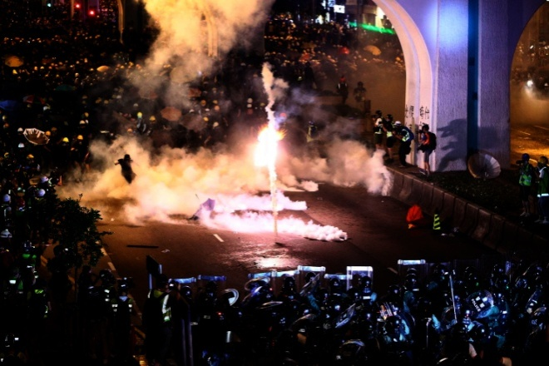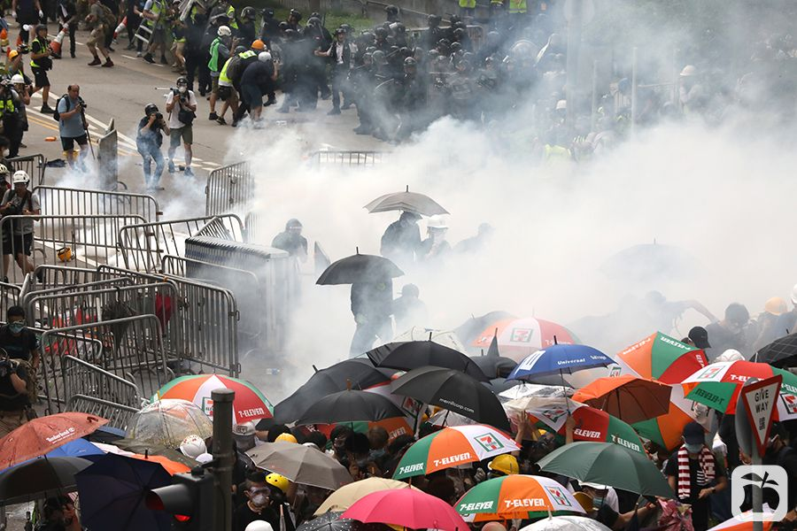
Police fire rubber bullets, tear gas, and purple dye into the crowds

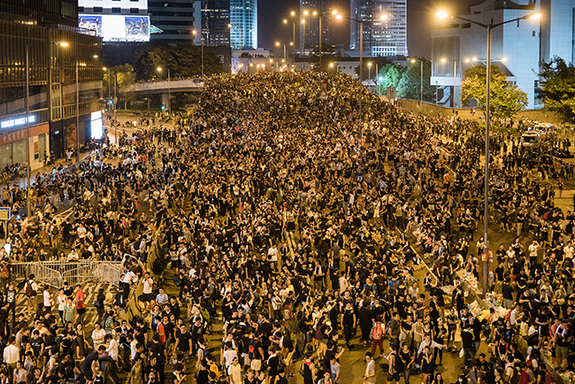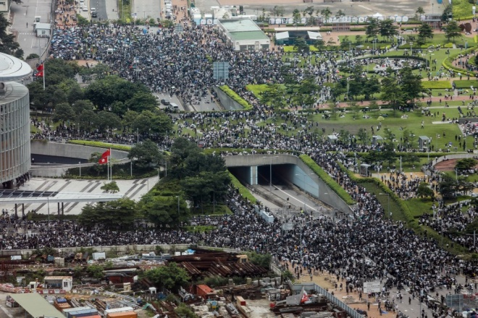
Jerusalem Post
The song “Sing Hallelujah to the Lord” is uniting Christians to pray and praise in the face of a destroying Beast. Christians are carrying their Bibles into the streets, too.
***Listen to their worship song as you pray: “Maranatha Singers (SING HALLELUJAH) YouTube-RomanianWarrior1966 or

Sing Hallelujah - The Maranatha! Singers [with lyrics] – YouTube/
https://www.youtube.com › watch - Aug 26, 2016 - Uploaded by Worship Videos
"Let everything that breathes sing praises to the Lord! Praise the Lord!" Psalm 150:6.
In China Bibles are destroyed. The believers who do not bow to the dictates of the Communist government when it crosses the Word of God and hinders their sharing the Good News of salvation – but carry on in peaceful service to Elohim. This results in denial of rights, torture, death, prison, and cruelty beyond belief. In Hong Kong they are free to worship, free to have democracy, free to be decent human beings with peace. China wants to take away their rights to be free.
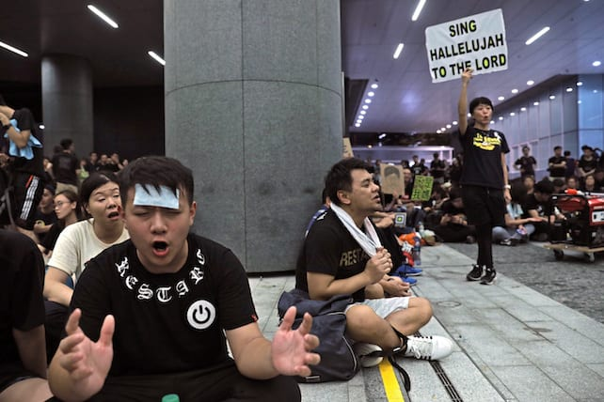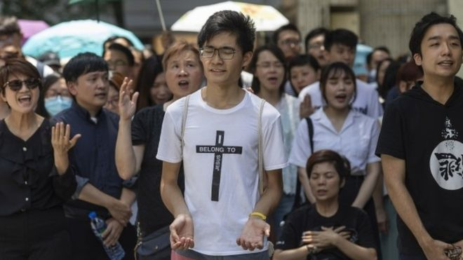
Left: Jerusalem Post: “`Sing Hallelujah to the Lord’ Emerges as Anthem of the Hong Kong Protestors”
Right: BBC “Sing Hallelujah to the Lord” became an unofficial anthem of the protesters.
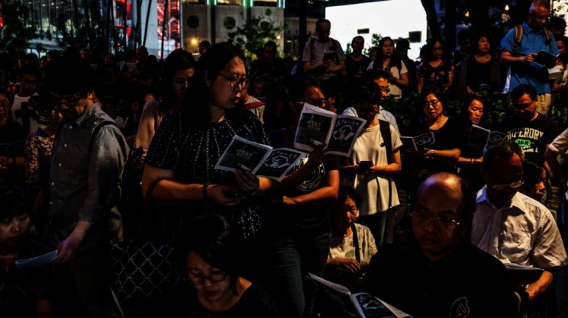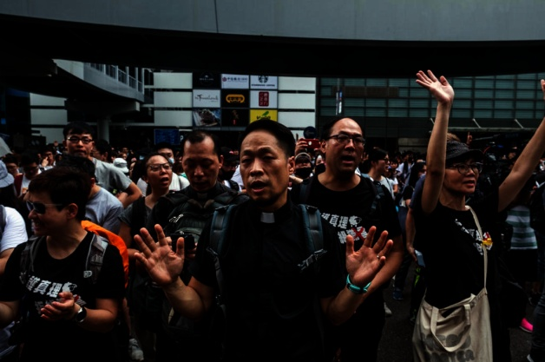
Left: New York Times: “With hymns and prayers Christians help drive Hong Kong Protests.”
Right: Today online: “Prayer and praise among the pro-freedom protestors”
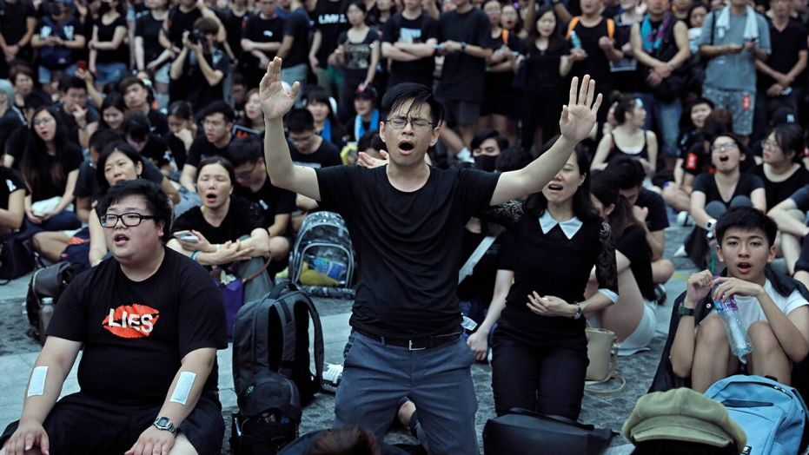
Fox News: “Hong Kong Protestors Embrace Unexpected Christian anthem…”
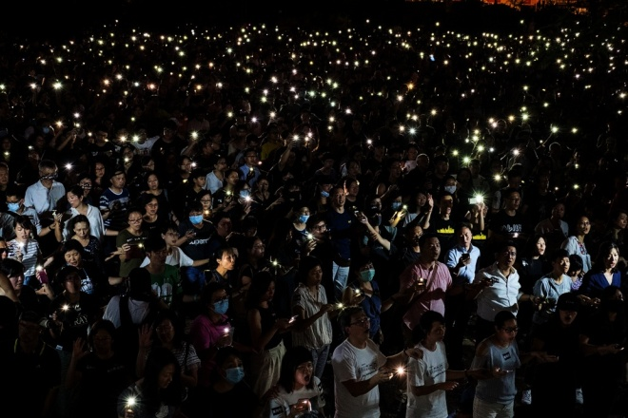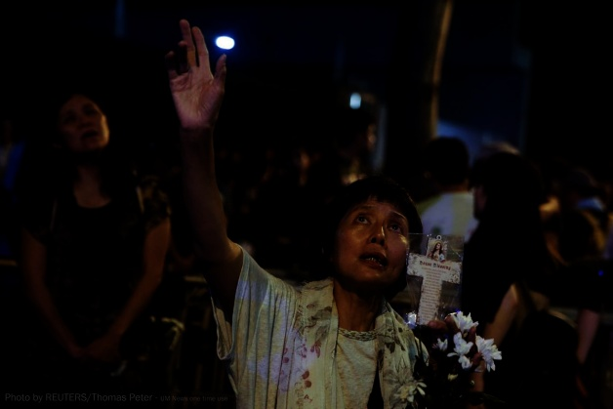
Left: Religion news service: “Christians lend an anthem and a pacifist spirit to the protests”
Right: UM news: Christian Hymn unites protestors
Join with them in praise, prayer, and proclamation that the believers will stand strong and not lose faith. So many protestors have been arrested and sent into China – never to be seen again.
Please refer to the recent article: “Hong Kong, China Extradition – Shanghai and Typhoon Lekima”/Mikvah of the Heart of Elohim.
The Christians of Hong Kong are a witness to the world of the strength of the believers in nations who do not lie down and let evil run over them. They are fighting a spiritual battle against a vicious attempt at the taking away of their rightful human freedoms by a regime that has total control over their one billion plus people.
The citizens of China are being watched by technology night and day to determine their “social credit” rating. If their rating is in good standing because a person does as they are told to do, thinks what their told to think, and pays homage to the government leader as a god, then they have a few “privileges.” If they do not do as the government demands of them, absolute allegiance, even in thoughts, their privileges will be taken away, and even their life. Yes, there is such a thing there as “thought police!”
That’s how the people live in North Korea too. That’s Communism! That’s what’s invaded and is taking over America. That’s the Beast system that is planned for the whole earth. We’re watching Revelation 13 coming into present reality.
In praying for those in Hong Kong who are protesting the encroachment of evil into their legal free state, you will be praying for yourself and your family. It’s coming to America; it’s coming to the world under the antichrist Beast system (Revelation 13). Pray like they do – with fervor. Pray as if it was you in the streets of Hong Kong.
This is very dear to my heart because of being in Hong Kong so much during 1994-1995 and reaching out into Mainland China from Hong Kong to help the persecuted believers.
I recommend God’s Smuggler to China by Brother David, and The Heavenly Man by Brother Yun to acquaint you with what the people in Hong Kong are standing against. Brother David and Paul Estabrooks worked out a plan years ago to get one
million Bibles into China in one night during the regime of Mao Tze Tung. Today, President Xi of China is being compared to Mao Tse Tung as a great honor to him.
Talk about real heroes! I met Paul Estabrooks in Ulaanbaatar, Mongolia, in 1996. What a privilege! Men who risk their lives to get Bibles to those being imprisoned, tortured and killed for having one, are real “men of God.” All who love not their lives, even to death, are real children of Yahuwah and Yahushua! (Revelation 12:11) They will not deny Yahushua! These are the ones who live in the throne room of Elohim forever. (Revelation 7) Whether by life or by death, they witness to the love of our Father and His Beloved Son, our Savior and soon-coming King!
Yes, among the protesters probably are some “plants” of the world government to steer things their way. Pray for the protection of the people who love our Savior. Pray for wisdom in the protests. Pray that China backs off. Pray for your family.
What’s happening there is planned for the U.S. and the world as the world comes into a “new world order,” a “one world government.”
In His love,
Yedidah
September 3, 2019

