LIGHTNING AND SNOW KILLED SHEEP IN NAPAL AND ARGENTINA
YAHUWAH’S SHEEP ARE DYING
ALL OVER THE WORLD

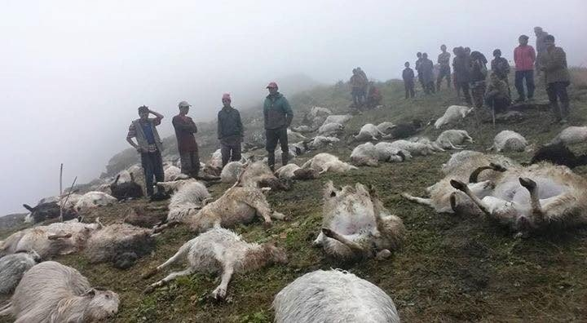
500 sheep killed by lightning in remote Nepal, August 23, 2020 Rising Nepali Daily
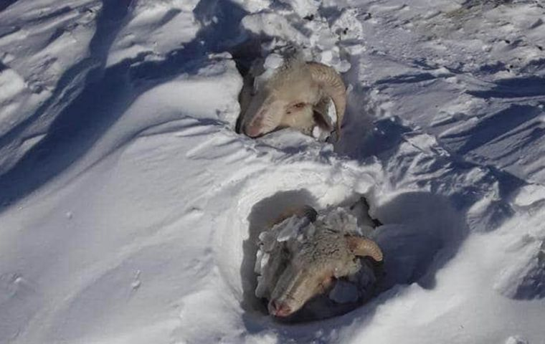
“We estimate that the worse losses are along the mountainous terrain between 1,000 and 1,300 meters above sea level” Merco Press photo August 23, 2020 [Argentina]
[Article taken from a news and Biblical teaching by Pastor Paul Begley August 27, 2020 Youtube.]
We must be in prayer, intercession, proclamation, and warfare more now than ever before, in the power of the might of the Spirit of Yahuwah!

Hosea 4:1-3, 6-7: “Hear the word of יהוה, you children of Yisra’ĕl, for יהוה has a case against the inhabitants of the land: “For there is no truth or kindness or knowledge of Elohim in the land. 2 Swearing, and lying, and murdering, and stealing, and committing adultery have increased. And bloodshed follows bloodshed. 3 Therefore the land mourns, and everyone living there languishes, with the beasts of the field and the birds of the heavens. And the fish of the sea are taken away…6 My people have perished for lack of knowledge. Because you have rejected knowledge, I reject you from being priest for Me. Since you have forgotten the Torah of your Elohim, I also forget your children. 7As they were increased, so they sinned against Me. My esteem they have changed into shame.”

On Sunday, August 23, 2020, 500 sheep were instantly killed during a monsoon storm as lightning struck them in Nepal.
On the same day, 100,000 sheep died on the mountains of Argentina because of a sudden deep snowstorm. 5,000 cattle died also. The animals were gazing on the hillsides when this freak snowstorm hit and froze them to death.
Pastor Begley said: “Whatever is going on in the physical world mirrors spiritual reality.” Definitely!
It’s not just the beasts of the field – sheep, goats, cattle, bison – it is the birds of the heavens and the fish of the sea. Since January of 2011, tens of thousands of birds have dropped dead out of the sky. Fish, sea mammals, and Crustaceans, have washed up on the sea shores world-over in the hundreds of millions. That was the month the destabilization of the Middle East began, the beginning of the fulfillment of Pike-Mazzini Plan Part III of 1871, and World War III to begin in the Middle East.
That three-part plan by the leader of the Scottish-Rite Freemasons, Albert Pike, and Giuseppe Mazzini, leader of the Bavarian Illuminati and founder of the Mafia, has been fulfilled to the finest details as World War I and World War II paved the way for World War III and global government under the son of Satan. [Refer to: “The Pike-Mazzini Plan of 1871”/Mikvah of Israel, Our Eternal Inheritance]
Wars and provoked wars are increasing in intensity. Riot charged with hate are filling U.S. cities, killing insanely anything that their hate directs them to. As the earth itself revolts against the sin, all creation is revolting. There is nearly no truth in the land, no love with compassion, mercy, kindness, gentleness, only cold hard hate – no knowledge of the love of our heavenly Father. We are “as in the days of Noah.” (Genesis 6)
Just two weeks ago, we saw members of Antifa burning Bibles in Portland. Churches are being vandalized, steeples pulled down, even a statue of Jesus was beheaded. It is an across-the-board hate for the God of the Bible and for Jesus, whether they’re attacking Catholic or Protestant churches it doesn’t matter – their focus is on desecrating anything to do with the God of the Bible.
It is the hate of Satan demonstrated through fallen angels and their disembodied seed – demons – possessing the people. It is the hate that will manifest through the Beast/antichrist, anti-messiah. This is why Revelation 20:4 – speaks of the martyrs as being beheaded.
I saw a video of a recent city riot that Steven ben Nun showed - a city in the U.S. A young man picked up a brick and threw it at the head of a police officer as he turned his back. The brick hit him in the back of the head, knocking him onto his face – out cold. Car windows were smashed for no reason but to smash them. People being shot for no reason but to shoot someone.
Please re-read the article, or listen to the podcast, in which I share a vision by Byron Searles in which Messiah is speaking of these things “Yahushua’s Prophetic Word to His People”/Mikvah of the Heart of Elohim. We’re seeing utter anarchy as a 21st century Bolshevik revolution is taking place before our eyes.
Matthew 24:12-13: “Because of the increase in lawlessness, the love of many will grow cold. However, he who shall endure to the end will be saved.”
For the most part, the love of Yahuwah and Yahushua is not flowing through His people to the lost, or to their own brothers and sisters – criticism reigns, religion reigns, division reigns, self-righteousness reigns, judgment reigns, and people are losing their faith.
Hebrews 10:25: “Forsake not the assembling of yourself…all the more as you see the Day approaching.” Mixed in with other mind-controlling Covid-19 restrictions is the forbidding of churches and congregations to meet in assembly. It has gotten so bad that if they do meet, even in small numbers, no one is allowed to sing, all must wear masks, practice “social distancing,” and no hugging, no shaking hands. In some places the law says “no Bibles” – they carry germs.
In most all western-culture churches, the sheep of His pasture (John 10) are freezing to death because the pastors are not teaching the whole Word, are starving the sheep – they are dying of malnutrition. Either that or they are being struck down by verbal lightning strikes that deeply wound them and isolate them.
The sheep of Yahuwah’s pasture are emaciated. They are pitiful and weak in overcoming faith. They are not taught that sin brings judgment. The strength of the Word is not taught to them – so they starve on milk and pablum. They are not taught that the real Messiah, Yahushua, demands we cut ties with the kingdom of darkness and He becomes our Master in training for the Kingdom at a true new birth. Easy-believeism is the norm, and also elements of the New Age Movement – like Yoga, self-examining meditation, and self-help, is what they’re getting. Lollypop and cotton candy messages pour forth to keep people pumped up is what most are getting, yet once in their cars to ride home, the oppression returns.
The sheep are dying from neglect. Many are going off the cliff because the hired, paid-for, “shepherds”/pastors don’t care for them. Many are turning to intellectual religions that keep them fascinated, but do not feed their spirit.
Messiah says in John 10: “I am the good Shepherd. The good shepherd lays down his life for the sheep. But the hireling, not being a shepherd, one who does not own the sheep, sees a wolf coming and leaves the sheep, and the wolf snatches the sheep and scatters them. Now the hireling flees because he is a hireling and is not concerned about the sheep. I am the good shepherd. I know mine and they know Me, even as the Father knows Me and I know the Father. I lay down My life for the sheep…because of this My Father loves Me, because I lay down My life…no one takes it from Me but I lay it down of Myself. I have authority to lay it down and I have authority to receive it again…My sheep hear My voice and I know them and they follow me and I give them everlasting life and they shall by no means perish and no one shall them out of My hand…”
This is what is happening because of hireling pastors and teachers – who leave the sheep for the wolves, even lead the sheep to the wolves.
The “love of many has grown cold” because of the lawlessness acted out in our streets - the hate, unforgiveness, bitterness, vengeance, violence – mirroring the days before the Flood, bringing total destruction of earth’s surface down on all except the tiny “remnant” family.
Today there is a “remnant family” in unity as Yahushua prayed in John 17. These are the “hidden ones,” the “treasured ones” who have submitted to the Spirit of Yahuwah, and in secret He has been transforming them into His nature, ways, and thinking, so that they truly represent Him on earth.
This remnant is rising – not so that the churches can be filled with a great revival, or “great awakening,” but so that the Word of Yahuwah would go forth to the nations, as well as the good news to the lost, as well as faith-building encouragement to the wounded, lovely, depressed, starving sheep, freezing sheep – covering them with a blanket of the love of Yahuwah.

APPENDIX A: An e-mail letter from South Africa Confirming Four Ways the Sheep Are Dying: wolves/wild dogs, freezing, starvation/lack of nurturing and feeding, and being washed away in a mighty flood.
“Yedidah: Thank you for your article on the sheep (August 27, 2020 – The Sheep Are Dying…/Heart of Elohim). It was such a confirmation of what Father has been showing us here…this lambing season.
“We have a flock of about 30 sheep and we have never had such a horrific and devastating lambing season as this year. We have been here now for 4-5 years.
I kept saying to my husband that Father is showing us what is happening to His flock of sheep and the reality of the destruction and disarray, as well as chaos in it. It hurt us to watch and be part of this chaotic season, how must it must hurt Him to watch what is happening to His children whom He paid such a high price for?
Of the 20 lambs born this season, 5 have survived. That is shocking!!
It seems as though the ewes have lost their nurturing ability. They reject their lambs even though the previous season they cared for them.
We have had to hand-rear more lambs than ever before, and all the hand-reared ones died or were killed by stray dogs. They were possibly not well adapted and equipped to operate within the flock for protection, because of the unnatural nurturing outside the flock. Also, quite a spiritual lesson! If we do things Father's way, children are better equipped for the dangers and realities they have to face in the world. In total, 6 were killed by stray dogs - a first here, and definitely portrays the enemy who kills and destroys. Jn 10v10. The lambs that were not killed by the dogs, died horrible deaths. The one froze to death right next to its little shelter, where it normally slept in every night,… Another one had its large intestine protrude out of its anus, and we had to put it down.
One little twin lamb rejected by its mother, got caught in the fence and died during the night. Yesterday another 2 rejected twins died.
One little lamb, who was very strong and had an excellent mother, was swept away in freak flood waters and drowned. The ewe was distraught and kept on going back to the spot calling for it. Such a robbing even though there was such good nurturing! We have been heartbroken watching all this destruction!!
We have prayed, blown shofars, declared Scripture, worshipped in song, done spiritual warfare … where they spend their days, and the enclosure where they sleep at night. Except for one, all of the dead sheep have been young lambs - the youngsters are under huge attack.
The Scripture you shared with us addressed to the assembly in Sardis, Rev 3v2, is so true of what Father is asking us to do re young people. He keeps sending young people to us for a season to disciple and help them find their way back to the narrow road. This lambing season has highlighted the urgency of this call. The enemy is destroying the younger generation and children.”
Refer to Podcast CCXXXXVII for an expanded version of this article!
Be a part of what He is doing! Don’t be a bystander. Don’t be a casualty. Be a savior. The remnant is also a savior (Obadiah 1:21) – a rescuer, a hider of those in danger – mirroring Revelation 14:1-5.
In His love, Yedidah
August 28, 2020

