MOSES’ TABERNACLE and the TEMPLES OF SOLOMON AND HEROD
THE HUMAN TEMPLE AND ETERNAL POSITIONING
OF ABBA’S CHILDREN
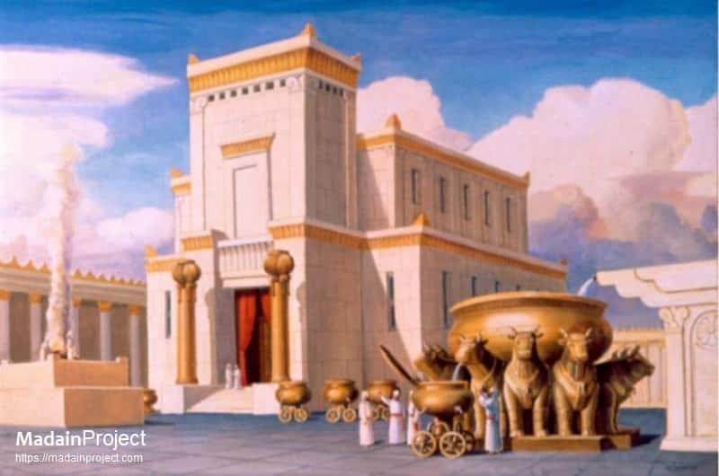
A diagram of Solomon’s Temple – the Outer Court
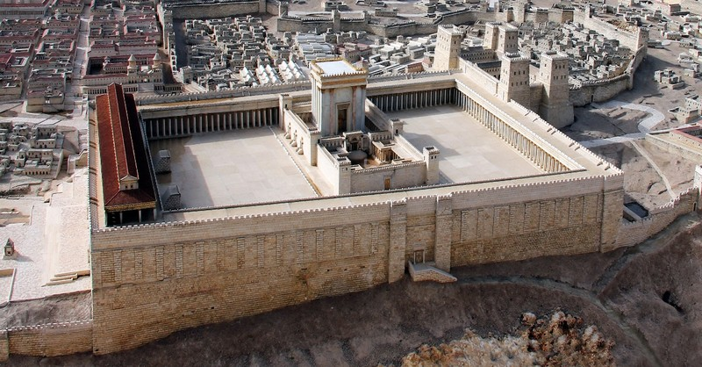
Herod’s Temple diagram
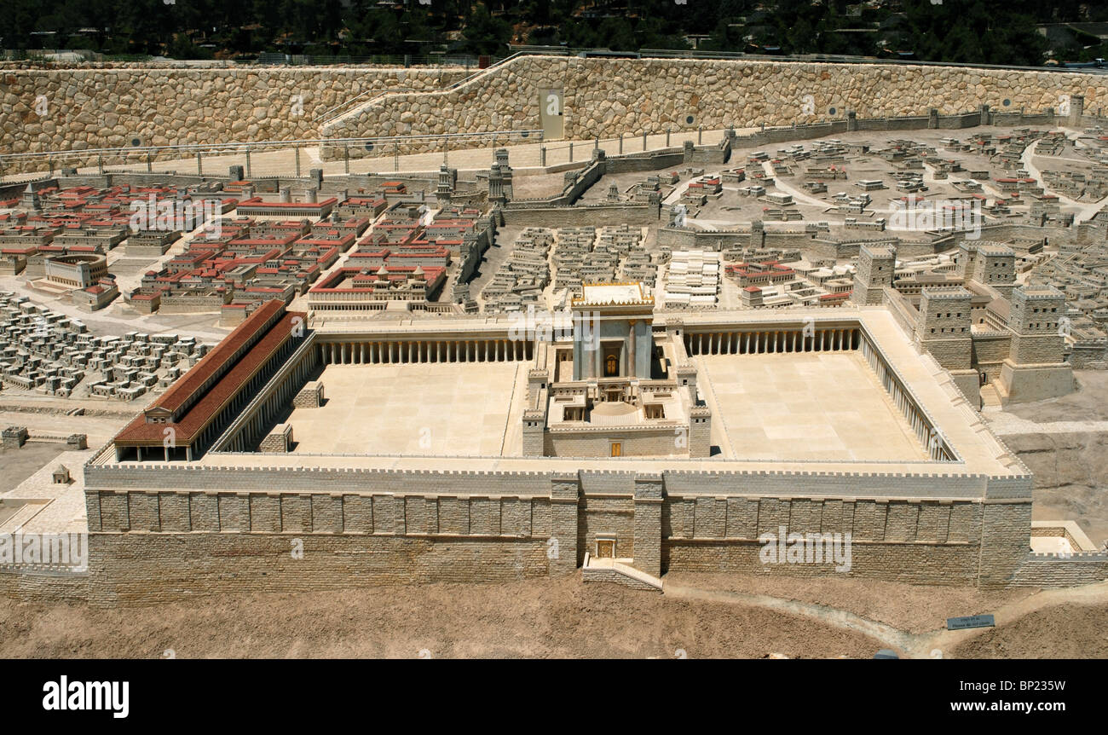
Herod’s Temple diagram – the large courtyard, the “upper rooms”
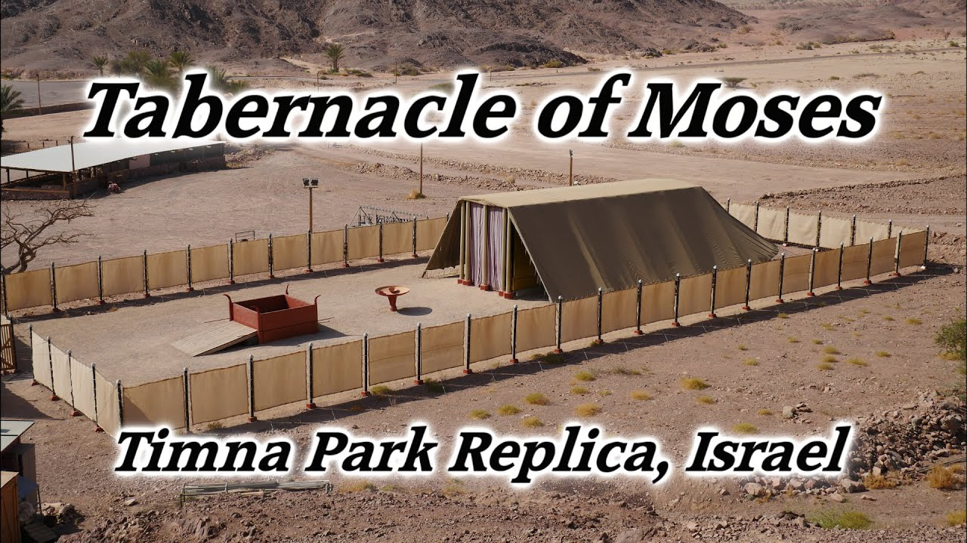
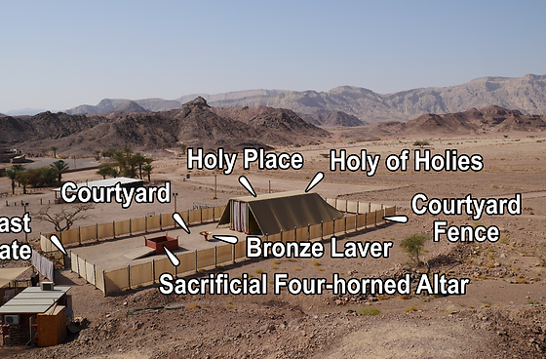
Timna Park Replica
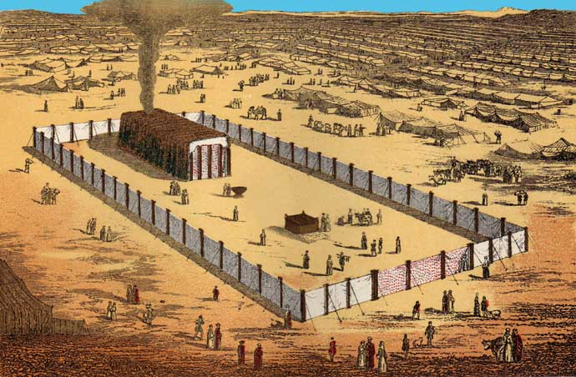
Cloud by day, fire by night, tents of the twelve tribes around the Tabernacle
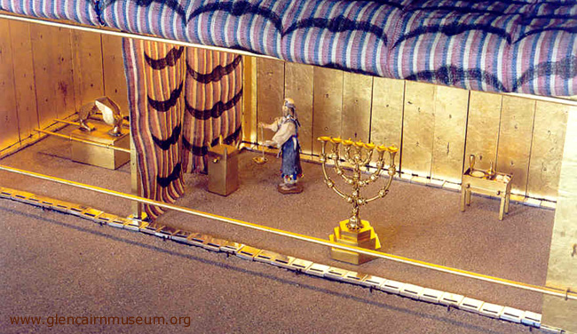 The Set-Apart Place and Most Set-Apart Place – Tabernacle of Moses 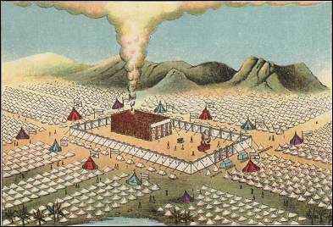
Position of the tabernacle with the tribes residing around it – three tribes in each of the four divisions
NOTICE THE THREE SECTIONS 1) OUTER COURT, ANIMAL SACRIFICE AND LAVER FOR CLEANSING-WASHING 2) THE PLACE WHERE PRIESTS MINISTERED TO YAHUWAH FOR THE PEOPLE, 3) VEILED OFF: THE MOST SET APART PLACE WHERE THE SPIRIT OF YAHUWAH DWELT OVER THE ARK
The area of the outer court – the largest area
The area of the priest’s ministry in front of the veil – a selected few trained priests, the next largest area
The area where the Spirit of Yahuwah dwelt among the people – a very small place

Please refer to: “The Ancient Hebrew Wedding Ceremony”/Mikvah of the Heart of Elohim 3.0, May 1, 2013
The largest group – the Outer Court: The born again, forgiven by the blood of the Lamb of Yahuwah – Yahushua Messiah! The Laver: Where the priests washed before entering into the large building in two parts
The Large building in two parts:
1) A smaller select group of trained priests, “attendants,” ministered before Yahuwah on behalf of the people, called the Set-Apart Place
2) Behind the large curtain: The place of Yahuwah’s Spirit’s indwelling in a second and smaller chamber.
On Yom Kippur, once a year, the High Priest would take the blood of a perfect lamb and apply it to the lid of the Ark, called “the mercy seat” for the redemption/salvation of the nation. First, He had to offer sacrifice for his own sins, then he could enter the most Set-Apart Place.
When Messiah died, rose again, and entered in heaven with His blood to sprinkle on the Altar in heaven. He told of His rising to Mary of Magdala: John 20:17 “Yahushua said to her: `Do not hold onto Me, for I have not yet ascended to My Father. But, go to my brothers and say to them, `I am ascending to My Father and your Father - to My Eloah and your Eloah.”
The need for the sacrificial system of animals and the priests to administer it was ended with Messiah’s death as the Lamb of Yahuwah (John 1:29) and clearly shown in Hebrews 8-10. This was the only portion of Torah (Instructions and Teachings for right standing in Yahuwah’s Kingdom) that ended, for it was the only portion of the Torah that Yahuwah was forced to insert due to the sin of the people over the golden calf (Exodus 32-33). Yahuwah wanted to wipe them all out, but Moses intervened. The priesthood was given to the Levites because of Moses, who gathered Levites to slay the perpetrators of the golden calf.
Yahuwah knew that His Son would come and die as His Lamb for the whole world – to REMOVE SIN. Then each person would be forgiven by the “blood of the Lamb of Yahuwah,” whenever they repented and received His death in their place. Yahushua rose from the dead to insure our eternal life.
In a true new birth, 40 things are done by Yahuwah’s Spirit to take us out of the kingdom of darkness into the Kingdom of Light. (Colossians 1). Refer to: “The True New Birth,” Mikvah of Eternal Salvation.
The “Laver” represents our right of passage into one of the two large buildings within the Temple Courtyard, divided into two groups. Without being cleansed of sin and set-apart by the Spirit of Yahuwah, we cannot pass out of the courtyard of His perimeters. We must be filled with the Spirit to leave the outer court.
Matthew 22: Messiah speaks of the “guests” of the wedding who must have on a “wedding garment,” symbolic of a true new birth. We are “clothed” with His righteousness when one is truly born of the Spirit. (John 3)
In a wedding there are three groups: 1) the guests, 2) the attendants, “friends of the Bridegroom, as so called in Mark 2 and John 3. 3), and the Bride, i.e. Revelation 3:7-13, 7:1-8, 9:4, 15:1-5, 22:3-5, Daniel 11:32, Psalm 45, etc.
Mark 4 speaks of the 30, 60, 100-fold division according to obedience to the Master. The division comes at the Judgment Seat of Messiah. Each group is trained for their position. All are known by Messiah, for He is their Master.
The ten virgins of Matthew 25:1-12 were guests. They went out to meet the Bridegroom and the Bride. Five prepared and aligned to the requirements, and 5 were “lazy fools,” as Hebrew Matthew puts it, and let their light go out. The oil for the lamp is a symbol of Yahuwah’s Set-Apart Spirit. They fooled around and did not prepare for the Bridegroom’s return. They did not maintain their oil. Thus, He said to them: “I do not know you.” You must be known by Father and Son because of your submission, obedience, and interaction with Them.
The “oil” that keeps the light burning represents the Spirit of Yahuwah within. It was understood by the early assemblies as a matter of pattern, that once a person received salvation, they became a servant of the Master Yahushua to learn from Him and prepare for the Kingdom. However, over and over, Messiah said that once He went back to heaven, He would send “the promise of His Father.” The “Promise” was Abba Himself, the Spirit. We cannot be His servants if we refuse to be baptized into His Father Spirit.
Luke 24:49, Messiah speaking: “And see, I am sending the Promise of My Father upon you, but you are to remain in the city of Jerusalem until you are clothed with power from on High.”
Luke 11:13: 13 “So if you who are evil know how to give good gifts to your
children, how much more will your Father in heaven give the Holy Spirit to those who ask Him!”
John 16:7-15: “But I say the truth to you. It is better for you that I go away, for if I do not go away, the Helper [“Paraclete” – one called alongside to help] shall not come to you at all, but if I go, I shall send Him to you. 8 And having come, He shall reprove the world concerning sin, and concerning righteousness, and concerning judgment – 9concerning sin because they do not believe in Me, 10concerning righteousness because I go to My Father and you see Me no more, 11concerning judgment because the ruler of this world is judged. 12 I still have many words to say to you, but you are not able to bear them now. 13 But when He comes, the Spirit of the Truth, He shall guide you into all the truth. For He shall not speak from Himself, but whatever He hears He shall speak, and He shall announce to you what is to come. 14 He shall esteem Me, for He shall take of what is Mine and announce it to you. 15All that the Father has is Mine. That is why I said that He takes from what is Mine and announces it to you.”
The Father and Son are “echad,” two in unity as if They were one, as were Adam and Eve in their marriage (Genesis 2:24). John 17 – read it slowly! Messiah prayed that we might be one as They are one. We “many” in total unity as if we were one (echad).
, Messiah said: “I am the Way, the Truth, and the Life. No one comes to the Father except through Me.”
The two main Temples (586 BCE and 70 CE) were destroyed. After all the years since Ezekiel 8-11:23, when Yahuwah was forced to leave off the Ark in Solomon’s Temple because of the sins of the priesthood and the people, Yahuwah did not return. He dealt with the Prophets. His Spirit caused many of them to move in the gifts of the Spirit. He waited around 400 years before the time Messiah came. Yahuwah was waiting until His Son rose from the dead to return.
Greece was conquered and Rome came in to govern the Levant. Yahuwah’s Presence was not over an Ark. He had left before the Babylonian Captivity. He did not return – and after the 70 years of captivity – the Truth was hanging by a thread in the face of a Nephilim-controlled priesthood.
Once Messiah died, no more need for animal sacrifice.
Today, the mainstream Greco-Roman culture-“church” and Messianic adherents, have, for the most part, denied the Baptism into the Spirit of the Book of Acts, the gifts of the Spirit, tongues, and anything from Yahuwah. They have pushed away Yahuwah while also pushing away Yahushua. Thus, these religions of man are dying and the people are abandoning them, denying Messiah’s Deity and rejecting the infilling of Yahuwah’s Spirit. Both Father and Son are totally outside religion.
A small remnant is arising, the Daniel 11:32 remnant of which it is said: “They know Yahuwah, are strong, and will do exploits” for He and His Son.
I John 2:22-23: “Who is the liar, except the one denying that יהושע is the Messiah? This is the anti-messiah, the one denying the Father and the Son. 23No one denying the Son has the Father. The one confessing the Son has the Father as well.”
Today martyrdom will be based on belief that Messiah is Deity like His Father, using the Noahide Laws of the Babylonian Talmud. Messiah warned of this in Matthew 10:32-40: “`Everyone, therefore, who shall confess Me before men, him I shall also confess before My Father who is in the heavens. 33 But whoever shall deny Me before men, him I shall also deny before My Father who is in the heavens. 34 Do not think that I have come to bring peace on earth. I did not come to bring peace but a sword, 35for I have come to bring division, a man against his father, a daughter against her mother, and a daughter-in-law against her mother-in-law – 36and a man’s enemies are those of his own household. 37 He who loves father or mother more than Me is not worthy of Me, and he who loves son or daughter more than Me is not worthy of Me. 38 And he who does not take up his stake and follow after Me is not worthy of Me. 39 He who has found his life shall lose it, and he that has lost his life for My sake shall find it. 40 He who receives you receives Me, and he who receives Me receives Him who sent Me.’”
The Pharisees were jealous and envious of Messiah, yet also terrified of Him. John 10:22-23: “Yahushua answered them saying, `Many good works I have shown you from My Father. Because of which of these works do you stone me?’ The Yehudim answered Him saying, `We do not stone You for a good work, but for blasphemy, and because You, being a man, make Yourself Elohim.”
In the middle of the night a few nights ago, in getting back in bed, that phrase came to me: “because You, being a man, make Yourself Elohim.” Messiah is Deity! He was “echad” with His Father, Yahuwah, who is Shaddai, El Yon, - Deity.
I guess you know by now that if a human father “father’s” a son, that son is of the same human makeup as his father and mother. Like begets like. This begetting like is clear in the wording of Psalm 2, written by King David: “Yahuwah said to Me, `You are My Son, Today I have brought You forth,” Messiah speaking.
The word for “brought forth” is the same wording as a woman having a baby, planted in her womb by her husband.
Today, Christians, Messianics, world governments, religious leaders in general, have joined Lucifer and the fallen angels in denying all the truths that set us free from the kingdom of Lucifer, the “dark kingdom.”
Colossians 1:12-17: “Giving thanks to the Father who has made us fit to share in the inheritance of the set-apart ones in the light, 13who has delivered us from the authority of darkness and transferred us into the reign of the Son of His love, 14in whom we have redemption through His blood, the forgiveness of sins, 15who is the likeness of the invisible Elohim, the first-born of all creation. 16Because in Him were created all that are in the heavens and that are on earth, visible and invisible, whether thrones or rulerships or principalities or authorities – all have been created through Him and for Him. 17And He is before all, and in Him all hold together.”
Messiah Yahushua spoke creation into existence in Genesis 1:1, 1:3. He formed Adam and Eve out of the clay of the earth. He clothed them after they sinned in the bloody skins of an animal, foreshadowing His own death for sinful man. He spoke to Abraham, wrestled with Ya’cob/Jacob, translated Enoch, saved Noah and his family, and continued our lineage of salvation through Noah’s son Shem.
Today, the three groups of “The Ancient Hebrew Wedding Ceremony” have been set-apart and prepared: The guests, the attendants, and the Bridal remnant.
Lucifer himself is preparing to inhabit the body of Nimrod, as he did in Genesis 10. The goal of world-uniting under Lucifer and the fallen angels through Nimrod is taking place right now. Lucifer has a portal opening right over the White House in Washington D.C., and from there is giving his orders to Biden as well as all involved with the takeover.
Yes, the nations know the “antichrist” is Nimrod, aka Osiris, aka Apollo/Apollyon (Revelation 9:11). Look at the architecture in Brussels of the tower of Babel, and the statement of an E.U. representative: “What Nimrod started, we will finish.”
All the while, the majority of Christians and Messianics waste time on entertainment, spend their lives like the world’s people, are totally mind-programmed to the point that when the alien invasion happens or they have to face the guillotines, they’ll panic and deny Him.
The weakness is a result that few have ever taken the time to get to know Messiah personally, and thus His Father. They are Bible-illiterate, dependent on man to tell them what to believe, and so are totally shutting the door for Yahuwah to even able to help them.
The pressure of our times, the air so filled with fallen angels and demons, is causing people to give up their faith. Soon the fallen angels and their offspring, aliens of their creating from the 2nd heaven, cosmos, will be entering people’s homes, terrifying them. Many strange hybrid creatures are being seen.
The U.S. and Israeli militaries are working with them – closely working with them. Their goals are the same – to destroy all those who know Yahushua personally as the Deity-Son of His Father.
Read “Beware of the Noahide Laws” under Present Reality. The other articles during December 2018 through 2019 are under the Mikvah of Israel, Our Eternal Inheritance. The one particularly you should read are the quotes from the Babylonian Talmud - #62.0.
The three-pattern began when Messiah formed Adam in Genesis 2 with a body, a soul, and an eternal spirit. Why am I so passionate in writing about these things? Because His people, in general, are so spiritually dead that they are easily falling away by the millions to the will of Lucifer, and will fall totally away when the shocking alien agenda comes to pass.
Yesterday I wrote for about 2 hours in my journal my experiences from Abba first hand, up close, in the reality of the fallen ones and their manifestations on earth today. I have lived a life of the miraculous. I have lived in the third heaven spiritually. I have known the terrible evil of the 2nd heaven experientially. I have lived in the 1st world as we all have – the earth-realm with its ups and downs. I have confronted hierarchy of fallen ones, principalities and powers of the dark kingdom, even Lucifer himself.
My education in all three realms is overwhelming to me, but Messiah started when I was 4 ½ to take me into another dimension – His – through my eternal spirit. I tried to put down as much of my very tangible experiences as I could. I’ve had so many from the dark kingdom, but also so many from the Kingdom of Light. I’m not talking spiritually – but in reality. I’ve had visitations from Abba’s realm as well as Lucifer’s realm. I am thrilled that Abba’s realm is where I feel most comfortable and at peace.
Therefore, I know what spiritual warfare means, and I podcasted a series about it recently. If people do not put into practice what will save them in the days ahead, I can do no more. I’m tired. I give 100%. All the watchmen are tired. The people are so dead, dulled, mindless, ignorant, and cannot wrap their minds around truth or reality. They do not want to. Thus, they do nothing to help themselves or anyone else. Without the infilling of Yahuwah’s Spirit there is no hope, no matter what belief system they embrace.
Just before Nebuchadnezzar attacked and destroyed the Temple of Solomon in Jerusalem, Jeremiah, using the hydraulic system installed by Solomon, lowered the Ark down into a tunnel below. By this time, the Presence of Yahuwah had already left (Ezekiel 8-11:23), not to return on earth until Acts 2 - after Messiah ascended back into heaven in Acts 1.
Rabbis told Paul Begley that the Ark was found under the Temple Mount and is being kept in a secret place by the rabbis. But what good is it without Yahuwah?
He now dwells in temples not made by hands – in our re-born spirit, if asked.
When Messiah died, a great earthquake occurred. The Roman soldier at the foot of Messiah’s stake could see into the Most Set-Apart Place. He saw that the lentil, holding up the 6” thick curtain had fallen down. There no ark there! It was in the tunnel beneath. After the six-day war in 1967, the chief rabbi and a couple of others, knowing approximately where the ark was, went down into the lower tunnel. They came very close to it. They said they could hear “breathing,” the breathing of Yahuwah’s Spirit, so they knew where it was, along with other things from Moses’ tabernacle. They had to flee because the Arabs flooded the tunnels. Just recently they went into the tunnels and found it, it is stored in a special place.
We know that Emperor Titus took the menorah in AD 70 back to Rome along with other things from the Temple. In 2013, I sat under the “Arch of Titus” in Rome. Just above me to my left was the famous carving of the Romans with the Menorah.
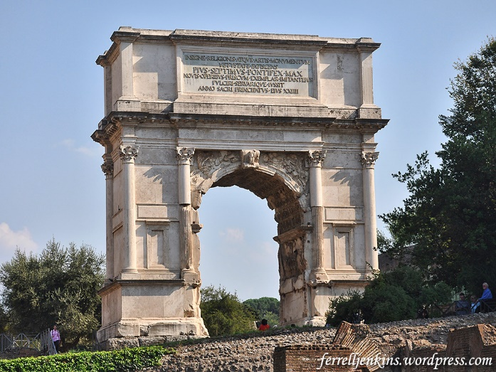
Yes, here is the Arch of Titus in Rome. I sat right there, and to my left was the famous carving showing the taking of the Menorah. To this day, the menorah is in the bowels of the Vatican.
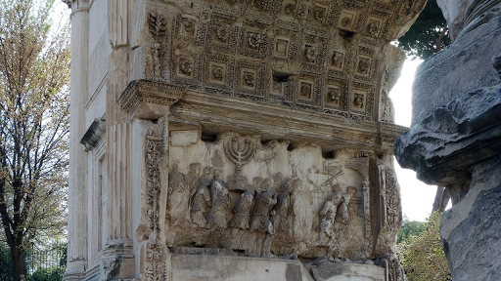
Jeremiah 3:14-17: Yahuwah says of the Kingdom of Messiah, and Jerusalem, “`Return, O backsliding children,’ declares יהוה, `for I shall rule over you, and shall take you, one from a city and two from a clan, and shall bring you to Tsiyon. 15 And I shall give you shepherds according to My heart, and they shall feed you with knowledge and understanding. 16And it shall be, when you have increased, and shall bear fruit in the land in those days,’ declares יהוה, `that they no longer say, ‘The ark of the covenant of יהוה.’ Neither would it come to heart, nor would they remember it, nor would they visit it, nor would it be made again. 17 At that time Yerushalayim shall be called the throne of יהוה, and all the nations shall be gathered to it, to the Name of יהוה, to Yerushalayim, and no longer walk after the stubbornness of their evil heart.”
Please go over the Scriptures in “Aliyah Scriptures”/Mikvah of the Covenant. It is the passion of Yahuwah’s heart to restore all of His children – all who have received His Son as their Savior – back to the Land, to give them an inheritance, as in Ezekiel 47-48.
I have no idea why I wrote this article, including all those nice pictures, except that YOU ARE in one of the three groups IF you are truly born of the Spirit and are preparing to enter the Kingdom of heaven. I ask: Where is your passion? Do you have a guest mentality? The guests are those from men like the “thief on the stake/cross” and all who pray to receive “Jesus” before dying “death-bed confessions” that are genuine. The guests can be also be long-term truly born agan believers. The guests can be soul-winners, sharing the Good News of salvation, workers in hospitals, or nursing homes to help people, those who actively walk in the nature, ways, and thinking of Yahuwah, like the ”wise virgins” of Matthew 25:1-12, these are keeping their lights burning, so that they are not taken over by the darkness. The guests stay loyal to the Master, even unto death. The guests live on the new earth in eternity. (Revelation 21:22-24a) The guests are also mentioned in Revelation 22:1-2.
The attendants, in eternity, become the “kings of the earth” in Revelation 21: 24b-26. They rule over earth, as well as represent those on the new earth into the throne room, as “friends of the Bride and Bridegroom do.” They are chosen by the Bridegroom and the Bride to go between them and the guests. As in any wedding, the attendants seat the guests, prepare for the entrance of the Bride and Groom, direct the ones standing by the Bride and Groom, or they themselves stand by the Bride and Groom. They are taken into the confidence of the Bride and Groom and share each other’s personal life. Messiah called His disciples “friends of the Bridegroom.” Yochanan/John the baptizer, was called a “friend of the Bridegroom.” In the 1,000-year reign on Messiah, the attendants “reign with Him.”
The three in Matthew 17:1-8 – friends of the Bridegroom, taken into His confidence. This is the second largest group after the guests, yet a small group of dedicated and known friends. Abraham, Isaac, and Jacob and the Prophets are leaders in the Kingdom, being Messiah’s servants to maintain rightness.
Then we have the Bride and Groom – definitely the smallest group. The Bride does not leave her husband’s side, not ever! This is in Revelation 3:7-13 and 22:3-5.
Where is the deepest passion of your heart? Your thoughts, words, and actions match the reality. Does the Master Yahushua know you? He can’t let anyone into the Kingdom He does not know. Oh the tragic deception coming for the followers of man’s ideas. We must have our extra-dimensional spiritual portal opened from our spirit into Yahuwah’s throne room at all times, so that He knows us.
We are a three-part being as a natural, normal human. Satan’s world does NOT want you to do know that! We have a soul realm, our mind, intellect, emotions, and will, and five senses that control our body. We have a body, and on the inside a “soul,” and also a spirit.
The body represent the guests – it is the largest part of us. 2) the soul, the part that serves our carnal life on earth, represents the attendants, and is the next largest part of us. 3) The spirit is in our belly area as Messiah so nicely said in John 7:37-39. It is the smallest area of us, from our breastbone to the top of our legs.
Go back and look at the pictures of the Temple. The largest area is for the people who offered sacrifices for sin, and other things in the courtyard area, as “the guests.” They don’t stay in the courtyard. They go home. Guests are strong believers, yet they are content to come to the music, sacrifice, praise area of the outer court and go home.
The next largest area was for the priests who served Yahuwah in the Set-Apart Place, the “attendants.” The priests go back and forth between the outer court, the people, and the Set-Apart Place as do attendants between the guests and the Bride and Groom. They serve two areas – the area of the courtyard and area of the service in the 1st big section of the building – the Set-Apart Place. They love ministry to the people and to Yahuwah.
The smallest area, representing the spirit and the Bride, is the area of the Most Set-Apart Place, where Yahuwah dwelt between the Cherubim on earth as He does in heaven (Psalm 99:1). This is where the Bride wants to dwell -- in His Presence forever. She starts this “dwelling” in her daily life, as in Psalm 91:1. This is why she is sealed and translated so as to be in an interdimensional state of being, where 1,000 fall at her side, and 10,000 at her right hand, and it does not come near her. She serves the Master forever, because she serves Him now.
Do you see that throughout the whole of the Word are these three groups, and also in Mark 4 (the 30, 60, 100-fold)?
It’s all through the Bible – 3 groups – the ancient Hebrew wedding ceremony.
Now for one more thing: Please refer to: “The Uniting of the Soul and Spirit…” and “Satan’s Greatest Fear” under the Mikvah of Set-Apartness #58.0 and #59.0.
The veil has been removed. Where is the longing of your spirit? He is working to remove the veil. Those who long to be with Him, will have their spirit and soul united by the working of the Spirit of Yahuwah. You cannot transform or unite your soul and spirit into one “spirit man” by yourself. It is a sovereign working by Yahuwah’s Spirit within. It comes with passion to be in His Presence, and so you prioritize your life to be there, to interact with Him.
As Messiah said: “I delight to do Your Will, Abba, so the Bride of Messiah has given herself 100% in obedience to Him, to learn how to please Him, and to give all esteem to Him and to His Father. The Father will only allow His Son to marry a certain type of Bride – a submitted, obedient, loving, kind, merciful, yielded woman who has faith, joy, peace, long-suffering, gentleness, faith, and patience with others. She knows how to keep herself under His authority, yet she is also powerful in bringing others to love Him as she does. Listen to yourself talk.
There are three groups of born-again believers, each blessed according to their personal relationship with, and obedience to, Abba. We’re talking eternity. How valuable is your goal for eternity?
What is the passion of what you talk about? A Bride can’t stop talking about her Beloved One. The born again, are passionate to honor their Savior. Messiah’s return is the focus of our life because He is the One who brought us our salvation and our ability to enter the Kingdom of Light.
Go over this material and study for yourself. Let Abba show you who you are. He loves His children, and only wants to “raise you up to live in His sight.”
Shalom, Yedidah - June 21, 2022

