Moses’ Face Shone with the Light of Yahuwah

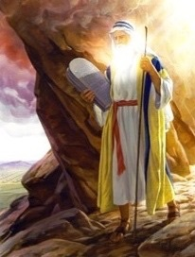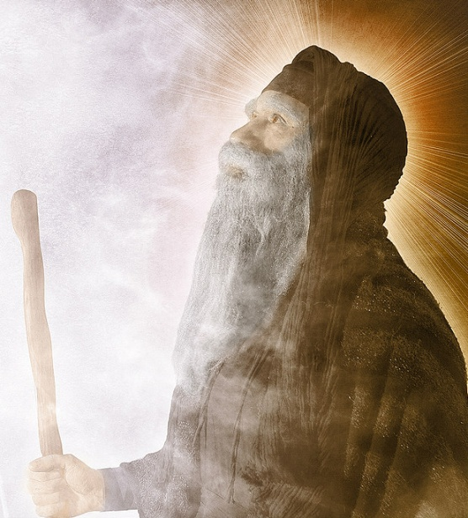

***Exodus 34:1-2, 4-5, 27-35: “And Yahuwah said to Moshe `Cut two tablets of stone like the first ones and I shall write on these tablets the Words that were on the first tablets which you broke. And be ready in the morning. Then you shall come up in the morning to Mount Sinai and present yourself there to Me on the mountain’…Then he cut two tablets of stone like the first ones. And Moshe rose early in the morning and went up to Mount Sinai as Yahuwah had commanded him…And Yahuwah came down in a cloud and stood with him there, and proclaimed the Name of Yahuwah…And Yahuwah said to Moshe, `Write these words, for according to the mouth of these Words, I have made a Covenant with you and with Israel.’ And he was there with Yahuwah forty days and forty nights. He did not eat bread nor did he eat water. And he wrote on the tablets the words of the covenant – the Ten Words. And it came to be when Moses came down from Mount Sinai, while the two tablets of the Witness were in Moshe’s hand…that Moshe did not know that the skin of his face shone since he had spoken with Him. And Aaron and all the children of Israel looked at Moses and saw all the skin of his face shone, and they were afraid to come near him. But, Moshe called out to them, and Aaron and all the rulers of the congregation returned to him, and Moshe spoke to them. And afterwards all the children of Israel came near, and he commanded them all that Yahuwah had spoken to him on Mount Sinai. And when Moses finished speaking to them, he put a veil on his face. And whenever Moshe went in before Yahuwah to speak to Him, he would remove the veil until he came out. And when he came out he spoke to the children of Israel what he had been commanded. The children of Israel would see the face of Moshe, that the skin of Moshe’s face shone, and Moshe would put the veil on his face again until he went in to speak with Him.”

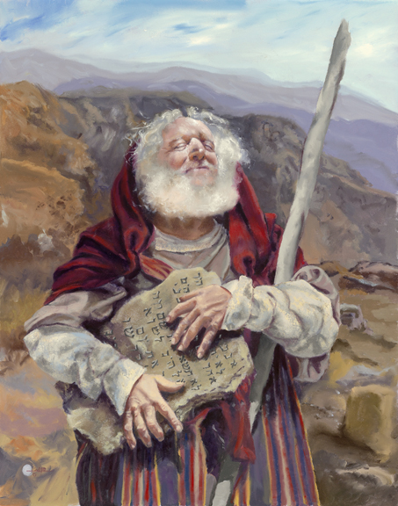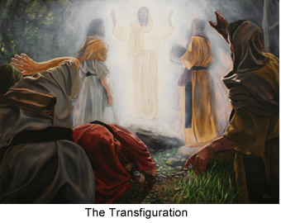
Left: "Moses was Unaware his Face Shone"
Oil painting by Mary Jane Q. Cross

Please read Exodus 32-34 in context
Moses lived in the Presence of Yahuwah. He was an extra dimensional man who knew Yahuwah “face to face,” and dwelled in His Presence. The term “extra-dimensional,” is equivalent with “spiritual,” for as true believers we have an open portal in our spirit to the eternal realm of Elohim.
Moshe (Hebrew name) walked in His Presence and saw Him manifesting over and over in all the aspects of His nature – in all His love and in all His righteous anger. Moses knew Him.
Deuteronomy 34:10: “And since then, no prophet has arisen in Israel like Moshe, whom Yahuwah knew face to face.”
***Deuteronomy 33:7-11: “And Moshe took his tent and pitched it outside the camp, and called it the Tent of Meeting. And it came to be that everyone who sought Yahuwah went out to the Tent of Meeting which was outside the camp. And it came to be that whenever Moshe went out to the Tent that all the people rose, each man stood at his tent door and watched Moshe until he entered the Tent. And it came to be when Moshe entered the Tent that the column of the cloud descended and stood at the door of the Tent and Yahuwah spoke with Moshe. And all the people saw the column of the cloud standing at the Tent door and all the people rose and bowed themselves, each one at the door of his own tent. And thus, Yahuwah spoke to Moshe face to face as a man speaks to his friend. And Moshe would return to the camp, but his servant, Yehoshua (Joshua) son of Nun, a young man did not leave the Tent.”
Most of the people Moshe shepherded those 40 years in the wilderness continued to long for Egypt, symbolic of the world system and its false security. They did not really know Yahuwah, even though they saw the cloud and fire, and His acts of provision and judgment. The people trusted in Moses to be their intermediary between them and Elohim. Therefore they never learned to trust Yahuwah for themselves, even though He manifested Himself to them over and over. They only saw what He did. They did not know His nature, ways, and thinking like Moshe did, because Moshe chose to dwell in His Presence. It was Moshe who wrote Psalm 90 and 91. “He who dwells in the secret place of the Most High shall abide under the shadow of the Almighty,” Moses wrote from his spirit and his own experience.
Yehoshua (Joshua) did not want to leave the presence of Yahuwah, so he stayed as close to Moshe as possible, and to the Tent of Meeting. His faith in Yahuwah was strong, as was the faith of his friend Caleb. (Numbers 13 and 14) These two were the only two of the original millions who came out of Egypt to enter the Promised Land after 40 years of wandering in the wilderness. It was because they knew they could trust Yahuwah, and they loyally obeyed His Torah. (Joshua 1)
Hebrews 13:12-14: “And so Yahushua also suffered outside the gate, to set apart the people with His own blood. Let us, then, go to Him outside the camp, bearing His reproach. For here on earth we have no continuing place, but we seek one to come.”
You’ll never know Yahuwah and Yahushua unless you, like Moshe, pitch your tent (your life and all you have) outside the camp, the carnal camp of the world system and self-orientation, so that the Spirit of Yahuwah can come down and meet with you. Only when we pitch our life outside the pleasures of this world, detaching from what is not of Yahuwah, can He come and meet with us. He is Light. He cannot fellowship with what is of the dark kingdom. All who sought Yahuwah went out to the Tent of Meeting outside the camp. Joshua would not leave it. The people sought Him for various reasons, but Joshua wanted to stay in His Presence for the sheer joy of being with Him. Therefore the anointing that was on Moshe passed to Joshua/Yehoshua. (Deuteronomy 34:9; Joshua 1)
Hebrews 12:14b: “Without set-apartness, no one will see Yahuwah!”
It is in set-apartness unto Yahuwah, leaving the pleasures of this world system to go out of it into His Presence that we find Him – face to face.
The most horrible thing Elohim could ever say to us would be: “I never knew you; depart from Me.” “Truly, I say to you, `I do not know you..’ ” (Matthew 7:21-23; 25:12)
Psalm 103:7: “He (Yahuwah) made His ways known to Moshe; His acts to the children of Israel.”
In 40 years of wandering and seeing His acts, the people still did not know Him – but Moses did, and Joshua and Caleb did. Aaron slowly caught on, but still, he did not walk with Him like Moses did, even though Aaron was the High Priest. Many who minister for Him do not really know Him. Enoch walked with Him, as did Noah, and Abraham, as will His remnant of these last days… [Refer to: “Walking”/December 25, 2016]
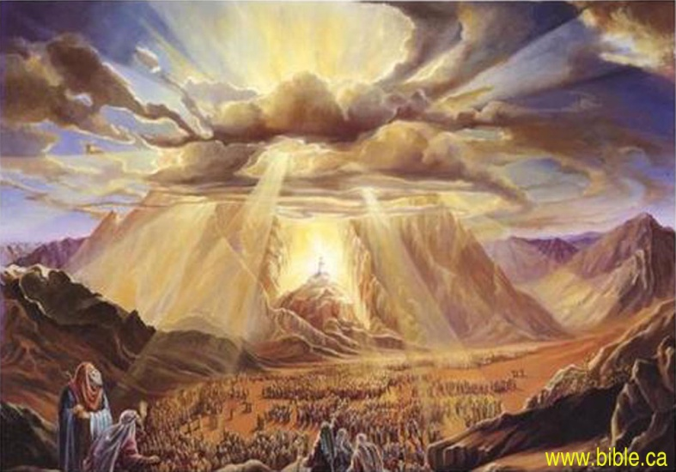
The Presence of Yahuwah – Exodus 19 …
The majesty and esteem of Yahuwah came down on Mount Sinai, but the people were afraid. Yet, Moses stood in the Presence of Yahuwah and heard Him speak to Him. Yahuwah called Moshe up into the mountain to be with Him to receive His Covenant of the Torah. (Exodus 19:16-22) The Torah is the instructions for right standing in the Kingdom of Elohim. It shows us His nature, ways, and thinking. If a person has truly been born again by the Spirit’s 40 actions within our spirit, then they become a whole new creation. Living within the boundaries of the Kingdom’s instructions brings peace and joy, blessings, and relationship with the King. [Refer to: “The True New Birth”/July 2015] Those truly born again can’t keep quiet about their “first love,” for their Savior – so they spend their lives telling others about Him!
During “the transfiguration,” (Matthew 17:1-8) on Mount Hermon, Messiah shone with the brightness of heaven, beside him stood Elijah and Moshe. Yahushua shines as the Light of the world. Those who walk in His Presence also have the “light of life” burning within their spirit. That light is a beacon to all who yearn for the salvation that only He can bring. We are children of light. “Let your light shine before men that they may see your good work, and esteem your Father who is in heaven.”
“Arise, shine, for your Light has come, and the esteem of Yahuwah has risen upon you.” (Isaiah 60:2)
Genesis 1:3: “And Elohim said, `Let there be light,’ and light came to be.”
John 8:12: “…Yahushua spoke to them again, saying `I am the Light of the world, He who follows Me shall by no means walk in darkness, but possess the light of life.”
John 3:19-21: “And this is the condemnation, that Light has come into the world but men love darkness rather than light for their deeds are evil. For every one who does evil hates the light, neither comes to the light lest his deeds should be reproved. But, he who does truth comes to the light that his deed may be shown to be rooted in Elohim.”
Matthew 5:14a: “You are the light of the world…”
I Peter 2:9: “You are a chosen race, a royal priesthood, and set-apart nation, a people for a possession, that you should proclaim the praises of Him who called you out of darkness into His marvelous Light.”
Ephesians 5:8: “For you were once darkness, but now you are light in the Master--walk as children of light.”
It is the greatest privilege of those who are truly born again by faith in Yahushua to walk with Yahushua in the light of Truth--to commune with Yahuwah and with Yahushua. The radiance of Their Presence dwelling in our re-born spirit will be manifested on our countenance. People will either be drawn to the light within us, or be repelled by it. The light is His plumb line.
It was because Moshe chose His Presence that the light in his spirit shone forth from his face. His whole spirit-man was filled with the Spirit.
I John 1:5: “If we walk in the light as He is in the light, we have fellowship one with another and the blood of Yahushua cleanses us from all sin.”
Daniel 12:3: “And those who are wise shall shine like the brightness of the firmament, and they who turn many to righteousness shall shine like the stars forever and ever.”
What a privilege we have as the children of Elohim, children of the Light, to sit with Him in heavenly places, to walk with Him, and hear His voice speaking to us. (Ephesians 2:6-7; Colossians 3:1-4)
Oh the joy and freedom of not having to control our life. It is our privilege to die to self, and let Him take total control. Then we walk in a realm of light, of peace, sound mind, and stable emotions that the world’s people has no concept of. For the children of light there is no anxiety, no fear, no fretting, no depression, no oppression – there is life in the Spirit!
[I recommend the wonderful Moses movie starring Ben Kingsley, The Bible Collection 1995. The DVD is sold on Amazon for $9.95.]
Shalom and blessings, in His love and joy,
Yedidah
January 1, 2017

