Our Brothers and Sisters are Being Slaughtered
Public News is Silent! Churches Are Silent! Are you Silent?

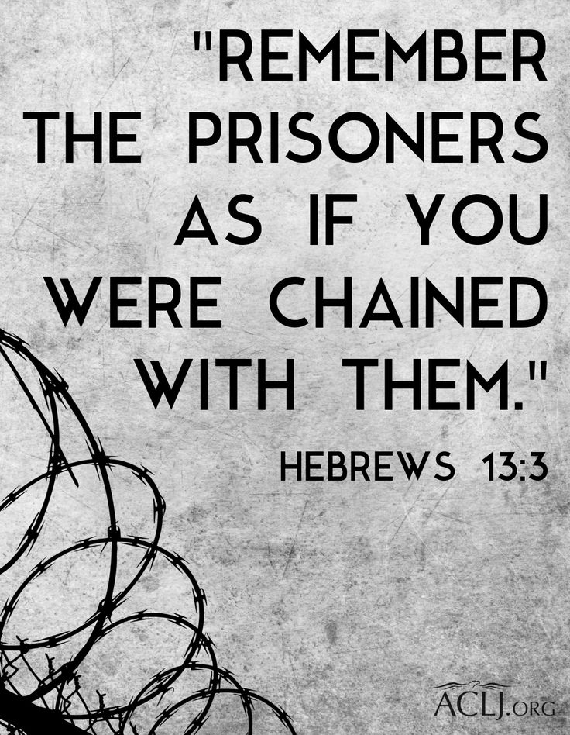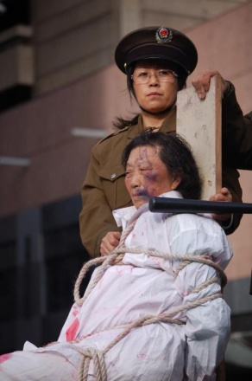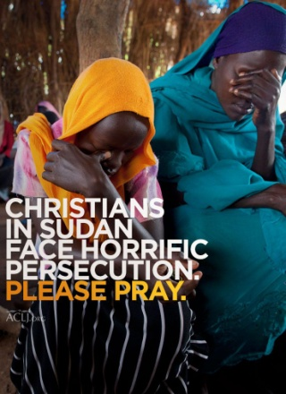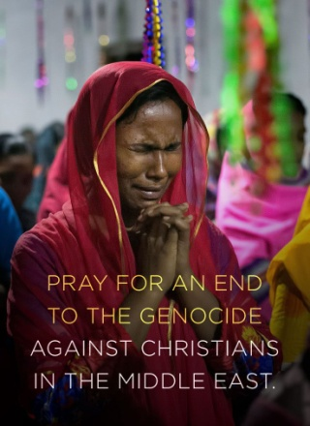
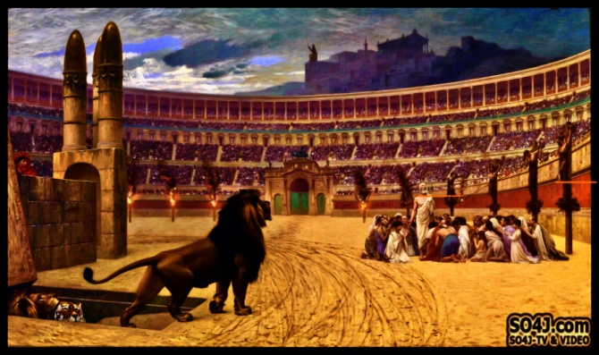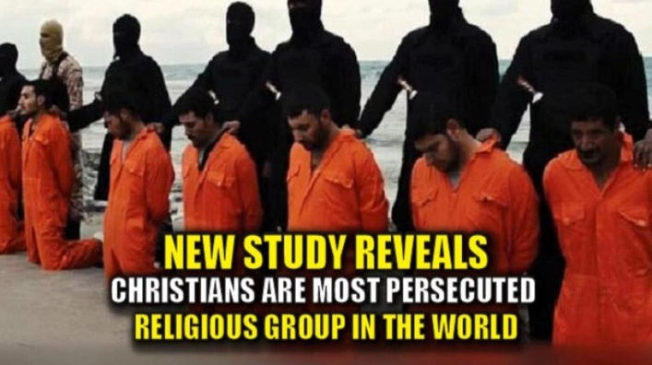
SO4J Persecuted Christians, Facts, Scriptures and Videos

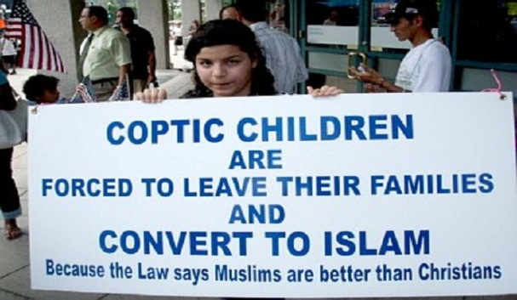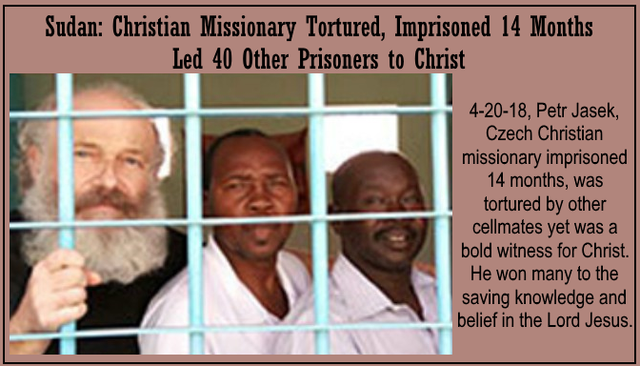
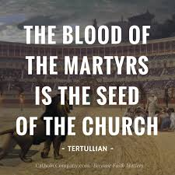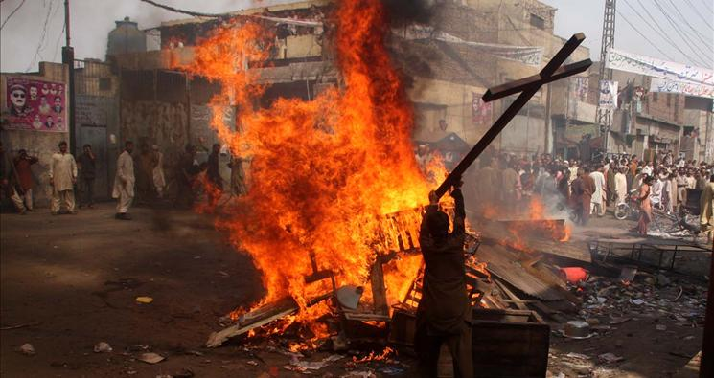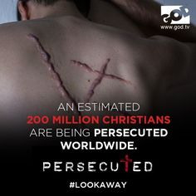
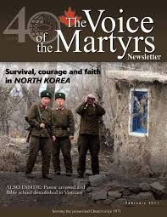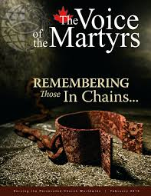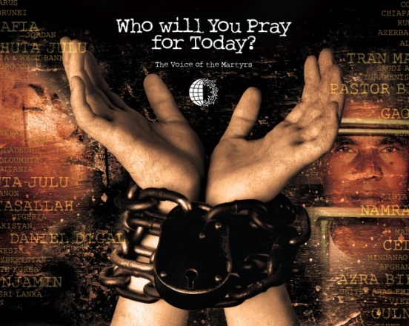
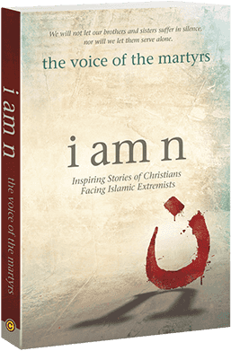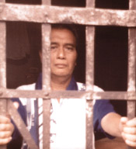
Prisoner Alert – Ministry of Voice of the Martyrs
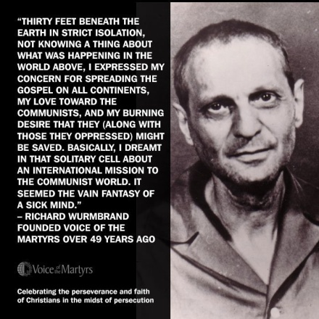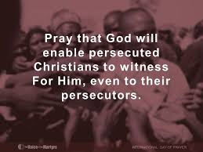
Left: She still smiles after being tortured, for her faith in her Savior has given her His joy! 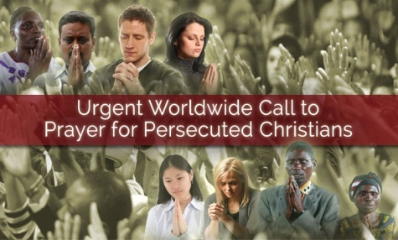 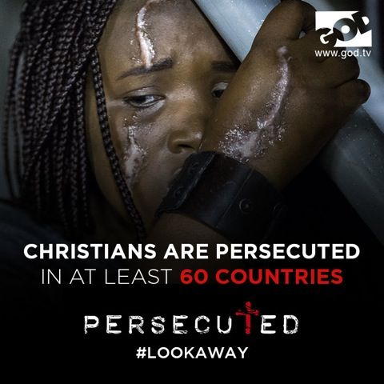 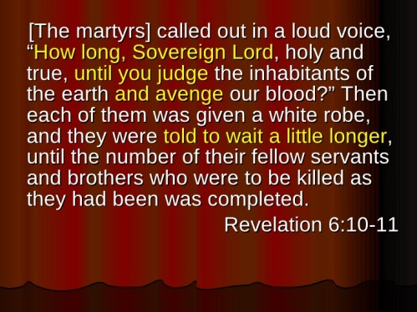
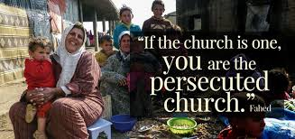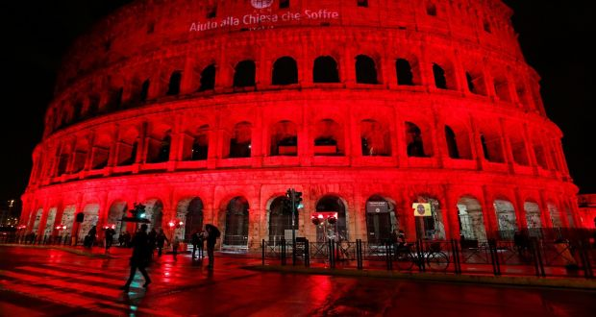
“Colosseum lit red in solidarity with persecuted Christians
Sat, Feb 24, 2018, 19:59 Irish Times
Right Photograph: Remo Casilli/Reuters – “Rome’s ancient Colosseum was bathed in red on Saturday in solidarity with persecuted Christians, particularly Asia Bibi, a woman condemned to death under Pakistan’s blasphemy laws.” The persecuted are NOT forgotten by everyone!

The word “martyr” simply refers to one who is a “witness.” There are living martyrs as well as dead ones. If your life is laid down for the Master, you may have to be imprisoned, even beaten and tortured, as told by Brother Yun in his autobiography: The Heavenly Man. But, the attitude of those living martyrs I met in China was that it was a privilege to be imprisoned for their faith, because in prison they can witness to the prisoners so that they can be forgiven of their sin by Elohim/God and have eternal life through Yahushua/Jesus. Is that an attitude that is found among the majority of believers in western nations of ease and comfort? NO! I worked among these people. Their faith is that of the early believers written about in the book of Acts. Their joy is awesome. Yes, they have to hide out. Yes, there is fear – from real enemies. But, their faith overrides their fear.
When I was coming back from teaching 3 months in Mongolia in 1996, the Mongolian Air plane flew us to Beijing where we would stay for a couple of days before flying back to the U.S. As the bus from the airport went along to our hotel, I noticed on the right there were shepherds attending their flocks of sheep. I was such a peaceful scene. I laid my head on the bus window and imagined 100 million (more now) truly born again believers. How did they feel about the incredible persecution against them? Then in a vision I saw millions of them marching down the big streets of Beijing. Their faces were radiant with joy-- they were smiling, praising their Savior. Tears ran down my cheeks. They were not defeated! They had overcome by the blood of the Lamb.
Revelation 12:11/read in context: “…And they overcame him (Satan) by the blood of the Lamb and the word of their testimony, and they loved not their lives even to death.”
These are the martyrs of our day, living and dead, whose lives witness to the power of our Elohim to stand with us through it all. And we will go “through” it all!
A couple of nights ago, before going to sleep, Abba spoke this into my spirit:
“ALL THAT STANDS BETWEEN US BELIEVERS AND THE HOSTS OF HELL IS THE BLOOD OF THE LAMB!” I thought: “And the blood of the Lamb is all we need for our salvation and our defense against all the hosts of Satan.” Then I was reminded of I John 3:8. Messiah’s blood paid the price we owe for our sin. His blood is the most powerful spiritual weapon we have against the onslaught of the enemy. Why? Because it was His blood that defeated Satan and all his hosts of hell – forever! And, by His resurrection, we too who are redeemed will rise to eternal life. [Refer to: “The Blood of the Lamb”/Mikvah of Eternal Salvation]
Don’t be a fool and throw away your Lamb! (Leviticus 17:11; Hebrews 9:22)
Revelation 7:9-17, the martyrs: “After this I looked and saw a great crown which no one was able to count, out of all nations and tribes and people and tongues, standing before the throne and before the lamb, dressed in white robes and palm branches in their hands, and crying out with a loud voice saying `Deliverance belongs to our Elohim who sits on the throne and to the Lamb!’ And all the angels stood round the throne, and the elders and the four living creatures and fell on their faces before the throne worshipping Elohim...saying `Amain! Blessing, esteem, wisdom, thanksgiving, respect, power, and might belong to our Elohim forever and ever, Ahamin!’ And one of the elders responded saying to me, `Who are these dressed in white robes and where did they come from?’ And I said, `Master, you know.’ And he said to me, `These are those coming out of the great persecution having washed their robes and made them white in the blood of the Lamb. Because of this, they are before the throne of Elohim and serve Him day and night in His Dwelling Place. And He who sits on the throne shall spread His Tent over them. They shall hunger no more, neither thirst any more, neither shall the sun strike them nor any heat because the Lamb who is in the midst of the throne shall shepherd them and lead them to fountains of waters of life. And Elohim shall wipe away very tear from their eyes.”
Revelation 14:12-13: “Here is the endurance of the set-apart ones, these are those guarding the commands of Elohim and the faith of Yahushua. And I heard a voice out of the heaven say to me, Write, `Blessed are the dead who die in the master from now on.’ Yea, says the Spirit `in order that they rest from their labors and their works follow with them.’ ”
Revelation 20:4-6: “And I saw thrones – and they sat on them and judgment was given to them – and the lives of those who had been beheaded because of the witness they bore to Yahushua and because of the Word of Elohim, and who did not worship the beast, nor his image, and did not receive his mark upon their foreheads or upon their hands, and they lived and reigned with Messiah for a thousand years. (the rest of the dead did not come to life until the thousand years were ended--this is the first resurrection.) Blessed and set-apart is the one having part in the first resurrection. The second death possesses no authority over these, but they shall be priests of Yahuwah and of Messiah, and they shall reign with Him a thousand years.”
Philippians 1:29: “Because to you it has been given as a favor on behalf of Mess, not only to believe in Him, but also to suffer for Hs sake.”
I Thessalonians 3:3-4: Sha’ul sent Timothy to Thessalonica… “to establish you and encourage you concerning your faith that no one should be unsettled by these pressures, for you yourselves know that we were appointed to this. For indeed, we did inform you before hand, when were with you that we should suffer pressure/tribulation, and so it came to be as you know.”
I Peter 4:1-2, 7-8, 12-14: “Therefore, since Messiah suffered in the flesh, arm yourselves also with the same mind, because he who has suffered in the flesh has ceased from sin, so that he no longer lives the rest of his time in the flesh for the lusts of men, but according to the will of Elohim…But, the end of all has drawn near, therefore be sober-minded and attentive in prayer, and above all have fervent love for one another, for love covers a multitude of sins…Beloved ones, do not be surprised at the fiery trial that is coming upon you to try you, as though some unusual thing has befallen you, but as you are Messiah’s, rejoice in order that you might rejoice exultingly at the revelation of His esteem. If you are reproached for the Name of Messiah you are blessed because the Spirit of esteem and of Elohim rests upon you. On their part He is blasphemed, but on your part His is praised.”
Guillotines in America! Oh yes, tens of thousands waiting for the execution of those who will not submit to the world ruler, and refuse to deny their faith in Jesus/Yeshua/Yahushua.

Apocalypse then, now, always: the truth about violence in Leer, South Sudan - Nick Turse – Salon – October 21, 2016
“This, truth be told, is no longer a town, not even a razed one. It’s a killing field, a place where human remains lie unburied, whose residents have long since fled, while its few remaining inhabitants are mostly refugees from similarly ravaged villages.
The world is awash in killing fields, sites of slaughter where armed men have laid waste to the innocent, the defenseless...locales where women and children, old and young men have been suffocated, had their skulls shattered, been left gut-shot and gasping. Or sometimes they’re just the unhallowed grounds where the battered and broken bodies of such unfortunates are dumped without ceremony or prayer or even a moment of solemn reflection. Over the last century, these blood-soaked sites have sprouted across the globe: Cambodia, the Philippines, the Koreas, South Africa, Mexico, Lebanon, Rwanda, Bosnia, Guatemala, Afghanistan, Iraq, Syria -- on and on, year after year, country after country.
Chances are, you once heard something about the 1994 Rwandan genocide that saw up to one million men, women, and children murdered in just 100 days.
A 2005 peace deal between U.S.-supported rebels in the south of Sudan and the government in the north was supposed to put a stop to such slaughter, but it never quite did…In late 2013 and 2014, Malakal, Bor, Leer, and other towns in the world’s newest nation, South Sudan, were indeed littered with bodies.
In 2014, I traveled to Malakal to learn what I could about the destruction of that town and the civilians who perished there. In 2015, I walked among the mass graves of Bor where, a year earlier, a bulldozer had dug huge trenches for hundreds of bodies, some so badly decomposed or mutilated that it was impossible to identify whether they had been men, women, or children. This spring, I find myself in Leer, another battered enclave, as aid groups struggled to reestablish their presence, as armed men still stalked the night, as human skulls gleamed beneath the blazing midday sun.”

The slaughter of Christians in Southern Sudan is very close to my heart. I first went into Uganda from Kenya in 1996. I learned of the slaughter of the Christians of Southern Sudan down to the Uganda border. I learned a lot from the Voice of the Martyrs reporting. I was a strong supporter and helper to promote the Voice of the Martyrs from 1993 at least. I spoke in churches to promote their work. I gathered Bibles from churches and Christian schools to take to them in Bartlesville, Oklahoma, for VOM to send to Nigeria. I collected coats and other warm things to send to Romania, and Ukraine. I was involved in writing prisoners, encouraging them. In 1994 I linked up with Open Doors with Brother Andrew, and went into Mainland China taking Bibles to the persecuted underground assemblies of believers. At that time it was estimated that 25,000 were being saved daily. The zeal of the persecuted to spread the Good News, even at the cost of their lives was mind-boggling. Many were shot dead in the baptism waters. They knew that to receive salvation through Jesus meant their death, or beating, torture, or imprisonment.
I went into Mainland China via many different border areas at least 40 times over my three extensive trips--1 in 1994 and 2 in 1995. I met with the persecuted who are routinely beaten, arrested, tortured, imprisoned, and killed--denied rights at the least, and martyred at the most. I worked with Brother Samuel Lamb in GuangZhou. He had been in prison for 20 years for his faith. He was let out of prion becaue they couldn’t convert him to Communism. They sent him back to his home. His wife had died. They put him under perpetual house arrest. Yet, he gathered a many as 1,600 believers to visit him for teaching. I went to many areas of China between Hainan Island and Beijing. It was probably the most awesome time of my life and ministry.
I began going to Africa in 1996. I went to Kenya, Uganda, and Tanzania. In Kenya I met a Pastor-Bishop from Rwanda, who had married the daughter of the President of Rwanda from the dominant tribe. When another tribe went on a rampage to overthrow the President, they literally slaughtered those in his churches, and tried to kill his wife and children. The bodies of those killed were floating in Lake Victoria. His wife, Mary, and two of the children escaped into the Congo. She lived with the Pigmies, until she was able to escape to Kenya and rejoin her husband near Nairobi. I met her husband, a close friend of my African Pastor from Zimbabwe, Robert Muwire (pronounced “moo-weary”). The Pastor-Bishop set up meetings for me in large churches in Nairobi.
When I returned to Nairobi from America on another trip, I stayed with this pastor and his wife and then four children. She was going to college at that time also. We became close friends. He told about the slaughtering of his people from many of his churches. Pastor Muwire showed the video at his church one evening of the bodies floating in Lake Victoria.
Working with Open Doors on site in China, and with Voice of the Martyrs, I learned to have a heart for our brothers and sisters in faith in Messiah who are part of the Revelation 7:9-17 victorious martyrs. These join with the 144,000 (Revelation 7:1-8) in the eternal state, and live before the thrones of Yahuwah and Yahushua forever – Revelation 22:3-5. These martyrs give all for their Master! As servants, we must give all for our Master, whether martyrs or not.
Living in the Middle East, in the Muslim nation of Jordan for eight years and later in Israel for part of another eight years, I learned about persecution. In Jordan, King Abdullah tolerated Christians. There was even a Bible College in Amman. In Egypt under Mubarak, Coptic Christians were allowed freedom to worship. In Syria under Assad, Christians were allowed freedom to worship and even witness in their local areas.
In 2011, U.S. President Obama singlehandedly destabilized the Middle East, and the Globalist elite, along with America and the U.N. have continued to destabilize nations in the Middle East, in Africa, Indonesia, and on and on, in 51 or more nations, Muslims have been free to slaughter Christians.
ISIS, created and funded by America under Obama, went on a massacre spree in northern Iraq among Kurds, and other countries beheading Christians, making videos, and showing them on YouTube. Above is one picture of ISIS about to behead Christians.
Please be aware that Al Qaeda is no more than a CIA data base for hiring mercenaries to carry out their heinous crimes. It was set up under the George W. Bush Administration. Osama bin Laden died shortly after 9/11 with a kidney disease. His family built most of the U.S. military bases in the Middle East. Osama was a business partner with the Bush family and the Queen of England in the Carlyle Group. The whole 9/11 thing was a false flag to get into Afghanistan for the evil purposes of those bringing about the right conditions for a world government.
The Taliban was created by President Jimmy Carter under the ruse of warding off Russia in Afghanistan. Hamas is funded by the U.N. where there is a slaughtering of Christians in Gaza. One of my Arab Christian friends in Jerusalem had a Bible Book Store in Gaza City. He was murdered by Hamas. Fatah, the terrorist arm of the PLO, is funded by America. The Muslim Brotherhood, an Arab- Nazi creation, is funded by America. It is amazing how many members of the Muslim Brotherhood have been in the U.S. government in high positions.
America funds the jihadists that are slaughtering Christians in Syria. They’re called “rebels,” against the forces of Assad. Assad protected Christians. I know – I talked to some of them from Damascus when I lived in Jordan, but that’s common knowledge in the Middle East. I met with Jordanian Christians from Amman, and in Aqaba. I lived in Jordan 8 years and never had any problems being a believer there, even a Torah-guarding believer. The Jordanian people were kind to us.
Hezbollah is funded by Iran of course. But, the U.N. protects Hezbollah against Israel. I know that from being on the Lebanon border and the Golan border. The Lebanese Christians cried very hard when the IDF (Israeli Defense Force) pulled out of southern Lebanon. The IDF was their protection against Hezbollah.
I was best friends with a missionary to Nigeria. She and her husband were caught in one of the slaughters of Christians there by Muslims in the North, trying to wipe out the Igbo Tribe which are Jewish Christians.
I talked to missionaries in Nairobi, Kenya, who had barely escaped with their lives when the new government took over – around 1997.
I guess since the early 1990s, I’ve been involved on site with the persecuted, and also via Open Doors and the Voice of the Martyrs. Now there are other groups that have formed to alert people to the reality of worldwide slaughter. I use the word “slaughter,” but I could also use words like butchering, torture, rape, beheading, and dismembering, which the Muslims like to do. They like cutting off a right arm and a left leg for example. Much of humanity, being charged with power by demons, is becoming more violent. We’re in Genesis 6 again. The main targets of violence are the unborn, babies, little children, youth and teens, and the elderly.
When I was in Kenya, going to villages where the people lived in mud huts, teaching, holding pastor’s seminars, etc., I took them stacks of Voice of the Martyrs magazines, for which they were very grateful.
In 1996, I attended a Voice of the Martyrs Conference in California. I met some of those who had escaped to tell their stories. One that impressed me the most was a lady from North Viet Nam. She said: “We do not pray for communism to come down; we pray for the Holy Spirit to come down.” She told of walking through the jungles to go to villages to preach the Good News, and a light would appear in the path to guide their way.
I talked to pastors in Tanzania who risked their lives to walk through jungles to villages controlled by witch doctors to preach the Good News.
I’ve written articles with quotes from Carl Lawrence’s book The Church in China, especially sharing the “Letter to the West.” I did a podcast on that letter recently. It should cause true believers to cry out to Abba in prayer – not as much for ones told about in the letter, but for themselves! Most of the persecuted are cut off from news of the outside world. One man who had been imprisoned for his faith asked Brother Andrew from Holland: “What is persecution for your faith like in Holland?” Brother Andrews said he had a hard time answering – how could he tell this precious brother that there was no persecution in the West.
But, yes there is persecution of the most subtle type – i.e. the continual mind programming to separate us from our faith by attracting our flesh to intellectualism, and materialism. The lady from North Viet Nam whom I heard speak in 1996 at the Voice of the Martyrs’ Conference said that the greatest fear of the believers in that Communist country was that Communism which kept pressure on the believers would be removed, and the luxuries of the West come in to take the hearts of the people away from sharing the Good News of salvation. Uh … Do you see what ease and comfort, materialism, intellectualism, has done to almost all believers in America, Canada, Europe, the UK, etc. – the First World nations?
To believers in China suffering is normal. It is the accepted thing, as Sha’ul wrote about in II Corinthians 4:7-10 and 6:1-11. I’ve told the story of Auntie Alice, arrested for witnessing on buses, thrown in prison where she scrubbed floor latrines. She was so joyful that she won many prisoners to salvation. When she was moved to another prison to stop her from witnessing, she asked to scrub latrines in the prison cells. There she continued to witness.
Brother Lamb was in prison 20 years, Wang Ming Tao in prison for 23 year. Even after 23 years in prison, Wang would often cross into North Korea with 1 page of the Bible in each shoe to take to believers.
I recommend the book about Tao, written by Brother David, entitled Walk the Hard Road. I recommend The Heavenly Man by Brother Yun. I recommend Bold As A Lamb by Brother Samuel Lamb. One day when visiting Samuel, he told me that God had released him to teach about America in prophecy. I asked him what chapters in the Bible he was given to teach on. He said: Jeremiah 50 and 51. I had been teaching on America in prophecy since 1992 – beginning with Jeremiah 50 and 51, followed by Isaiah 10, 13, 18, 47; Zechariah 2:7; Revelation 18.
I recommend the movie/DVD “Behind the Sun.” It is a story of a young Muslim man who became a believer when attending college in the U.S. When he returned home to his family, in Iran I think, they found out about his being a Christian. The persecution began. His escape from his own family who tried to kill him is very dramatic. His finding other believers in hiding is very sobering. It is a movie that I saw in Hong Kong when I was with Open Doors.
I recommend the Voice of the Martyrs’ book I Am N. It contains stories of humble Middle Eastern believers “of whom the world is Not worthy!” (Hebrews 11)
I recommend that you read Hebrews 11-12!
I recommend that you read the book of Acts. I recommend that you pray and work to help the persecuted. II Timothy 3:12: “And indeed, all those wishing to live reverently in Messiah Yahushua, shall be persecuted.”
I recommend you read Tom Horn’s book: Blood on the Altar. It’s happening!
I cannot see the pictures or read the stories of the persecuted without bursting out crying. I suggest you get the Voice of the Martyrs magazine.
I suggest you get involved with their projects, like sending Bibles into places where their Bibles have been burned. I suggest that you write letters to the prisoners through Voice of the Martyrs. GET INVOLVED! Prayer is good, but we must also put our prayers into action and help others in need!
I John 3:16: “Little children, let us not love only in word, neither in tongue, but in deed and in truth.”
Two-three years ago I wrote an article telling about Brother Yun and the persecuted in China. I told how his mother only had learned three verses of the Bible. Their greatest passion was to find a Bible of their own, as told about in The Heavenly Man. Even while Brother Yun was in prison, his mother would invite women into her home and share the verses with them, as she led them to salvation through the blood of the Lamb and His resurrection. She gathered believers into her home and they prayed for people to be saved. I encouraged all on my address list to follow her example of gathering people, even once a week, into their homes to pray for the persecuted and for those who needed to be saved. I got ZERO responses. In podcasting four episodes on how to witness to others, about prayer walking, etc. I had a few enthused about it when I began. But, by the second podcast I had no one respond. I wanted so much to interact with those who were witnessing to others. I’ll be real with you: Since I began teaching on line in 2000, with all the admonitions to share the Good News, to teach the Word, the Acts 1:8 pattern, etc. I’ve not heard one person tell me they led anyone to salvation, or even about any witnessing at all. That doesn’t mean no one did it. It was just never reported to me so that I could be encouraged. My whole life from age six was telling people how to be “saved.” My youngest daughter began witnessing to her friends from kindergarten. She was born again and filled with the Spirit at age 5.
That is called our “first love.” In Revelation 2:4-5, Messiah says that if we lose our first love, He will remove our Light. How can we children of light and hide in the shadows?
On February 12, 1994, I traveled with a small team with Open Doors by train north of GuangZhou for a two hours ride. As we arrived and got our suitcases filled with Bibles into a small town, at the same exact time, and pastor had taken Bibles to a congregation north of us about two hours ride. The Chinese Cadres found out about his visit, and broke into the meeting, beating the people, taking the Bibles, and beating the pastor until his ribs broke. When I got back to the States, I read about this in a Voice of the Martyrs magazine. I wrote them about where I was at that time. How amazing is Abba’s work! While this pastor and the congregation were being beaten and many taken to jail, Bibles confiscated, I and our team were bringing in more Bibles. We even got to take out Bibles held in a warehouse there, and they were brought back into Mainland China on a later visit. The work of Abba is not stopped by the work of man and demons! This pastor went home and healed up. After healing up, he went right back to the same congregation again with more Bibles. How can we give up, if Yahuwah doesn’t give up?
Years ago, my youngest daughter was having trouble in her marriage. She called me every day crying. I finally told her to contact the Voice of the Martyrs and write letters to the prisoners. The next day she called me. She was not crying. She said, “I wrote three letters.” I asked, “what letters?” She said letters to prisoners for Voice of the Martyrs. What an awesome daughter. She got involved with those dying for their faith, those of Revelation 20:4, those imprisoned for their faith. She’s involved with VOM to this day, about 12 years later. By the way, Abba answered her prayers and worked things out in her life.
We don’t have problems! We have opportunities to spread the Good News! If we have no persecution for our faith, we’re not doing something right by His Word!
Did you know that there is persecution of Messianic believers in Israel? Yes, Orthodox Jewish Rabbis control the “aliyah” process. Many of them are in league with the Vatican, like the Sanhedrin. A few years ago, these Orthodox Rabbi leaders over the “aliyah” process revoked over 22,000 citizenships because the people who made aliyah were Christians or Messianic?
Do you remember the bomb put in a package a few years ago, left on the doorstep of Messianic believers--the Ortiz family? Thinking it was a Purim present, the youngest boy picked it up and took it into the kitchen and it exploded. He was nearly killed. The police traced that dastardly deed to radical Orthodox Jews.
Don’t think this won’t happen in America, England, Canada, Europe, Australia, New Zealand? It will happen to every nation.
Please read: “Hitler’s Secret Plan for World Conquest EXPOSED - IT IS UNFOLDING BEFORE OUR EYES in Western Europe, the U.K., and America”
The weaponizing of Muslims is reality! The religion, created by the Vatican, supported and funded by the Vatican, the Nazis, Hitler, and now modern day Communist and Nazis, has the goal of wiping out Christianity and taking over the earth for the coming Beast. It’s the plot of Globalists, the Elite, the Nephilim and their hoards --Satan’s plan! What we’re seeing in Europe, the U.K., and now America is aimed at destroying the children of Ya’cob, the children of Yahuwah!
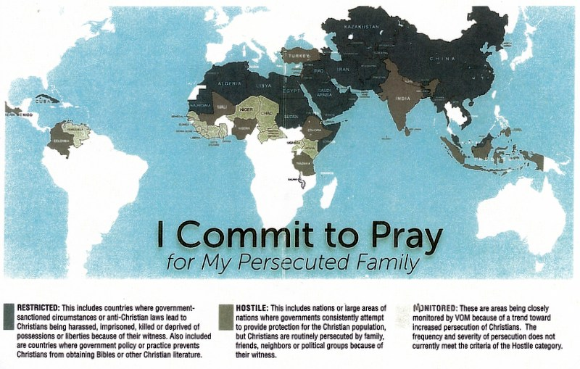
Matthew 25:31-46: “And when the Son of Aḏam comes in His esteem, and all the set-apart messengers with Him, then He shall sit on the throne of His esteem. And all the nations shall be gathered before Him, and He shall separate them one from another, as a shepherd separates his sheep from the goats. And He shall set the sheep on His right hand, but the goats on the left. Then the Sovereign shall say to those on His right hand, ‘Come, you blessed of My Father, inherit the reign prepared for you from the foundation of the world –for I was hungry and you gave Me food, I was thirsty and you gave Me drink, I was a stranger and you took Me in, was naked and you clothed Me, I was sick and you visited Me, I was in prison and you came to Me.’ Then the righteous shall answer Him, saying, ‘Master, when did we see You hungry and we fed You, or thirsty and gave You to drink? And when did we see You a stranger and took You in, or naked and clothed You? And when did we see You sick, or in prison, and we came to You?’ And the Sovereign shall answer and say to them, ‘Truly, I say to you, in so far as you did it to one of the least of these My brothers, you did it to Me.’ He shall then also say to those on the left hand, ‘Go away from Me, accursed ones, into the everlasting fire prepared for the devil and his messengers –for I was hungry and you gave Me no food, I was thirsty and you gave Me no drink, I was a stranger and you did not take Me in, was naked and you did not clothe Me, sick and in prison and you did not visit Me.’ Then they also shall answer Him, saying, ‘Master, when did we see You hungry or thirsty or a stranger or naked or sick or in prison, and did not serve You?’ Then He shall answer them, saying, ‘Truly, I say to you, in so far as you did not do it to one of the least of these, you did not do it to Me.’ And these shall go away into everlasting
punishment, but the righteous into everlasting life.”

Who are His Brethren? Matthew 12:48-50: “Who is My mother? Who are My brethren? And He stretched for His hand toward His disciples and said, `Behold My mother and My brethren! And whoever shall do the will of My Father which is in heaven, the same is My brother, My sister, and My mother.’ ” Those who are true disciples of the Master are His family!
From ACLJ: “Jihadists Escalate the Persecution and Slaughter of Christians Worldwide by Matthew Clark 2014: “In Iraq, ISIS terrorists are targeting Christians and destroying churches. There are stories of forced taxes, rape, kidnapping, murder, and other horrendous persecution of Christians by ISIS militants. It’s believed that since 2003, two-thirds of Iraq’s Christian population has fled. Some experts believe the number of Christians there could dwindle to as little as 50,000 in the next 10 years due to increasing persecution. ISIS’s leader has declared a “caliphate,” an Islamic state, in Iraq and Syria and has demanded the imposition of Islamic Shariah Law. Experts have described the goal and brutality of ISIS as “annihilating Middle Eastern Christians.” In Syria, ISIS has actually crucified 9 people in recent days.”
I am proud of Iraq. As of late 2017, Iraq announced that they had run ISIS out of their country, yet a few stragglers still threaten the people. Where did they go? They went into other nations. As of July 2018, ISIS had jihad camps in every state of the United States. Since they were created by the Obama Administration, they are “right at home” among us Americans. Remember this statement by Obama:
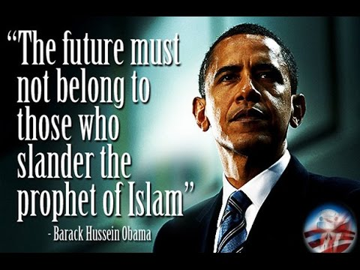
The following Scriptures are from SO4J TV and Video: PERSECUTED CHRISTIANS FACTS, SCRIPTURES, & VIDEOS - so4j.com/persecuted-christians

Hebrews 13:3 (ESV) "REMEMBER those who are in PRISON, as though in PRISON with them, and those who are MISTREATED"
Hebrews 11:35-40 (ESV) "Some were TORTURED, refusing to accept release, so that they might rise again to a better life. Others SUFFERED MOCKING and FLOGGING, and even CHAINS and IMPRISONMENT. They were STONED, they were SAWN in two, they were KILLED with the SWORD. They went about in SKINS of SHEEP and GOATS, DESTITUTE, AFFLICTED, MISTREATED— of whom the world was not worthy—wandering about in DESERTS and MOUNTAINS, and in DENS and CAVES of the earth. And all these, though commended through their FAITH, did NOT receive what was PROMISED, since God had provided something better for us, that apart from us they should not be made perfect."
Acts 12:5 (NASB) "So Peter was KEPT in the PRISON, but PRAYER for him was being MADE FERVENTLY by the CHURCH to GOD."
Acts 14:22 (NASB) “STRENGTHENING the SOULS of the disciples, ENCOURAGING them to CONTINUE in the FAITH, and saying, "Through MANY TRIBULATIONS we MUST enter the KINGDOM OF GOD.”
2 Timothy 3:10-12 (NASB) Paul speaking to Believers, "Now you FOLLOWED my TEACHING, CONDUCT, PURPOSE, FAITH, PATIENCE, LOVE, PERSEVERANCE, PERSECUTIONS, and SUFFERINGS, such as happened to me at Antioch, at Iconium and at Lystra; what PERSECUTIONS I ENDURED, and out of them ALL the LORD RESCUED me! (12) ALL who DESIRE to LIVE GODLY in CHRIST JESUS will be PERSECUTED."
2 Timothy 3:12 (NASB) "Indeed, all who desire to live GODLY in CHRIST JESUS will be PERSECUTED."
Revelation 12:11 (NASB) "And they OVERCAME him (Antichrist) because of the BLOOD of the LAMB (JESUS) and because of the WORD of their TESTIMONY, and they did NOT love their LIFE even when faced with DEATH."
Matthew 5:10 (NASB) "BLESSED are those who have been PERSECUTED for the sake of RIGHTEOUSNESS, for theirs is the KINGDOM OF HEAVEN."
John 15:20 (NASB) Jesus: "If they PERSECUTED ME, they will also PERSECUTE YOU."
1 Peter 1:6-9 (NASB) "In this you GREATLY REJOICE, even though now for a LITTLE WHILE, if necessary, you have been DISTRESSED by VARIOUS TRIALS, so that the PROOF of your FAITH, being MORE PRECIOUS than GOLD which is PERISHABLE, even though TESTED by FIRE, may be found to result in PRAISE and GLORY and HONOR at the revelation of JESUS CHRIST 8)and though you have NOT SEEN HIM, you LOVE HIM, and though you do NOT SEE HIM now, but BELIEVE in HIM, you GREATLY REJOICE with JOY INEXPRESSIBLE and FULL of GLORY, 9)obtaining as the outcome of your FAITH the SALVATION of your SOULS."
James 1:12 (NASB) "BLESSED is a man who PERSEVERES under TRIAL; for once he has been APPROVED, he will receive the CROWN OF LIFE which the LORD has PROMISED to those who LOVE HIM."
2 Thessalonians 1:7-12 (NKJV) "..When the LORD JESUS is Revealed from HEAVEN with His MIGHTYANGELS, in FLAMING FIRE taking VENGEANCE on those who do NOT know God, and on those who do NOT OBEY the GOSPEL of our LORD JESUS CHRIST. These shall be PUNISHED with EVERLASTING DESTRUCTION from the Presence of the LORD and from the GLORY of HIS POWER, when He comes, in that DAY, to be GLORIFIED in His SAINTS and to be ADMIRED among ALL those who BELIEVE, because our TESTIMONY among you was BELIEVED. (11) Therefore we also PRAY always for YOU that our GOD would Count you WORTHY of this CALLING, and FULFILL ALL the GOOD PLEASURE of HIS GOODNESS and the WORK of FAITH with POWER, that the Name of our LORD JESUS CHRIST may be GLORIFIED in YOU, and YOU in HIM, according to the GRACE of our GOD and the LORD JESUS CHRIST."
1 Peter 4:12-14 (NASB) "Beloved, do not be surprised at the FIERY ORDEAL (TRIAL) among you, which comes upon you for your TESTING, as though some STRANGE THING were happening to you; but to the degree that you SHARE the SUFFERINGS OF CHRIST, keep on REJOICING, so that also at the revelation of HIS GLORY you may REJOICE with EXULTATION. If you are REVILED for the NAME OF CHRIST, you are BLESSED, because the SPIRIT OF GLORY and of GOD rests on you."

Sharing More Articles
“The Slaughter of Christians” July 11, 2018 Golden Report [Entire article]
Tens of thousands of Christians have been slaughtered by Muslims in Syria, and throughout the Muslim world, in Egypt alone there are daily mass murders in Christian Churches. As you read this there are Christians being massacred in Nigeria and all over Africa. Europe is being cleared of Christians with thousands of Churches being turned into Mosques.
I used to think that with the Muslims killing Jews and running them out of Europe that the Christians won’t care to much until the Muslims come after them. Well I was wrong it seems they don’t even care when they are the target of the Muslims. Sure I know there are some who really care but the truth is the large majority just don’t care as long as their Church opens its doors on Sunday morning with Pastors preaching prosperity messages giving little to no attention to the slaughter of Christians and Jews around the world. And when they come after you there may be no one left to help you. But we’ve all heard that before and the sun comes up the same way every day and goes down on time as well, so everything will be okay.
On the other hand what is it you or anyone else you know in your Church could do to stop the massacres anyway? If you answer is “nothing” you are wrong again, to begin with we can start our day off with asking God what you have me do, should I write letters to the President to your Congressman demanding them to do something to stop the slaughter of Christians around the world. God may even send you out in ministry. But I really believe that if you ask with a pure heart and really mean you are willing to do whatever it is God lays on your heart and spirit that you will follow that leading you will hear from God and receive directions. You know as I do that God knows when you are serious or when you are just speaking words that reach no higher than the ceiling. [There is VOM too]
To be honest with you I have spent time crying and for those who know me know I am not a crier. Asking God what I could do if there is anything but the answer never varies for me and that is to continue with the commission you now have. I am praying for two things this report will do, one that it will cause some to get on their knees and ask God what He would have them do, and how to serve Him to save many, to save their lives and to save their souls. You see once they are dead you can’t be used by the Holy Spirit to save their souls because you have to be willing to help save their lives first. It would be like telling a hungry man God bless you and then walk into a restaurant and buy yourself a big meal. And if this letter causes some or even one to do what he or she can do to help stop the mass slaughter of Christians around the world I will rejoice to God saying thank God thank God. We have come a long way with two boats and the many contacts and communications in place for us to falter now so much is now depending on our obedience to God’s call on our lives.
Pray for the peace of Jerusalem for our son Joel and all the IDF soldiers…
Shalom, Jerry and Connie Golden

I encourage you to read this article:
“Italian bishop says he’s ready to `turn all the churches into mosques’ to aid the cause of mass Muslim migration”-July 10, 2018 - Robert Spencer - Jihad Watch
WHY? - Because the Vatican created Islam to facilitate the long-term goals of the popes for world conquest by weaponizing the pagan tribes of Arabs. It’s working! However - not for long!

“Christianity is Either Illegal or Severely Restricted in 51 Different Countries” By Meranda Devan – Why God?
“What is the most persecuted religion in the world? Have you ever thought about this question? Most people are not aware that Christianity is the most persecuted religion in the entire world. It is illegal or severely restricted in 51 different countries.
Fundamentalist Muslim nations, fanatical Hindu countries and hard line Communist regimes are not shy about their hatred for Christianity. Christians in the United States do not realize how easy they have had it. In many areas of the world following Christ means paying a very high price. Too often that price is the life of a Christian believer.
For example, Iran’s parliament has passed a new law which makes it illegal for a Muslim to become a Christian, and that any Muslim that does become a Christian must be executed.
What would you do if you had to choose your faith in Christ or execution?
In many areas of India, Christians who try to proclaim the gospel of Jesus Christ are regularly attacked by Hindu extremists.
The following is a recent example of this persecution that was emailed to us by The Voice of the Martyrs:
On April 25, Pastor Mohan Babu and two other believers were severely beaten by 35 Hindu extremists for holding a Vacation Bible School (VBS) near Bangalore City, in Karnataka State. According to The Voice of the Martyrs contacts in India, the three-day VBS was organized by Ragigudda Baptist Church. VOM sources said, “Around 60 children from different backgrounds were attending the VBS. As they were worshiping, about 35 people belonging to a Hindu extremist group forcefully entered the hut chanting slogans and demolished the hut. The extremists mercilessly beat Mohan, Samuel and Krishna, alleging forceful conversion. The perpetrators chased the children without any courtesy and tore the Bibles. Mohan was severely injured on his lips and was profusely bleeding. The believers are living in fear and did not lodge complaint with the police.” Pray for healing for all those injured in this attack. Pray they forgive their attackers and for the children who were attending VBS to continue growing in their faith despite the attack.
Unfortunately, the persecution of Christians in India has gotten worse as 4 more churches in eastern India have been burned to the ground and thousands of Christians have been driven from their homes.
But it is not just in a few areas where Christians are persecuted. It is truly a worldwide phenomenon…..
* It has been estimated that more Christians were martyred in the 20th Century than in the previous 1,900 years combined.
* There were more than 26 million documented cases of martyrdom in the 20th century alone.
* More than 200 million Christians in over 60 nations face persecution each day, and it is estimated that over half of these are children.
* It is estimated that between 150,000 and 165,000 Christians are martyred each year.”
Following in this article is a partial list of countries where there is current persecution and a description of that persecution. Check it out on line. The worst countries of persecution mentioned are: North Korea, China, Iran, Saudi Arabia, Indonesia, Nigeria, Pakistan, Somalia, Sudan, Cuba, Tibet …
Article continued: “Pastor Florescu couldn’t bear to watch his son being beaten by the Communist officers. He had already been beaten himself, and he had not slept for two weeks for fear of being attacked by the starving rats the Communists had forced into his prison cell. The Romanian police wanted Florescu to give up other members of his underground church so that they, too, could be captured.
Seeing that the beatings and torture weren’t working, the Communists brought in Florescu’s son Alexander, only fourteen years old, and began to beat the boy. While Florescu watched, they hammered his son’s body unmercifully, telling the pastor that they would beat his son to death unless he told them the locations of other believers. Finally, half mad, Florescu screamed for them to stop. `Alexander, I must say what they want!’ he called out to his son. `I can’t bear your beatings anymore.’ His body bruised, blood running from his nose and mouth, Alexander looked his father in the eye. `Father, don’t do me the injustice of having a traitor as a parent. Stand strong! If they kill me, I will die with the word Jesus on my lips.’
The boy’s courage enraged the Communist guards, and they beat him to death as his father watched. Not only did he hold on to his faith, he helped his father do the same.
But perhaps you don’t think it could happen in the United States?”

“MAPPED: The 50 countries where you CAN'T be a Christian in 2017”
“MILLIONS of Christians across the world are facing punishments including imprisonment, torture and death for practicing their faith, shocking new research has revealed” by Harvey Gavin - Express - Nov 8, 2017

“Pakistan is among worst places for Christian persecution. Open Doors UK and Ireland investigate hate crime internationally.
North Korea, Somalia and Afghanistan are the worst countries to openly follow the teachings of the Bible, according to the study by Open Doors. North Korea has been branded the most dangerous country in the world for Christians since 2002.
…And the research discovered followers of Jesus living in India were faced with a `very high’ level of persecution as `Hindu nationalists batter the churches.’
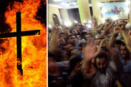
Christians pelted with ROCKS in attack - four churches forced to shut
Millions of Christians around the world now live their lives against varying levels of discrimination, discovery, violence and arrest
Open Doors: The charity concludes `millions of Christians around the world now live their lives against varying levels of discrimination, discovery, violence and arrest’. The study highlighted the top 50 countries where it is most difficult to practice the Christian faith, and rated levels of persecution as `extreme’, `very high,’ or `high.’
North Korea topped the list because of dictator Kim Jong-un’s brutal crackdown against the nation's estimated 300,000 Christians. The tyrant’s family are worshipped like gods and any suggestion there is a higher authority than the supreme leader is “immediately crushed”.
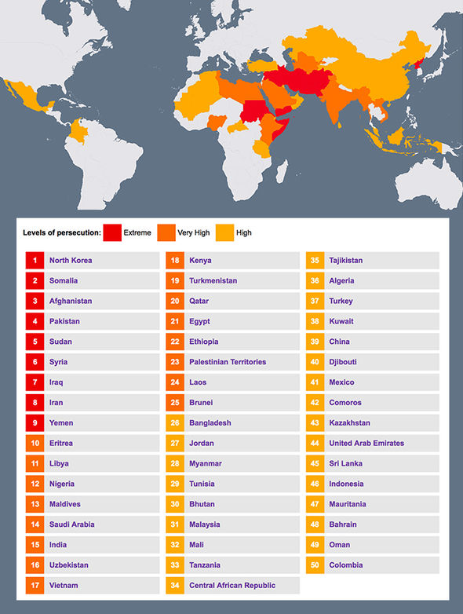
OPEN DOORS UK
Open Doors says: `Tens of thousands of Christians are incarcerated in horrific labor camps, and thousands more keep their faith in Christ a complete secret - often their own family members do not know of their faith.’
In lawless Somalia, which ranks second for persecution, the charity says people even suspected of being a Christian can be murdered on the spot.
The militant Islamist group al-Shabaab, which is highly active in the East African nation, has made making Somalia `free of all Christians’ one of its missions.
And the Open Doors study cites a horrific case from 2016 when at least 12 Christians were killed after their faith was discovered.
Open Doors says: `Discovered believers will sometimes be sent to a mental hospital, as families believe no sane person would leave Islam.’
The study ranked India 15th on its list because it says there are efforts to impose national anti-conversion laws to prevent anyone from practicing anything other than Hinduism. Open Doors says a massive 63.9 million Christians are living in the vast South Asian state, and face persecution from the Hindu nationalist Bharatiya Janata Party. The research says: `Some of those who have left Hinduism to follow Jesus have been attacked and even killed by their own parents.’ (Mark 13:12)
China is ranked 39th and was found to have a `high’ level of persecution. The world’s most populous country is home to an estimated 97.2million Christians and Open Doors says `a considerable number’ of those are still imprisoned for practicing their faith. The study says: `Violence is at a very high level and is increasing. Church meetings continue to be disrupted in several provinces. Churches were also closed and landlords pressured to stop renting premises to Christians.’
Open Doors has identified eight main 'engines' of persecution that describe why Christians are persecuted in a particular area or setting.
1) Islamic extremism - attempts to bring the country or the world under the 'House of Islam' through violent or non-violent actions
2) Religious nationalism - attempts to conquer the nation for one's religion. Mainly Hinduism and Buddhism, but also Orthodox Judaism or other religions
3) Ethnic antagonism - attempts to force the continuing influence of age-old norms and values shaped in 'tribal' context. Often comes in the form of traditional religion or something similar
4) Denominational protectionism - attempts to maintain one's Christian denomination as the only legitimate or dominant expression of Christianity in the country. [Like the war between Catholics and Protestants in Ireland]
5) Communist and post-Communist oppression - attempts to maintain Communism as a prescriptive ideology and/or controls the church through a system of registration and oversight that has come from Communism
6) Secular intolerance - attempts to eradicate religion from the public and private domain, and imposes an atheistic form of secularism as a new governing ideology
7) Organized corruption and crime - attempts to create a climate of impunity, anarchy and corruption as a means for self-enrichment
8) Dictatorial paranoia - does anything to maintain power; not specifically focused on realizing a vision.”

International Community Ignores Genocide of Christians in Nigeria
07/09/2018 by Raymond Ibrahim – Raymond Ibrahim website
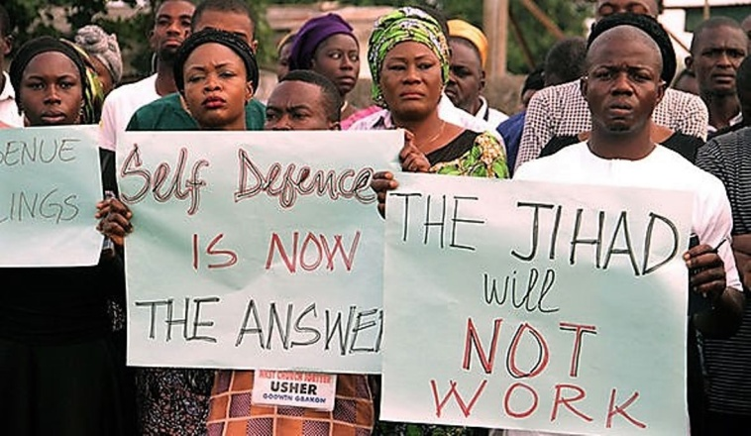
“In what the Christian Association of Nigeria is calling a `pure genocide,’ 238 more Christians were killed and churches desecrated by Muslims last week in the west African nation. This brings the death toll of Christians to more than 6,000 since the start of 2018.
According to a joint statement by the Christian Association, an umbrella group of various Christian denominations, `There is no doubt that the sole purpose of these attacks is aimed at ethnic cleansing, land grabbing and forceful ejection of the Christian natives from their ancestral land and heritage.’
The statement condemned the recent attacks, `where over 200 persons were brutally killed and our churches destroyed without any intervention from security agencies in spite of several distress calls made to them.’
The statement adds that the majority of those 6,000 Christians massacred this year were `mostly children, women and the aged… What is happening in … Nigeria is pure genocide and must be stopped immediately.’
The details of the murder of these thousands, though seldom reported, are often grisly: many were either hacked to death or beheaded with machetes; others were burned alive (including inside locked churches or homes); and women are often sexually assaulted or even raped before being slaughtered.
For long, both the Nigerian government and the U.S. government have sought to present this protracted jihad as territorial clashes between the haves (apparently always Christians) and haves-not (apparently always Muslims).
…Following the 2012 Easter Day bombing of a Nigerian church that left 39 worshippers dead, former U.S. Assistant Secretary of State for African Affairs, Johnnie Carson, said, `I want to take this opportunity to stress one key point and that is that religion is not driving extremist violence’ in Nigeria. Similarly, the Obama administration reportedly agreed to spend $600 million in a USAID initiative launched to ascertain the `true causes’ of unrest and violence in Nigeria—which naturally lay in the socio-economic, never the religious, realm.
However, in its recent statement, the Christian Association of Nigeria denied all these claims. After saying that those responsible for slaughtering Christians are always allowed to `go scot free’ by the Nigerian government—which further portrays the attacks as `farmers/herdsmen clashes’—it inquired: `How can it be a clash when one group [Muslims] is persistently attacking, killing, maiming, [and] destroying, and the other group [Christians] is persistently being killed, maimed and their places of worship destroyed? How can it be a clash when the herdsmen are hunting farmers in their own villages/communities and farmers are running for their lives?’
…Some of the more telling points in the group’s executive summary of issues follow: It is clear to the Christian Elders that JIHAD has been launched in Nigeria by the Islamists of northern Nigeria led by the Fulani ethnic group [the `herdsmen’]. This Jihad is based on the Doctrine of Hate taught in Mosques and Islamic Madrasas in northern Nigeria, as well as being the supremacist ideology of the Fulani. Using both conventional (violent) Jihad, and stealth (civilization) Jihad, the Islamists of northern Nigeria seem determined to turn Nigeria into an Islamic Sultanate and replace Liberal Democracy with Sharia as the National Ideology.
The object of course, is to supplant the Constitution with Sharia as the source of legislation. The current 1999 Constitution is plagued with dual conflicting ideology of Democracy and Sharia. There are certain values which are non-negotiable in a pluralistic society and it seems the advocates of the Caliphate do not respect this. A dual-ideology-driven Nigeria cannot be the Nigeria of our dream. We want a Nigeria, where citizens are treated equally before the law at all levels…. Bearing in mind that Christians constitute over 50% of the Nigerian population, the goal of the Islamists is bound to create serious conflicts which if not checked is capable of escalating into another civil war. Already, the Islamists are murdering Christians with impunity and destroying vulnerable Christian places of worship and communities at an alarming and inhuman rate.
That 6,000 Christians, `mostly children, women and the aged,’ have been butchered in just the first six months of this year is a reminder of how violence only escalates when left unchecked, which is the story of the Muslim persecution of Christians in Nigeria. For example, it took three times as long (a year-and-a-half, between December 2013 to July 2015), for the same Muslim herdsmen to slaughter only 1,484 Christians (532 men, 507 women, and 445 children), critically wound 2,388 Christians (1,069 men, 817 women, and 502 children), and burn or destroy 171 churches.
But the Nigerian government and the international community have from the start done little to address the situation—which is unsurprising since they cannot even acknowledge its roots, namely, the intolerant ideology of jihad. As a result, the death toll of Christians has only risen—and will likely continue to grow exponentially through the years, until such time that reality is not only acknowledged but properly addressed.”

Links to two main organizations working directly with the persecuted:

Serving Persecuted Christians Worldwide Open Doors USA
https://www.opendoorsusa.org/
Open Doors serves persecuted Christians worldwide in more than 60 countries, empowering and equipping Christians who are suffering for their beliefs

Voice of the Martyrs: Voice of the Martyrs
https://www.persecution.com/
A non-profit, interdenominational organization with a vision for aiding Christians around the world who are being persecuted for their faith in Christ
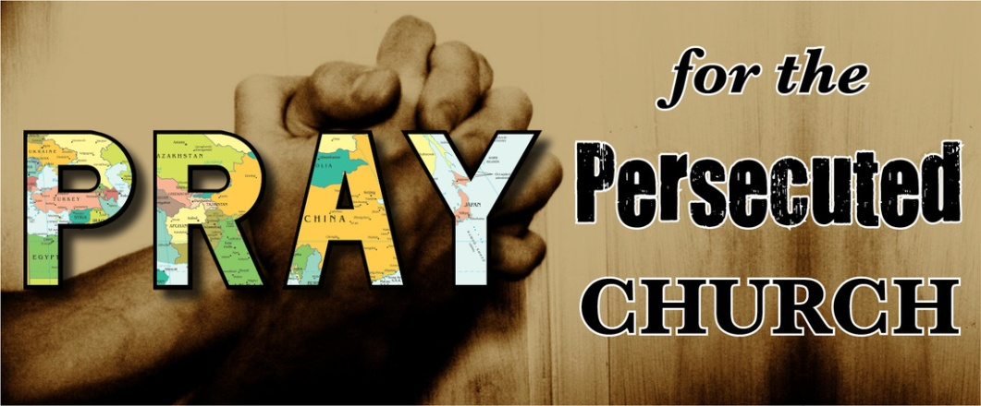
Shalom in His love,
Yedidah
July 14, 2018

