PERSECUTION BRINGING REVIVAL IN CANADA – A PASTOR SPEAKS OUT
https://youtu.be/g4McY1seSEo
Please watch this 4.3-minute video! This dear pastor, Henry Hildebrandt, in the
in the Province of Ontario, is obeying the Word of Almighty Yahuwah. What the Chinese have done, and are doing in China from the days of Mao Tse Tung until today is being done in a nation that has allowed China to take over – Canada. Yes, Trudeau has given Canada over to the control of China in many ways. I’ve known about Chinese infiltration into Canada and the U.S. for a long time, and reported on things Canadians did not know about this subtle takeover. Now, Canada is turning into another China, just as is the United States.
Listen to the words of this pastor. Precious! His words sound so much like the pastors in China who stand firm in obedience to the Word. The average prison term for a pastor in China is 17 years. I’m not talking about the government controlled “church,” which evidently President XI is coming against, too. I’m talking about the “underground church” that obeys the Word of Yahuwah and not man’s defilement.
Yahuwah’s people are denied basic rights, gunned down in baptismal waters, hunted down, beaten, imprisoned, tortured, and killed. This persecution is spreading worldwide. In Muslim countries, like Iran, there is a great outpouring of the Spirit and many are becoming born-again believers. Miracles are happening. And the persecution is rising. However, persecution is rising in what we once called “free nations,” and becoming more cruel and more violent.
Revelation 6:9-11; 7:9-18 and 14:9-12 is ready to go forward in all nations.
Recently another pastor was arrested in Alberta, Canada. When released, he went back to conducting services for a few of his people. The police came and fined everyone a huge amount of money, and took the pastor away again.

1) “Canada Churches Closed Pastors Arrested Persecution on our doorstep May 8 2021” “BREAKING: Calgary Pastor Artur Pawlowski ARRESTED moments after church today” by Rebel News May 08, 2021
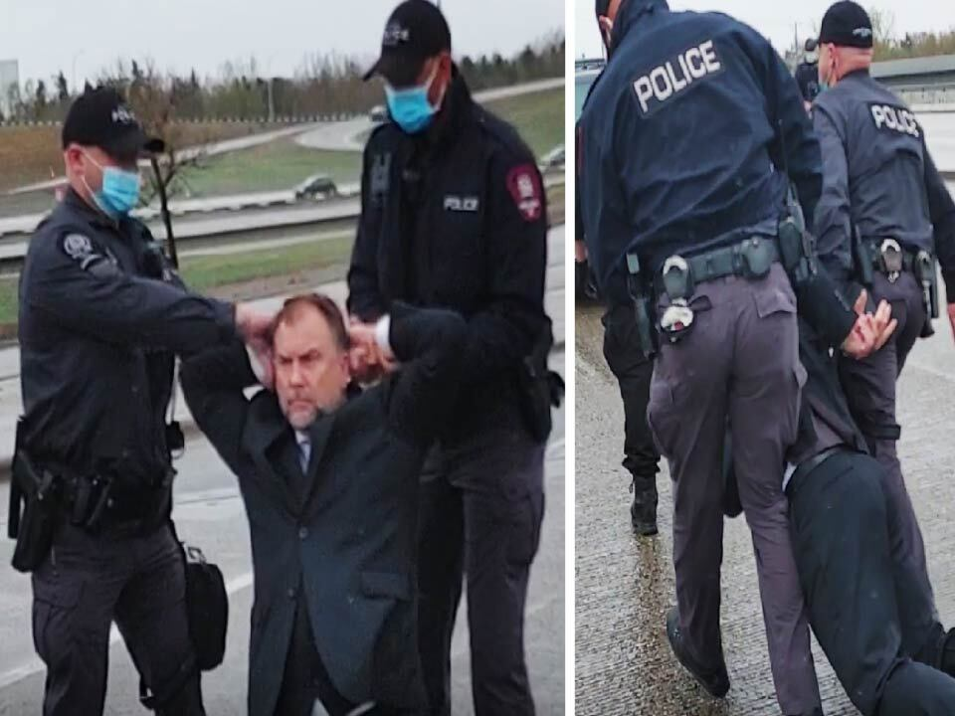
“Just minutes ago, Pastor Artur Pawlowski was arrested for opening his church in Calgary. Half a dozen police cars swarmed around him and he was taken into custody.
What have we come to when Alberta — once known as the freest province in Canada — now routinely prosecutes and jails Christian pastors? I don’t know of anywhere else in the free world that has that disgraceful distinction.
Wal-Mart and Costco are open across Canada, so are liquor stores and marijuana stores. But a Christian pastor cannot open his doors with a massive police raid. This is the second Christian pastor jailed in Alberta this year — the first was Pastor James Coates of GraceLife Church outside Edmonton.
He was kept in a maximum security prison for 35 days for refusing to close his church. Eventually police raided the church itself, expropriating it and turning it into a permanent police garrison.
If you think today’s arrest is an outrage — not only to Pastor Artur, and his congregants, but an outrage against our constitutional freedoms — then please help us…”

2) Police Issue 26 Churchgoers The Steepest Known Fines in North America for Attending Services Staff Writer for Potestia - May 14 2021
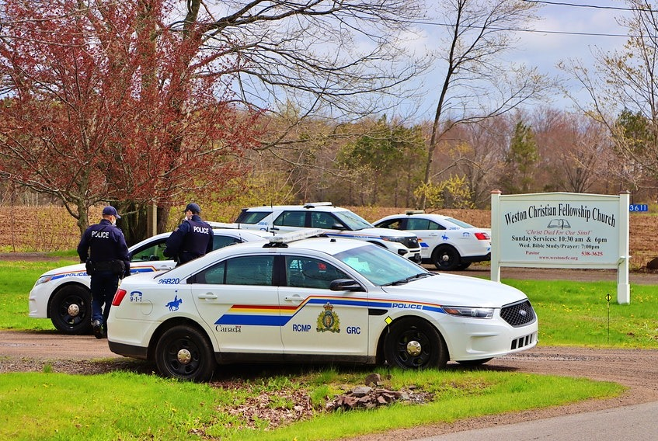
Police in Nova Scotia have fined 26 churchgoers a total of $2,422 each for attending an “illegal faith gathering” on Sunday. This is believed to be the highest value of fines handed out to individual parishioners in North America since the pandemic began. Officers were called to Weston Christian Fellowship Church in Weston, N.S., where they found the service in progress. Nova Scotia has one of the strictest rules in Canada, where it is illegal to have any in-person church service, irrespective of the number of people or the space it is being done in. RCMP spokesperson Cpl. Chris Marshall explains:
Twenty-six people were charged in the event, as a result of the gathering, and then the organization itself that was hosting the gathering was also charged. Basically, anybody that was over the age of 16 was issued a fine. There were some children and things there, but the children weren’t issued fines.
Not only were the congregants charged, but the church itself was charged as a corporation and given a $11,622 fine. In total more than $74,000 in fines were issued…
[Editor’s note: Speaking as a Canadian, I have to wonder where all the brown shirts are. When did we wake up in Nazi Germany?]”

3) Canadian Troops Sent to Louisiana for Training with American Troops
Red alert! Foreign troops will be training in America. Canadian military is coming to Louisiana - Feb 24 2021 YouTube Days of the Pandemic
Canada is having to defend itself as to why they are sending thousands of their troops to Louisiana for a training exercise. These guys trained thousands of Chinese on the Canadian border with the East U.S., and they attacked us… shot down one of our F-16s of Michigan and tried invading via Maine, but trump attacked back and stopped them. Lots of the Canadian military are protesting – saying why go to the US at a time when Covid is rampant and there’s no need to go… They also stood against having to train the Chinese …
They’re being sent to the US for a few weeks to work with the American soldiers.
They will be stationed at U.S. Army Joint Readiness Training Center Fort Polk”
[I think this is a first. I don’t remember foreign troops working with the American – oh yea – Chinese, Russian troops in the US by the tens of thousands are working with the US military – WHY??? Other troops from Europe - Holland? Anyway, other nations have sent their troops to America and they’re still here. This is not a first!!!] One Canadian solider said: `I think everyone is concerned about the liberties they take with health and wellness, not only of the members participating, but the public, for such a trivial exercise. It is definitely not necessary…’”
As I said sometime back, Germany and France will join with Russia and China, and North Korea, and Iran, in an attack on America. Recently I got the news that Germany and France have pledged their loyalty to Russia, and if Russia goes to war with America, they will side with Russia! Many German troops are in America now.

4) Christian persecution Has Openly Begun Military Involvement June 30, 2020
“Navy bans troops from indoor religious services while allowing protests, house parties 'The U.S. Navy has threatened to court-martial service members if they go to church.' Tue Jun 30, 2020 - by Doug Mainwaring
WASHINGTON, D.C., June 30, 2020 (LifeSiteNews) — “In open defiance of the Commander in Chief, who recently declared churches as essential to America, the U.S. Navy has threatened to court-martial service members if they go to church,” said Mike Berry, First Liberty Institute general counsel.
First Liberty, a legal organization dedicated to defending religious freedom, is representing Major Daniel Schultz, who is seeking religious accommodation. `It is absolutely outrageous that our troops can’t go to church, but they can attend a protest or host house parties of any size,’ said Berry in a statement.
On June 24, the Navy issued an order that banned troops from attending indoor religious services, although other activities such as using mass transit, hosting social gatherings of any size, and participation in protests are all permitted,’ explains First Liberty. `But the order specifically states that service members are prohibited from visiting, patronizing, or engaging in ... indoor religious services.’
…`We are stunned that the Navy would issue this unlawful order,’ said chaplain Col. Ron Crews, U.S. Army (ret.), executive director of the Chaplain Alliance for Religious Liberty, which represents 2,700 active-duty chaplains serving the Armed Forces. `Our chaplains have fought, bled, and even died for the right of every service member to enjoy religious freedom wherever they are, at home and abroad,’ Crews told Fox News. `For the Navy to strip away that freedom in this manner is unconscionable.’
`…This order affects millions of service members who are willing to risk their lives for the very freedom that has been taken away from them,’ he added.
`…This sounds like the beginning of those stories we hear of superior armies losing battles, why? Because they have abandoned God.’”

5) “Christians ordered to renounce faith or starve to death: `Renounce God or we'll cut off food and housing.’ It has become difficult to maintain belief in God because of religious persecution” By WND Staff Published June 28, 2020
China's communist government is warning elderly Christians that they will lose basic benefits if they don't stop practicing their faith.
Bitter Winter, the online magazine about religious liberty and human rights in China, reports the Communist Party is threatening `to take away the last means of survival from elderly believers,’ the government benefits of `housing, food, clothing, medical care, and funeral expenses.’ …`This form of religious persecution is on the rise in the area of China where we have our Save a Widow Campaign. I was just informed that in our area, a government official has instructed our widows to stay home on Sundays and not to go to church. He also ridiculed Jesus, saying, 'The Chinese government gives you 160 RMB (about $23). How much money does Jesus Christ give you?'
Just weeks ago, officials in Fuzhou `forced an 80-year-old Christian women to cover up a cross image in her home, again threatening her subsistence allowance.’
Authorities also have begun an intensive campaign of `return" inspections to make sure that people don't resume practicing their faith,’ the report said.
… In Yingtan city, authorities `deprived a local Christian of her government aid for hosting religious meetings at home, even though the woman was immobile from an illness,’ the report said. And they also harassed a Catholic, in her 70s, to replace religious symbols with images of President Xi Jingping.”

For many years, I’ve kept up with the persecution and killing of Christians worldwide, as the hate for the God of the Bible and His Son increases worldwide - Yahushua, the Hebrew name of our Savior and Messiah, aka Yeshua, Jesus, Isa, and other names that He’s called. Now we are near the time of worldwide martyrdom. “You will be hated by all men for My Name’s sake,” Yahushua said (Matthew 10).
Now the number of guillotines in America in F.E.M.A. camps, refurbished military camps across America, has gone up by 10,000 since the last time I reported the approximately 245,000. Revelation 20:4 is real and coming upon us.
I have a list of America’s potential “terrorist organizations” that are being “monitored” by the government now. One on the list is: “Evangelical Christians.”
This goes back to the Executive Order I’ve written about, signed by President Obama. The camps are stocked and ready for opening, the same with the one America built in Israel on the former airport site. It is identical to the ones in the U.S., complete with underground gas chambers.
It seems at times that “ignorance is bliss,” as the old expression goes. Yet, “ignorance” will send a lot of people to the lake of fire because they won’t be prepared for Mark 13:9-13, Matthew 24, Luke 21, or the book of Revelation, or Daniel. They’ll hit hard core reality and totally go mentally insane.
Prophetic intercessors like myself have been warning since the late 1980s, but few have done anything to prepare in any way. It is because they do not flow in the commission of our Master, but are their own masters - shielded and encouraged by their religion. All the while Yahuwah has been pouring out His Spirit on new believers in dangerous places. In the midst of great persecution and martyrdom people are being born again. What a wonderful report the pastor gives in the short video - link at the top of page 1.
Persecution of believers in America is becoming more extreme by the day. Now with Chinese communism taking over America from the inside, what is happening in China will happen here. Bible confiscation will be part of it, along with denial of rights, arrests, bestial treatment, imprisonment, and death. And all this time Yahuwah has been building His force on earth, His remnant, who will go forth in the midst of it all to do “exploits” at the time of antichrist’s rule. (Daniel 11:32 ff)
Pray for the good pastors who are teaching, and obeying the Word, along with real believers who face execution.
I just got word from Australia yesterday that the elderly face their pensions being taken away and all medical help taken away if they don’t take the vaccine. The persecution on the healthy that want to maintain their Creator-given DNA, their genetic code, their ID as children of Elohim, is increasing. Israel is a leader in this.
Now this weekend Israel is a leader once again with their huge gay-pride parade. Those protesting it are being arrested. Jerusalem is being prepared for “The Return of Nimrod.” I hope you’ve read that recent article!
An irritation: Notice that now almost all pictures and videos of Biden are close-ups, and the background is blurred. That started just after he took office. It’s very irritating. I wrote about it. Biden is not there – it’s a clone, a hologram, a photo insert, a “double,” but he’s not there. Like I said, whoever or whatever is running the country wants to be kept secret, hidden. Very strange!
Side with what is on the heart of Elohim. As you pray for those standing for righteousness, Yahuwah will notice your love and be tender towards you. Sow compassion and mercy; reap compassion and mercy.
In His love, Yedidah – Shabbat Shalom
June 4, 2021
Happy Anniversary Noah and Darlena! I love you!

