PRAYER RALLY IN WASHINGTON D.C. AND ACROSS AMERICA SEPTEMBER 26, 2020
WAS IT THE WILL OF YAHUWAH?

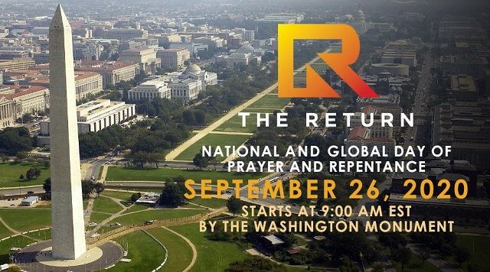

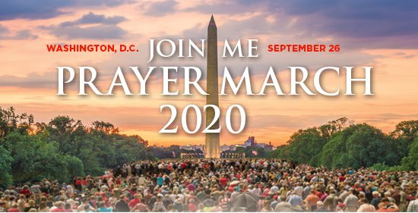

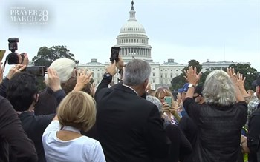
The gesture of blessing. How can we bless what Yahuwah has cursed?

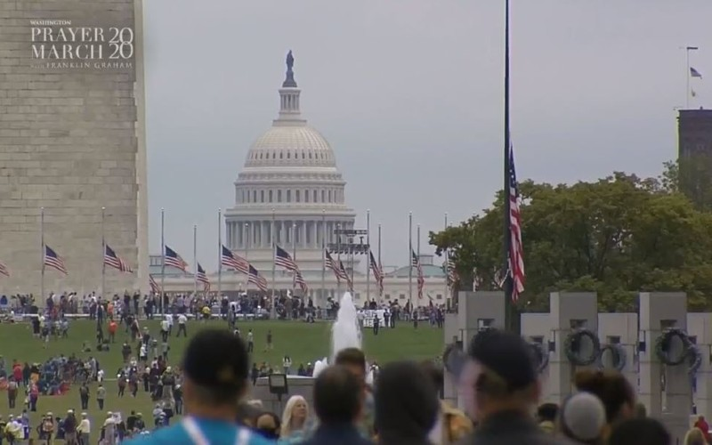
What a picture! The dome of Isis, the statue of the goddess Columbia, flags flown at half-mast in honor of an abortion promoter - one of the Supreme Court’s most liberal judges, and Christians praying for God to heal our nation based on a scripture addressed to Solomon.

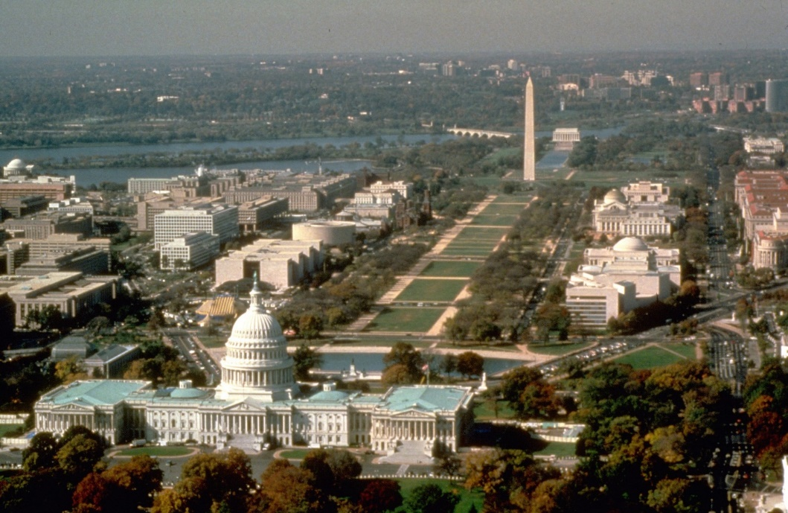
National Mall, Washington D.C.
The phallus symbol of Osiris and the pregnant belly dome of Isis
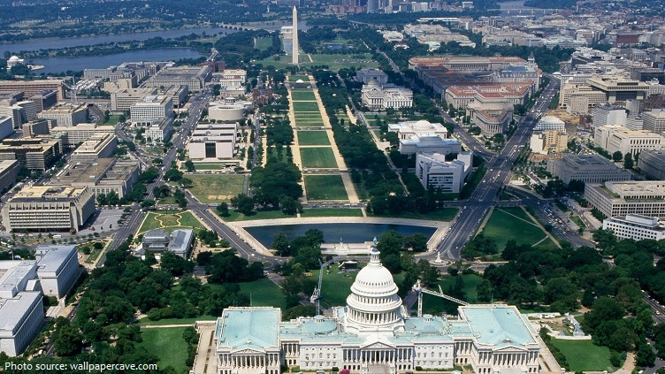
Notice the pattern of the streets… thousands were packed into that area between the obelisk and the dome …

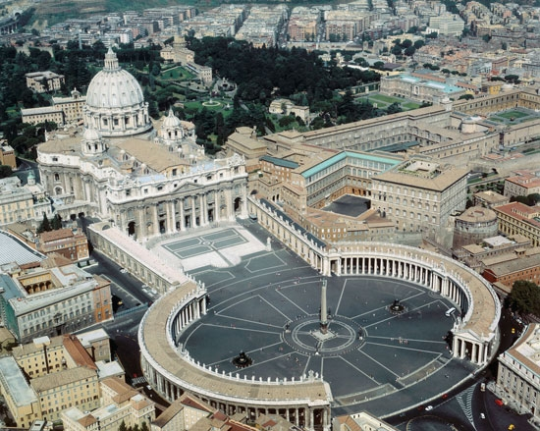
Vatican City and Washington D.C. are considered “sister cities.” In the early days of American history, our forefathers wanted to name our capital “Rome.”
Again, the combination of an obelisk, and a dome, picture the phallus of Osiris and the pregnant womb of Isis. Every secret society, the Illuminati, Beast-system governments, are based on the legend of Osiris and Isis. The combination sends the message that the sun gods rule earth, beginning with Nimrod, aka Gilgamesh, Osiris, Horus, Apollo, and finally Apollyon of Revelation 9:11, 11:7, 17:8 and II Thessalonians 2:3.
Within the area between the phallic symbol of Nimrod-Osiris and the pregnant woman dome, are a concentration of powerful fallen angel and Nephilim spirits that control the city. I know this from history, present reality, and my own experience in 2012 on an intercession assignment for Yahuwah. I was well aware that as I stood between the two symbols of the legend of Osiris and Isis, the basis of world government under the fallen angels, and gave Yahuwah’s message to the hierarchy of the satanic realm, that I was flanked on all sides by very powerful angels of Yahuwah. I had to give the message three times, once in between the two symbols outside, then inside the Vatican, then outside the door of the Sistine Chapel.
What I present here is backed by years of research to dig to the root of what is going on in the spirit realm to bring about the world ruler now, called “antichrist,” the Beast of Revelation 13:1-10.

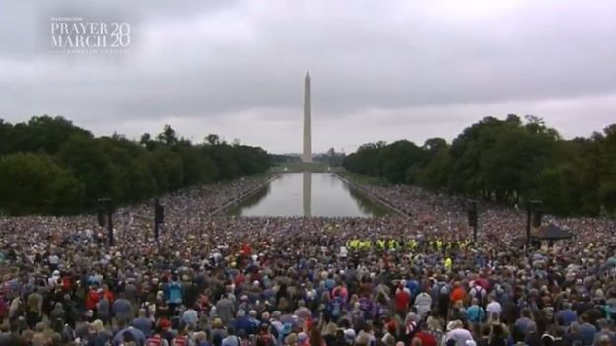
“Tens-of-thousands traveled to Washington, D.C., today to participate in the 2020 Prayer March with Franklin Graham. People from all 50 states assembled in prayer for our divided nation. Vice-President Mike Pence delivered remarks on behalf of the administration.”

Today is September 26, 2020. It is Shabbat.
Abba had me stay inside my apartment today. He gave me prophetic understanding and a warning to Yahuwah’s people. Two prayer marches in Washington today gathered Christians from all over America into two main areas – where there was music by well-known artists, speeches by well-known men, including Vice President Pence, Franklin Graham and others, and prayers led by well-known people for thousands standing to join in with, and/or pray on their own.
Yet, today, with all the excitement across America as Christian groups met for prayer, along with the events in Washington D.C., calling America back to God, Abba spoke to me: This is a day of the release of judgment upon America.
I explain why below. As thousands prayed for America to be healed, repented of sin for the nation, and called America back to God, Yahuwah said this began His judgment upon the nation.
His judgment was passed 2,500 years ago on a nation that was chosen to bring forth the Beast to rule the world. Please refer to: “The Secret Destiny of America”/Mikvah of Present Reality. On the Mayflower came those of the secret society The Order of the Quest, along with Jesuits pretending to be Protestants, and others from Europe who would lay a foundation for the establish of a post-flood Golden Age in which the gods would rule earth once again.
I have been a loyal, law-abiding, and good American citizen all my life. This is the land of my birth. I do not speak against the nation I once knew, but against what it has become as its reason for existence is now being fulfilled.
Today, many are repenting for the nation. But that is not Scriptural. We can pray that people turn to the Bible and find salvation, but individuals must receive by faith and repent for themselves.
Many are asking for mercy upon the nation, that it be “great again,” not knowing Abba put America under judgment 2,500 years ago through the Prophets Isaiah and Jeremiah, and later Yochanan in the Revelation (1,900 years ago). Also, Zechariah warned end-time Babylon.
Oh the tragedy of ignorance! All those people standing between the phallus of Osiris (Washington monument) and the womb of Isis (dome of the capital building) were praying to stop the judgment of God on the nation, based not on “thus says Yahuwah,” but on one verse He spoke to Solomon – II Chronicles 7:14. Read it in context.
They do not realize the concentration of the power of the fallen ones in that space known as the “National Mall.”
Oh how His people are playing into the hands of the deceit. Yes, very sincere, humble and precious Christians were there praying from a sincere heart. Bless and protect them Abba! Yet, the judgment of Yahuwah has been passed.
Instead of being caught into a great display in Washington, are these same people reaching to the lost around them with the Good News of salvation? If they were, if all believers were, there might not be need for a great national day of repentance.
Reality is not known by most. Pastors are keeping their people in ignorance for the most part. Few believers even know they are supposed to prepare for anything.
Yahuwah’s people are the ones needing prayer – that they stop believing lies and deceptions of men! The rapture doctrine is rising to world-recognition, even discussed in England’s top newspapers quoting Pastor Paul Begley. Now, it is almost too late to prepare, after a century of mind-programming into fantasy. I do not have any judgment in me for His people. I cannot condemn anyone after all the mercy Abba has shown me, a “chief” of sinners.
I hear Yahuwah tell Jeremiah just before Nebuchadnezzar’s attack “do not pray for this people.” His people are adoring, submitting to, even worshipping whom they deem to be important men, teachers, government officials, people of wealth and importance in this world. Yet, what is on the heart of Yahuwah as He is grieved to the core, that once again He must judge a deceived people?
Read Ezekiel 14 carefully. Noah escaped the wrath of Yahuwah. Daniel escaped the wrath of man. Iyob/Job escaped the wrath of Satan.
The judgment of Yahuwah, using the fallen ones, is going forth today from D.C. And, what does D.C. stand for? It stands for “District of Columbia.” And who is “Columbia?” She is a goddess of the pagan world. Her statue tops the Capital dome.
Today in Washington and all over America, sincere people are trying to get “God” to heal America and make it great again. Tragically, they have no clue as to what they are doing.” Even the name “Amaruca, an Incan name, from which America was named, means “land of the plumbed serpent.” Timothy Alberino’s astute research proves it to be true in a video on Amaruca. The inside circle of the Capital dome also proves it true. I sat underneath that dome and saw the reality of all I have learned about the nation’s very, very pagan capital.
Today, as I stayed inside at the leading of Yahuwah, He began by telling me about the loosing of demonic spirts within the National Mall today because of what that narrow area really is between the phallus (Washington Monument) and the belly of Isis (capital dome). First of all, the people packed that area - home to so many spirits of fallen angels and Nephilim. It is a portal into the realm of the fallen ones – into their dimension. The spiritual energy of the dark kingdom is concentrated between a phallic symbol and a dome, as also in St. Peter’s Square.
***REPEAT, THE AREA BETWEEN THE WASHINGTON MONUMENT AND THE CAPITAL DOME IS A PORTAL INTO THE COSMOS REALM OF THE FALLEN ONES.
AS THE PEOPLE PRAY IN THE NAME OF JESUS, THE FURY OF THE FALLEN ONES GOES FORTH. PLEASE KNOW: WITHIN ALL THOSE PRAYING PEOPLE WERE MANY WITCHES AND WARLOCKS, VOODOO PRIESTS, SHAMEN, AND DARK SORCERERS. THEY KNOW WHO IS THERE, AND THEY KNOW WHERE THEY LIVE. IT IS A DANGEROUS THING THEY ARE DOING, YET THEY ARE SO NAÏVE.
Yahuwah said that His Judgment, using the fallen ones, is going forth today from DC. He’s not just telling me! Amos 3:7 comes into play here!
I’ve heard watchmen lately say that His judgment is soon to be loosed. Well, just before Yom Teruah it is being loosed! The words of the handwriting on the wall of Belteshazzar’s palace in Babylon is what is written on America today. America, historically, is the final Babylon, even further back, the final Babel, the tower of Babel, and the rule of Nimrod. Rome in the first century was called the second Babylon. Jeremiah 50-51 identifies America as the final Babel to bring forth its ruler – Nimrod.
Daniel 5: Bĕlshatstsar the King made a great feast for a thousand of his great men, and drank wine in the presence of the thousand. 2While tasting the wine, Bĕlshatstsar gave orders to bring the gold and silver vessels which his father Neḇuḵaḏnetstsar had taken from the Hĕḵal/Temple which had been in Yerushalayim, that the sovereign and his great men, his wives, and his concubines could drink from them. 3Then they brought the gold vessels that had been taken from the Hĕḵal of the House of Elah which had been in Yerushalayim. And the sovereign and his great men, his wives, and his concubines drank out of them. 4They drank wine, and praised the elahim of gold, and of silver, of bronze, of iron, of wood and of stone. 5At that moment the fingers of a man’s hand appeared and wrote opposite the lampstand on the plaster of the wall of the sovereign’s palace. And the King saw the part of the hand that wrote. 6Then the King’s color changed, and his thoughts alarmed him, so that the joints of his hips were loosened and his knees knocked against each other. 7The King called loudly to bring in the astrologers, the Chaldeans, and the diviners. The sovereign spoke and said to the wise ones of Babel, `Whoever reads this writing, and shows me its interpretation, is robed in purple and has a chain of gold around his neck, and shall be the third ruler in the reign.’ 8So all the King’s wise ones came, but they were unable to read the writing, or to make known its interpretation to the King. 9Then King Bĕlshatstsar was greatly alarmed, and his color changed, and his great men were puzzled. 10The Queen, because of the words of the King and his great men, came to the banquet hall. And the Queen spoke and said, “O King, live forever! Do not let your thoughts alarm you, nor let your color change. 11`There is a man in your kingdom in whom is the Spirit of the Set-apart Elah. And in the days of your father, light and understanding and wisdom, like the wisdom of the elahin, were found in him. And King Neḇuḵaḏnetstsar your father, made him chief of the magicians, astrologers, Chaldeans, and diviners, 12because an excellent spirit, knowledge and understanding, interpreting dreams, and explaining riddles, and solving difficult problems were found in this Dani’ĕl, whom the King named Bĕlteshatstsar. Now let Dani’ĕl be called, and let him show the interpretation.’ 13So Dani’ĕl was brought in before the King. The King spoke and said to Dani’ĕl, `Are you that Dani’ĕl who is one of the sons of the exile from Yehuḏah, whom my father the King brought from Yehuḏah? 14I have heard of you, that the Spirit of Elah is in you, and that light and understanding and excellent wisdom are found in you. 15And the wise ones, the astrologers, have been brought in before me, that they should read this writing and make known to me its interpretation, but they were unable to show the interpretation of the word. 16And I myself have heard of you, that you are able to give interpretations and to solve difficult problems. Now if you are able to read the writing and make known its interpretation to me, you are to be robed in purple and have a chain of gold around your neck, and shall be the third ruler in the kingdom.’ 17Then Dani’ĕl answered and said before the King, `Let your gifts be for yourself, and give your rewards to another. Yet I shall read the writing to the King, and make known the interpretation to him. 18 O King, the Most High Elah gave Neḇuḵaḏnetstsar your father a reign and greatness, and preciousness and esteem. 19And because of the greatness which He gave him, all peoples, nations, and languages trembled and feared before him. Whomever he wished he executed, and whomever he wished he kept alive, and whomever he wished he raised up, and whomever he wished he made low. 20But when his heart was lifted up, and his spirit was so strong as to act proudly, he was put down from his throne of reign, and they took his preciousness from him. 21Then he was driven from the sons of men, and his heart was made like the beasts, and his dwelling was with the wild donkeys. He was given grass to eat like oxen, and his body was wet with the dew of the heavens, till he knew that the Most High Elah is ruler in the kingdom of men, and He sets up over it whomever He wishes. 22And you, his son, Bĕlshatstsar, have not humbled your heart, although you knew all this. 23And you have lifted yourself up against the Master of the heavens. And they brought before you the vessels of His house, and you and your great men, your wives and your concubines, have been drinking wine from them. And you have praised the elahim of silver, and of gold, of bronze, of iron, of wood, and of stone, which neither see nor hear nor know. But the Elah who holds your breath in His hand and owns all your ways, you have not made great. 24Then the part of the hand was sent from Him, and this writing was inscribed. 25And this is the writing that was inscribed: MENĚ, MENĚ, TEQĚL, UPHARSIN. 26This is the interpretation of each word: MENĚ – Elah has numbered your kingdom, and put an end to it. 27TEQĚL – You have been weighed on the scales, and found lacking. 28PERES – Your kingdom has been divided, and given to the Medes and Persians.’ 29Then Bĕlshatstsar gave orders, and they robed Dani’ĕl in purple and put a chain of gold around his neck, and they proclaimed concerning him that he is the third ruler in the reign. 30In that night Bĕlshatstsar, sovereign of the Chaldeans, was slain. 31And Dareyawesh the Mede took over the reign, being about sixty-two years old.”

America has been weighed in the balances and found to be lacking - lacking Yahuwah’s Presence, Protection, Power, Law and Authority. It is a nation that was destined to bring about the Beast/antichrist and his kingdom on earth, a restored Nimrod, the gibbor of Babel, founder of the world system of the fallen ones after the Flood. Today a physical lineage goes back to the Nephilim hybrid Nimrod and has worked through six empires to bring us to the point of the establishment of the final 7th empire of the son of Satan. (Egypt, Assyria, Babylon, Media-Persia, Greece, Rome) Please carefully read “America’s Secret Destiny”/Mikvah of Preparation.
America has been blessed because of true Christians who have stood for righteousness through the last 400 years on this continent. Yet, because Moses and Joshua/Yehoshua killed Og and Sihon and went forth to terrorize the Nephilim tribes of what is today Israel, they fled West, bringing Babel with them. Evidence is found all over the world of these tribes. America is covered from coast to coast with this evidence. Giants were before and after the Flood. (Genesis 6:1-4)
“America’s Stonehenge” in New Hampshire shows evidence of Canaanite tribes, worshippers of Ba’al and their human sacrifice, their connection to the fallen ones of the cosmos. L.A. Marzulli has two new DCDs showing how America’s Stonehenge is connected to other megalithic sites all over the world. Straight lines, that can only be seen from very high above the earth, connect these sites. The same is in places like Nasca, in Peru. The earth was covered with the fallen angels and their offspring before and after the Flood. Evidence is nearly everywhere. Nimrod was the connector between the two as the son of Bel, or Cush, and grandson of Noah’s son Canaan. Nimrod was of the tribe of Canaan.
The secret societies of the fallen ones in Europe, along with Jesuits, infiltrated America as far back as the sailing of the Mayflower to create a nation that would restore Nimrod and the kingdom of the fallen angels and their children, the Nephilim, the hybrids of part human and part fallen angel. Evidence of the Genesis 6 narrative is found worldwide. The goal of world government is for the prince of darkness to reign over earth in a new Golden Age of pre-flood life.
Humans, promised great power and wealth, are but lackeys of the returning fallen angels and Nephilim. Once again, giants are being seen all over the earth – like the 15’ giant in Afghanistan who ate some of the U.S. soldiers. He was brought down by a special U.S. team, and flown back to America.
Why was the body of Gilgamesh/Nimrod/Osiris/Apollo/Apollyon of Revelation 9 uncovered at the gate of ancient Babylon is southern Iraq and flown back to the U.S. by the military, along with treasures of Nimrod’s preserved in the Baghdad Museum? The military knew just what to look for in the Museum (April 2003). Thus, the reason for Gulf War II. Whatever they confiscated; they got the DNA of Nimrod.
Today those spirits inhabit the nation’s capital, a cesspool of pagan statues and satanic symbolism. The image of Baphomet, the goat headed representation of Satan, is laid out in the streets of Washington D.C. I walked the head of Baphomet from the tip of his goat-beard, which rests on the White House, up to the House of the Temple – the top of the candle sitting on Baphomet’s head. I took a tour through this “temple,” the infamous 33rd Degree Scottish Rite Freemason headquarters in America. I made the tour guide nervous by asking him questions about things I was not supposed to know.
Why is America’s Capital building called a “temple?” On top of it is the dome, the pregnant belly of Isis. At the head of the “Washington Mall” is the phallic symbol of Osiris, another name for Nimrod. The legend of Osiris and Isis is at the core of world government and all occult teaching. Do you know this legend? This same layout is in St. Peter’s Square in the Vatican. See pictures above.
What is going on now in Washington D.C. is that naïve deceived Christians in America have opened portals for the uprising of the spirits of Osiris and Isis to get rid of all opposition and rule the world. Today was an act of playing with Promethean Fire, without the participants understanding what they were doing.
The prayers of truly born-again people, truly repenting, truly calling on the Savior to help us, loosed lust for vengeance, and a declaration of war went forth. They desperately hate the name “Jesus,” “Yeshua,” “Yahushua.” We know that in underground places like Area 51, Los Alamos, the Dulce Base, etc. are reptilian Nephilim working with the U.S. Military. Their one rule is that the name “Jesus” was not to be spoken, even in swearing. America has housed these beings for their knowledge of technology. Yahuwah sits and looses these entities to do His will.
The judgments of Isaiah 10, 13, 47, Jeremiah 25, 50-51, and Revelation 18 has been loosed upon America. Great tribulation, spoken of my Yahushua, has been loosed.
In 1992, while reading Jeremiah 50-51, Yahuwah spoke to me: “This is America.” Yes, we were chosen to bring forth the Nephilim Nimrod and prepare the way for His return. We were chosen to orchestrate a worldwide massive sacrifice to Satan to bring the new world order to pass. America is the world’s leader and funder of abortions and the trafficking in aborted baby body parts. America is the leader in human trafficking of little children for pedophilia, the leader of world illegal drug trade, and instigator and promoter of war. The war that will fulfill the goals of the Pike/Mazzini Plan of 1871, is now being created – World War III. World War I and II followed that plan, and millions were killed. Sacrifices to Satan …
Except for perhaps 2, or 3, our Presidents have all come from the Illuminati Bloodline of England and Europe that directly links them with Nimrod himself. Yes, that bloodline goes back to Nimrod and has been ruling over the UK and America for centuries. It is not conspiracy theory – just fact.
Yes, the Presidents have known their lineage and some have been a combination of fallen angel and human, depending on the breeding. As far as what is said of Trump, he’s not into that mix, so they hate him – but they also use him as they can. He is quite independent however, and he has been the “wedge” of Yahuwah for Americans to heed His warnings.
Yet, with all the warnings by faithful watchmen for decades, hardly anyone has heeded the warnings of His watchmen, so He has to proceed with the judgment that will lead to the coming of Messiah with His wrath upon the whole world. His judgments and His wrath are two entirely different things. His judgments separate the true believers from the religious fakes. His wrath comes as Messiah descends. That is called throughout Scripture, “The Day of Yahuwah.” Refer to “The Day of Yahuwah”/Mikvah of Preparation.
My calling has been that of Revelation 3:2, also the calling of the watchmen, but few, very few, are in anyway prepared for reality.
I realize that there are thousands of good people today praying for our nation, for repentance, for a return to God. Congressmen and Senators are praying at the microphone at the Washington Mall. VP Mike Pence spoke before the Mall audience.
In March of 1991, the U.S. Congress adopted the Jewish Talmudic Noahide Laws into American law. Read “Beware of the Noahide Laws”/Mikvah of Present Reality. The Babylonian Talmud is an extensive set of volumes of the writings of rabbis. In the ensuing years, more laws from the Babylon Talmud have been introduced into American law and executed as American Law. At the same time, the laws of the rabbinic Babylonian Talmud have been adopted by the United Nations and the International Court at the Hague, Netherlands. Now, these laws are international laws.
Please relate this to what we are now coming under. Communism is a means of executing these Talmudic laws by suppressing the people of earth into one world unity, government, economic, military and religious – the 4 winds of Revelation 7:1-3. Communism was created by Zionist rabbis. Rabbis oversaw the slaughter of 60 million Russian Jews and Christians, and many millions who died in German and Poland in Hitler’s concentration camps. Learn how the Mazzini Pike Plan organized all of this and it has been carefully carried out. Read the articles about this to understand what is happening now, Mikvah of Israel, Our Eternal Inheritance.
The targets for extinctions are Christians. The Talmud’s punishment for breaking one or more of the Noahide Laws is death by beheading. No, Revelation 20:4 is not talking about Muslims, but those controlling Talmudic “justice.”
I do not judge anyone! I obey Romans 2:1-4. I have no judgment or criticism in my heart against anyone – nor unforgiveness, hate, bitterness, or condemnation. I just expose what is harming Yahuwah’s people! I speak for what I know is on Abba’s heart. As one He called to be a prophet, a spokesman for Him, in 1985, I cannot speak outside of what He wants said. I do not want to lose His favor!
Only the Spirit knows the heart of a person. I, and all of His watchmen, are horrified at the ignorance of His people regarding hard-core truth, even the truth of the Word of God. No, we must not condemn - only discern by the Spirit what is right and wrong for ourselves, and warn others.
In watching what is going on Washington, I know what is being stirred up there because of the legend of Osiris and Isis. Osiris is simple another name for Nimrod, and Isis another name for Semaramis. Their lineage ends in Revelation 9:11 – the final Nimrod – the Apollo/Apollyon who rises from the pit. The Beast himself of Revelation 11:7, 17:8, the “apolea” or lawless son of perdition of II Thessalonians 2:3. Refer to “The Apple Man”
My concern is for those participating today inside a portal that reaches from the National Mall into the planetary system of the fallen ones. Their presence there in a city given to great idolatry, is opening portals/
gateways/doorways, for their entrance into the people’s lives with great vengeance. Their prayers also have opened a portal for Yahuwah to come in judgment, to divide who belongs to Him and who does not.
Learn! As an intercessor in many parts of the world, I understand that when you go to a pagan place to intercede, you must let Yahuwah lead the words and actions, lest one does anything or says anything that might bring the “spirits” to life and the people go home to disaster. The ignorance of most Christian intercessors, is because they are man-taught, not Spirit-taught. They go into very demonic areas and so often come back with all kinds of things happening wrong to them, even the deaths of loved ones.
As an example, one common thing taught by a Christian guru who learned by a New Age guru, is to put the bread and wine of communion on a demonic stronghold. Steve Lightle took a team to Russia to do intercession. A pastor in the group was a disciple of the lady guru from Arkansas. He put a communion wafer on a demonic site and poured wine over it. Steve knew that was wrong but was afraid to interfere, since the man was a pastor. They went home. One of the pastor’s children was killed, and other things happened to those in the group to tear up their lives. We can’t put what is set-apart to Yahuwah onto what is dedicated to Satan and expect the set-apart to cleanse the demonic. That is clearly laid out in Haggai 2. That is a principle of Yahuwah. The set-apart must remain set-apart.
This Yom Kippur beginning the eve of the 27th, and the day of the 28th, the “Day of Atonement” (Leviticus 16), we see that sin is laid on the head of Azazel, the prince fallen angel under Satan. The goat representing Azazel goes into the wilderness bearing the sin of the nation and dies there. Yahushua died to remove our sin as far as the east is from the west. Let us not blaspheme Him who is our only hope of salvation – the Lamb of Yahuwah who takes away the sin of the world.
Judge no one before the time, is the admonition. Pray for those who have put themselves at risk today in Washington, pray for President Trump. Pray for the people of America to repent and turn to Jesus, yes, by whatever name - Yeshua etc. – the one in Matthew, Mark, Luke and John, and Acts.
Yahuwah is moving us forward quickly. Do not fail to move with Him!
In His love, Chag Sameach, Shabbat Shalom, blessings, Yedidah
September 26, 2020

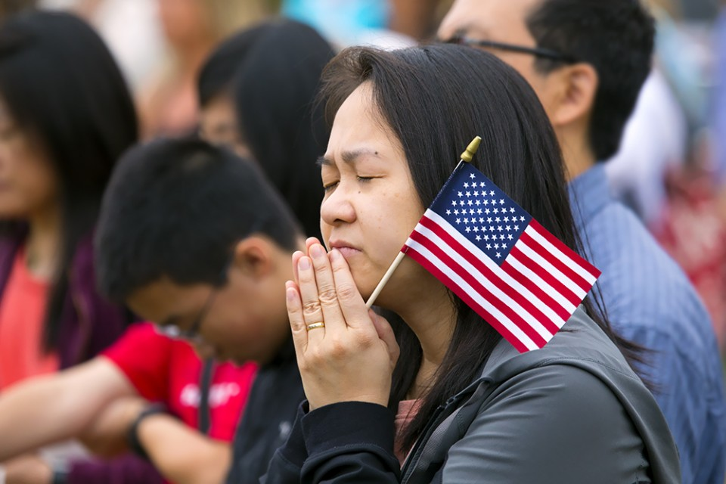
Pray for the precious people of all races in America who call our Savior their Savior! We are a family in Yahuwah and Yahushua! His people need to know the truth so, hard as it is, so that the great deceptions planned by the enemy will not come upon them.

