PROPHECY FROM MESSIAH: THE FIRST FOUR SEALS ARE OPEN AND UNITED
THE COMING FULNESS OF THE FIFTH SEAL IS NEAR

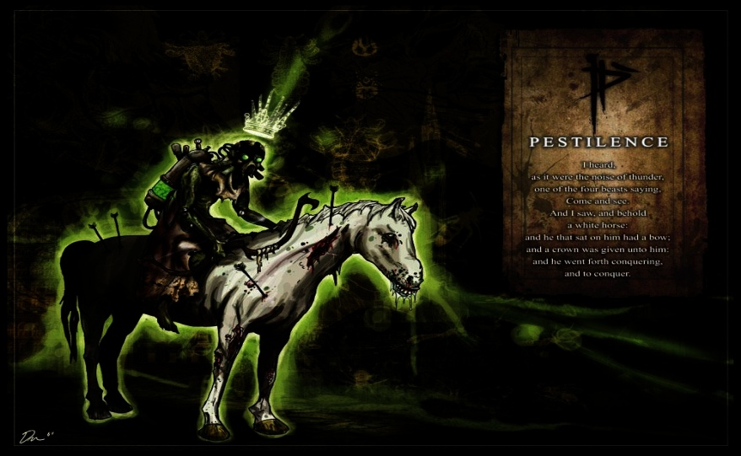

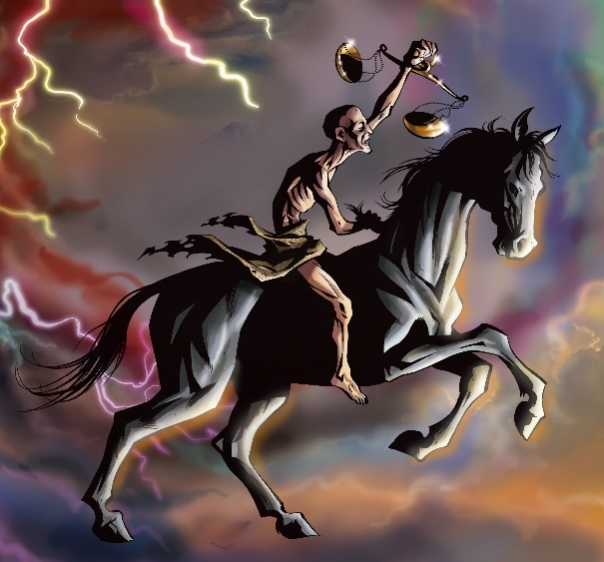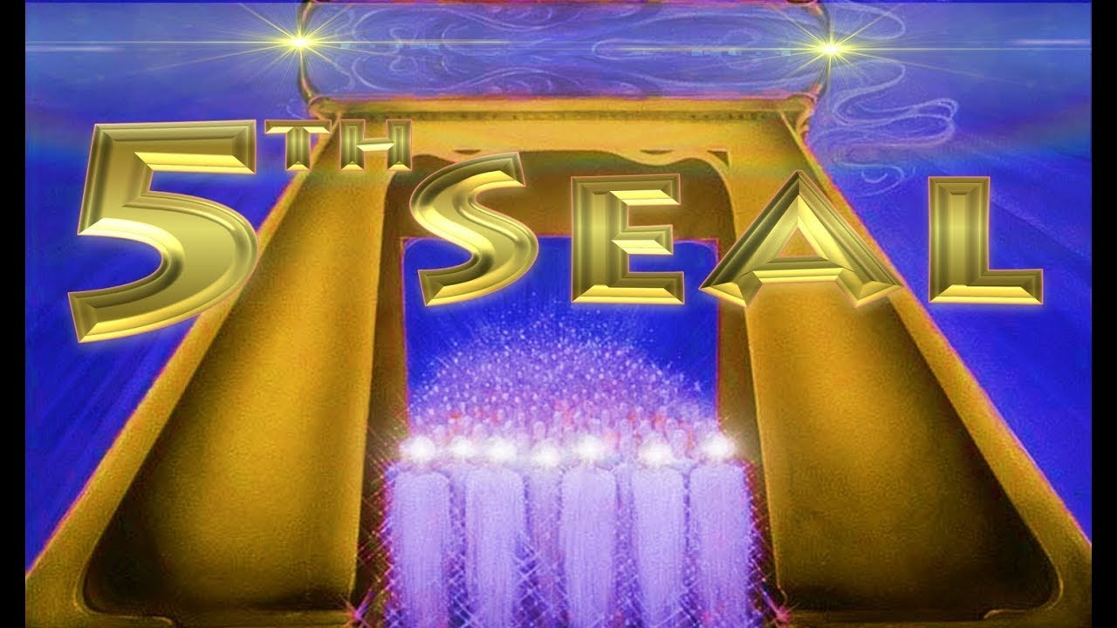
Revelation 6: “And I saw when the Lamb opened one of the seals, and I heard one of the four living creatures saying, like a sound of thunder, `Come and see.’ And I looked and saw a white horse, and he who sat on it holding a bow. And a crown was given to him, and he went out overcoming and to overcome. And when He opened the second seal, I heard the second living creature saying, `Come and see.’ And another horse, fiery red, went out. And it was given to the one who sat on it to take peace from the earth, and that they should slay one another. And a great sword was given to him. And when He opened the third seal, I heard the third living creature say, `Come and see.’ And I looked and saw a black horse, and he who sat on it holding a pair of scales in his hand. And I heard a voice in the midst of the four living creatures saying, `A quart of wheat for a day’s wage, and three quarts of barley for a day’s wage. And do not harm the oil and the wine.’ And when He opened the fourth seal, I heard the voice of the fourth living creature saying, `Come and see.’ And I looked and saw a pale horse. And he who sat on it had the name Death, and the grave followed with him. And authority was given to them over a fourth of the earth, to kill with sword, and with hunger, and with death, and by the beasts of the earth. And when He opened the fifth seal, I saw under the altar the beings of those having been slain for the Word of Elohim and for the witness which they held, and they cried with a loud voice, saying, `How long, O Master, set-apart and true, until You judge and avenge our blood on those who dwell on the earth?’ And there was given to each one a white robe, and they were told that they should rest a little while longer, until both the number of their fellow servants and their brothers, who would be killed as they were, was completed. And I looked when He opened the sixth seal and saw a great earthquake came to be. And the sun became black as sackcloth of hair, and the moon became as blood. And the stars of the heaven fell to the earth, as a fig tree drops its unripe figs, being shaken by a strong wind. And heaven departed like a scroll being rolled up, and every mountain and island was moved out of its place. And the sovereigns of the earth, and the great ones, and the rich ones, and the commanders, and the mighty, and every slave and every free one, hid themselves in the caves and in the rocks of the mountains, and said to the mountains and rocks, `Fall on us and hide us from the face of Him sitting on the throne and from the wrath of the Lamb, because the great day of His wrath has come, and who is able to stand?’ ”

Prophecy given by Messiah to Byron Searle – Messiah speaks
Prophecy of the Seal Judgments Feb 11 2020
“THE SEALS ARE SNAPPED!!!”
Revelation Chapter 6 (The Lord led me to read Chapter 6 several times, with emphasis on verse 8)
8 And I looked, and behold a pale horse: and his name that sat on him was Death, and Hell followed with him. And power was given unto them over the fourth part of the earth, to kill with sword, and with hunger, and with death, and with the beasts of the earth.
Transcript:
“My son, I HAVE NOW OPENED THE FIRST FOUR SEALS, and power has been given to them over one-fourth of the Earth. They will kill with the sword (wars) and with hunger (famine) and death (various causes) and with the beasts of the Earth (i.e., viruses from birds, swine, rats, bats, etc.)” (parenthesis by Byron)
NOTE: (The Lord had given me a vision recently of His hand holding the scroll, and I saw that all the seals were intact. Then He began to break or snap the seals - one after the other, in very quick succession. He was showing me at that time that when the seals were to be broken, that He would do it very quickly, one right after the other.)
“Many will BLAME the Christians for allowing this and bringing the wrath of God down on man. THE FIFTH SEAL WILL OPEN, and many who call themselves Mine will be slain for My Word and their testimony!! Prison camps will be set up, and they will be worse than the extermination camps of Hitler!!
My son, I WILL CALL MY REMNANT HOME” Byron remarks: (He is not speaking of the rapture/gathering - but of the transformation) … TO EMPOWER THEM WITH THE POWER OF ALMIGHTY GOD! NOTHING WILL HARM THEM!!! THEY WILL BE MY SUPER SOLDIERS during the reign of the evil one!! My Remnant will lead those who have refused the mark to safety!”
“WHEN THE SIXTH SEAL IS OPENED, THE WORLD WILL FOREVER CHANGE, AND MY REMNANT WILL BE MIGHTY ON THE EARTH!! THE EVIL ONE WILL TRY TO OVERCOME MY REMNANT, BUT HE CANNOT!!! (Daniel 11:32)
My son, you ask, When? (Byron: I had asked Him, When will these things be, Lord?) I say, OPEN YOUR EYES -- THEY ARE NOW UNFOLDING, AND THE HORSES ARE RUNNING!!! PREPARE!! PREPARE!! PREPARE!! WHILE YOU STILL CAN!!!
IN ONE DAY, IT WILL ALL STOP, AND YOU MUST BE READY!! IF NOT -- YOU WILL PERISH!! DO NOT LOOK FOR A REPRIEVE!! THE HORSES WILL NOT SLOW DOWN -- BUT WILL GO FASTER!!!
My son, MANY who think they are prepared -- ARE NOT!! Many think the Gathering will happen before the seals are opened!! (The gathering after translation is Revelation 14:1-5.)
I ask you, `What is written on the scroll that have the seals attached?’ (Byron: When He asked this, I again thought of the vision where I saw Him snapping the seals, and I thought, I don't know, Lord.)
That is for Me and the Father to know -- but the Gathering could happen any time during this time.” (Byron: I understood this to mean during the time after the seals have been opened.)
“ARE YOU READY??? Is your house in order?? Have you repented and turned from your evil ways to Me?? IF NOT -- WHAT ARE YOU WAITING FOR??? I invite you now to follow Me!!! My son, in the coming days, many things will be revealed and will send this Nation and the world into HYSTERIA AND PANIC!!! Stay in prayer, and I will guide you. Stay in My Word, and I will speak to you.
THUS SAITH THE LORD, I AM COMING SOON FOR THOSE WHO ARE READY, REDEEMED, AND PREPARED!!!
I WILL FILL THOSE SEEKING ME WITH MY SPIRIT, AND GREAT POWER AND FIRE WILL EMIT FROM YOU!!! GREATER WORKS WILL YOU DO THAN THOSE IN THE BEGINNING!! YOU MUST HAVE YOUR HOUSE IN ORDER AND CLEAN!! YOU MUST SEEK ME FIRST AND KEEP ME FIRST IN ALL THINGS!! DO NOT FEAR!! DO NOT DOUBT!! BUT HAVE FAITH -- NO!!! HAVE GREAT FAITH!!! (Emphasized very loudly.) I love you, My Children. Love your brothers and sisters! FORGIVE OFTEN!! Amen.”
This prophecy has really overwhelmed me because for many years, the Spirit of Yahushua has given me the same information, the same timing, right up to His confirmations right now. The Spirit teaches all of His students the same things so that we are in unity. In this prophecy Messiah speaks, as He spoke to Yochanan the Apostle on Patmos. “Messiah is the spirit of prophecy.”
Messiah said in John 16, that the Spirit of Yahuwah would show us things to come. The four horsemen are riding in unison. Great martyrdom has begun. But, the great worldwide martyrdom of the full extent of the 5th seal is soon to come.
REGARDING THE RESULTS OF THE OPENING OF THE FIFTH SEAL: Revelation 7:9-17: “After this I looked and saw a great crowd which no one was able to count, out of all nations and tribes and peoples and tongues, standing before the throne and before the Lamb, dressed in white robes, and palm branches in their hands, and crying out with a loud voice, saying, “Deliverance belongs to our Elohim who sits on the throne, and to the Lamb!” And all the messengers stood around the throne and the elders and the four living creatures, and fell on their faces before the throne and worshipped Elohim, saying, `Amĕn! The blessing, and the esteem, and the wisdom, and the thanksgiving, and the respect, and the power, and the might, to our Elohim forever and ever. Amĕn.’ And one of the elders responded, saying to me, `Who are these dressed in white robes, and where did they come from?’ And I said to him, `Master, you know.’ And he said to me, “These are those coming out of the great distress, having washed their robes and made them white in the blood of the Lamb. Because of this they are before the throne of Elohim, and serve Him day and night in His Dwelling Place. And He who sits on the throne shall spread His Tent over them. They shall hunger no more, neither thirst any more, neither shall the sun strike them, nor any heat, because the Lamb who is in the midst of the throne shall shepherd them and lead them to fountains of waters of life. And Elohim shall wipe away every tear from their eyes.’ ”

Revelation 14:14 “Here is the endurance of the set-apart ones; here are those guarding the commands of Elohim and the belief of יהושע. And I heard a voice out of the heaven saying to me, `Write, Blessed are the dead who die in the Master from now on.’ `Yes,’ says the Spirit, `in order that they rest from their labors, and their works follow with them.’ ”
When He spoke of the conditions being worse than Hitler’s death camps, He was speaking of the F.E.M.A. camps in America, and those like them worldwide. The Christian and Messianic believers will be brought there as “terrorists,” those who have to be exterminated. This is where the guillotines will be used as in the global laws of the Babylonian Talmud. In America there are several hundred million guillotines, mostly on military bases and the F.E.M.A. 851 camps on abandoned military bases. I’ve known about the plans for these “camps” for years. When the 5th seal is broken the other seals and trumpet judgments rapidly take place. Thus, the Revelation 7:1-8 and Revelation 14:1-5 remnant must be transformed so that they cannot die. They have the Daniel 11:32 assignment: “Those that know Their Elohim will be strong and act to do exploits.”
Peace has been taken from the earth. The U.S. has been at the helm since September 11, 2001. “America’s Secret Destiny”/Mivah of Preparation. However, the full extent did not accelerate until January 2011, when President Obama began destabilizing the Middle in preparation for Part III of the Pike/Mazzini Plan of 1871. Please refer to: “The Pike-Mazzini Plan of 1871: The Plan For Global Government – The Perfect Execution of Parts I, II, and Now Part III”/Mikvah of Israel, Our Eternal Inheritance.
I have nothing to say against President Trump. I pray for him. He’s done some good things for America. I don’t like what’s been done to him by his D.C. enemies. But, like all other Presidents, he is under orders from much higher ups, the entities who rule the world under the dark kingdom, and their earthy representatives. Trump has the potential of doing much good, however, nearly everything he tries to do to help us is fought “tooth and nail.” Under orders from others, he has loosed much evil on the earth that has taken peace from the earth.
Now other riders on their white horse of peace join in with Trump – the U.N. and their 1 million Peacekeepers in America, the W.H.O. of the U.N., F.E.M.A. and their “camps” awaiting their victims. The mind programming goes forth, i.e.: If everyone just does as they’re told, we can maintain peace.
Wars have been started all over the earth, bringing economic collapse to nations, famine, and death by many means. False flag have allowed earth’s people to be greatly deceived as to who their real enemies are.
Along with the full force of martyrdom at the 5th seals full impact comes the translation of the Revelation 7:1-8, Revelation 14:1-5 remnant. As the time for great martyrdom comes, also comes the translation of the Daniel 11:32 company who goes forth to pronounce the judgments of Yahuwah upon the nations (Jeremiah 25:15-17, 27-33) and the Good News of salvation.
At this same time comes the opening of the sixth and 7th seals.
Revelation 6:12-17 with 8:1-2, 6-9: “And I looked when He opened the sixth seal and saw a great earthquake came to be. And the sun became black as sackcloth of hair, and the moon became as blood. And the stars of the heaven fell to the earth, as a fig tree drops its unripe figs, being shaken by a strong wind. And heaven departed like a scroll being rolled up, and every mountain and island was moved out of its place. And the sovereigns of the earth, and the great ones, and the rich ones, and the commanders, and the mighty, and every slave and every free one, hid themselves in the caves and in the rocks of the mountains, and said to the mountains and rocks, “Fall on us and hide us from the face of Him sitting on the throne and from the wrath of the Lamb, because the great day of His wrath has come, and who is able to stand?” … “And when He opened the seventh seal, there came to be silence in the heaven for about half an hour. And I saw the seven messengers who stand before Elohim, and to them were given seven trumpets…And the seven messengers who held the seven trumpets prepared themselves to sound. And the first messenger sounded, and there came to be hail and fire mixed with blood, and they were thrown to the earth. And a third of the trees were burned up, and all green grass was burned up. And the second messenger sounded, and what looked like a great mountain burning with fire was thrown into the sea, and a third of the sea became blood, and a third of the living creatures in the sea died, and a third of the ships were destroyed….”
These first two trumpet judgments are the result of asteroids hitting earth some time after the mid-point of the last seven-year cycle. It is at this point that the set-apart remnant must be sealed, and translated into their resurrection bodies, the “first fruits of the resurrection,” Revelation 14:1-5.
China is calling its 27 or so quarantined cities, “interment camps,” as I recently wrote in “Update! Alert America!...” These are the 851 F.E.M.A. camps in the U.S. on once-abandoned military bases, turned into internment camps for such a time as this, as stated above. Thus, the turning point of the massive martyrdom that Messiah mentions in the above prophecy is at the time at or right after the 4th seal. The 5th seal is like a divider between what is, and the final compacting of events before Messiah comes.
The anti-messiah also appears close to the time of the 5th seal’s enactments. The remnant army of Yahuwah will go forth at the time of the Beast/anti-messiah.
We see in Revelation 8, the 3rd trumpet judgment, that a “star” comes, named Wormwood, or “bitterness.” It is very likely that this “star” is an angelic being, who is also mentioned in Revelation 9:1, the “star” that opens the bottomless pit from deep in the Pacific ocean, right where the asteroids hit, to release the locust army and the Beast/anti-messiah of Revelation 9:11. As you see from Revelation 9:4, the sealed ones, the translated remnant of Revelation 7:1-8 and 14:1-5, is not harmed by the demonic locusts. This is also the Joel 2 locust plague – they are demonic entities of the fallen kingdom who accompany the rise of Apollyon/Abaddon – Nimrod/Osiris/Apollo (Daniel 7:23-27, 8:23-27, Revelation 9:11, 11:7, 17:8, and the “apolia,” entity of destruction of II Thessalonians 2:3)
Our Abba Yahuwah is no sadist! His mercy even extends in His judgment! Messiah said in Matthew 24 that the days would be “few” for the sake of the elect, and for the sake of humanity also, because if He does not stop the carnage no flesh would be left alive.

His Judgments come before Messiah returns.
His wrath comes as Messiah descends. (Isaiah 63:1-6; Revelation 19)
If you do not prepare by submitting yourself to the Master Yahushua, aligning to Yahuwah Elyon, allowing Him to transform you into His image, with His nature, ways, and thinking, then because of the shortness of the time, you’ll not be ready to overcome in martyrdom or death of any type. Your intellect will fail, your reasonings, your theories, your opinions, and all the teachings of man will fail and become a curse - Jeremiah 17:5-10.
If you are too busy, or too self-absorbed, to spend time to seek His Presence, to build personal relationship, allowing Him to speak to you so you can obey, your mind will fail in the terrors to come.
It takes time to build trust in Yahuwah’s faithfulness by experience. Our faith is built as we remember what He has done for us! It takes time for Him to be able to trust your obedience. Only those who live by their re-born, Spirit-filled, Spirit-controlled spirit, will have a chance for faith to rise as in Mark 13:9-12. I’ve been teaching on these things for over 50 years. This is the way I live.
It is quite ludicrous to believe in something for oneself that has no anchor within the coming Kingdom other than intellectual belief. The new birth is extra-dimensional. The baptism into the Spirit is extra-dimensional. It taps into the eternal realm of the Kingdom of Yahuwah and Yahushua. Walking with Them in personal relationship is similar to Deuteronomy 15:16-17. Being a loving servant-Friend is the only way to live free. It is a walk in another realm, which manifests its reality on earth through us. If there is no eternal dimension to your beliefs and passion within His throne room, then it is all fake.
What mankind has read about in the Word all these millennium is now taking place. Take that prophecy to Abba in prayer. Let Him teach you the whole of it from the Word. As you sit in His Presence, you will hear Him speak in your spirit. He does not speak to the volatile sin-prone carnal mind, emotions, reasoning, feelings. Neither does He tamper with your will. He wants you to choose to give yourself totally to His control. Otherwise, He cannot help you. He cannot hear you. If He does not know you by personal interaction with you as you yield to His will, then you push Him out of your life. (Matthew 7:21-23; 25:12; Luke 13:22-28)
The fallen ones believe and tremble. They know the Word well. They know the power of Yahuwah and they fear. But they try to distract you by the pleasures of the mind, or by fears, anger, bitterness, depression, etc. – and by these means they seek to control you. The decision is up to you, control by Yahuwah or control by Satan and his forces. I’m sure you’ll make the right choice! I know that many of you have walked with the Master for a long time!
In His love, Yedidah
February 18, 2020

