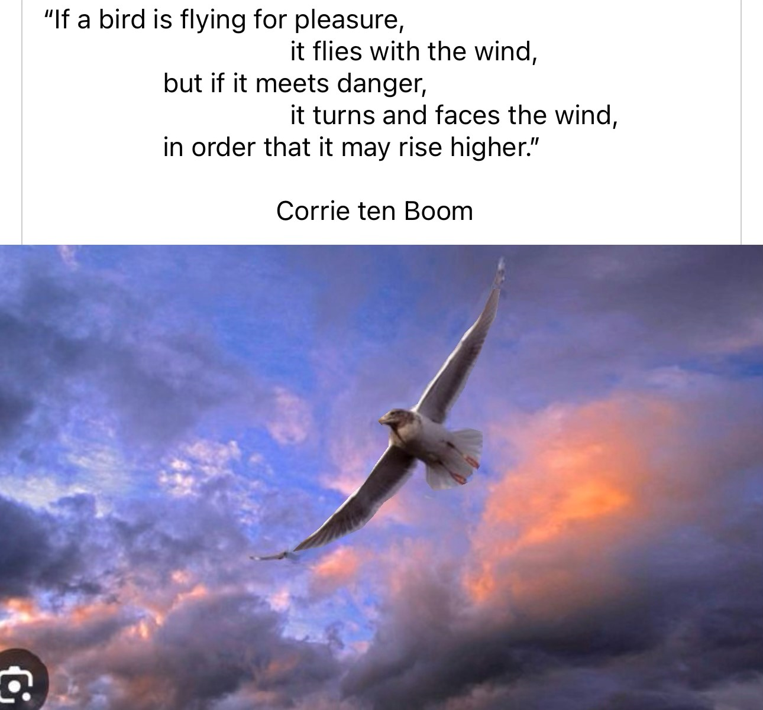
RISING HIGHER INTO THE WIND

Acts 14:19-23: “But Jews came from Antioch and Iconium, and having persuaded the crowds, they stoned Paul and dragged him out of the city, supposing that he was dead. 20But when the disciples gathered about him, he rose up and entered the city, and on the next day he went on with Barnabas to Derbe. 21When they had preached the gospel to that city and had made many disciples, they returned to Lystra and to Iconium and to Antioch, 22strengthening the souls of the disciples, encouraging them to continue in the faith, and saying that through many tribulations we must enter the kingdom of God. 23And when they had appointed elders for them in every church, with prayer and fasting they committed them to the Lord in whom they had believed.”
Isaiah 40:31: “They that wait upon Yahuwah shall renew their strength. They shall mount up with wings as eagles. They shall run and not be weary, and they shall walk and not faint.” (My son just texted this verse to me. He didn’t know I was writing this article, but Yahuwah did! HalleluYah!)
It is our going through the hard times that strengthens us - mentally, emotionally, physically, spiritually. Messiah Yahushua had to go through death in order to be raised from the dead. We must go through whatever we must go through from Him, not the enemy, from HIM – in order to learn from Yahuwah His perfect will for us, and so “set-apart” unto Him.
The secret is to be in the center of Yahuwah’s will, so that even if we “appear dead,” or feel “down,” and “wiped out,” He will raise us up to keep going. I’ve speak from the hard lessons I have learned through my 4 concentrated surgeries.
Our times are very depressing and getting more so as Lucifer and the fallen ones with him are taking over the earth - taking over the minds of the people of the earth very strongly. Without pressing through, without dedicated focus, there is no rising higher. There is only defeat and weakening and falling away.
Shunning the narrow path because it is “hard pressed” (Matthew 7:13-14) is a real dumb thing to do. The broad road ends with a sheer drop off into the lake of fire. People are plunging over it by the tens of thousands daily. The wise rise higher, press in harder to the Word and the Presence of Yahuwah and Yahushua, making stronger and stronger proclamations of praise, worship, faith, Word, and what will be “thus says Yahuwah.” Their obedience is also “yes Sir” all the way.
Daniel 12:1-4: “At that time shall arise Michael, the great prince who has charge of Your people. And there shall be a time of trouble, such as never has been since there was a nation till that time. But at that time your people shall be delivered, everyone whose name shall be found written in the Book. 2And many of those who sleep in the dust of the earth shall awake, some to everlasting life, and some to shame and everlasting contempt. 3And those who are wise shall shine like the brightness of the sky above; those who turn many to righteousness, like the stars forever and ever. 4But you, Daniel, shut up the words and seal the book, until the time of the end. Many shall run to and fro, and knowledge shall increase.”
He speaks of Yahuwah’s people no matter where they are on earth. Oh my brothers and sisters, the great division of the religious game players is nearly over. Those who choose the “broad path” appear to be OK for a while, but they are on the broad path with a world government uniting that is controlled by Lucifer, fallen angels, Nephilim, Rephaim, and all the “down in the pit” residents.
The only final victory will be as we go through the many small trials, and the big ones, and the bigger ones, learning and applying what we’ve learned through it all, which lead us to the eternal victory forever. Through it all also we learn the nature, ways, and thinking of Yahuwah.
Isaiah 55:8-13: For my thoughts are not your thoughts, neither are your ways my ways, declares the LORD. 9For as the heavens are higher than the earth,
so are my ways higher than your ways and my thoughts than your thoughts. 10 For as the rain and the snow come down from heaven and do not return there but water the earth, making it bring forth and sprout, giving seed to the sower and bread to the eater, 11so shall my word be that goes out from my mouth;
it shall not return to me empty, but it shall accomplish that which I purpose,
and shall succeed in the thing for which I sent it. 12 For you shall go out in joy
and be led forth in peace; the mountains and the hills before you shall break forth into singing, and all the trees of the field shall clap their hands. 13Instead of the thorn shall come up the cypress; instead of the brier shall come up the myrtle;
and it shall make a name for the LORD, an everlasting sign that shall not be cut off.”
In this world system, athletes train and train, work hard, very hard, to go to the Olympics. They train for winning in sports in many ways. Professionals get college degrees, Master’s Degrees, PhDs, in order to be successful and win.
In my last article I recommended you watch two movies with messages you must absorb into your spirit: “Secretariat” and “Iron Will.” This is the winning spirit of man. How much more is this spirit to grab hold of you in submission to your Master Yahuwah – Yahushua? The spirit of overcoming. I spent near a lifetime of falling from twisted knees and ankles, getting up, healing, and going on. It has made me tough. It has established a focus, a determination through the years. In those movies you’ll see those two winners didn’t just win, they had to struggle through – horse and human both. You either win, spirit-first, mind, emotions also, then body, then in actuality all the way through. Yahuwah and Yahushua are our TRAINERS, our Teachers … for the victory win at the “END” OF THE RACE.
I wrote before this Halloween about the blood sacrifice required by Lucifer to give him the power he wants to bring forth the world ruler/Beast/anti-messiah to power. Yes, as Abba showed me and I wrote in the article, confirmed later, this last October 31st eve/Halloween was the greatest of all blood sacrifice worldwide, especially in America, of children and babies to Lucifer than ever before – for the time is now and Lucifer realizes that “he has a short time.” If he knows he has a short time, how much time do we have to do Abba’s perfect will?
As you “lock your wings” in place to soar, let the wind – a symbol of the Spirit of Yahuwah - take you higher into His realm so that your peace and joy emanate from your position in the eternal realm.
John 3:8: “8The wind blows where it wishes, and you hear its sound, but you do not know where it comes from or where it goes. So it is with everyone who is born of the Spirit.”
Our Abba is Spirit, the Set-Apart Spirit, the “Ruach ha Kodesh.” He is omnipresent, omniscient, omnipotent. Yet, after a true new birth, we must asked the Master, our Savior, to baptize us into His Spirit so that as in I Kings 8, in the prayer of Solomon in dedication of the Temple. Then Yahuwah, the Spirit, (II Corinthians 3:17-18) came down over the ark that was brought up from the City of David, Zion, and placed in the Most Set-Apart Place of the Temple. When He came, the priests could not stand up for the power of Yahuwah’s Spirit, as He came over the Ark of the Covenant.
Slowly through the years, His people went into deep sin. They were into idolatry, worship of Ba’al, Ishtar, and Moloch. They were sacrificing their children in the fires of Moloch. The people ceased being His children and became servants, “pawns,” usable to the destruction of what Yahuwah wanted to build into beauty. He had to use Nebuchadnezzar to judge them and punish them. Please refer to my podcasting of Jeremiah – especially the chapters on America today Jeremiah 50-51, associated with many other prophetic books and prophecies, as in Isaiah 13 and Revelation 18. America has been taken over by the nations that will destroy it – yet the people go on as if nothing is happening to disturb their future plans.
America is the largest “holding tank” for the House of Israel – the ten northern tribes of Ya’cob/Israel. Next would be England and western Europe. Israelis are upwards in the 90 percentile of being DNA-traced to the Khazarian empire of the 8th century – not Judah. Most of Judah in the nation of “Israel” is in the blood line of those old families of “Palestine,” or old families of Arabs, Kurds too. Lucifer wants all connection to Abraham, Isaac, and Jacob destroyed. He wants all of the creation of Yahuwah and Yahushua destroyed. These are the original set-apart ones to Yahuwah. Through Messiah, all in Yahushua are blood-bought children of Yahuwah and Yahushua, no matter what the biology.
I wrote 22 articles on this very important subject, explaining these things from Ezra 9-10, Jeremiah and just well-known history of the tribes who went into Babylon in 586 BCE. According to the prophet Hosea, the northern tribes would lose their identity, and so they have. Yet, Yahuwah raised up an Orthodox Jew known as Ya’ir Davidy who wrote the classic book The Tribes. Ya’ir and his Messianic helpers, traced the 10 tribes to certain specific areas of western Europe and the U.K. I met all but one of Ya’ir’s Messianic helpers, and also met the one radical Jewish rabbi, Abraham Fels, who also assisted him - what a “divine appointment,” I had with this man who tried to convert me to Judaism. He even introduced me to his mother as he gave his conversion spiel (smile). My replies to him disgusted him (smile).
Then we have the National Underground Railroad Freedom Museum in Cincinnati, Ohio, who knows full well and reports on it how the children of Solomon and Sheba migrated into African tribes. In my 7 years of being in East Africa, I found out that they know that – even those in remote areas on tops of mountains in Kenya and Uganda. I went to minister in one area in a village high up in a mountain from M’bale, Uganda. Upon entry, I saw signs, all in Hebrew. I was told that they got news from Israel via short wave. “Those are our people” they said.
Then I met John, who came down from a very high mountain, bringing former witchdoctors who had been born again, for me to pray for them to receive the baptism into the Spirit. They only had a New Testament in his language. He said that they prayed for “the peace of Jerusalem” every day. I asked him how he knew to do that. He said, it was in their spirit to do that. I got him a complete Bible in his own native/tribal language. My point: As the Word teaches, no one in Messiah is a “gentile.” All truly born again are grafted into the “tree” of Israel and become one of Yahuwah’s children. The Word is emphatic about this, now and in the future.
In America, and the English speaking world in general, the Christians are rejecting the Bible up into the 90 percentile, saying they do not believe it is the Word of God, just moral stories. It is like 722 BCE, when the tribes of the northern kingdom were scattered into Assyria and all over the world for their idolatry, child-sacrifice, and deep sexual sin. The remnant of the last days is small, very small, very few (Matthew 7:13-14).
“The whole world lies in the evil one,” I John 5:19. To align to the world’s way of thinking, acting, reasoning, is to align to the evil one – Lucifer and his fallen angel servants. Ya’cob/James 4:4 is clear. I John 2:15-17 is clear. To love the world is to be anti-Yahuwah, anti-Yahushua/Yeshua/Jesus. It is to be as an adulterer or adulteress.
So, how do we fly higher? The winds of the fallen ones are blowing hard over the earth, preparing the earth’s people for willful submission, mental submission, to the Beast, the “Leviathan,” the world ruler of Revelation 13.
II Thessalonians 2: The Apostle Sha’ul gives a masterful prophetic sermon of right now. It is happening exactly as he wrote. The “great falling away” is happening, and the Beast is here, ready to reign. It’s just a matter of setting up the world’s people to a desperate and frightening condition so that they will bow to whatever they are told to do.
Yahuwah’s people only bow to what He and Yahushua say to do – for they are united “as one” – as husband and wife, two, and “one.” John 17!
So, instead of giving in, accepting abuse, even martyrdom which most will go through who are loyal to Yahuwah, rise higher and higher into His Presence, dwell there, become friends of Yahuwah and Yahushua. Remember, Psalm 91 is for those who live Psalm 91:1, and John 15:7 – who “dwell,” and “abide.”
Prepare in the natural realm. Hear and obey Him daily – not just as you read the Word, though that is of supreme importance to know His will – but as you hear from Him in your spirit – if He dwells over the ark within you … I Corinthians 6:19-20/Acts 2.
Isaiah 43:1-2: Now this is what the LORD says—He who created you, O Jacob, and He who formed you, O Israel: `Do not fear, for I have redeemed you; I have called you by your name; you are Mine! 2When you pass through the waters, I will be with you; and when you go through the rivers, they will not overwhelm you. When you walk through the fire, you will not be scorched; the flames will not set you ablaze…’” Remember Daniel 3!
Our Abba takes us “THROUGH” as we see in the Word, and in the way He deals with His children across-board. He wants us to know Him as He is … not as a “God” who is up there somewhere, but as a “Heavenly Father.” He wants us to sit with Him in heavenly places, to “abide” in Him dwell in His Presence from our re-born spirit, through His Spirit within our “most set-apart place of His temple inside of us.”
It’s called “knowing.” It’s called “relationship.” It is NOT called “religion.” Is your relationship with your dearest friend a religion? Of course not. Neither must our relationship with Elohim (Father and Son) a religion.
He is separating now, those “birds” who decide to give in to what is attacking them and go down, hoping to be free of the attackers. Those who rise higher into the wind – the storms, the turbulence, and learn from Yahuwah and Yahushua how much they can protect, how much they love, how much They are for you and are cheering you on. He has to test us to see if we really are born again, if we really are in His camp, hearing from Him, obeying Him. He has to test.
This has been my learning experience since July 29, 2022 to right now – 4 broken bones, 4 different surgeries, months and months of recovery. He let me know He was “taking notes” and teaching me more how to fight, how to stand, how to rise higher with victory as I learned more of who He is, and how much He loves me.
You’ll never know the extreme of His love for you until you submit to your Teacher and give yourself 100% to learn what He has for you.
You have a position in the Kingdom allotted to you. You are either one of the guests who spends eternity on the new earth, or one of the attendants, aka “kings of the earth,” who are representatives of those on earth into the throne room, or one of the Bridal remnant whose desire is to live only by the side of Yahushua forever and never leave Him. Our eternal position is dependent on our condition of relationship with Yahuwah and Yahushua – and the total submission of our will due to our love relationship with Them – the “knowing.”
It’s all our choice! All of the born again must appear before the judgment seat of Messiah. He wants to be able to say to you the words of Matthew 25: “Well done, good and faithful servant. You have been faithful in little; I will make you faithful in much. Enter into the joy of your Master.”
In the Kingdom reign of Yahushua we have positions, and also in eternity, as we see in Revelation 21-22.
Revelation is the now book. The one who wrote I, II, III John, is the one who saw the Revelation unfold, who spoke with Messiah and learned while on Patmos. He is the one who stood at the foot of the stake/pole/tree by the side of Miriam, mother of Yahushua, and did not leave as He died for us. Messiah looked down and saw the “joy set before Him,” thus He endured the death for us. He would give the Revelation to the Apostle Yochanan, John. He should share His second coming in detail with this one who stood at the foot of the stake as He died for us.
We all have to go to our spiritual Patmos to learn the reality of what Yahuwah and Yahushua want to share with us. That was Yochanan’s/John’s testing place. He came back and wrote I, II, and III John. His main theme: “Little children, love one another.” It’s not an earthly emotional love, but a deep love for what our heavenly Father loves. “Our Father who is in heaven, set-apart is Your Name. Your Kingdom come, your will be done on earth, as it is in heaven.” (Matthew 6:10)
Above all, His will must be done in our earth, our “dirt-body,” our mind, emotions, our will. We must regard Father and Son as Master. “Do you not know that your body is the temple of the set-apart Spirit … You are not your own, you are bought with a price, therefore…” (I Corinthians 6:19-20, 7:23)
The Word is His instructions to us – Genesis to Revelation. The only thing that changed was the end of animal sacrifices and the priesthood that carried them out.
Messiah is our Lamb – the “Lamb of Yahuwah” who was slain for us. We are now “a royal priesthood,” as He wanted in Genesis 19. (I Peter 2:9)
Rise higher!!! We have so little time left, especially those in America, the UK, the NATO nations. Total annihilation – sacrifice of hundreds of millions of people – is the plan for Lucifer to bring the Beast/the 8th Kingdom ruler to power over the earth. His loyal subjects are ruling America now, Israel now, and the world now in general.
Yahuwah spoke to me in a dream years ago: “When the rains of judgment fall, the ark will float.” We are in “the days of Noah.” The rains of His judgment are falling now. Are you building the “ark” that Yahuwah has told you to build? It could be physical, but always eternal. Heshvan 17 was, this year, November 2nd. He was referring to the “days of Noah” which we are right in now.
Rise higher into the wind, as Noah’s ark rose higher on the waters. Rise in the spirit to the realm of eternity, into the Presence of Yahuwah and Yahushua. Then you will have peace, even joy, and know what you are to do, and be empowered to do it.
In His love, Yedidah November 9, 2023

