Recent Prophecy From Messiah Confirms and Strengthens the Words of Yahuwah

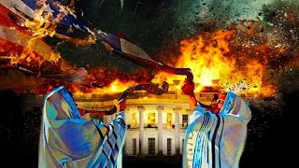

In my article on the September 26, 2020 “Prayer Rally in Washington D.C…,” I said some very strong things. I asked Abba for confirmation, and He gave it - specifically. As new pictures were posted of the march among the Monuments of D.C., one in particular stood out, confirming that Abba’s people - His caring, sincere, born-again people - are being greatly deceived into even participating in the adoration of the ancient Beast system of Baylon (Nimrod) and Egypt (Osiris) - falling into line with his plans.
In that article, I declared what Yahuwah had shown me – that on that day, He was releasing His judgment on the nation of America for our heinous sins against humanity, especially against His people. Thus, the coming Isaiah 10, 13, 47, Jeremiah 50-51 and Revelation 18 judgment is soon-coming to America. Yes, judgment is coming to the world, but you must understand, that America is, and has been, the greatest holding tank of the greatest majority of the whole House of Ya’cob, all the tribes, in the entire world. We have been the leader in the destruction of His people worldwide for at least 73 years. As per Jeremiah, the final “Babylon” of Nimrod’s dream, America, will be utterly destroyed. Jeremiah 50-51 tells how in detail. We even know that from the positioning of the kings of the north right now for attacking America.
I have been a good and patriotic citizen of my country, proud of America. Yet, Abba took me to live overseas for 16 years, and around the world, and He taught me the truth.
On October 5th, Byron Searles posted a prophecy from Messiah confirming what I knew in my spirit regarding the day of “The Return” march. To understand what I say here, you should read that article with Yahuwah’s understanding. No criticism, no judgment, no unloving thoughts, were slipped into that article because, as with Yahuwah and Yahushua, my heart is grieved at the naivety, ignorance, or religious pride and stubborn nature of His people, often so calloused to the slaughtering of other believers right now overseas.
In 2003, while in a prayer meeting in Aqaba, Jordan, I sat with my Bible open. I had just opened it. But, when I looked down, I saw Ezekiel 2 and 3.
As I read the words of Ezekiel 3, the Spirit of Yahuwah spoke to me: “I am sending you to your own people in America.” I was sick inside - OH NO! I wanted to remain overseas. I went on to live in Israel, as much as the government would allow me at each time, then I lived in Panama for 3 years, then in Costa Rica for 1½ years. Yet, each time Abba shut the door and sent me back to America. Ezekiel was in Babylon, but Abba sent him a little north to Parthia, to the House of Israel. He also said OH NO!
From 2006 on, I taught the Jeremiah 50-51, Zechariah 2:6-7, and Revelation 18:4 message of fleeing since I first received it in 1992. While reading Jeremiah 50-51 in 1992, Yahuwah clearly said to me: “This is America.” He took on to other passages and explained them. Then within a few days, He began the confirmation.
Now, it is all coming to pass. These Scripture align: Isaiah 10, 13, 18, 47, Jeremiah 25:8-12, 15-17, 27-33, Jeremiah 50-51, and Revelation 18 speaks of a nation which is the super power of the earth AFTER 1948, in the time of the return of Messiah. The wording is very clear. I’ve studied the prophets of the Tenach since 1962, and they are consistent in their phrases, i.e. “in that day and at that time,” “that day,” “in the latter years,” etc.
In October 5th article, “Is Yahuwah Removing the Wedge From Us?” (Recent Articles), I wrote about watching President Trump closely. Too many things were not right. It was made out that he was very sick with Covid-19 - so sick that they took him away from the White House staff of doctors to Walter Reed Hospital. His doctor said there were “complications,” and he was being “monitored.” In Walter Reed they injected him with experimental drugs, as well as Vitamin D3 and C, but no hydroxychloroquine, which has been known to cure Covid quickly. Then in 3 days they released him. He comes home saying he feels great. Somethin’ ain’t right here folks!
I heard from inside sources that there were plans for 4 assassination attempts and that his security officers took him away to deal with that. OK … But, as I wrote, my concern was what is alarmingly happening with world leaders going into the hospital for Covid, or for some reason, and temporarily disappearing from public sight. Then they re-appear, but observed that they are not themselves. They might even look a little different, and they act really different. Cloned! Nephilim, AI, or ??? inside. They, then, proceed to enforcing rules that are draconian, against the nature of the original person.
So, after being so sick that his own doctors could not care for him, 3 days later he’s the picture of health. Somethin’ ain’t right folks. But I’ll leave it there. You pray, you watch, you discern, you prepare, you act! I am not prophesying regarding Trump’s adventure at Walter Reed! I was just sharing my concern for the real President Trump.
As words from Messiah to Byron Seales and others have said, Trump was put into office because of the pleading of His people for him to be President. Yahuwah allowed him to be a wedge, to hold off judgment until it could not be held off anymore.
Below are two pictures of Yahuwah’s people, born-again, caring people, laying their hands on the symbolic phallus of Osiris and praying blessings over the nation. They are standing between the ancient myth of Osiris aka Nimrod/Apollo/Apollyon, and the pregnant belly of Isis (Capital dome of the Senate/Congress).
Perhaps I should give you a quick rundown of the story, because the world is fast returning to pre-Flood times, i.e. “in the days of Noah,” and this “myth” applies also to Nimrod, Semaramis, and Tammuz after the Flood. The birth of the child of Osiris and Isis will be the antichrist – the ultimate “son of perdition.”
This symbolic “myth” is at the basis of world government - the driving force at its base for all those working for Satan. I highly suggest the video “Belly of the Beast” which can be purchased at SkywatchTV store. (skywatchtv.com) It may be available via Amazon (?) From the tip of the “phallus” to the hexed Bible in its depths in 666 feet.
This is the Egyptian story of Nimrod, Semaramis, and Tammuz
Quick story: Osiris is killed by his brother Seth. Seth cuts him up into 13 pieces. Isis collects 12 pieces but could not find his phallus, for it was thrown into the Nile river and eaten by a fish. So, Isis made an obelisk, and impregnated herself with it. And out came Horus, son of Osiris. Really goofy huh, but it is at the core of all of Satan’s plans from Nimrod to 2020 CE. The Washington Monument is symbolic of the phallus of Osiris. The 13 colonies were not numbered for the 13 tribes of Israel, nor are all those 13s on the back of the dollar bill – but for the 13 pieces of Osiris.
A subscriber who lived in D.C., wrote me that the area between the Washington Monument and the Capital building dome (the pregnant belly of Isis) is called “the area between Egypt and Babylon,” or the area between Nimrod and Osiris and Horus.
Have you noted, even in some U.S. shopping centers and church toppings, you see phallic symbols – obelisks, spires, and round domed roofs?
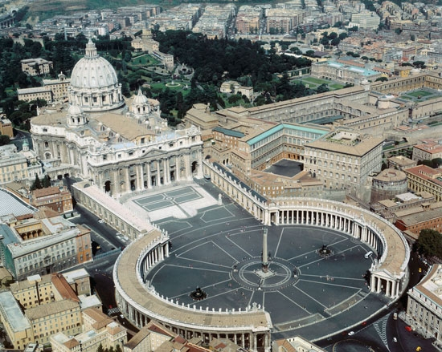
Left: Washington National Mall Right: The Vatican and St. Peter’s Square
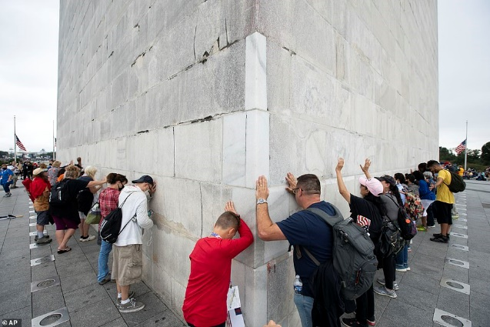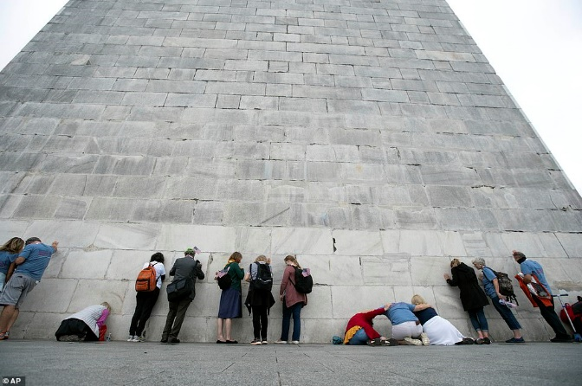
From Daily Mail news: “Followers of Franklin Graham pray at the base of the Washington Monument as they march from the Lincoln Memorial to Capitol Hill, during the Prayer March at the National Mall” “Christians join in prayer the base of the Washington Monument as they march from the Lincoln Memorial to Capitol Hill”
What was the main theme that the attendees were praying for? - To “heal America,” and make it great again. The main theme was not repentance, but a plea to God to hold off any judgment He might have for America, and give us more time. The plea was also for the re-election of Donald Trump as President.
I have no doubt but that there were many sincere and pure-of-heart people there. But, to see them going from monument to monument, i.e. the Lincoln memorial, a statue to pray over, well folks – that is touching base with idolatry!
In this prophecy from Messiah via brother Byron Searles, we see more confirmation of how Yahuwah, Elohim of Israel, and the incarnate Word of Yahuwah, Yahushua, feel about this display of national “return.”
Read II Chronicles 7 and ask Abba if that one verse was supposed to inspire thousands of Americans to gather in the area “between Egypt and Babylon,” to lay hands on the symbolic phallus of Osiris, and pray for an apostate nation to become great in the eyes of an all-Kodesh (holy) Yahuwah?
The manipulation of Scripture to make it say what a person, or group, denomination, or nation, wants it to say, is utter blasphemy against the whole of the Word – yet it is extremely “normal” to Christians, and Messianics. In Christendom, doctrines are created this way that offer people a joyride to the Kingdom, yet setting them up actually to hear Messiah say to them “Truly I say to you, `I do not know you.” (Matthew 7:21-23, 25:12, Luke 13:24-28)

Here is Byron Searle’s recent prophetic word from Yahushua. I have, so far, shared with you seven or eight of his prophecies from Messiah. They align to what He is saying!!! They are to be taken seriously. In this one, he also personally shares his heart.
Prophecy From Messiah I AM COMING!!! – Byron Searle
Posted by 444 Prophecy News on 2020/10/05
OCTOBER 5, 2020 BYRONSEARLE.BLOGSPOT.COM Given 10/04/2020
Revelation 3:5-6
5 He that overcometh, the same shall be clothed in white raiment; and I will not blot out his name out of the book of life, but I will confess his name before my Father, and before his angels. 6 He that hath an ear, let him hear what the Spirit saith unto the churches.” (Letter to the assembly of Sardis)
For the last few days during my times of prayer and also throughout the days, I have heard the Lord speak these words to me over and over, “IT IS COMING” and “IT’S COMING SOON.” As I continued to pray and seek the Lord and ask what this is referring to, and He gave me the message that follows my comments below.
Over the several months, the Lord has revealed to me an issue that grieves Him and weighs heavily on His heart. He has shown me that too many in His Body are prideful and believe it is their job or duty to call out their brothers and sisters in the Lord and to mock and belittle His watchmen and prophets as false, wrongly thinking that they are doing Him a service. Out of their pride, they foolishly try to prove that they are right and another is wrong, that they are speaking truth and another is speaking falsely. The Lord has said that those who are involved in these activities are the `Pharisees’ of the day, that they are murderers, murdering their brothers and sisters with their words, just as the Pharisees tried to murder Jesus in his day with their words. (See the recent word about this from 09/27/2020, “The Wedding is Ready — Are You???” https://byronsearle.blogspot.com/2020/09/the-wedding-is-ready-are-you.html )
This is a stern warning from the Lord to His Body. He desires that ALL in His Body show love and to pray for one another, not murder each other with their words. We are in the world, but not of the world, and need to stop acting like the world, tearing up, ripping to shreds, devouring and murdering our own! If we disagree with or believe others are wrong, then we need to love them and pray for them. He has told me many times that MOST in His Body are like doubting Thomas’ who MUST SEE IT TO BELIEVE IT. He said that He will allow His Body to go through the FIRES OF TESTING, like the three Hebrew children in the FIERY FURNACE, and is allowing these testings to come upon His Body through His Judgments so His Body will WAKE UP AND LEARN TO WALK IN GREAT FAITH, and no longer be doubting Thomas’. ALL in His Body MUST LEARN TO TRUST HIM COMPLETELY and WALK IN GREAT FAITH in the days to come, or they will not be able to stand, but will fall and perish in the days ahead. How many in the Body of Christ can honestly say before the Lord that they are right now WALKING IN GREAT FAITH as those in the days of His Early Church?? One cannot walk in Great Faith and murder his brother.
The Lord has shown me IT IS COMING very soon. Every vision, dream and word that He has given to me over these last four years have been speaking of future events that He has shown me WILL COME TO PASS in the days ahead. Some have tried to claim that the words are false since they have not come to pass yet. Many have no understanding that these words all speak of future times for the days ahead. Some have misread the words and made incorrect assumptions of dates when none were given. A month or a season may have been spoken of or referred to, but no date or year was given, as they all speak to future days.
The Lord told me that just as his servant Jeremiah had warned and warned His people for many, many years and the people did not believe him, but mocked, scoffed, and nearly killed him, that this is how His Body is today. Most are like the Hananiah’s of Jeremiah’s day, mocking, scoffing, murdering with their words, and not believing that the warnings will come to pass, but they will, just as they did in Jeremiah’s day. The Lord gave me the word “BRACE FOR IMPACT!!!” on 5/29/20, and a vision and word “TURBULENCE!!!” on 3/20/20 which also said to Brace for Impact. He has shown me visions and dreams of horrific scenes and events that are coming upon America and the world that are far beyond what most can imagine or could bear to see. He has been warning and pleading with His Body to repent, prepare, and get ready, for the things that are coming will shock and terrify most in His Body as they have not listened and are not ready. Most did not understand that the 7 Weeks Warning was a call for His Body to prepare, to get their houses in order, and to pray and fast for the whole month of September (not just one day) as He said a time of testing for His Body would be at the end of the 7 weeks. Most of His people did not listen, they missed it completely and failed the test. They cannot hear the Lord speak to them as they are too busy mocking, scoffing, and murdering their brethren.
The Children of Israel wandered in the desert for 40 years, complaining and rebelling, and they failed the tests and were forced to go around the mountain again and again. In the same way, those in the Body of Christ who continue mocking and murdering their brethren, will continue to fail the tests and be made to go around the mountain again and again, but one day soon it will be too late. No one will ever want to hear our Lord say to them on that day when they see Him face to face that they are a murderer the brethren. We do not know another person’s heart, only the Lord does. So please think long and hard about that face-to-face appointment all will have one day soon the next time you get ready to use your tongue to speak forth stabbing words in your video or use your keyboard to type online to cut your brother or sister to pieces. Since His Children are His Body, when you murder one of them, you do the same to Him.
This is the word the Lord spoke to me:
My son, WRITE UNTO MY BODY WHO BLINDLY AND SELFISHLY AWAIT DESTRUCTION — JUST TO SATISFY THEIR LUSTS.
They are QUICK TO ACCUSE AND BERATE My Chosen Watchmen because they are TOO LAZY to ask for themselves. My desire is that ALL WHO EARNESTLY SEEK ME WILL FIND ME, but alas, many ONLY seek Me to make a gain for themselves (asking for God to bless them). My True Remnant seek Me out of their hearts, and I inhabit their prayers.
My son, I speak tonight, NOT to give warning, for the HEARTS of the people have grown COLD and HARD. They DO NOT PREPARE nor do they believe I speak to My servants.
Tell them I WILL COME QUICKLY UPON THEM AND REMOVE THE LIGHT FROM THEM.
THEY ONLY ENJOY MOCKING AND SCOFFING MY WORDS. I HAVE HEARD THEM ALL, THE JUDGING AND LAUGHING AT MY CHOSEN. I HEAR THEIR HEARTS, AND BLACKNESS FILLS THEM.
My son, many attended a “GATHERING” — thinking they were repenting.
I DID NOT HEAR THEM. THIS NATION HAS NOT REPENTED.
THE KING HAS MADE NO DECLARATION OF REPENTANCE.
THE PEOPLE OF THIS NATION HAVE NOT REPENTED — THEY ARE IN REBELLION.
TO THESE BLIND, DUMB SHEEP BEING LED ABOUT BY BLIND, DUMB, MEN PRETENDING TO BE SHEPHERDS WHO ARE NOTHING MORE THAN LIARS — I SAY — RETURN TO ME IN HOLINESS AND HUMILITY — NOT FOR A SHOW — BUT IN SOLITUDE.
My son, I AM ABOUT TO RELEASE UPON THIS NATION A TURNING STONE — WITH IT WILL COME CALAMITY AND DESPAIR. DID I NOT SAY TO PREPARE?
DID I NOT SAY SEPTEMBER WAS A TEST??? THUS SAITH THE LORD — YOU FAILED AND NOW JUDGMENT COMES. I SAY UNTO YOU — ARE YOU READY???
I AM COMING AND BRINGING JUDGMENT IN MY HANDS.
YOU SAY, “MY LORD IS NOT JUDGMENT!! HE IS LOVING AND WOULD NEVER SAY THAT!!” THUS SAITH THE LORD — READ MY WORD!! LEARN OF ME, NOT WHAT MAN SAYS I AM!! I AM THE ALPHA AND OMEGA — THE FIRST AND THE LAST — THE BEGINNING AND THE END. I HOLD ALL THINGS IN MY HANDS, AND THE BOOK WILL BE FULFILLED. TIME IS UP AND NOW THE END IS AT HAND.
REPENT NOW AND TURN FROM YOUR EVIL WAYS. REPENT NOW AND SEEK ME WITH ALL YOUR HEART. REPENT NOW AND BE SAVED FROM THE HOUR OF TESTING.
FOLLOW NOT MAN — FOLLOW ME, SAYS THE LORD.
THE GREAT DECEPTION IS UNDERWAY, AND MANY HAVE FALLEN FOR IT. REPENT NOW. Amen. Given by the Lord and Savior Jesus Christ”

As I was closing this article for posting, I received an alert from one of Steve Quayle’s contacts. CONFIRMATION AGAIN…
“HELLO STEVE-10/6/2020: IT IS RAPIDLY BECOMING CLEAR THAT THE JUDGEMENT OF GOD IS LANDING ON THE NATION. THE SPLITTING OF THE CONTINENTAL PLATE IS BEYOND THE ABILITY OF MAN TO ACCOMPLISH IN THE HUMAN REALM. THERE IS SUBDUCTION ZONE HEAVY ACTION ON BOTH THE EAST COAST AND WEST COAST NOW.
IT IS JUST LIKE EVERYONE HAS SAID IN VISIONS IT IS HAPPENING NOW BEFORE OUR EYES!!! BRACE FOR THE GRAVEYARD HEAVY IMPACT!!! HOW MUCH MORE CLEAR AND BLUNT, DIRECT AND SIMPLE, CAN THE MESSAGE BE!!! IF YOU DO NOT BELIEVE, NO PROBLEM - JUST WALK OR DRIVE THE NEW MADRID FAULT LINE AND WATCH THE MELTING GROUND!!! IF YOU DO NOT BELIEVE GO TO CALIFORNIA AND WATCH A FIRE TORNADO SUCK AWAY A WHOLE TOWN AND FOREST ON THE WAY BY LEAVING NOTHING BUT ASHES ON THE GROUND!!! DON'T BELIEVE IT? GO TO THE MIDWEST IN THE CORN AND WHEAT FIELDS AND GET HIT WITH 10+ POUND HAIL STONES!!! IF THE THINGS ABOVE DO NOT GET THE ATTENTION OF A PERSON THEN THEY ARE SO DEAD ALREADY THAT THERE IS NO HOPE FOR THEIR BODY OR SOU. I HOPE THIS WARNING GOES FAR AND WIDE BECAUSE THIS NOT FUTURE EVENTS THESE THINGS ARE HAPPENING WHILE YOU SLEEP!!! ONE DAY YOU MAY WAKE UP TO SEE ASH OR FIRE BALLS LANDING ALL AROUND YOU. SCIENCE GUY … Oct 6, 2020”

As on wrote on September 26th, Yahuwah spoke to me: “My judgment on the nation has begun.” His people were committing abomination in following man to lay hands on pagan altars to ask for Him to heal their land. Dear ones: WATCH AND PRAY! STUDY THE WORD UNDER THE TUTELEGE OF YAHUWAH’S SPIRIT! PREPARE IN ALL WAYS! LET HIS SPIRIT RULE YOUR LIFE, YOUR THOUGHTS, YOUR EMOTIONS, YOUR ACTIONS!
Shalom! Chag Sameach! Yedidah
October 6, 2020

