RUN THAT YOU May WIN!
Today’s Historic Marathon Victory

I Corinthians 9:24-10:5, 11-12: “Do you not know that those who run in a race indeed all run, but one receives the prize? Run in such a way as to obtain it. And everyone who competes controls himself in every way. They do it to receive a corruptible crown, but we for an incorruptible crown. Therefore I run accordingly, not with uncertainty. Thus I fight, not a one who beats the air, but I treat my body severely and make it my slave, so that after having proclaimed to others, I myself should be a castaway…For I do not wish you to be ignorant, brothers, that all our fathers were under the cloud, and all passed through the sea, and all were immersed into Moshe in the cloud and the sea, and all ate the same spiritual food, and a drank the same spiritual drink, for they drank of that spiritual Rock that followed them, and the Rock was Messiah. However, with most of them Elohim was not well pleased, for they were laid low in the wilderness…And all these came on them as examples, and they were written as a warning to us on whom the end of the ages have come, so that he who thinks he stands, let him take heed lest he fall” 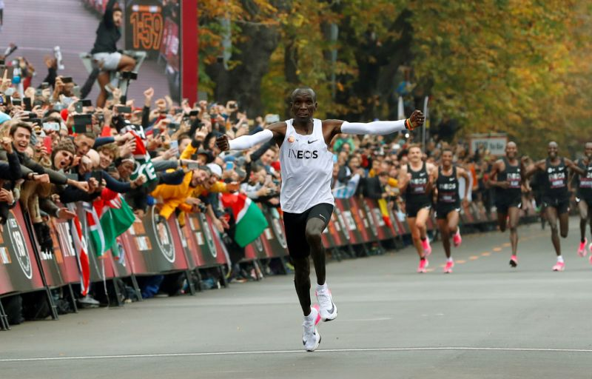 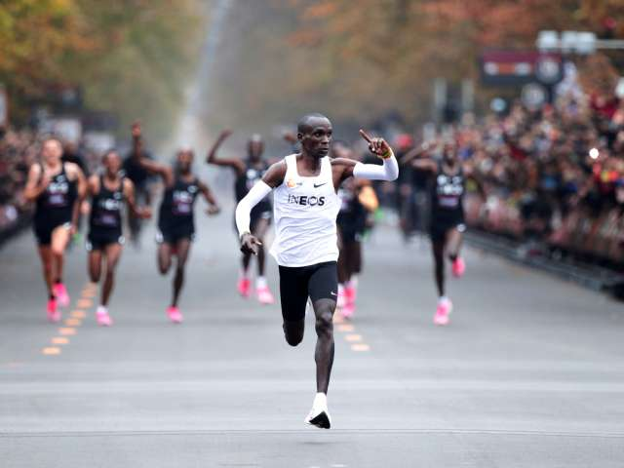
Kenya's Eliud Kipchoge, the marathon world-record holder, crosses the finish line during his attempt to run a marathon in under two hours in Vienna, Austria, October 12, 2019. (REUTERS)
Note the “pacers” in black running behind him to keep him moving forward at a certain pace. They’re not part of official marathon runners, but helpers.

Headlines read: “People gathered in Kipchoge’s hometown of Eldoret, Kenya to watch him break the record, and they went crazy in the streets. Kenya celebrates!”
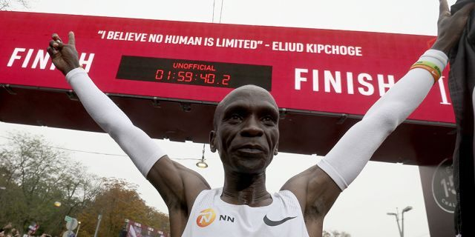
Eliud is 34 years old. He ran the 26.2 mile race in 1 hour 59 minutes 40.2 seconds – Vienna, Austria – October 12, 2019

Read II Samuel 15-19. Ahima’ats, son of the High Priest, Zadok, longed to run to King David who had fled for his life over the top of the Mount of Olives. He longed to bring the news of victory to the King. When David’s son Absalom was killed, and the rebellion against David over with, Joab planned to send an Ethiopian runner to David to tell him he could come back to Jerusalem. In II Samuel 18:19-23, Ahima’ats pleaded with Joab: “let me run.” Finally, Joab, captain of David’s military, said “yes.” Appointed runner, a “Kushite”/Ethiopian, also ran, but Ahima’ats outran him.
Abba’s questions to you are: How fast are you willing to run to take the news of salvation to the nations? How fast are you willing to run with the Good News that the Savior is returning? Are you running to win towards the finish line?
Our King has triumphed over all of our enemies. Now He must return to save us from the plans of the defeated ones who still struggle to take us down.
Look at I Kings 18:41-46. Read about the supernatural strength in Elijah’s run from the base of Mount Carmel in today’s Haifa, Israel, down the Jezre’el Valley all the way past Megiddo to the town of Jezre’el, capital of the northern kingdom of Israel/Ephraim—to the palace of King Ahab and Queen Jezebel. He outran Ahab’s horse driven chariot! Supernatural strength! In these last days, we need it!

Washington Post, October 12, 2019 from Vienna, Austria: “Kenyan long-distance runner Eliud Kipchoge on Saturday became the first person to run a marathon in less than two hours, blowing through the barrier by nearly 20 seconds in a special event in Vienna. With thousands cheering him on, Kipchoge completed the 26.2-mile challenge in 1 hour, 59 minutes and 40 seconds.
As he crossed the finish line, the 34-year-old pounded his palms on his chest and smiled brightly. He threw his arms around his wife, who was waiting for him at the end, then let a throng of supporters hoist him into the air. `I’m the happiest man,’ said Kipchoge, a Kenyan flag draped over his shoulders. `No human is limited. You can do it.’

Fox News Headline: “Kenya's Eliud Kipchoge becomes first person to shatter 2-hour marathon barrier”
“Superstar runner Eliud Kipchoge broke the elusive 2-hour marathon barrier Saturday—an achievement once considered beyond a human’s reach. The Olympic champion and world record holder from Kenya clocked 1 hour, 59 minutes and 40.2 seconds at the INEOS 1:59 Challenge in Vienna”
`Today we went to the Moon and came back to earth!’ Kipchoge said on Twitter. `I am at a loss for words for all the support I have received from all over the world.’ He pounded his chest in triumph at the end of the race set up for the attempt.
SUPERSTAR MARATHONER SECONDS FROM 2-HOUR RECORD TO TRY AGAIN: `That was the best moment of my life," he told reporters before adding that he trained four-and-a-half months for his extraordinary race against the clock. The pressure was very big on my shoulders. I got a phone call from the President of Kenya. I am the happiest man today.’ ” This is being called “a historic run.”
Today we see end coming into sight. We’re in a historic race to win!
My youngest daughter, Darlena, called me this morning with this exciting news. I sure needed to hear it! It encouraged me so much! She works in the medical field, but also is a body-building coach and nutritionist. She will be running another marathon in March 2020 in Atlanta. She has begun to prepare. I order to “run that you might win” you must prepare, train - discipline yourself to bring your body into subjection. This is a physical principle and a spiritual principle. Lazy, apathetic, comfort-loving weaklings, win no prizes.
I was the badminton champion of my high school. I loved sports. I loved the challenges to win. My ½-Cherokee dad was the swimming and tennis champion of his college in Oklahoma. Young people today must be challenged for winning in the right games of life; all of humanity must be challenged to win in this end-game race to heaven, or to hell. In Kenya, Uganda, Mexico, on the Navajo Reservation in New Mexico, and in other countries, I have challenged young people to rise up and become true disciples of the Master Yahushua/Jesus, to be filled with the power of the Spirit. I find that they rise to the challenge. There is no greater challenge now than to prepare for the coming of the King of Kings and Master of Masters!
I love watching the Kentucky Derby, the Preakness, the Belmont Stakes – I love to see beautiful horses run. I feel their spirit as their main flies in the wind. I love John 3:7-8! “Do not marvel that I said to you `you must be born from above.’ The wind blows where it wills, and you hear the sound of it, but do not know where it comes from or where it goes. So is everyone who is born of the Spirit.” Yet, even the wind has paths that it takes, and is guided by the Spirit of Yahuwah.
When my third child, second daughter, Debbie, was in elementary school, she ran in the Fort Worth 10K run (6 miles) marathon each February. I stood on the sidelines cheering for her every year with great excitement and enthusiasm. Even after marriage, she ran in 10K races and in two ½-marathons, 13 miles, and broke her records each time. Darlena, started at an early age to run in the Fort Worth 10K run each February.
I loved watching the race, cheering. I watched those from old age to elementary school age cross the finish line. One year, I was right at the finish line. Over the loud speaker came Congratulations to a muscular lady in her mid-80s who had run the whole 26-mile marathon with a broken arm. Her arm was in a cast. As she crossed the finish line victorious, the crowds cheered.
I cry now thinking of it - the anointing rising in my spirit. Yahuwah cheers on winners in the race of life who stand strong and bold as warriors representing Him, representing His Son. Only those who run in the race and who cross the finish line are rewarded. So today, I am proud of this Kenyan.
I love to see individuals in the Olympics winning their gold, silver, or bronze metals. Abba’s children will receive rewards for 30, 60, or 100-fold fruit-bearing as they run their race to the Kingdom of Elohim. Winners in this race of overcoming and enduring to the end will be 1) positioned on a new earth to dwell, 2) to rule as a king over the earth, 3) or to live in the throne room before the throne of Messiah.
As in the Olympic Games with prizes of gold, silver, or bronze metals, so there are three prizes for Yahuwah’s winners as shown clearly in the Bible. At the true new birth we enter the race. We enter His military and become a warrior-soldier of the Captain of the Hosts of heaven.
To fail in this race by looking to the side, looking around, looking back, slowing down, or dropping out, there will be no crossing of the finish line. To not run the race, a person is a “drop out” from the start. Only those that focus eyes ahead will ever stay on course to cross the line and receive the prize.
All over the world, many are reporting on this historic race today – the victory of this lone man from Kenya today (October 12, ’19). We run to obtain an eternal crown of life. Where are you in this race? Do you see the finish line? I do.
As we see the finish line, we enter “sprinting season.” We let go of all that would hold us back. We turn up our speed. We keep our eyes focused on the line.
If you’ve never watched the movie “Iron Will” I recommend it, especially for the young, or young of heart. It is the story of a novice at sled-racing in snow and ice. He has to win to get the cash prize to save his mother’s home. How he defeats hardened racers who cheat to try to stop him, is incredible. When he crosses the finish line barely, everyone cheers, including those who watch the movie. It is a lesson in winning. I love to be challenged by others who are winners!
It is now that the true remnant rises. Daniel 11:32: “They that know their Elohim will be strong and will act/do exploits.”
While living in Jordan, while looking out my kitchen window at the Red Sea, I had a profound vision: I was riding a horse at gallop speed. I realized I was out there on the trail all alone. I got to thinking: Where were my friends? Where were those that I left at the starting gate; they were nowhere to be seen. I saw in my mind that some had not even mounted their horses, but stood around chitchatting with each other. Some were trotting. A few were riding faster. I thought about stopping to wait on them, to make sure that they caught up with me. I was feeling very alone. Just at that moment, I looked to my right and saw an old wood-burning train. The engineer waved at me with a big smile. It was Yahushua. He was keeping pace with me. As He sped up, so did I. Just then, I saw ahead of me an old western style town, like something out of the 1800s in America. Lining the streets were opaque figures of men, women, and children, dressed in the clothing of 1800 western culture. They were cheering and clapping, very excited – beckoning me to come on. I rode into their midst. This was the third time I had seen “the cloud of witnesses.”
Speaking of those who went before us in faith before Messiah’s death and resurrection, from Hebrews 11:40-12:2: “Elohim has provided a better way for us, that they should not be perfected (completed) apart from us. We, too, then, having so great a cloud of witnesses all around us, let us lay aside every weight and the sin which so easily entangles us and let us run with endurance the race set before us, looking to the Author and Perfector of our faith, Yahushua, who for the joy that was set before Him endured the stake…”
Religions of man pave the way to eternal death; religion’s paths are the sure way of the broad road that leads over the cliff of destruction. Most all of humanity is on this broad road to eternal damnation. But, the “few” enter the race and run on the narrow path that leads to life. It is a path that is “hard pressed,” fraught with pain, suffering, persecution, mental anguish, plagued with doubts and fears, and with many enemies to fight with our spiritual weapons. It is a road that presses us to go forward as we keep the finish line in sight. As it says in Matthew 7:13-14: “Few there be that find it.”
Be encouraged! Watch the videos of this history-making run. Let this Kenyan be an example to you of what it means to run to win.
I congratulate this amazing man from Kenya. I remember my 7 trips to Kenya in 6 years (1997-2002). I remember staying in their mud houses out in primitive areas – going from village to village preaching the Good News, teaching on the baptism in the Spirit, leading them to be baptized in the Spirit, delivering people from demons, and building their faith. I traveled with my Kenyan Director, Vincent Wanyonyi Wabuke, part of my ministry corporation based in Texas. Later I traveled with my Ugandan Director from Kampala, all over Uganda to the Rwanda border.
These are a strong people in faith, strong willed to follow the Master. I challenged young people in Uganda, near Rwanda, to follow the Master. The schools opened up to me in Kenya, too. In 1998, my daughter Darlena, went with me, age 17. She also spoke to the youth. We ministered together in many ways. Many of the “youth” in Uganda had never heard of a computer, or of any modern technology. Darlena, blond and blue-eyed, and I, ministered with other local believers and pastors in the “bush” areas of Kenya and Uganda where some had never seen a white person before.
We must be disciplined in body and soul (mind, emotions will, desires)--aligned to obedience and submission to the Master Yahushua if we are going to win! The Spirit of Yahuwah within us will aid us in discipline if we let Him. (Hebrews 12)
Get alone with Abba. Open up your heart to Him. Let Him show you where you are on the race to eternal life. Keep focused on the finish line. The cloud of witnesses is getting closer to us. Yahushua waits to gather us at the finish line! He waits with His rewards to give to everyone who has overcome and “endured to the end.” (Matthew 10)
This will be podcasted tomorrow, October 13th – as Podcast CXXXXI under “Audio Messages” - comeenterthemikvah.com.
Shabbat Shalom, love, Yedidah
October 12, 2019

