Snowstorms in the Northeast - Wildfires in California
Prophecy Given to Steve Quayle in 1994
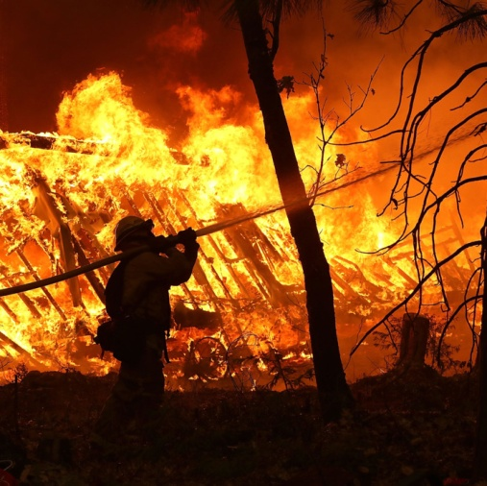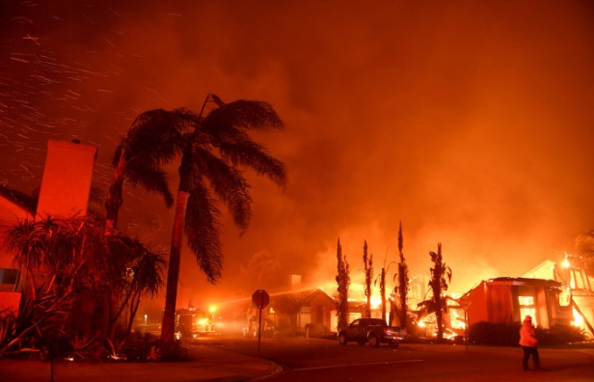
As of November 16th AM, 8 are dead; there have been 500 car and bus crashes in one state, 400 in another, 300,000 without power. The tragic statistics are mounting up. What has Yahuwah been saying for a long time through His watchmen regarding America? What is He saying now?
I had a dream around 2013 when I was living in Florida. In the dream, a man’s voice said to me over and over: “the Northeast Region.” I woke up with the words still ringing in my mind. I got out my new National Geographic Atlas to look up that area. I did not know that the Atlas had grouped the states of the United States into regions. I saw at the top of a page: “Northeast Region.” I lightly put the fingers of my right hand over the map to pray and hear what Abba wanted to tell me. When I did, I felt incredible evil coming up off the map into my hand. I felt it! I could see darkness over the region in the spirit. It was so tangible that I didn’t leave my fingers over it very long. It felt like a gathering of spirits was gathering there. I knew that principalities and powers of the air were amassing over that region. I’ve often pondered that dream and that experience.
Below are three screen shots taken from an All News Pipeline article of November 15th, of three segments of prophecies given to Steve Quayle in 1994 that tell how about a time when it would be freezing in the Northeast, and fires burning in California, and why. I also encourage you to listen to the interview in which Steve tells about it, along with his anointed prayers.
In the well-documented book Eye to Eye by Bill Koenig, we see how Yahuwah’s judgments have befallen America systematically in relation to how we have treated the nation of Israel and His born again children worldwide. Refer to As America Has Done to Israel (John McTerrnan) and The Omen Parts I and II by John Brennan.
The eye of Yahuwah has been over America from the early 1900s, when the evil elements of the nation began to take control via the military, the government, the Eugenics program, and abortion, when the nation began siding with, and later became the promoter of, the greatest evils on earth.
A heavy oppression has hovered over Americans for a long time – the kind you can feel – the kind “you can cut with a knife.” That feeling is increasing in those sensitive to His Spirit. Our praise and worship lifts it off!
The use of mind-control and experimentation on the America people from the early 1900s by our military, especially since 1945, is a result of our military and government began bringing thousands of Nazi scientists, doctors, mind-control experts, space exploration specialists, former Nazi murderers of Jews, into America to take over the American Medical Association, the field of Psychiatry, education in public schools and Universities, the space program, and underground weapons programs.
Children have been methodically programmed into the “world brain,” with hunger for the return of the gods and demigods of old, the “ super heroes,” especially through public education, television, movies, games, and, toys.
Slowly but surely, the minds of the people have been dulled into submission to what they are told to do. Free thinking is discouraged, question asking is discouraged. The mind-programming of young people began subtly in the early 20th century, but is now clearly done openly. The programming has told our youth what to think and what to do, exalting their teachers--not parents, not pastors, not grandparents – but government-approved leaders. Our bodies, our health – physical, mental, and emotional - has been broken down by systematic means, from genetically modified food, fluoridated water, medicines, vaccines, and aluminum etc. dropped by “chem.-trails.”
By being continually bombarded with advertisements appealing to the lusts of the flesh, Americans have become dulled by ease, comfort, and convenience. People want what they want! They don’t want to hear what they do not want to hear! They want things easy, quick, and satisfying. The message of laying down one’s self-life to obey a Master, to follow the Spirit in obedience, to die to self-will, to saturate the mind with the Word, to know Yahuwah and Yahushua personally, are things that cannot even penetrate the mind programming of most all western-world Christians and Messianics. They cannot wrap their minds around that which is child-like and simple.
This is why we don’t see the miracles of healing and deliverance, the true new birth (greatest miracle of all), the real baptism into the Spirit, and people walking in the power of Yahuwah like in the early day of the 20th century. Materialism and intellectualism have put out the fire in the spirit. But, those who daily saturate their mind in the Word, taught to their spirit by Yahuwah’s Spirit are clear of mind, so that we are not deceived.
I am re-reading for the fourth time Tramp for the Lord by Corrie Ten Boom. She was incarcerated in Ravensbruk concentration camp in Germany for helping protect Jews in Holland. The horrors of the concentration camp were mind boggling. She also wrote the book that became a movie--The Hiding Place. How this experience of suffering changed her nature from self-sufficiency to one of child-likeness is amazing story that comes through Tramp for the Lord. I recommend that you read it. It’s beautiful! That is the nature our Abba expects in us if we want to enter the Kingdom of Light.
The dulling of American minds has been aided by the lack of truth from the public news media, the culture as a whole, and from religious institutions in general. It has become a nation of easily manipulated people, fearful of losing their security blankets. Please refer to: “Mind Control, Hidden Manipulation, and the World Brain,” and “Quiet Wars and Silent Weapons”/Mikvah of Great Adventure. Keeping one’s mind clear of programming is definitely a great adventure in obedience and faith.
The entertainment industry has also been a strong programmer of the minds of the people. Hollywood is given over the Satanism in general, from Wicca witch Walt Disney’s subtle Mickey Mouse and the “Sorcerer’s Apprentice,” to the evil movies produced today. They are the arm of the Illuminati to let the masses know what they are doing years before the masses find out the real truth!
The mind control over the American people has spread in varying degrees to all the nations on earth. Our acceptance of the easy life, abundance, and security, has become the root of the peace of Americans. When it is taken away, fear, panic, and emotional reactions begin, then terror, then depression, then despair will set in. As in the past economic collapses, like in October 29, 1929, people will commit suicide when their security is removed. And, yes, economic collapse is in our near future.
The thinking of the average American has become, “If we do as we’re told, we’ll be all right,” i.e. the government will take care of us, the electricity will be turned on again, the water will flow again, and we’ll carry on with life as usual.
So weakened by lack of solid Word-teaching about the nature, ways, and thinking of Yahuwah and Yahushua, few have any real solid faith left. Few know how to live out of their re-born spirit. The programming is aimed at the mind, so even so-called Bible scholars and teachers nowadays speak of the soul (mind, emotions, reasoning, will, seat of sin nature, and natural life force) and the body, but few understanding the temple within a re-born spirit. The emphasis is intellectualism, which cuts off relationship with Elohim. Few understand the eternal message in Matthew 18:1-4.
People are running from what is “hard.” The soft life has taken its toll. The words of “suffer hardship as a good solider of Yahushua ha Machiach,” do not penetrate the heart of those loving the carnal life. Those of Hebrews 11 are considered people of history, yet, I’ve seen with my eyes some of them in the cloud of witnesses cheering me on.
The religion of modern Christianity in the West has adjusted itself to the ease of the culture. Pastors and teachers do not tell their congregations how to know and walk with Elohim, and how to be led by the Spirit. It is no different with the Messianic movement. Many Messianic congregations have gone a step further into oblivion by demoting Yahushua, demoting our need to share the Good News, demoting Him as important, and promoting prideful Phariseeism. Yet, it was Yahushua who spoke the Torah into existence, as well as the heavens and earth, as the living Word of Yahuwah!
The true new birth is not taught in Western culture, for it begins with repentance, burning the sin bridge behind us, and submission to our new Master who saved us. In most churches, the “new birth” is simply a belief-system thing of head. The days of emphasizing the need for repentance to obtain salvation, submitting one’s life to the service of a Master, humbly enduring hardship, persecution, and suffering for the Master, are days long past. The book of Acts is relegated to the past by most. “Truth is relative” to what one wants to believe is the modern term. Sharing the Good News of salvation with others is considered passé – i.e. an repugnant option that infringes on one’s comfort zone.
Yet, in countries where there is persecution and death of Christians, faith is high and, as in China for many years, tens of thousands a day are finding salvation through the death and resurrection of Jesus. Recently, there has been a new purge by the Communist Chinese government against real Christians, and the persecution has greatly increased.
Yahuwah is bringing judgment to America. Judgment will come exactly as foretold in the Word to do with end-time Babylon – i.e. Jeremiah 50-51, Isaiah 13, and Isaiah 47 with Revelation 18 for examples. Refer to: “Thirty Clues and More Identifying America in Prophetic Scripture”/Mikvah of Preparation.
The spirit of Nimrod and his lust to rule the world finds its home in America. As I’ve written in “America’s Secret Destiny,” and is explained so well in Chris Pinto’s “The New Atlantis,” “Riddles in Stone,” and “The Eye of the Phoenix” CDs, America was created to reincarnate and restore Nimrod, founder of Babel, to take power over the world. As an E.U. spokesman said: “What Nimrod started with his tower, we will complete.” Notice the tower image in E.U. Parliament building and the many images of the woman riding the Beast in statues, as the Greek goddess Europa rode Zeus, the beastly bull.
The Watchmen are blowing the shofars! Are you listening and arising, or going back to sleep? Your eternal destiny depends on what you do now, “having done all you can do to stand, stand therefore…” - Ephesians 6:10-18. The apathetic--those who do not know Yahuwah, Yahushua, and Their Word, nor do they live it--will be wiped away in the deluge of His wrath to come. Make sure your faith is deeply rooted, and you are acting on it with boldness!

Below are Quayle’s Prophecies 1994 in three screenshots from this article:
“Eerily Accurate 1994 Prophetic Word Warned of Biblical Fires on West Coast and Brutal Cold in the East Ahead of God's Judgment Upon America - These Events of 2018 Prove the Word 'Normal' Is Gone Forever - by Stefan Sanford November 15, 2018, All News Pipeline.
You also might want to listen to the recent interview of Steve Quayle on Hagmann and Hagmann that All News Pipeline includes at the end of this article. During his interviw Steve prays three times under heavy anointing, as if the spirit of prayer came down on him. His part in this episode of Hagmann and Hagmann is two hours. But, there is never a boring moment in any Steve Quayle interview!

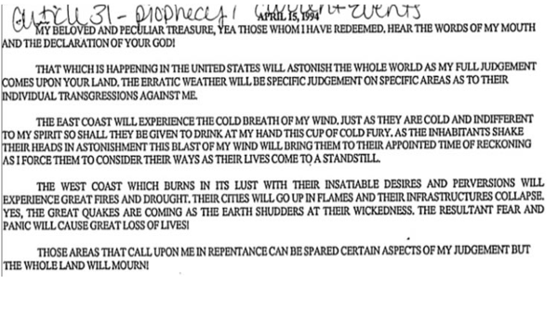
ANP: “As we see in the next screenshot below, Steve was also warned then that all of the little skirmishes that we're witnessing around the world now would one day turn into huge bloody battles and explosive wars and with them, entire financial systems would come crashing down. Warning also of judgment coming not only to America but to the entire world, Steve also mentioned global government back in 1994, long before the confirmations we've gotten of such government existing in 2018, though the mainstream media still runs as gatekeeper.

Continue below…
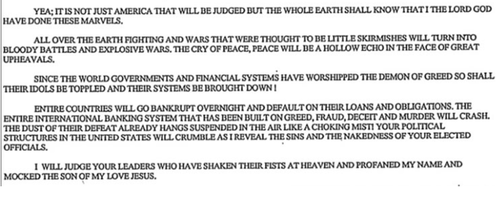 “And on April 13th all the way back in 1997, Steve was warned that everything we know about America would soon change and nothing will be as it was with the foundation of our nation destroyed. Warning that leaders from other lands would conspire against us and divvy up the riches of our lands, we've seen just that in the 20+ years since as America has been sold out to the highest bidders…”[Revelation 18; Jeremiah 50-51]
Also warning all the way back then of foreign invaders at our borders and the Russians and Chinese scheming to take parts of America, we've seen just that with convoys of thousands of people rushing up to America from the south while China owns huge chunks of land in America already, including a big play made by them back in 2016 to buy up American farms and farmland. As the American Thinker reported back on October 27th, the United Nations wants to be our world government by 2030, just over 10 years from now, and the UN has previously made it quite clear that they'll be happy to jump into the skirmish should widespread hostilities break out in America.”

Continue below…
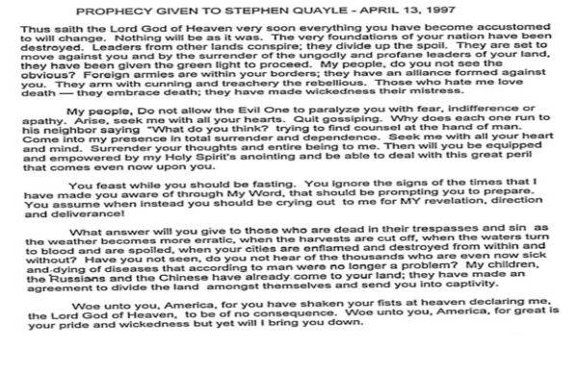
The ANP article concludes: “As Steve mentions, our world under judgment is accelerating beyond what most people can even embrace.”
Give yourself to prayer and fasting. Fear not! Find out what Yahuwah wants you to do. Repent of sin. Submit to Him totally. The whole geopolitical scene on earth is shifting to align to the globalist agenda. The U.N. is making demands. Israel is at war. The U.N. wants Israel to give back the Golan Heights, earthquakes abound.
We’re in the time period of the outskirts of tribulation. Are you ready?
In His love,
Yedidah
November 17, 2018

