TEXAS WILDFLOWERS ALONG HIGHWAYS AND IN FIELDS REFLECT YAHUWAH’S
UNCHANGING NATURE

15 BEAUTIFUL PICTURES BELOW

From the time I was five, my parents took long trips across and all over America every summer until I graduated from High School. We took a trip all the way across Canada, too, and ended up a few feet away from Queen Elizabeth and Prince Philip when I was 15. We lived in southern California. My mother was a school teacher, so she was not in school. My dad saved up his vacation and sick leave time. I would sit in the back seat of the car with my two favorite dolls, and off we’d go for adventures. My dad stopped at most all the caves and caverns, and displays of local things, like cages of snakes in the desert. My parents bought a 1949 Hudson and our traveling days were in it.
On one trip we were headed for North Carolina. We drove south from Orange County across the lower California desert on the famous Highway 66, across Arizona, New Mexico, and Texas. It took 3 days to cross Texas. As we cut north to Highway 40, we headed towards Fort Worth. We were on our way to Arkansas to my mother’s sister’s farm. I was about nine. I was asleep in the backseat of the car. I woke up, looked out window, and saw a sign that said “Welcome to Fort Worth.” I don’t know what came over me, but it was love for Fort Worth. As an adult, I lived in Fort Worth for 23 years, and now I’m back. It feels like home. Fort Worth is still called “Cow Town.” It was the center of the nation’s cattle buying and selling. Texas, as a whole, is still the land of cowboys, range riders, ranches, and goodhearted people who like to “sit a spell,” and “get ta know ya.”
At the turn of the 20th century, a little woman named Maria Woodsworth Etter came to Dallas to hold an evangelistic crusade in a big tent. The crusade went on for about 18 months, thousands were saved, baptized with the Spirit, healed, delivered, set free to serve the Master, and taught what the book of Acts really looked like. People from all over the U.S. and Canada, and the world in general, came to the meetings, but particularly the Texans. Her autobiography is A Diary of Signs and Wonders. It’s well worth reading. When you read about those early days in the great “Pentecostal” revivals, you ask yourself “what happened.” In those days, the book of Acts was alive and well and demonstrated, and the message went worldwide. Yahuwah hasn’t changed. This Spirit’s desires for us have not changed. Yahushua has not changed. The book of Acts has not changed – it our “normal.”
I was out driving this beautiful morning to the Walmart Market Place near open country and the toll road going south as it opens up into open country toward Cleburne. Texas. For the most part, it’s flatland, with cows, horses, farms, and even buffalo. The big skies have always been a fascinating for me, the sunrises and sunsets are spectacular.
As I drove, tears fell. All along the roadside were wildflowers, bright pinks, yellow, orange, purple, and the Texas Bluebonnets. Along all Texas highways are the fields of wildflowers. That didn’t just happen.
Claudia Taylor, better known as Ladybird Johnson, wife of President Johnson, decided Texas needed beautifying. She took it on as her personal project, her delight, to sow wildflowers all along the Texas highways and roads and in the fields.
As I saw the spring wildflowers so thick all along the road, it spoke loudly to me from Abba: “I am faithful.”
I encourage you to read the article “The Sunrise Lessons”/Mikvah of the Spirit that I wrote about getting up every morning to see the sun rise over the Golan Heights and Lake Kinneret, the Sea of Galilee. Yahuwah’s one message to humanity is: “I am Yahuwah; I change not.” (Malachi 3:6) Yahushua never changes (Hebrews) “Though we are faithless, yet He remains faithful, for He cannot deny Himself.” (II Timothy 2:13)
While man goes on his way, never considering Him, taking His creation for granted, He remains faithful. His creation reflects His nature. Beauty reflects His nature, the order of earth, the consistency of season, days and nights, the wisdom of everything He created, and above all is the love of creation across board for all people – sinners or set-apart saints. Look at the faithfulness of dogs, cats, even my pet chicken and duck when I was a teenager. Look at the way creation responds to the children of Yahuwah who care for it. All life interconnects with Him, except man.
When a person is truly born again, their nature changes. They take on His nature, His thinking, His ways of doing things. Out of the chaos of the dark kingdom, comes the order of His Kingdom in the born-again. The “order” that the dark kingdom is seeking to bring to the world by uniting all humanity under a central ruler, is not Yahuwah’s order. Religion tries to gather all under its umbrella, but it results in chaos and slavery at its best. Man cannot bring the order of Yahuwah unless he has the Spirit of Yahuwah within him.
Even an atheist farmer can plant seeds and they grow. Yahuwah honors His order. I John 3:14, 16 “We know that we have passed from death unto life because we love our brothers and sisters in Messiah.”
In August of 2012, I sat on the bema of ancient Corinth and looked out over the agora (market place) and the temple of Apollo. The Apostle Sha’ul/Paul preached from that bema/judgment seat. He was also arrested there too. I was all by myself in those ruins. As I sat on the bema, I saw some bright red poppies sticking out their beautiful faces through cracks in the rocks. In the midst of man’s rebellion and blasphemy against Him, His beautiful nature still smiles at us.
I walked around the ruins of Bethesda, the day before First Fruits in 2003. I saw the poppies bursting out from the cracks in those ruins. Out of the decay of what man builds to enslave others, He brings forth His beauty.
Enjoy the springtime. Enjoy His creation a while longer. His earth is so beautiful. It is a reflection of the Kingdom of heaven. Colossians 1 tells us that Messiah spoke the creation into existence and it holds together by His power.
Thank Yahuwah and Yahushua for all the beauty. Man wants to destroy it. “We look for a new heaven and a new earth, in which dwells righteousness.”

TEXAS WILDFLOWERS ALONG HIGHWAYS AND IN FIELDS

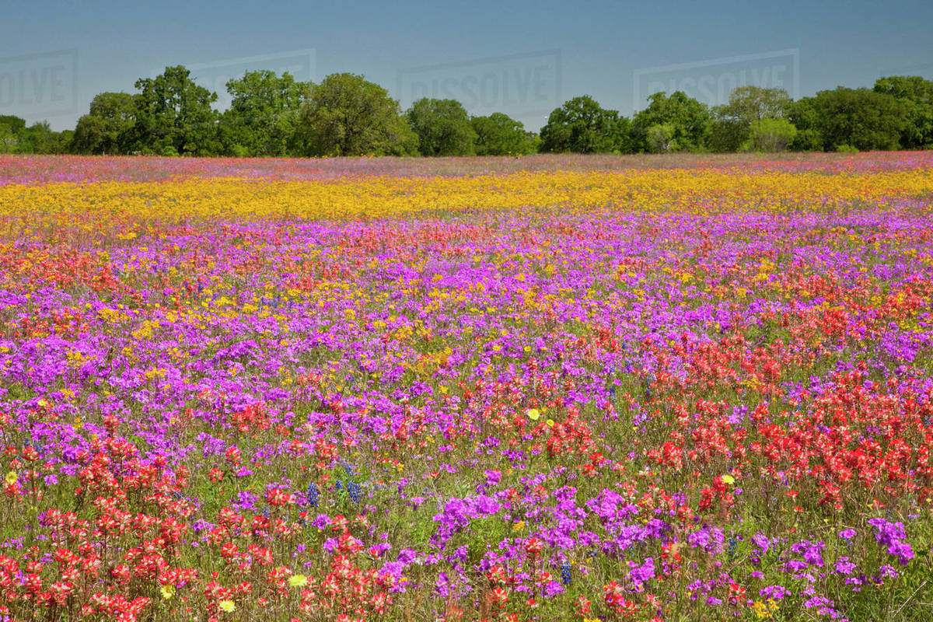

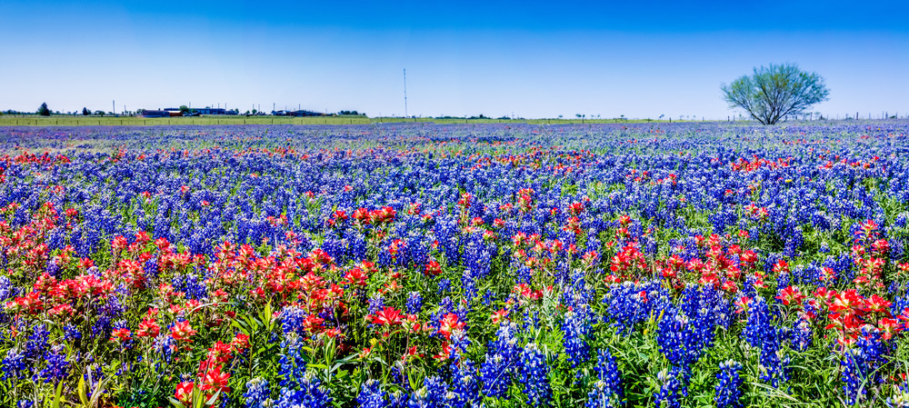
Texas Bluebonnets 2020
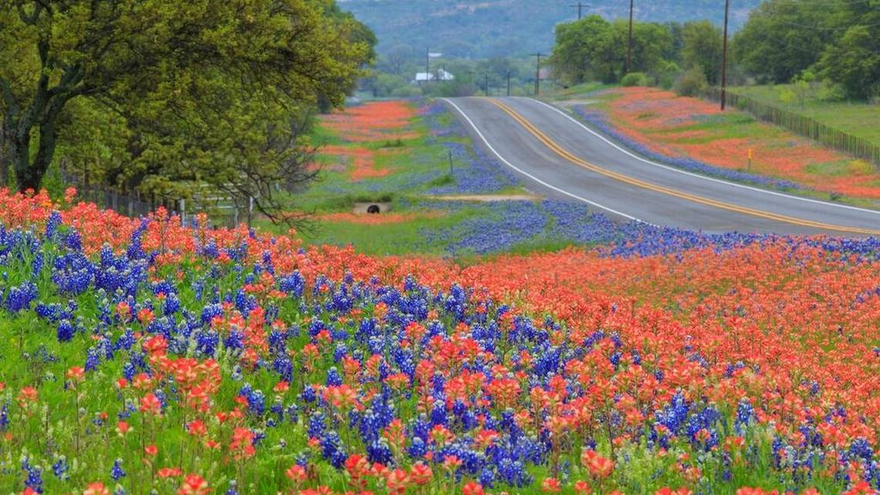
Alone a highway near Austin
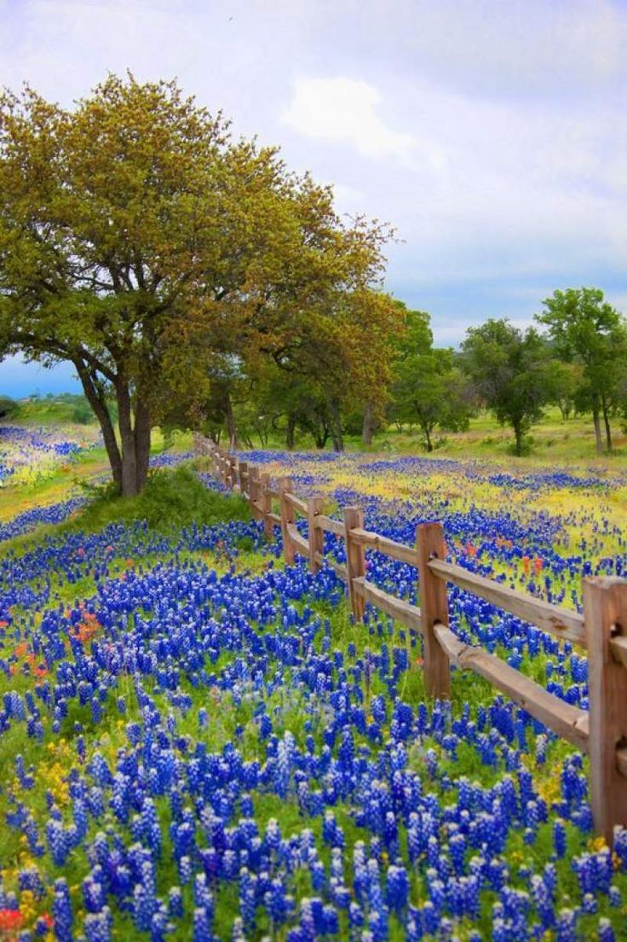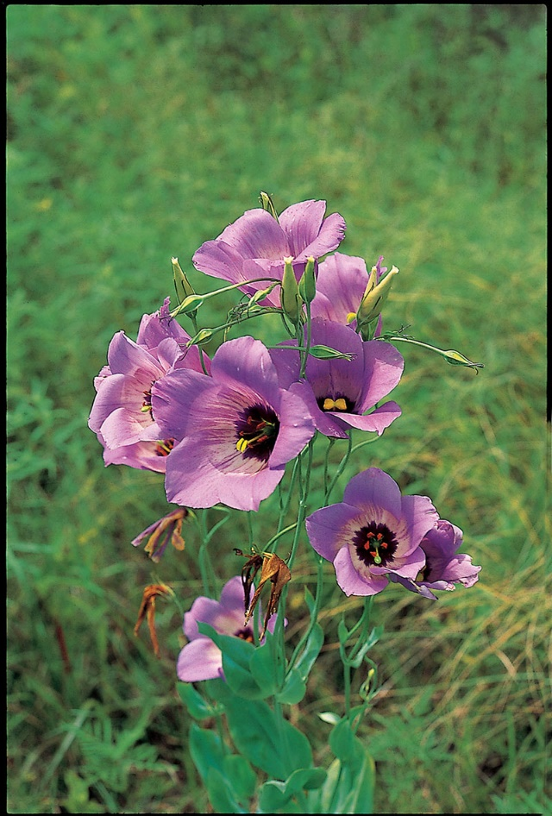

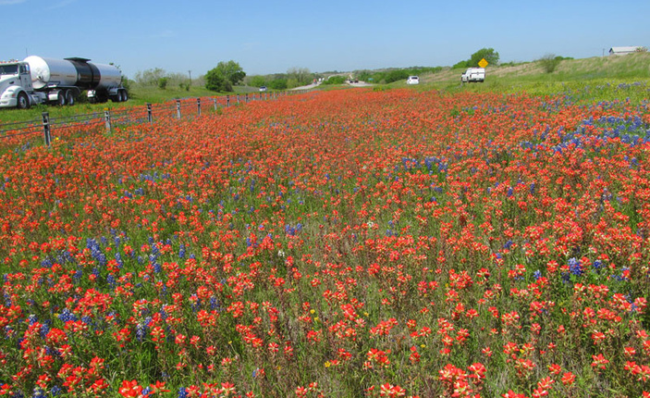
Along a highway

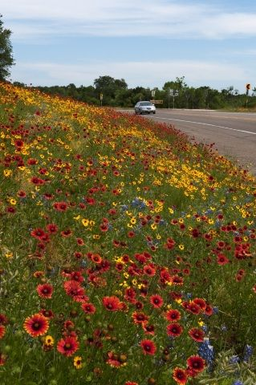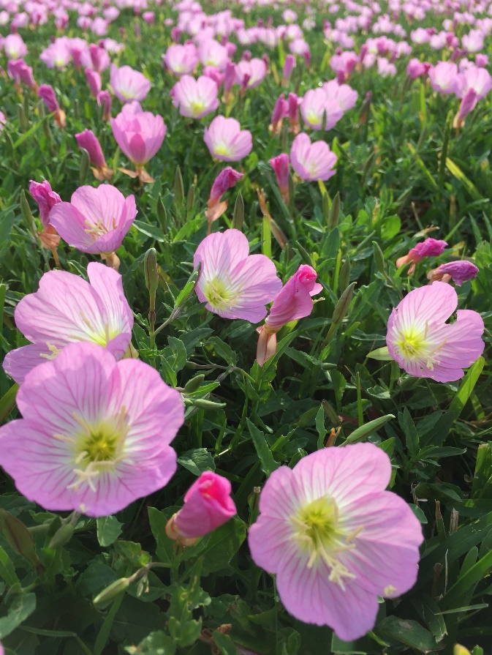

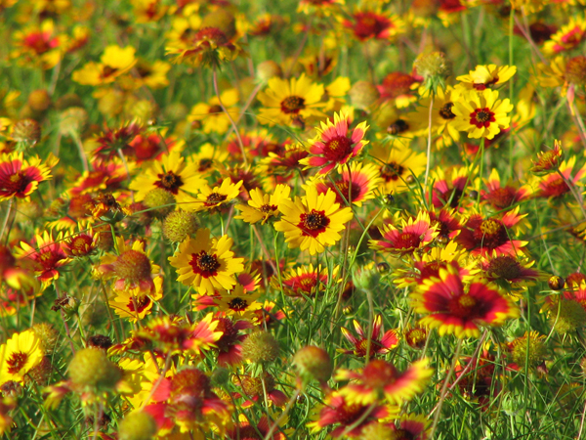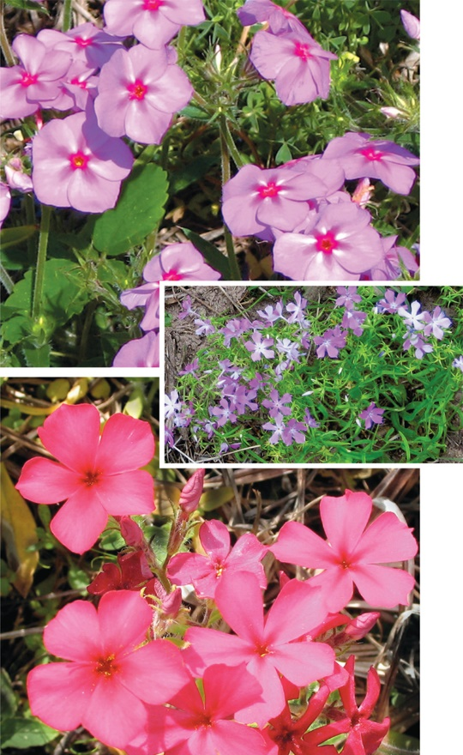
Beauty along Texas highways. Photo: Texas Wildflowers group/flickr.com
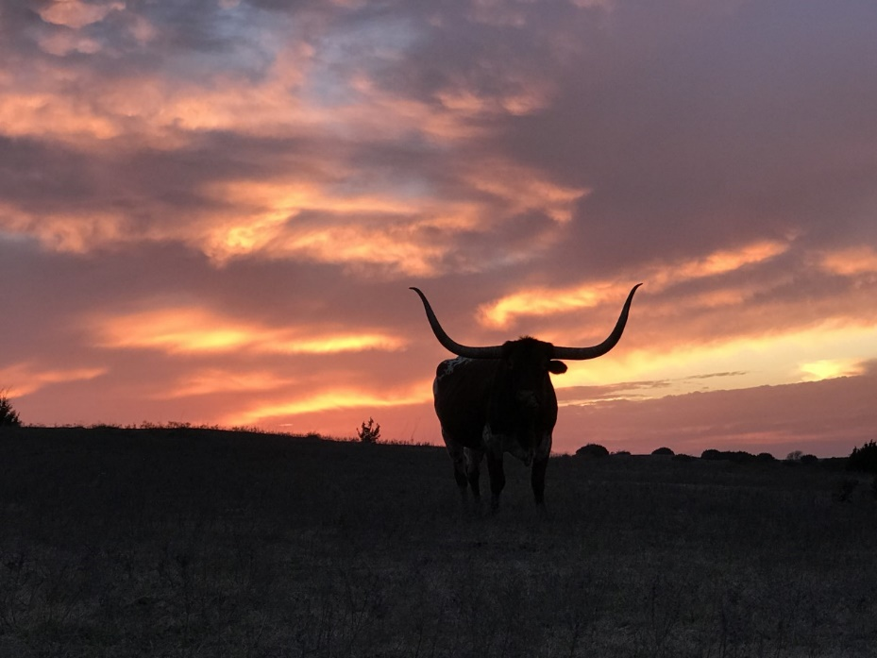
“Lucky,” a Texas Longhorn in a Texas sunset, picture by Derek

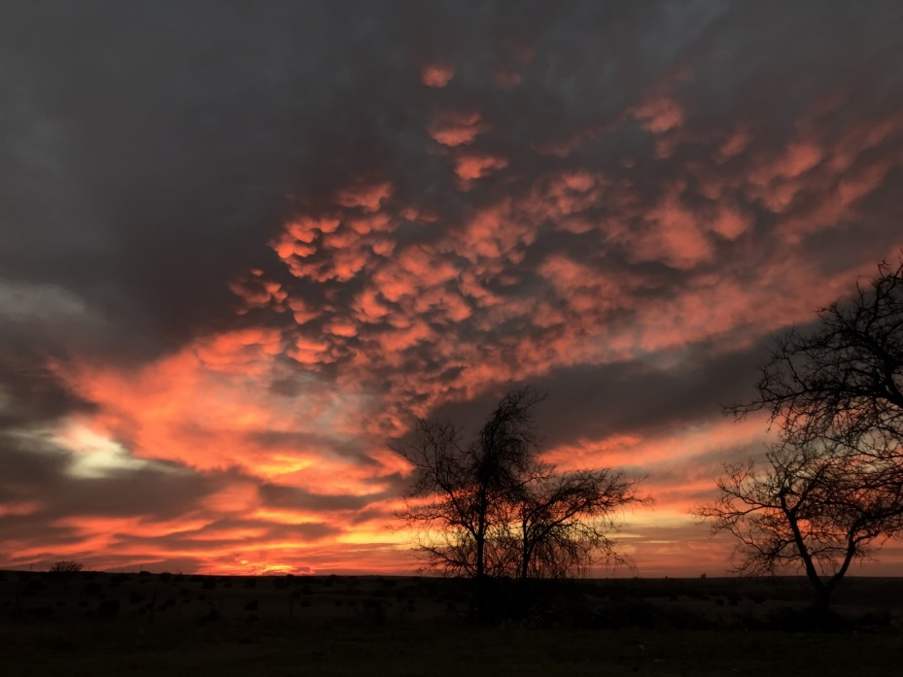
Texas sunset, picture by Derek
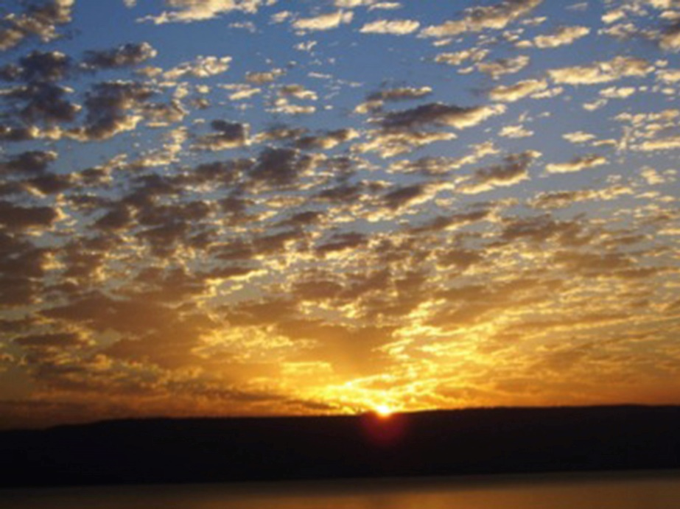
Sunrise over the Golan Heights and the Sea of Galilee May 2008
Picture by Yedidah – “The Sunrise Lessons”/Mikvah of the Spirit
In His love, with praises, Yedidah
April 23, 2020

