THE WARNING CRY TO SAVE AS MANY LIVES AS POSSIBLE

“The Beverly Hills Supper Club fire in Southgate, Kentucky, is the seventh deadliest nightclub fire in history. It occurred on the night of May 28, 1977, during the Memorial Day holiday weekend. A total of 165 people died and more than 200 were injured as a result of the blaze.”
Here is the story of why hundreds more were not burned to death that night, because of one brave busboy named Walter Bailey.
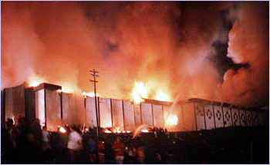
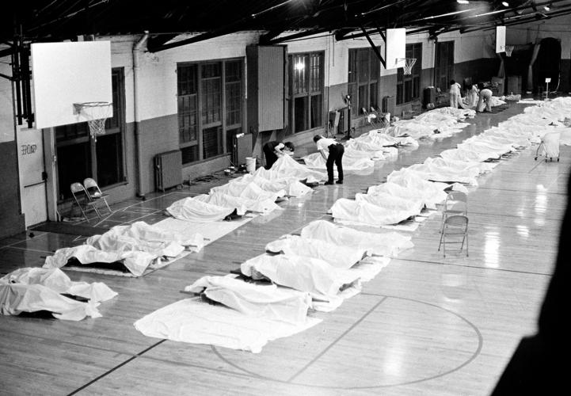

I first heard of this story reading my Evangelism Fellowship news booklet by dear long-term friends, Ken and Becky Dornhecker, seasoned world-traveling evangelists. Ken’s conclusion is powerful. I wanted to share it with you.
Quoting and paraphrasing Ken’s account: “At 9:06, busboy, Walter Bailey, slipped into the large room. A large audience had packed the Cabernet room, for dinner, and to hear a well-known comedian. He quickly approached two supervisors near the back of the room and told them that a fire had broken out and to have all evacuated quickly. The two men, thinking he’s just an over-zealous busboy, dismissed it. So, right in the middle of the comedian’s performance, Walter ran up on the stage and grabbed the microphone and told the people a fire had broken out and they had to evacuate right then. They did not realize they had four minutes to do so.
About 200 of the 600 in the room got up and walked out. The others just stayed there and stared at him. The audience, for the most part, dismissed it. Four minutes later, the luxurious wood paneling, rich carpeting, thick curtains, were ablaze. People were trampling each other trying to get out. Just four minutes changed the lives of nearly 600 people in that one room. Other parts of the massive building contained many others too, but the Cabernet room was the largest gathering (see photo above of the room).
The fire produced incredible smoke, so many died from smoke inhalation. Instead of running out with the first ones who took Walter’s words seriously, Walter stayed, going in and out of the Cabernet room to rescue as many as possible. In the panic, the terrified ones jammed the door ways. You can see some of the bodies laid out in the picture above.
The fire department came 4 minutes after they were called. The impossible inferno, and enormous mountains of smoke were already in full blaze by the time the firemen came. The roof imminently collapsed, forcing the brave firefighters out. The untrained staff of the nightclub was also credited with fanning through the huge entertainment complex and safely evacuating the almost three thousand strong crowd of patrons from bars, restaurants, event spaces and corridors.
Tragically, the indifference to the warning in the Cabernet room brought a horrendous toll. When the firemen finally were able to enter the Cabernet room, they discovered to their horror two massive heaps of charred corpses lying near the blocked exists – 165 souls lost.”
Walter Baily acted as quickly as he knew to act. However, few listened to him and acted on his warning. They were saved, the other lost. In our world today, there are the saved and there are the lost – for eternity. An 18 year old boy who cared enough about the people to warn them, even risking his job and his reputation as a sane person to do so, acted because he wanted people to be saved.
Ken wrote: “Many within modern Christianity would never even consider the concept of warning people of impending judgment. Now we have been taught to be sensitive, relevant, cool, upbeat, positive, and fit in. The contemporary gospel has more of a motivational speaker vibe. The straight forward approach of telling people about salvation in Jesus, about sin, judgment, heaven or hell, is dismissed as old fashion, crass, even hateful. I’m convinced we have lost a very Biblical concept in the modern day – Boldness.”
Walter Baily did not think of himself, his reputation or job, he just acted to save lives. In today’s Christian world, those who lay down their life, their reputation, their “self,” to warn others of the fire of hell are called radical, fanatic, dangerous, even “domestic terrorist,” as are labeled by the US government. Ken and Becky Dornhecker are two of the most-gentle, kind, loving people on planet earth. Yet Christian pastors and congregation members mock him, and scorn him, even saying he is a “hate monger,” a “fire and brimstone” preacher. It hurts him deeply, for, just like Walter Bailey, his one motive is to see people born again and on their way to heaven. He includes the following scriptures: Please read these carefully.
Acts 4:29, Acts 4:31, Acts 13:46, Acts 14:3, II Corinthians 3:12, Acts 28:31,
I Thessalonians 2:2, Proverbs 28:1.
Revelation 20:11-15: Yahushua’s final warning to Yochanan (John) is that there will come a day when all the wicked will be judged and condemned to the lake of fire forever. So, how important is it to be born again? How important is it for you to fulfill your calling – to share the message of salvation with as many as you can, by all means that you can.
Ken wrote: “One correlation that stands out, and simply could not be more-clear, is just like the Beverly Hills Supper Club, our warning ultimately is about saving people from a fire! Jude 1:23: “Save others by snatching them from the fire.”
Tragically, the book of Acts is now considered by most Christians and Messianics as “passe,” non-applicable to our modern times – in western cultures that is. The book of Acts is alive and well in places where the Good News of salvation is being preached by the common folk in the midst of horrendous persecution from the fire of Satan’s anger – like in Iran, Pakistan, China, Nigeria, Indonesia, etc. These lovely joyful and zealous believers are spreading the Good News of salvation in the midst of death all around them, imprisonment, beatings, slander, etc. I know, I was among them many times in China. Great persecution of Christians worldwide is coming on the earth, as Lucifer wants us all dead.
Because of the love of ease and comfort, wealth and possession of things wanted, advancement, lust for one’s own carnal desires, few in America even talk to anyone about the fire that is coming. The whole earth will be consumed in fire – especially America, very soon – nuclear-created fire. Where are the warning voices? Few, but powerful believers, are warning, because they love the Master who provided for us “so great a salvation.” Because of love for Him and for His Father who loves His children, they are His ambassadors on the eve of great tribulation!
As Messiah said would happen, love is almost gone from the earth, but is gaining strength and fervor in those who know Yahuwah, who know Yahushua, who are on their way to the Kingdom of Light.
Ken’s passion is centered around the concept of reconciliation with God. His messages contain the truth that without the savior we are lost in sin, needing forgiveness, or else experience Yah’s judgment. He said “I most definitely go on to warn the about eternity in hell – to bring them to a sense of urgency about their lost condition. To make it clear to them the consequences of rejecting God’s merciful offer of forgiveness and redemption in Jesus the Savior.
Virtually every single time I warn people of judgment and Hell, my demeanor is anything but angry and condemning, but just the opposite. But more often than not, tears are usually running down my cheeks. The audience or individual I’m speak to feels my love and concern. Being branded as a hater by Christians and pastors is truly one of the sadist things I deal with.”
Think of the preachers of old who cried out in warning to people to not be burned in the fire of Hell, but to find salvation in Jesus. Like the result of Walter Bailey’s warning, many are saved. You can’t be lollypops and cotton candy, especially when it comes to heaven or hell. Now, even by the church, “sin” is mocked. The Word is mocked. Righteousness is mocked. Messianics keep to only limited Scripture that backs their beliefs, same with Christians.
Today, those zealous for Jesus, or Yeshua, or Yahushua, is considered someone to laugh at. Churches are promoting a religion without Elohim, without Father and Son, without the baptism in the Spirit, without personally knowing Them as dear Abba and dear Beloved Savior. Satisfying the mind, emotions, carnal will is the focus of everything. Rescuing the lost is not even considered.
The church is focused on Jesus’ blessing in this life. Yes, He does bless in this life, but His focus is to prepare us for the Kingdom and eternity. The process of salvation is “set-apartness” unto Father and Son, knowing Them, serving Them in preparation for entering eternity with Them. The transformation into Their nature, ways, and thinking, is mandatory before entering the Kingdom. Self-ruled people live in a gray-area of sin without knowing it. And they don’t care who around them goes to hell - it’s all about “me.” They live in a carnal realm of appeasing self- thoughts and emotions. The idea of warning anyone else to “flee from the wrath to come,” is not acceptable to their self-centered minds. Thus, they never go on to “perfection” as the Word demands - not perfect by man’s standards, but by Their standards. Religion is a numbing illusion, not the reality that Yahuwah demands.
The reconciliation of man with Creators is our main focus. “Be reconciled to Elohim,” is our message.
II Corinthians 5:19-20: “…that God, was reconciling the world to Himself in Christ, not counting men’s trespasses against them. And He has committed to us the message of reconciliation. 20Therefore we are ambassadors for Christ, as though God were making His appeal through us. We implore you on behalf of Christ: Be reconciled to God. 21God made Him who knew no sin to be sin on our behalf, so that in Him we might become the righteousness of God in Him.”
This is our calling – to “rescue the perishing, …” Yahuwah’s judgment that is coming on the earth will be judgment by fire.
We will enter the Hebrew month of Heshvan October 27th at sunset. On the 17th of Heshvan, Noah and family were sealed in their ark of safety, and the rains began. The earth was covered in water. Only those in the ark survived. Today the judgment of Genesis 6-9 is in the earth. Only those in Yahuwah’s ark of safety will make through His judgment by fire.
What are you doing to align to His heart – to warn the people that the fire of hell is very real, and Yahushua/Y’shua/Yahushua/Jesus is the only one who can save them? His name is different in different languages. It is Isa in Arabic. His original name is as “Joshua,” the savior or His people – pronounced in Hebrew as Yahushua (Yahuwah is salvation). We speak to people under the authority of Yahuwah, the Father, the “Most High” (El Yon), the “Almighty” (Shaddai).
Jude 1:23: “Save others by snatching them from the fire.”
Great fire is coming, from the sun’s coronal mass ejections, to nuclear holocaust. Do you understand, as did Walter Baily, the urgency of warning people to flee from sin into the loving arms of our Savior? Please carefully read:
Ezekiel 3:17-19; Hebrews 11:7; I Thessalonians 5:14; Luke 16:22-24; 27-28; Acts 20:31
Like our brother Sha’ul, we must keep on warning and keep on sharing the Good News of salvation. There is a closing date ahead; if you fail to warn the lost, the closing date may apply to you. Be diligent in your work for the Master, “…for night comes when no one can work.” No more time left for self-centeredness and controlling in this life … rescue your future – reach out to others!
Written with His passion and love, Yedidah
October 26, 2022

