THE WILL AND DECREES OF LUCIFER AND THE FALLEN ANGELS FOR CHILDREN BECOMING LAW
The appeal of lucifer and the fallen ones to mankind’s pride and self absorbsion with the desires of the flesh have taken over the world’s people, primarily those in western culture, primarily those in America. From the return of the principle fallen ones in 1896, following the ending of Enoch’s 70 generation prophecy, to present time, the one country they have zeroed in on to use as their launching and testing ground for world takeover is the U.S. In the midst of it all, Yahuwah sent a great outpouring of His Spirit during the late 1800s, early 1900s, that swept over into the nations, like South Africa with John G. Lake, and England with Smith Wigglesworth, and all over the United States with those like Charles Finny and Maria Woodworth Etter.
In 1906, the great outpouring of Yahuwah’s Spirit began with Evan Roberts in the Rhondda - the coal mining area of Wales. It swept into Europe. In 1909, the Lutheran Church of Germany banned the teaching and forbade it in their churches. They got Hitler and his “spirits” instead. In 1906, in America, we got the great revival of Azusa Street in Los Angeles and across the U.S.
Yahuwah, the Spirit Himself goes where He is wanted. He is more than willing to pour out His power for salvation, healing, deliverance from demons, blessings in abundance on His faithful people, but withholds His blessings from those that reject Him. To reject the Acts 2 outpouring that never stopped with the apostles, is to reject Yahuwah Himself, for He is the Spirit, the Spirit is Yahuwah. I Corinthians 3:14-15 for example.
By His mercy on His true children, He has had mercy as all the 200+ prophecies of Yahushua Messiah’s second coming have begun to unfold … compounded, compacted, all coming down at once to different degrees. So many of those prophecies are showing more and more signs of fulfillment daily. I began in 1963 to keep watch and report on these things. Yahuwah gave me a profound clear dream around the late 1980s, in which He spoke to me and called me to be a “watchman,” saying “tell My People to watch.” I began to teach on the signs of the return of Yahushua/Yeshua/Jesus.
One of the biggest signs is the blatant open parading literally of evil against the Creators, and the open hate of “Jesus,” broadcast worldwide from the WEF (World Economic Forum). There the Elohim of the Bible (Father and Son) are not just hated, but mocked vilified and nullified, and thrown down in despising hate.
However, Yahushua let us know that would be part of these days before His return in Matthew 10: “You will be hated by all men for My Name’s sake.” Yes, His Hebrew Name carries His Father’s Name. In Isaiah 42:8, He states “I, I am Yahuwah, THAT IS MY NAME, and My esteem I will not give to another.” In Psalm 68:4: “Sing to God, sing praises to His name; Extol Him who rides on the clouds, By His name YAH, and rejoice before Him.” In Exodus 6:2-3: “And Elohim spoke to Mosheh and said to him, “I am יהוה (Yahuwah) and I appeared to Aḇraham, to Yitsḥaq, and to Ya‛aqoḇ, as Ěl Shaddai. And by My Name, יהוה, was I not known to them?... 8 And I shall bring you into the land which I swore to give to Aḇraham, to Yitsḥaq, and to Ya‛aqoḇ, to give it to you as an inheritance. I am יהוה.’
The Name “Yah” means “I AM” – more fully “I AM THE EVER-LIVING ONE WHO BREATHES.” Yahushua/Jesus said He came in His Father’s Name: Yahushua means “I AM,” OR “YAHUWAH IS SALVATION.” So, when He told the Pharisees “Before Abraham was I AM, they knew what He was saying. The religious leaders of the first century CE would not speak the Name “Yah.” The religious leaders of Talmudic Rabbinic Judaism today do not speak the Name “Yah.” However, He came in His Father’s Name – which is clear throughout the Tenach as “Yah”/”Yahuwah.”
Because of His love and mercy for the ignorant, He does not send lightning bolts after those who use “Jesus,” or “Isa” or any other name of religion that honors Him. We’ll all get everything straight in the Kingdom folks. In China, most believers have no Bible of their own, and if they do it is only a New Testament. They live the Word to the fullest. It is in their spirit, and they are persecuted and imprisoned and killed for their faith. I highly recommend the book The Church in China by Carl Lawrence.
When I was preparing to go to China in 1994, reading that book was a requirement of the group I was going to be with. I did not have the $8.00 for the book. I was reading my Bible, lying on my bed. Abba spoke to me: “Go to Joshua’s Bookstore right now.” I threw my legs over the side of the bed, put on my shoes and hurried to get to Joshua’s bookstore just up the near Hulen Street in Fort Worth, Texas. As I walked in the door, to my right was a table that said “All Books $1.00.” In the middle of the table was one book with a bright red cover: “The Church in China” by Carl Lawrence. I’ve quoted from it in several articles. Yet, as said in that book, those with several translations of the whole Bible, in English, mostly do not read it at all, and are far from obeying the instructions and teaching (Hebrew: Torah,) or anything Messiah or the apostles said.
So, I ask, who will rule and reign in the Kingdom of Yahushua, meaning “Yahuwah is salvation?” The ones who are like those in Matthew 18:1-4 Messiah talked about: “Unless you become like a little child, you cannot enter the Kingdom of heaven.” The truly born again, Spirit-filled, submissive, obedient, who are kind, forgiving, loving and gentle, whose nature is that of their Heavenly Father, who KNOW Father and Son, – these enter the Kingdom. (Daniel 11:32)
I got information yesterday morning about further moving into dehumanizing not just adults, and youth, but children – showing the Luciferic contempt on human beings who were created in the image and likeness of Yahuwah and Yahushua – with an eternal spirit. It’s gone far beyond Darwin.
Yes, the U.N. refers to humans as “cattle,” as those on the inside relate, even as insects. There is no humanity in these people who sacrifice babies and children, yes under the White House, that’s been proven, yes, in the Pentagon, yes, in the Vatican, yes, in the U.N., yes in Hollywood, including cannibalism of their butchered and cooked bodies.
Now out in the open are new laws saying that children are born with sexuality so to be used for sexuality is nothing wrong. Here I share the article with you. Read it and weep. Go to Yahuwah about it, but one thing I want to get across to you is that America and the world is under the judgment of Yahuwah, beginning with the “household of faith,” as the Word says. The great falling away of the “household of faith” is reaching its height now.
There is little to no love of the Word or its application being necessary – in fact 96% of American Christians, by recent survey, don’t believe the Bible is applicable for a “world view.” I wrote an article giving the survey results in 2022 of Evangelical and Charismatic, and High Church falling away. Amazing that the worst were the Charismatic/Pentecostals.
Please Read: “Apostasy Precedes the Coming of the Beast’s Reign - An Indication of What Time It Is On Yahuwah’s Calendar” number 209.0 under the Mikvah of Present Reality. This article for at least the stats on the downfall of western world Christianity especially in America in November of 2020. The II Thessalonians 2 great falling away greatly accelerated through 2021-2022 and now is incredibly huge in 2023. Could you even imagine in 2020 that Christians in America would deny the Deity of Jesus and reject the Bible as the Word of “God?”
We know about the U.N. presentation of 100 gender groups to public schools to teach to 5 year olds in kindergarten, requesting that the children choose their gender. We know of the mutilation done by doctors under the will of parents or by teenagers with or without parental OK - the cutting off of girl’s breasts and the removal of the male sex organs of little boys, the taking of hormone treatments to change a boy into a girl and a girl into a boy, etc. Some mother go so far as to dress their little boys in dresses and fix their hair like that of little girls.
We haven’t heard much from Planned Parenthood for awhile, however they have not been idle in their pursuit of destroying babies and children. It is hard to believe what is said here, but it is happening. Lucifer wants all humans dead.

PEDOPHILIA AND SEX TRAFFICKING MADE TO LOOK NATURAL AND ACCEPTABLE - Gates foundation donates millions to NGO that seeks to normalize child ... Gates foundation donates millions to NGO that seeks to normalize child prostitution and sexualization of children under 10 By NewsTarget Apr 20, 2023
The Bill & Melinda Gates Foundation has been giving millions of dollars to a nongovernmental organization that tries to normalize commercial sex work and education on gender identities for children 10 and under.
(Article by Amber Crawford republished from 100PercentFedUp.com)
The International Planned Parenthood Federation (IPPF) is made up of 120 independent organizations in over 146 countries and has received over $80 million from Gates.
The World Health Organization has also significantly contributed to the IPPF.
The IPPF claims that they work “to ensure people are free to make choices about their sexuality and wellbeing in a world free from discrimination.”
This NGO teaches sex education to children around the world and, in a 2017 “toolkit” that was recently spotlighted, the organization suggests that prostitution should be categorized under “types of relationships” like marriage and dating. This toolkit recommends that children under 10 should be taught that “sexual activity may be part of different types of relationships, including dating, marriage, or commercial sex work, among others.”
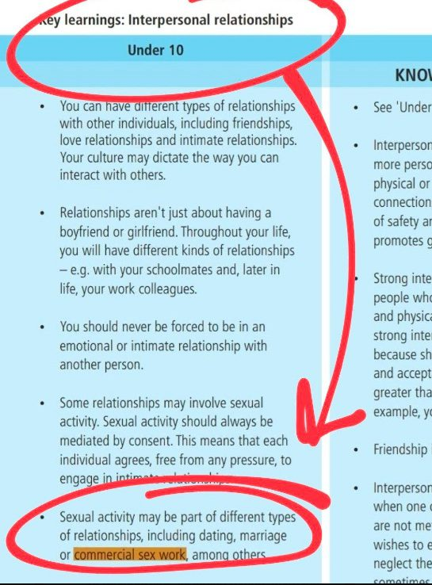
The toolkit also insists that children are “born sexual” and that sexuality “develops and changes throughout your life.”
A recommendation is that children under 10 should be told, “As you grow up, you might start to be interested in people with diverse gender identities.”
The IPPF toolkit focuses heavily on the sexuality of children under 10, encouraging the teaching that “sexuality is a part of you from the moment you are born.” The organization tries very hard to make people view children as “sexual beings, regardless of their age.” “Sex positivity acknowledges that human beings, including adolescents and young people, are autonomous sexual beings,” the toolkit states, weirdly trying to normalize the sexualization of children.
“Sexual rights include… the right to say yes or not to sex; the right to express sexuality, including the right to seek pleasure; the right to enjoy bodily autonomy,” the toolkit says. The IPPF document also recommends talking to children as young as 10 about emergency contraceptives and deciding to continue or terminate a pregnancy.” [Children are considered no more than young cattle, sheep, goats – mammals – to be used to gratify the pleasure of adults sexually, or be butchered and eaten as what is happening greatly in America. This is directly license approved in the Babylonian Talmud, which is law in America – “Quotes That Will Forever Dispel Damning Illusions” #62.0 Mikvah of Israel Our Eternal Inheritance]
Take it to Yahuwah in prayer. It goes beyond abortion, to slaughter, to sexual defiling and destruction, to cannibalism, to mutilation, to splitting the mind to reprogram it as in “MK Ultra,” torture, butchering, drinking blood, and all in worship of Lucifer and the fallen angel. Satanism is the fastest growing religion in America.
In the love of Yahuwah, Yedidah -April 23, 2023

