TRUMP PORTRAYING HIMSELF AS JESUS
What is going on? President Donald Trump is a Babylonian Talmudist and Kabbalist. He signed papers a few years ago, when he converted to Judaism, never to mention the name of Jesus. Yet here are two pictures to note.
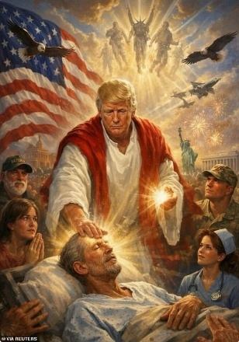 and 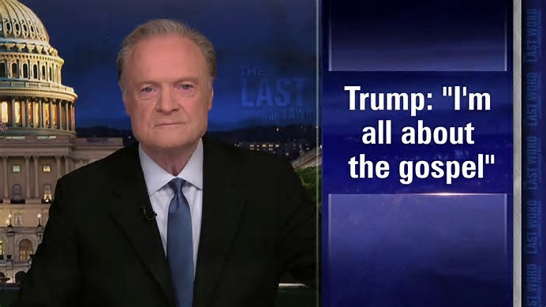
On Easter Sunday, I watched a sickening video of Trump standing by pastors who were exalting him, comparing him to Jesus, saying he suffered in his helping of humanity. Trump stood listening with a smug smile on his face – agreeing with all they said – at least by facial expression. His expression was full of pride, arrogance, and haughtiness, and seemly in agreement to what was being said of him. Then he posted this, now famous picture of Trump the healer. Yet behind him in the air are 3 demons, one in the middle with horns. Now he’s said to be “about the gospel.”
Trump and Khazar Netanyahu hate Jesus, they want to slander Him, vilify Him, remove Him, and remove all Christians from planet earth who worship Him. I’ve been warning about the “Noahide Laws” since at least 2018, yet, the ignorance and deadness of most Christians in America think all is well. This “law,” designed to kill all Christians, is already International law, from the Illuminati itself.
It is being noticed that Trump continually lies, as does the Congress, the Senate, and every other group of the government. A very few tell the truth. They are vilified. Now Trump says “the Iran war should be over soon.” He has said that many times. The lies are for the public news to repeat, to keep the people ignorant.
Daily Mail reporting April 17, 2026: “Texas Republican calls Trump 'almost the second coming' amid feud with Pope Leo and viral Jesus meme” 17 April 2026
“Republican Congressman Troy Nehls said President Donald Trump is 'almost the second coming' of Jesus Christ while being interviewed by a CNN reporter on Capitol Hill on Thursday. Nehls, a 58-year-old Republican representing Texas's 22nd congressional district, made the comments when CNN's Manu Raju asked him about Trump posting a now-deleted AI image that appeared to depict himself as Jesus. 'Come on, I think that's all been taken out of context,' Nehls said.
'Is it?' Raju interjected. 'I do. I believe that Donald Trump is better than sliced bread. I think he's almost the second coming in my humble opinion. I think he's done a fantastic job, he's got a very difficult job,' Nehls said.
Nehls said that Pope Leo XIV, who Trump attacked Sunday for criticizing the war in Iran, 'needs to stay out of the political arena'. Nehls, who was elected in 2021, has emerged as one of Trump's most ardent defenders and supporters. During Joe Biden's State of the Union address in March 2024, Nehls wore a shirt that had Trump's Georgia mugshot on it.
Rep. Troy Nehls of Texas told CNN's Manu Raju that Donald Trump is 'almost the second coming' in response to a question about the president posting a picture of himself as a Jesus-like figure:
Trump posted this image of himself in robes and healing the sick on April 12, days after Pope Leo XIV criticized his conduct of the war in Iran
Three days after Trump was inaugurated, he co-sponsored a bill that, if passed, would rename Dulles Airport in Virginia the 'Donald J. Trump International Airport'.
Trump's feud with Pope Leo began last week, when the pontiff condemned the president's warning that 'a whole civilization will die tonight' if Iran failed to meet his deadline to reopen the Strait of Hormuz.’ 'Today, as we all know, there was this threat against the entire ​people of Iran, and this is truly unacceptable,' the pope said on April 7.”
On Orthodox Easter Sunday, Israel attacked southern Lebanon (home of thousands of Christians) to bomb them, and kill thousands. But that was blown off. Did your church pray for the Lebanese Christians? I had a Lebanese landlady in Jordan when I lived there. I met other Christians from Syria, Sudan, Egypt, while living in Jordan. They were a joyful people, true believers in Jesus. Yet these Christians have been treated with evil – by orders of America – i.e. the taking out of good leaders and replacing them with bad leaders, submissive to America.
Videos are being shown of Trump saying “I’m all about the Gospel.” What does that mean? He’s speaking against the Pope. He hates the gospel, and hates Jesus, and supports the Noahide Laws. I know that, I wrote an article showing a picture of Trump in the Oval Office around 2016 with representative from several states of governors – they had signed the Noahide Laws into effect as the law of the U.S.
That means, churches with the clergy response teams can arrest Christians and put them in FEMA camps with thousands of guillotines each, to be separated by men, women, and children, while their pastors go to South America for sanctuary.
Mark 13 tells about this. Christians are Lucifer’s enemies, so are enemies of the new world order.
The Iran war, as the last war before the bestial system comes to power, has been planned for a long time. The purposed destruction of earth continues, as we face hurricanes, typhoons, fires burning cattle and crops, chickens and crops. The pollution of our food continues. Now Trump faces creating another war with Cuba.
Some of Trump’s most loyal supporters are beginning to publicly express their growing dissatisfaction with the president in handling the Iran war. There was no need for it. Iran was not threatening anyone. Iran continually told Israel, “we don’t want war.” But this is America’s pattern that goes way back in history from the early 1900s – going to war with those who want no war and have done nothing to encourage war. The horrible U.S. Civil War was backed and supported by the Pope of the Vatican for the North U.S. against the South U.S. It’s all documented. I’m not giving you fake history. And, we never broke from England to begin with – we still pay taxes to England.
All of our holidays are either pagan or contain some type of falsehood. War and lies, treachery and deceit – please learn what the Word says. It’s the truth.
So much deceit. Khazarian-ruled Israel is not the Israel that is promised in the Bible that is to come. Ezekiel 47. It will be expanded. It will be peaceful, as told in Zechariah and other prophetic words. Zechariah 14:13-21 speaks of Messiah’s return, and of a new Jerusalem where there is righteousness. Isaiah 2:1-5 speaks of Jerusalem after Messiah returns. The Bible does not speak of the Israel that is now, except in terrifying terms. Speaking of the latter years, before His return - Ezekiel 38-39 must take place. The Israel of today is slaughtering Christians and will slaughter more. It is connected to the Illuminati itself, via the “Zionist” movement that is controlled by Lucifer. Therefore, Israel has now passed laws against Christians. Great hate has spread among most Israelis now. It’s tragic.
Ignorance of the Word leads to emptiness and disillusionment. It leads to dependency on what man says. Religious denominations in Christianity of today say that Acts 2 is not for us. The gifts of the Spirit in I Corinthians 12 are not for us.
What lies! We have to hear from Abba, in the Bible, and in our spirit. Remember John 7:37-39! Father wants to live in our spirit, as He once lived in the Holy of Holies in the Most Set-Apart place of the Temple. I Corinthians 6:19-20.
I want to pass on to you what a fellow-servant friend, sent to me: “This Israel is NOT the Israel of the Bible that is to Come in the Kingdom of our Savior!” This Israel is, and has been, slaughtering Christians in Gaza, and turning on all Christians in particular, and will turn on Christians to their death by the Noahide Laws. The leadership has stated its hatred for America, but its Talmudic and Kabbalistic rabbis sure take in billions of dollars from ignorant American Christians for projects that are anti-scriptural. This temple they want to erect now is said, in the Word, to be inhabited by the antichrist.
Regarding the chart below: In general approximately 95% of those who made Aliyah to Israel are from the ancient empire of Kazaria, or a mixture of Khazar and Judah. Early on, the empire of Kazaria called for a copy of the Babylonian Talmud – not the Torah. They made it their national religious book.
Please read the article “Quotes That Will Forever Destroy Damning Illusions” under the Mikvah of Israel, Our Eternal Inheritance and read various parts of the Talmud. The Talmud is a filthy book, filled with hate for Christians – promoting pedophilia and prostitution and the killing of Christians.
Tel Aviv, just got devastated by Iran. Tel Aviv is/was the most LGTBQ city in the world, “gay pride” parades and all. These Khazars infiltrated the European Ashkenazi Jews. Netanyahu admitted to this truth for himself and the nation.

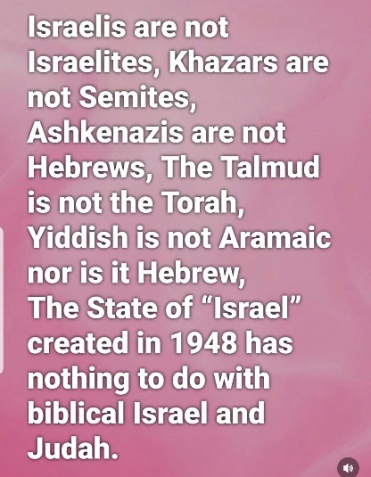
There are about 5% who are true Judah. A few still go by the Torah. The Talmud says for parents not to teach children the Torah. The Kabbalah is a demonic book. It teaches about several gods, even a wife (Shakina) for the main male god it represents. Also is the belief that the serpent that temped Eve in the Garden got “saved,” and now he is the coming messiah. Yes, Israel’s messiah is really Lucifer. But this liar is not a saved Lucifer or a now-nice Lucifer.
Thus, with Trump giving himself to pure evil leadership in Israel, you can see why both Netanyahu, an admitted Khazar, and Donald Trump, a devotee of Chabad, have been deeply involved in the Epstein Island horrors, and are in love with blood sacrifice, as now in Lebanon and Iran. They work together. It is said that the real president of the U.S. is Netanyahu. Though he isn’t, Trump is, the same spirit of evil rules – of filth, and blood lust, and the sacrifice of children in abortion or young children. All this evil is covered over by nice-sounding religion. But, notice the trafficking of children has not been done away with by Trump. Notice that the end of the abortion industry has not come through Trump. Notice that the government is most all Luciferians or Satanists, and that billionaires reign.
I conclude this with an exhortation - Jeremiah 17:5-10. Pastor John Hagee says that Israelis have a different gospel than we do. He says that because they are Jews, they are under another religious umbrella than we are for their eternal salvation. How stupid can it get? Ignorance reigns among most American Christians because they’re trusted in man to tell them what they want to hear. We have the privilege of having the Father, Yahuwah, within us to teach us. He leads us into all truth. He aligns us with what is truth, and directs our spirit. Most humans have a religion, but they do not know the real God of heaven, or His Son. Listening to man has caused thousands of denominations. There is only one way to understand the Word of God – by letting Him teach. Isn’t that sane?
Ok, done for now. Blessings, peace, joy, Yedidah – April 17, 2026

