THE BUS OUT OF DELPHI

August 6, 2012, Athens, Greece
I had faithfully done my proclamations and intercession for Yahuweh in Rome and on the Isle of Patmos. I had addressed the powers of evil, and given them Yahuweh’s message. He is giving them a short time to do as they will, and then He will come and reclaim the earth. (Revelation 11:15-18; 12:10-12) The summer Olympics were still going on in London at the time. The whole of their ceremonies were directed at calling for the return of Zeus and Apollo (Apollyon)--Revelation 9:11.
I was in Athens. The next day, at 4:00 AM, I had to be at the airport to fly back to America. I pondered whether to go to Delphi or not. It was a long trip there, and a long trip back. But, Abba’s Spirit impressed me to go to Delphi. Delphi is very high up in the mountains southwest of Athens, about a 3 hour drive by car. Yet, Delphi is only about 10 miles from the Corinthian Channel. At the tip of the channel sits Corinth--the small modern town, and, the ruins of ancient Corinth about 13 miles further south. In going to ancient Corinth in May of 2001, I sat on the bema where Sha’ul preached, and was later arrested. In front of me were the ruins of the temple of Apollo. I and II Corinthians came alive to me.
The temple of Apollo could be seen from anywhere in the city. In comparison to it, Sha’ul wrote in I Corinthians 6:19 KJV: “What? Know you not that your body is the temple of the Holy Ghost which is in you, which you have of God, and you are not your own. For you are bought with a price: therefore glorify God in your body, and in your spirit, which are God’s,” and I Corinthians 7:23 KJV: “You are bought with a price--be not the servants of men.”
On a large stone that had fallen onto the bema, was carved in Greek and English: “For our light affliction, which is but for a moment worketh for us a far more exceeding eternal weight of glory, while we look not at the things that are seen, but at the things which are not seen--for the things which are seen are temporal, but the things which are not seen are eternal.” (II Corinthians 4:17-18 KJV)

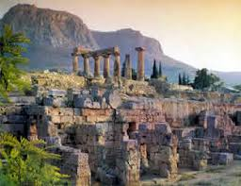
Ancient Corinth: The temple of Apollo rises above the agora (market)
Photo by greeceathensaegeaninfo.com

Delphi was the original place of the Olympic Games and home to the greatest temple of Apollo in the Greek world. It was home also to the mythological “Oracle of Delphi,” which took the form of a great python that Apollo mistakenly slew. It was also home to the Cumaean Sibyl who prophesied the return of Apollo in these last days. It is to hasten that prophecy that the high priestess of Apollo on Mount Olympus prays each time the Olympic torch is lit there. The prayer aligns to the prophecy by the Cumaean Sibyl, calling for the reign of the ancient Nephillim to return to earth, led by Apollo. This Apollo is the “Apollyon” of Revelation 9:11, 11:7, 17:8, and II Thessalonians 2:3.
The prayer over the Olympic torch was no different at the lighting of the Olympic torch before the London Olympics. A painting of the Cumaean Sibyl by Michelangelo can be seen in the ceiling of the Sistine Chapel in St. Peter’s Basilica, Vatican, Rome. He painted her as a huge manly-looking woman with six fingers--a Nephillim.
I took an early bus to Delphi. It was a 3½ hour trip, but a lovely one. Once in the fairly modern town of Delphi, which was little more than a bus stop, a restaurant, and a few stores for tourists, I had four hours before the last bus of the day left for Athens. I had to be on that bus or I’d miss my plane the next morning. I also would need to eat something, pack my things in my hotel in downtown Athens, and try to rest. The last bus was to leave about 4:oo PM, getting into Athens about 7:30. I would leave the hotel for the airport at 3:00 AM by taxi.
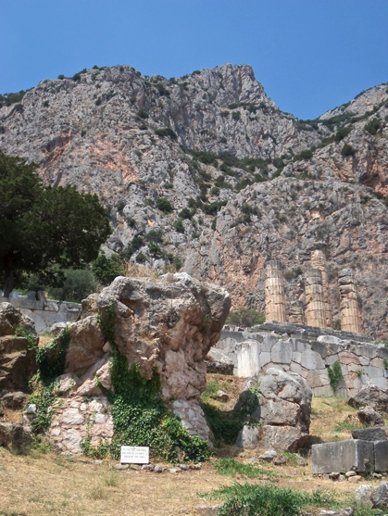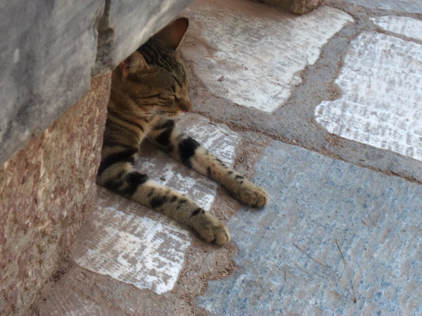
1st picture in Delphi: The rock seat of the Cumaean Sibyl in the foreground and the ruins of the temple of Apollo in the background
2nd picture: A peacefully resting cat below ruins of Delphi

Delphi was a major Greek city, the center of the worship of Apollo by 330 BCE.
I walked to the ruins of Delphi, about 1/2 mile from the small town. It was very hot, especially being up so high in the mountains. I did not bring a hat. At nearly noon, shade was almost non-existent. I climbed the hill to the ruins. I sat in front of the platform-seat on which the Cumaean Sibyl sat and gave her “oracle,” prophecy. This prophecy is the cry of the world today--for the ancient gods to return to rule.
There were five famous Sibyls. There was a “Delphic Sibyl,” besides the Cumaean Sibyl. The Sibyls were called “pythoness,” since Apollo’s symbol was the python. The spirit of the python rules America. The headquarters for its worship is in Arlington, Virginia. America was founded to restore the sun gods to power, especially Nimrod, who was Osiris in Egypt and Apollo in Greece. [Refer to: “America’s Secret Destiny”]
The crushing of the python spirit on the minds of Americans is being tangibly felt by many. Sha’ul and Barnabas dealt with this spirit of python in Acts 16:16-19 by casting it out of a pythoness--a “medium,” a fortune teller--who channeled demonic spirits. It got them into a lot of trouble with those who used her demonic powers to make them money. Portraits of three other sibyls, painted by Michelangelo, are also on the ceiling of the Sistine Chapel, equaling five in all. Now why would paintings of Sibyls and statues of Zeus, Apollo, Mithra, Diana, and other pagan sun gods and goddesses, be in the Vatican, especially in paintings in a chapel? It is because, the tap root of the Roman Catholic Church was planted about 30 years after the flood into the soil of the worship of Lucifer, the ”Illumined one,” and the continuance of Nephillim, “men of renown,” who were looked upon as sun gods. From the time of Canaan, son of Ham to Nimrod, to Moses and David, to the time after Solomon, when the northern tribes separated from the southern tribes, a trail of Nephillim (demonic-human hybrids), Rephaim (giants), and hybrids of mixing human DNA with that of other species, are described specifically in the Scriptures. “Bashan,” today’s Golan Heights, was called “the land of the giants.”
I went to Delphi to do proclamations and message-giving for Abba. I walked up the hill to the ruins. The sun was very hot. We were up several thousand feet above sea level in high mountains. I began getting symptoms of sun stroke. I had a severe case of sun stroke when I was 14, and was temporarily blind, so I knew the symptoms. I began to feel chills all over my body. There was no shade except back at the entrance of the ruins. I tried sitting in the shadow of some of the pillars of the temple, but that didn’t help much. I knew I was in danger. After seeing what I felt in my spirit that I was there to see, learn, and proclaim, I made my way down to the entrance and sat a while in the shade. I looked below my feet and saw a pretty cat sleeping under a stone. (Picture above) In that pagan place, so filled with spirits of the past that were still there, this cat was at rest. I have always loved cats, so this spoke to me of the life of rest in Yahuweh.
While sitting in the shade I gained strength, knowing I had to get back to the area where the bus would come. So, I got up and walked about 1/2 of a mile back to the bus area. When I got there it was almost 3:30. The bus was due to come at 4:00. I sat in a small restaurant that served as a bus stop, had a cold drink, and relaxed. A young girl came in with a heavy backpack. She was also going on the bus, too. About 3:45, the proprietor of the restaurant said for us to go across the street to wait for the bus. So, the girl and I went. There were also two young boys already waiting for the bus. But, at 4:00, the bus did not come, nor at 4:10, nor at 4:20. In my many travels for Abba to many countries, I am dependent on buses a lot of the time. But, this time my destination was a long ways away, and my flight to America was going out in a little over 12 hours – at 5:30 AM.
During the trip, I had been listening to Kent Henry’s worship music on my I-pod. One song stood out that kept singing in my head day and night: “Faithful God” – from Kent’s album Come to the Oasis. [I wrote an article “I Judge Him Faithful”/September 28, 2013, which gives my heart on the matter of His faithfulness]
As the bus didn’t come and didn’t come, the song kept getting louder and louder in my head. My spirit remained in peace, and His joy soared up from spirit.
Words to the song:
“This I testify, until I see it with my very own eyes
That Your Word is true, my God—no, You cannot lie!
And, I would have despaired unless I had believed I’d see your goodness,
But Your Word says Your mercy will follow me all of my days,
And I would have despaired unless I had believed I’d see your glory
And I know that by seeking You promised that I’d see Your face.
My faithful God ...”
This song is based on Lamentations 3:21-26: “This I recall to mind, therefore I wait – the kindness of Yahuweh! For we have not been consumed; His compassions have not ended--they are new every morning: Great is Your faithfulness! `Yahuweh is my portion’ says my soul. `Therefore, I wait for Him! Yahuweh is good to those who wait for Him-to the soul that seeks Him. It is good, both to wait and be silent, for the deliverance of Yahuweh.’ ”
Notice the word “wait” -- 4 times in this Scripture! Finally, as the song was playing at its loudest in my head, over a rise in the hills coming from up the Corinthians Channel, came the bus out of Delphi! I joyfully boarded, paid my fee, and road back to Athens. I couldn’t sleep that night, but I rested. Abba gave me the strength to get back to America and continue on for Him.
I wrote three articles at this time from what He taught me about what really happened at the London Olympics in July/August 2012. I had been at the very spot where the Olympics originated--the very place where Apollo was said to have ruled from as a god.
As a whole, mankind has rejected Yahuweh and His Torah. He is departing earth for a short time, except in the spirits of those servants whom He trusts and has called to serve Him in these end times. He is leaving the world to its lusts for a short time, just as Yahuweh allowed the Nephillim to continue and multiply all over the earth--before the Flood, and with unbroken succession until about 722 BCE when Yahuweh had to drive the ten northern tribes of the House of Ephraim/Joseph/Israel into the nations for their terrible sins against Him. For several reasons, I am convinced that they had returned to DNA mixing, so the only way to preserve the pure seed of the ten northern tribes was for Yahuweh to scatter them out into all nations of earth. [Refer to: “Who Are the Ten?”/2005] They were never lost to Him. Messiah came specifically to re-gather them (Matthew 15:24; 10:5-6; I Peter 1). Throughout the Scriptures there are hundreds of verses that tell about His marvelous restoration of a remnant from all of the tribes of Ya’cob. “El is not a man that He should lie…Has He not said, and will He not do it?” He is faithful to keep His promises! [Refer to: “The Aliyah Scriptures”/February 11, 2007]
While He did not manifest Himself to any others on earth, He did to Noah. There is a “Noah” remnant in our day. Entering this Shmittah year 2015, we entered the symbolic seventh day of Noah’s final week (Genesis 7). As he was spared through the Flood, so Yahuweh will spare a remnant through the fire of His wrath. [Refer to: “Shmittah Year 2015”/September 11, 2014] Isaiah speaks of His faithfulness, referring to the judgment of the Flood that is past, and the judgment that is coming of fire (Isaiah 43)
What was the most important thing about my trip to Delphi? - I did as Abba instructed. I saw what He wanted me to see. He saved me from heat stroke. He made sure I got the bus out. These are all very important things. But, what stands out to me has nothing to do with me. It has only to do with the consistency of His faithfulness! True faith does not rest in what we see, feel, hear, or think we know. Our faith must only rest in His faithfulness!
His ways are not our ways for sure! (Isaiah 55:8-13) Our human thoughts are not His thoughts! But, as we allow His Spirit to transform us from within into His nature, with His thinking, then we can tap into the heart of our Creator! (II Corinthians 3:17-18)
I love getting up to see the sunrise. The sun might not rise when we want it to, but it rises when it is supposed to rise--so are His dealings with us! Sunrises remind me of Lamentations 3.23: “Great is Your Faithfulness.” I love the old hymn by the same name:

Chorus: “Great is Thy faithfulness; great is Thy faithfulness
Morning by morning new mercies I see.
All I have needed Your hand has provided.
Great is Thy faithfulness Lord unto me.”

The blessings of His faithfulness fall on the just and the unjust. The rain fell and watered the crops that Cain brought to bring to Yahuweh as his offering, just as the water on the earth provided drink for the sheep that Abel offered to Yahuweh.
What matters in life is not that you have a head full of intellectual knowledge. What matters is that you are in the right place at the right time, trusting 100% in His faithfulness to get you where He wants you to go!
In the days before us in this Shmittah year, you will have opportunities to think that He has left you, stranded you, forsaken you, and you have no hope. He will seem a billion miles away at times. But, He has said, “I will never leave you or forsake you.” The word “forsake” carries the meaning “to strand along the roadside with no help.” He will never strand His precious children along the road of life with no help!
He always has a means of some type to get us where we are to go. Our responsibility is to be at the right place at the right time to get the right vehicle that will take us where He wants us. If we are late and miss it, we lose out--we only strand ourselves. Don’t blame someone ambiguously titled “God” by religion if you find yourself stranded with no help in the future. We have our part to play. We must daily flow in His perfect timing, in obedience to His will If I had walked back to Delphi-town at 5:00 PM because I lollygagged around in the ruins, I would have missed the bus and had no one to blame but myself. But, I was there 30 minutes early. If you are a servant of Yahuweh, you are always on assignment. Keeping time is very important! [Refer to: Flowing Daily in His Perfect Timing”/February 7, 2007 and “On Assignment”/November 12, 2009]
In His service, you always have somewhere to go. Don’t miss your bus! He has so much to show you and teach you. But mostly, He wants to teach you how to trust Him totally as a little child and to rest in peace and contentment, knowing He is the One in control! If we try to control, we become frustrated, confused, anxiety-stricken, and full of stress. But, if we, like a little child, turn over all control over our lives to Him, we have peace.
Learn the lesson of the bus out of Delphi! In that center of paganism, dedicated to a Nephillim god, He brought the bus for one of His lowly children who trusted totally in Him, and in that place a cat rested sweetly in the shade, free of care.
If there is any lesson you must learn to survive in the coming days, it is the lesson of knowing Him well enough to trust Him explicitly without losing your peace. He won’t fail you--guaranteed. He won’t fight you for control. You have to relinquish control to Him! You must put the ax to the root of any rebellious self-will in you, and then, is He free to take control! Once He is in control, don’t take back the reigns! You must pass the test of Iyob (Job) - He is Elohim, and you are not. [Refer to: “The Test of Iyob”/January 30, 2013]
Shabbat Shalom, blessings, in His love,
Yedidah, December 4, 2014

