THE BIRTHING OF RAIN

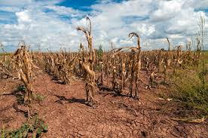

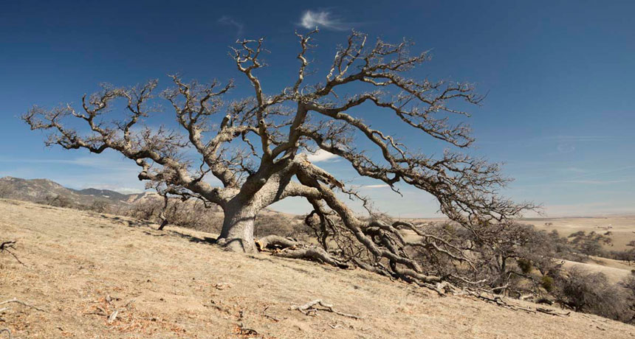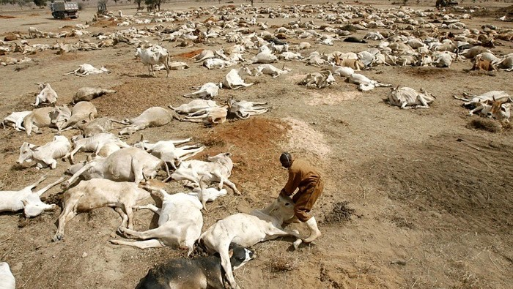
Cattle dying in Ethiopia, drought bringing famine

Deuteronomy 11:8, 10-15: “And you shall guard every command which I command you today so that you are strong and shall go in and shall posses the land which you are passing over to possess…for the land which you are going in to possess is not like the land of Egypt from which you have come, where you sowed your seed and watered it by foot like a vegetable garden, but the land you are passing over to possess is a land of hills and valleys which drinks water from the rain of the heaven, which Yahuwah your Elohim looks after. The eyes of Yahuwah Your Elohim are always on it from the beginning of the year to the latter end of the ear. And it shall be IF you diligently obey My commands which I command you today, to love Yahuwah your Elohim and to serve Him with all your heart and with all your soul, then I shall give the rain on your land in its season, the early ran and the latter rain, and you shall gather in your grain and your new wine and your oil. And I shall give grass in your fields for your livestock and you shall eat and be satisfied, Guard yourselves lest your heart be deceive and you turn aside and serve other gods and bow do to them. Then the displeasure of Yahuwah shall burn against you and He shall shut up the heavens and there shall be no rain and the land not give its increase. And you shall perish quickly from the good land which Yahuwah is giving you.”
Note: In Israel, the former rains are after Sukkot, in October/November. The latter rains are in March/April to bring forth the barley crop, and later on the wheat. The time of the outpouring of His latter rain will be in the spring, preparing the earth for the coming of Messiah, the final outpouring of His Spirit before judgment descents on the Day of Yahuwah (Yom ha Din). [Refer to the Scriptures in “The Day of Yahuwah”/Mikvah of Present Reality]
From I Kings 17:1, 18:1-2, 17-46: “Eliyahu the Tishbite of the inhabitants of Gilead said to Ahab, `As Yahuwah of Israel lives, before whom I stand, there shall be no dew or rain these years except at my word’… (drought came immediately for 3 years). And after many days it came to be that the Word of Yahuwah came to Eliyahu, in the third year, saying “Go present yourself to Ahab, and I shall give rain on the earth. Thereupon Eliyahu went to present himself to Ahab. And famine in Samaria was very severe…”
In the meantime the awesome contest on Mount Carmel took place, and Eliyahu, a Levite, slaughtered Jezebel’s prophets of Ba’al by the Wadi Qishon. The story picks up in I Kings 18: 41-46: “And Eliyahu said to Ahab, `Go up, eat and drink, because of the sound of the noise of rain. And Ahab went up to eat and to drink. And Eliyahu went up to the top of Carmel and he bowed down on the ground and put his face between his knees and said to his servant `Go up, please, and look closely toward the sea.’ So he went up and looked closely and said `not a speck.’ And seven times Eliyahu said to him `go again.’ And it came to be the seventh time that the servant said `see, a little cloud as small as a man’s hand is coming up out of the sea!’ And he said `Go up. Say to Ahab “Hitch up and go down before the rain stops you.’ ” And in the meantime, it came to be that the heavens became black with clouds and wind and there was a heavy rain while Ahab rode and went to Jezre’el. And the hand of Yahuwah was on Eliyahu. And he girded up his loins and ran ahead of Ahab to the entrance of Jezre’el/Yizrel’el.”
Hosea 5:14-6:1-3: “For I am like a lion to Ephraim, and like a young lion to the House of Judah. I Myself tear them and go. I take the away and there is none to deliver. Then I shall go. I shall return to My place until they confess their guilt and seek My face in their distresses, and diligently search for Me and say `Come and let us turn back to Yahuwah, for He has torn but He does heal us. He has stricken but He binds us up. After two days He shall revive us, on the third day He shall raise us up, so that we live before Him (in His sight). So, let us know, let us pursue to know Yahuwah. His going forth is as certain as the morning. And He comes to us like the rain, like the latter rain watering the earth.’ ”
Joel 2:25-32: “And I shall repay you the years that the swarming locust have eaten, the crawling locust, and the consuming locust, and the gnawing locust, My great army which I sent among you (Revelation 9:1-11)…And you shall know that I am in the midst of Israel…and My people shall never be put to shame. And after this, it shall be that I will pour out My Spirit on all flesh. And your sons and daughters shall prophesy, your old men shall dream dreams, your young men shall see visions. And also on the male servants and on the female servants I shall pour out My Spirit in those days. And I shall give signs in the heavens and upon the earth: blood and fire and columns of smoke, and the sun shall be turned into darkness and the moon into blood before the coming of the great and awesome Day of Yahuwah. And it shall be that everyone who calls on the Name of Yahuwah shall be saved…”
The Spirit of Yahuwah is symbolized in Scripture as wind, water, rain, and wine, and fire. At Sukkot, Messiah interrupted the Ceremony of the Water Pouring to interject His Truth, John 7:37-39: “And on the last day, the great day of the Feast, Yahushua stood and cried out saying, `If anyone thirsts, let him come to Me, and let him who believes in Me drink, as the Scripture have said: `out of His innermost being shall flow rivers of living water.’ And He said this concerning the Spirit, which those believing in Him were about to receive, for the Set-Apart Spirit was not yet given because Yahushua was not yet esteemed.”
The gift of salvation through the blood of the Lamb Yahushua Messiah and eternal life through His resurrection will be offered to mankind up until nearly the end, marked by the death of the two witnesses, three days before Messiah comes. (Revelation 11:5-18) Who will proclaim His salvation to the nations?
Matthew 24:12-14: “And because of the increase in lawlessness, the love of many shall grow cold. But, he who endures to the end shall be saved. And this Good News of the Kingdom shall be proclaimed to all the world as a witness to all the nations, and then the end shall come.”
Who will do the proclaiming? The Daniel 11:32 remnant will proclaim His Word into the earth, His message of both salvation and of judgment. Those of Mark 13:9, the martyrs/witnesses, will proclaim it before their beheading. Both groups are found before the throne of Yahuwah in Revelation 7! The message of Messiah is the ultimate separator forever – Matthew 10:32-39.
In Revelation 14:6-7 we find His final plea with mankind to repent and turn to Him: “And I saw another angel flying in the middle of the heavens holding the everlasting Good News to announce to those dwelling on the earth, even to every nation and tribe and tongue and people saying with aloud voice `Fear Elohim and give esteem to Him because the hour of His judgment has come. And worship Him who made the heavens and the earth and sea and the fountains of water.” [Refer to: “Just Acknowledge Me As Creator”/Mikvah of the Great Adventure]
As Revelation 14 progresses, we see that this is the dividing line between two divisions of humanity – for it is time of the great slaughter of the believers, and the sealing of the damnation of those who take the “mark of the Beast,” and the return of Messiah in judgment. It is the time of Revelation 9:20-21 when no one will repent. It is the time of Revelation 16:10-21, when no one repents.
All we have is today. Are you ready for this great time of purging? Spiritual drought blocks blessings. Spiritual drought closes the heavens. They become like a brass dome over the land. It is a sign of judgment on the land, whether Israel or any other land. His sign of blessing is gentle rain needed to produce good crops.
Do you want the rain of the anointing of the Spirit right now? If so, STOP READING FOR A FEW MINUTES and put the following link into google:

“It's Beginning To Rain” – YouTube - https://www.youtube.com/watch?v=EC27qDd7yHc (***3:35 minutes)
[Mar 13, 2014 - Uploaded by Bill Gaither Provided to YouTube by Universal Music]
Lyrics for the whole song: “It's Beginning To Rain: by William and Gloria Gaither/Aaron Wilburn

Verse 1: The turtle dove is singing its sweet song of morning,
The leaves of the trees turn their silver cups to the sky;
The silent clouds up above are beginning to gather,
The barren land is thirsty and so am I.
Chorus: It's beginning to rain hear the voice of the Father,
Saying "Who-so-ever will, come drink of His water;
I promise to pour My Spirit out on your sons and your daughters."
If you're thirsty and dry, look up to the sky, it's beginning to rain.
Verse 2: A young man's eyes start to shine as he tells of his vision,
And the old understand what he sees for they've dreamed their dreams;
With the thrill of being alive they reach for each other,
And they dance in the rain with the joy of the things that they see.
Chorus
Verse 3: At the first drop of rain that you feel, throw open the windows,
Then call all the children together, throw wide the door;
When the rains of the Spirit are falling, fill every vessel,
For he who drinks his fill will thirst no more.
Chorus

CONTINUING ON… In I Kings 18:42, we see that Eliyahu went into an ancient birthing position. He went into “travailing prayer.” Refer to: “Travailing Prayer”/Mikvah of the Heart of Elohim.
In travailing prayer one assumes the ancient squatting birthing position of Eliyahu, or kneels on the ground with face to the ground. Either way, the travailing is a groaning of the Spirit within our spirit that speaks His will into existence.
Travailing prayer is found in Romans 8:23-27: “…we ourselves who have the first fruits of the Spirit also groan within ourselves, eagerly awaiting the adoption, the redemption of our body…and in the same way the Spirit helps our weaknesses, for we do not know what we should pray for, but the Spirit Himself pleads our case for us with groaning unutterable. And He who searches the heart knows the mind of the Spirit because He makes intercession for the set-apart ones according to the will of Elohim.”
We must be filled with the Spirit within our re-born spirit (behind our stomach area to the top of our legs, the “loins area”). This is His throne room within us IF we have asked Him to come and dwell within us (I Kings 8 – notice the pattern! (I Corinthians 6:20-21) He brings with Him His Presence, power, authority, and gifts (i.e. I Corinthians 12:1-11), and He begins to teach us His Truth, lead us, speak to us, and speak through us in an angelic tongue. He “anoints us” with the oil of His Presence, so that we are transformed into the nature of Yahuwah, the Spirit.
Jeremiah 17:5-8 gives us the end result of trusting in man for help and rejecting the help of the Creators: “Thus said Yahuwah, `Cursed is the man who trusts in man and make flesh his arm and whose heart turns away from Yahuwah. For he shall be like a shrub in the desert, and not see when good comes and shall inhabit the parched places in the wilderness, a salt land that is not inhabited. Blessed is the man who trusts in Yahuwah and whose trust is Yahuwah, for he shall be like a tree planted by the waters which spread out is roots by the river and does not see when heat comes, and his leaf shall be green and in the year of drought, neither is he anxious, nor does he cease from yielding fruit.” [Please refer to: “Green Leaf in Drought Time.”]
Spiritual, or natural, drought is a curse. It makes for a parched land that bears no crops, no grain, no vegetables, and no fruit. It is dry and empty, and all life disappears from it, because life depends on rain, whether life on land, in the air, in the seas, or spiritual life in the Spirit.
Terraforming of the earth to make it a parched wilderness for the fallen ones – Isaiah 13:19-22/Septuagint Version has been purposely taking place since 1947. [Refer to: “70 Years of Weather Geoengineering – 70 Years of Man’s Destroying Earth’s Life Support Systems”/Mikvah of Present Reality and “Terraforming the Earth”/Mikvah of Present Reality]
Turbulence in people lives is drying up the fruit of their spirit, the life of the Spirit within their spirit, so that their soul is also drying up - the mind and emotions taken over by dullness, deadness, demonic spirits, and the body diseased and infirmed. There will be an outpouring of the Spirit before judgment.
Ya’cob/James 2:13: “For the judgment is without mercy/compassion to the one who has shown no mercy/compassion. And mercy/compassion boasts over judgment.”
Mark 13:9-10: “Take heed to yourself, for they shall deliver you up to the Council (“Sanhedrin” in Greek), and to congregations. You shall be beaten and you shall be brought before rulers and kings for My sake for a witness to them. The Good News has to be proclaimed first to all nations. And when they lead you away and deliver you up, do not worry beforehand what you are to say. But whatever is given to you in that hour speak that, for it is not you who is speaking but the Set-Apart Spirit.”
We see this time as a time of great harm for the believers in the Biblical Savior, the born-again and Spirit-filled believers. Only those who are Spirit-filled and Spirit-taught will hear Him speak what they are to say when they are to say it. It is not so that we can wax eloquent and be spared beheading. It is so that we might die as witnesses/martyrs for His Name. He will send forth a remnant company to proclaim His Word, even into the face of the antichrist. But, He will also have His witnesses, martyrs. Both of these groups are in Revelation 7 – and are before the throne of Yahuwah!
These who stand for the truth of the whole Word are brought before the Sanhedrin to be tried under the Noahide blasphemy and idolatry laws before being beheaded (Revelation 20:4). What is it that the Spirit would have them say, so that they don’t have to think beforehand? Mark 13:10 tells us: It is our witness before the executors, so that in the judgment they cannot say that they never heard the Good News of salvation. The word “martyr,” in Greek, means a “witness.”
His faithful servants are in training for reigning. There is an open heaven for those that do not try to escape death out of fear, those that stand strong when facing death and confess Him before man. Matthew 10:34-38 is the deciding factor for all humanity. I encourage you to get Derek Townsend’s mini-book For the Love of Truth – Possessing Your Eternal Life through Amazon Kindle. He goes into detail in Matthew 25 about means to “possess.”
Mark 4:24-25 and Luke 8:17-18 tell us that if we do not possess, protect and use what we have been given, even what we think we possess shall be taken away from us. The time period we are entering is designed by the enemy to take away all that we have been given, in the natural realm and the spiritual realm. If we do not possess what has been given to us by the Spirit, even our salvation can be removed. This is in many, many passages of Scripture. It’s our choice. We do any forfeit that is done. Yahuwah does not take it away unless we first take it away.
My story of rain in Kisumu, Kenya 1996 at Charis Bible College: It was my first time in Africa, and my main assignment was to teach at Andrew Womack’s Bible College in Kisumu, Kenya. The nation of Kenya had been in great drought for many months. Even though Kisumu is on Lake Victoria, it had not rained, and so drought conditions remained. On some of the islands in Lake Victoria, people were dying from having no food but mangos to eat. I gathered my pastor-students together to pray and command it to rain in and around the Kisumu area. We “prayed and commanded up a storm”--figuratively and actually. That night we heard the thunder and the rain, which poured out in abundance. At the Bible College the next morning, the pastors told me that no rain fell anywhere in Kenya except in our area. They said the newsmen were astounded, wondering why only in our area!
What are you birthing? What do you spend your time birthing – your own plans, your dreams, your wants? Are you like Ahab who feasted royally, then upon hearing Eliyahu’s proclamation, got into his chariot and rode as fast as possible to Jezre’el, to his second palace home? Or are you like Eliyahu? All the while Ahab was enjoying his food and drink, Eliyahu was up on the top of Mount Carmel birthing the rain in groaning and wailing travail. But, when the cloud was seen, his prayer was quickly answered. He quickly ran from Mount Carmel all the way down the Jezre’el/Yizra’el Valley to Jezre’el, running past Ahab and his chariot, because he was under the power of Yahuwah. In a car today, to go from the top of Carmel, which rises above the Mediterranean Sea, all the way down the longest valley in the world to Jezre’el, south of the modern town of Afula, near Megiddo, would take nearly an hour. Oh to run like Eliyahu did!!!
The seven thunders of Revelation 10 are thunders of finality – the final invitation to receive His salvation and the coming rain of the Spirit, before His ultimate Judgment is poured out at the coming of Messiah. The thunders announce a line drawn in the sand by Yahuwah – as Eliyahu once told the prophets of Ba’al – get on one side or the other, because if you’re in the middle, as Messiah said, you’ll be vomited you out of His mouth. Thunder is a result of lightning.
Psalm 77:17-18: “The clouds poured out water. The heavens rumbled. Also, Your arrows flashed back and forth. The voice of Your thunder rolled along. Lightening lit up the world. The earth rumbled and shook.”
When a person hears the noise of thunder, the mind says “it’s going to rain.”
Look again at what Eliyahu told Ahab in I Kings 18:41: “Go up, eat and drink, because of the sound of the noise of rain.”
Then Eliyahu went up to the top of Carmel which overlooks the Jezre’el Valley on the East and the Mediterranean Sea to the West. I’ve stood on that exact spot. Below is the Wadi Qishon. The view of the Mediterranean Sea is clearly below to the West. The Jezre’el Valley is so clear that one can see all the way to Mount Tabor to the East, which is after the turnoff through Afula to the ruins of Jezre’el.
The palace of Ahab and Jezebel has been excavated. It faces the drop off to the floor of the Jezre’el/Yizre’el valley. Just down that steep slope was Naboth’s vineyard, and from the palace Jezebel was thrown out to her death and her dogs ate her as Eliyahu prophesied. Just near is Ein Herod, where Gideon amassed his army. It overlooks the Jezre’el Valley also, where the Midianites amassed to attack Gideon’s 300. That valley is called the greatest battlefield in the world. More wars have been fought in that valley through the millennium than anywhere else on earth. It is the place of the gathering of the army of Ezekiel 38 and Zechariah 14:1-5 that comes down towards Jerusalem, which Messiah wipes them out with the Word of His mouth. (Revelation 19)
Hosea 1 – Read it! That valley is very prophetic. Hosea 1:10-11: “Yet, the number of the children of Israel shall be as the sand of the sea which is not measured nor counted. And it shall be in the place where it was said to them `You are not my people,’ they shall be called `You are the sons of the living El.’ And the children of Judah and the children of Israel shall be gathered together and appoint for themselves One head and shall come up out of the earth (the first resurrection), for great is the day of Jezre’el!”
It is the Day of Yahuwah – the Day of Judgment. It is the Day of the resurrection of the justified. Revelation 19-20:6! It is the final reckoning judgment! [Refer to: “The Day of Yahuwah”/Mikvah of Present Reality]
Just before judgment comes, the rain also will come--birthed by a remnant who know how to birth His will into the earth. This is true intercession! Are you birthing the final invitation of Yahuwah to the world’s people--the last invitation given for salvation?
Oh what exciting times we live in! Talk about living on “the edge!” Press into Him, travail and be a part of the birthing.
“`For I know the plans I am planning for you,’ declares Yahuwah, `plans of peace and not of evil, to give you a future and expectancy. Then you shall call on Me and shall come and pray to Me, and I shall listen to you. And you will seek Me and you will find Me, IF you search for Me with all your heart.’ ” (Jeremiah 29:11-13)
In His love and mercy, Yedidah
March 2, 2019 [Podcast C: “The Birthing of Rain”/March 3, 2019]

