The Crucified Life of the Iranian Christians

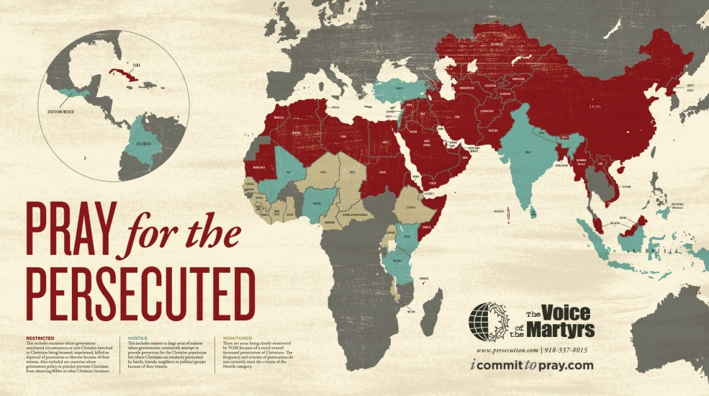

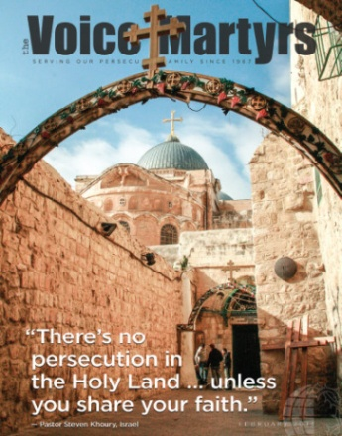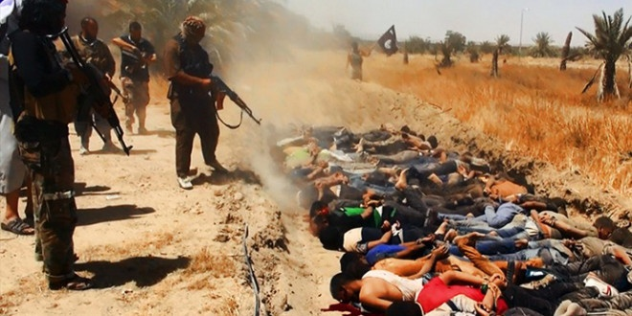

Look at the light of the Savior flowing through this precious girl! She suffered greatly but she did not deny her faith in Jesus. Could this be your joyful child because you taught them that suffering and martyrdom was an honorable and righteous witness to their Savior? (Mark 13:9-12) Have you taught them that those of Hebrew 11-12:2 are returning to join with us, to encourage us as we face death for His sake? Have you taught them Revelation 7:9-17? Someone taught these Christian of today that martyrdom was worth for all eternity!

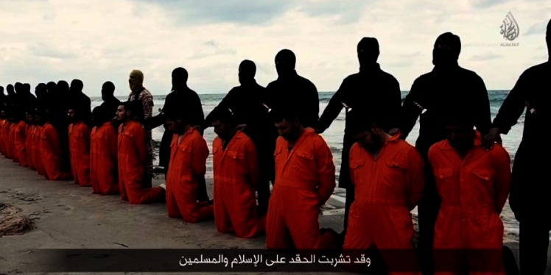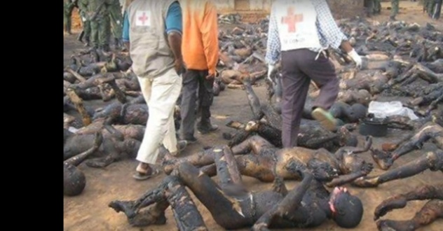
Left: ISIS beheads Iraqi and Syrian Christians
Right: Nigerian Christians burned to death

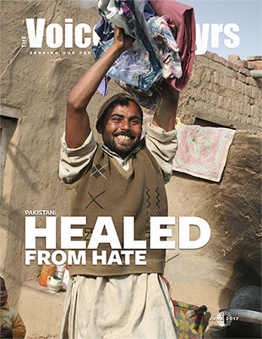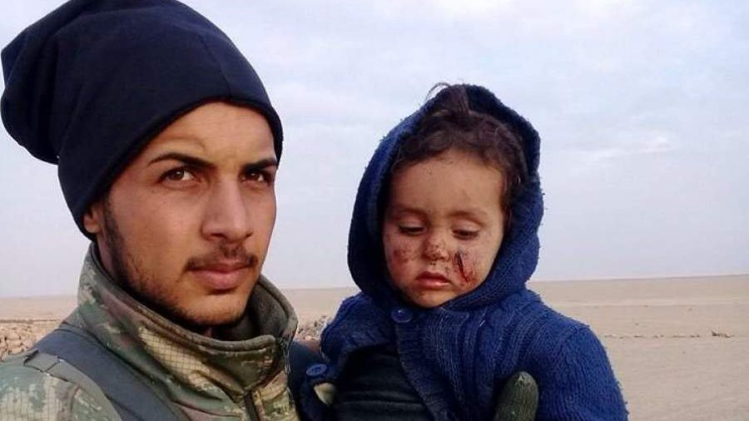
Left: A former Pakistani terrorist is now born again
Right: A Kurdish Christian with his injured child
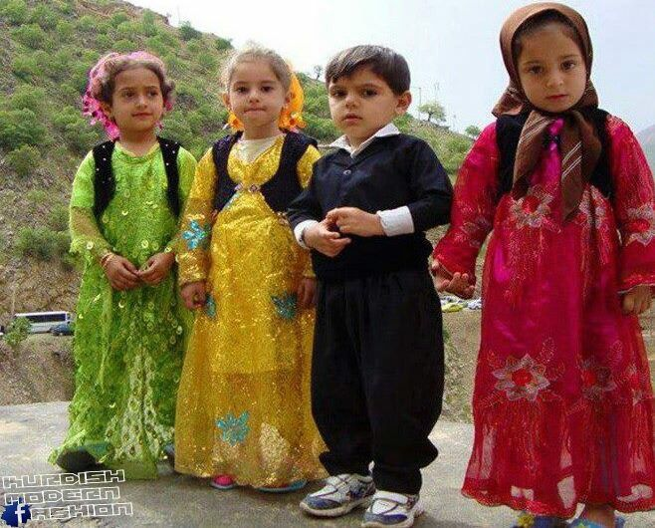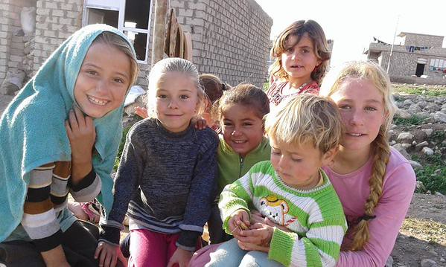
Left: Kurdish children in traditional dress – beautiful children!
Right: Happy Children! Now being raped, tortured, and killed by ISIS

Western-Culture “Believers”: What “Bible” are you reading? By the reaction of most in the affluent world of comfort and ease regarding the basics of being a disciple of Yahushua/Yeshua/Jesus, you must be reading a very different Bible than the one read by Christians who are suffering and dying for their faith. Hundreds of thousands of true born-again believers today are living with persecution worse than any other time period in the last 2,000 years. But, they accept that as “normal” for a follower of the One who died for them. They look to Him as their example of faithfulness.
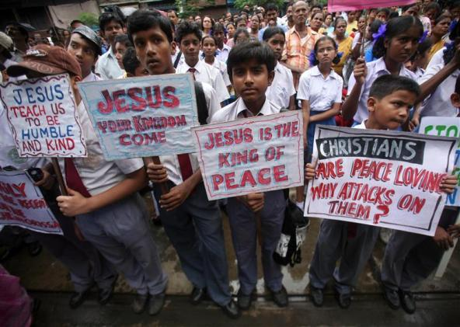

“Sheep Among Wolves Volume II” (Official Feature Film) August 23, 2019
FAI STUDIOS This movie is a priceless documentation of the lives of the Iranian Christians.
Christians worldwide risk death daily for sharing Good News of salvation through the death and resurrection of Jesus Christ. “The blood of the martyrs is the seed of the church” is a very famous quote. Historically, it is evident that it is when facing persecution that leads to death that most believers become dedicated to spreading the good news of Yahshua – the “salvation of Yah.”
The strongest faith of all believers is to be found in places like mainland China, North Korea, Iran, Nigeria, Pakistan, Saudi Arabia, and near 40 other counties where to believe in Savior of the Bible is a crime worthy of death.
Punishment for the crime of having salvation through the blood of the Lamb of Elohim, and the double crime of telling others about Him, is soon coming to the western world. ISIS has camps in all 50 America states. Remember ISIS is the creation of Barak Obama and “friends.” Also remember the greatest slaughterer of Christians in the Middle East has been, and is being, done by terrorist groups that were/are created, funded, directed, and given weapons, by the United States.
Today there are tens of thousands of people within America ready to behead those who confess Jesus/Yeshua/Yahushua/Isa as Savior and Lord. Many secret cells of terrorist groups and Muslims are waiting for their orders. But, also, many future executioners are simply military men who are experts at beheading, whether by sword or by guillotine. Those who approve of beheading by guillotine are overjoyed by the tens of thousands of guillotines stationed throughout America, on military bases, in F.E.M.A. camps, in government buildings, and in prisons.
Yes, beheading is the manner of execution by radical Muslims. It has been confirmed that the reason Turkey went into Syria to bomb the Kurds was so that they could release many thousands of ISIS prisoners. Two days ago the thousands were released in mass to be taken to three strategic locations along the border with Iraq to begin their job of toppling the government of Iraq for takeover. The new world order plans are being implemented quickly. Today we hear that Secretary of State, Mike Pompeo, has told Israel they can bomb anywhere they like – Iran or wherever they feel it’s necessary.
The first thing the released ISIS prisoners vowed openly, recorded on video, was to behead all Kurds they found, especially those not submitted to Islam. That means the Christian Kurds. ISIS about wiped out all Christian Kurds in northern Iraq, and Christian Syrians too.
I watched video footage of the release of ISIS that was shown by Steven ben Nun, and I heard the words vowed to behead all Kurds not submitting to strict Islam. London’s Daily Mail recently covered the story very well!
Beheading is the manner of execution written about in Rabbinic Judaism’s Babylonian Talmud, for anyone believing in the deity of Jesus/Yeshua/Yahushua, Isa, or any other name that refers to Him. This is international law under the “Noahide Laws.”
Already, the Bible is considered a hate crime book internationally, and the name Yahweh is considered a name associated with murderous fanatics. It was banned under Pope John Paul II from all Catholic bibles, prayer books, and hymnals. All Catholic Church members were forbidden to use that name in churches or even in private prayer.
Revelation 20:4: “And I saw thrones and they that sat on them, and judgment was given to them – and the lives of those who had been beheaded because of the witness they bore to Yahushua and because of the Worrd of Elohim - and who did not worship the beast, or his image and did not receive his mark upon their forehead or upon their hands. And they lived and reigned with Messiah for a thousand years…”
Revelation 14:12-13: “Here is the endurance of the set-apart ones, here are those guarding the commands of Elohim and the faith of Yahushua. And I heard a voice out of heaven saying to me, `Write: Blessed are the dead who die in the Master from now on.’ `Yea’ says the Spirit, `in order that they rest from their labors, and their works follow them.’ ”
If you are submitted 100% to the Master Yahushua and His Father Yahuwah then this is your battle cry: “I am crucified with Messiah, nevertheless I live, yet not I but Messiah lives in me. And the life that I now live, I live by faith in the Son of Man who loves me and gave Himself for me.” (Galatians 2:20)
The reason most persecuted believers are so bold is because they are dead already. They understand that, as Shaul wrote in Romans 6, when they are baptized, they go under the water symbolically dying to self, and rising up out of the waters as new creations, alive only to their Master.
The idea of 100% submission to a new Master following repentance and salvation is natural to those in non-Western culture. Yahushua is not just their Savior but Master/Lord. He is the one who bought them from the kingdom of darkness and took them into the Kingdom of Light. They understand that as citizens of the Kingdom of Light, they owe absolute unfailing allegiance to their new King.
They understand submission as servants to a Master who saved them from eternal damnation, and they go out right away to witness, knowing they may be killed immediately. Many in Mainland China are killed by the Chinese Cadre as they are in the baptismal waters of a river. To die for the One who died for them is natural.
This concept is carried forth in Islam. Many, even little children, choose to be suicide bombers, or to go to war against infidels and risk their lives. They believe that through death they will be rewarded for their faithfulness to Allah.
Christians in areas of persecution do not purposely die to get rewarded in heaven, but they understand that this life is only temporal and heaven is forever.
Tragically, most Western “believers,” not persecuted for their faith, have a religious belief system without any reality attached to it. Churches are not preaching repentance as a requirement for salvation, or emphasizing what it means to die to self, to lay down one’s life to reach the lost, or what it means to be a “disciple” of a Master. Most only have a shallow concept of what it means to be “saved.” Almost all Messianic religion emphasizes Torah observance over knowing Yahuwah and Yahushua personally, and has almost no understanding of submission to Yahushua as Master.
Relationship with Father and Son is not taught for the most part anywhere in the Western world of religion. Abraham knew Yahuwah as a Friend. Moses knew Yahuwah face to face. Steven saw Yahushua standing up receive him as he was being stoned to death by the Pharisees (Acts 7).
We’re all called to a “crucified life.” Unless we die to self, we cannot enter the Kingdom of Elohim.
In closing, I share with you an article that gives an overview of the crucified life of the Iranian believers. Yahuwah is indeed pouring out His Spirit on all flesh (Joel 2:30-33) as we face the onslaught of great tribulation. But, very few are receiving His precious gift.
I zero in on the Iranian Christians now because it is being called the fastest growing church in the world, under extreme persecution. Their persecution is bringing great revival. Through a broken heart, Yahuwah and Yahushua rejoice that Their love for mankind was not in vain!!!

“Iran has world’s ‘fastest-growing church,’ despite no buildings - and it's mostly led by women” by Caleb Parke | Fox News October 2019
… “People in Iran, a Muslim-majority nation, are fleeing Islam in droves as believers bow their knee to Jesus and become aggressively pro-Israel, according to the documentary `Sheep Among Wolves Volume II.’
`What if I told you Islam is dead?’ one unidentified Iranian church leader says in the film …`What if I told you the mosques are empty inside Iran?’ he continues. `What if I told you no one follows Islam inside of Iran? Would you believe me? This is exactly what is happening inside of Iran. God is moving powerfully inside of Iran.’
IRAQI CHRISTIAN SURVIVES BEING BURNED ALIVE BY ISIS 3 TIMES: '[JESUS] SPOKE TO ME'
The pastor adds: “What if I told you the best evangelist for Jesus was the Ayatollah Khomeini? The ayatollahs brought the true face of Islam to light and people discovered it was a lie...After 40 years under Islamic law — a utopia according to them — they’ve had the worst devastation in the 5,000-year history of Iran.”
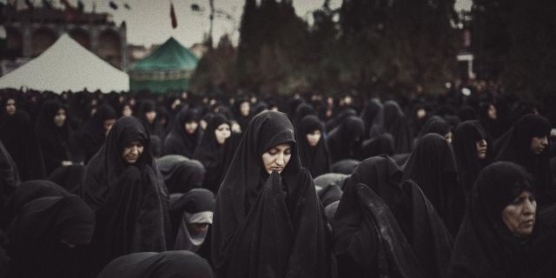
More Iranians have come to faith in Jesus in the last 20 years than the 1,300 years since Islam swept through Persia-combined. Thomas calls the movement `the Iranian awakening.’
`It owns no property, no buildings, no central leadership, and is predominantly led by women," he said in a statement.’
`Named after the Bible verse Matthew 10:16 which says, “Behold, I am sending you out as sheep in the midst of wolves, so be wise as serpents and innocent as doves,” the documentary claims `Muslim-background Iranians are leading a quiet but mass exodus out of Islam and bowing their knees to the Jewish Messiah -- with kindled affection toward the Jewish people.’
But the new believers in the Islamic Republic face great risks.
CHRISTIAN PERSECUTION CLOSE TO 'GENOCIDE LEVELS,' LARGELY IGNORED DUE TO 'POLITICAL CORRECTNESS' REPORT
`We know that if they get us, the first thing they will do to us as a woman is rape us and then they will beat us and ultimately they will kill us,’ one believer said. `This is the decision we have made that we want to offer our bodies as sacrifices. Because I have this thought when I wake up, that when I leave, that door I might not come back.’
A leader of the Iranian underground church explains their goal is not planting churches but rather making disciples, the majority of whom are women.
MORE ON FAITH
…Pastor Bill Johnson on the recipe for revival, how Bethel Church exploded onto the global scene: `Disciples forsake the world and cling to Jesus 'till he comes. Converts don't,’ the leader said. `Disciples aren't engaged in a culture war. Converts are. Disciples cherish, obey, and share the word of God. Converts don't. Disciples choose Jesus over anything and everything else. Converts don't. Converts run when the fire comes. Disciples don't.’
And a pastor explains, everything they do underground is built on prayer.
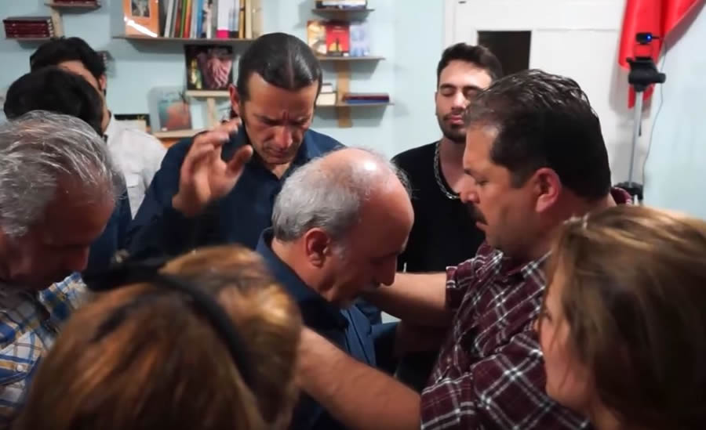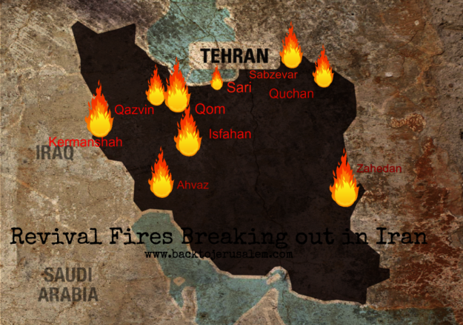
Pray for those dying for their faith as if it was your family!
The Bible of the persecuted believers says: “…It has been given to you as a favor on behalf of Messiah not only to believe in Him but also to suffer for His sake…Therefore, since Messiah suffered in the flesh, arm yourself also with the same mind, because he who has suffered in the flesh has ceased from sin, so that he no longer lives the rest of his time in the flesh for the lust of men but according to the desires of Elohim…Be sober, watch, because your adversary the devil walks about like a roaring lion, seeking someone to devour. Resist him, firm in faith, knowing that the same hardships are experienced by your brothers in the world. And the Elohim of all favor who called you to His everlasting esteem by Messiah Yahushua, after you have suffered a while, Himself will perfect, establish, strengthen and settle you. To Him be all the esteem and the might forever and ever. Amen.” (Philippians 1:29; I Peter 4:1-2, 8-11)
“See, I send you out as sheep in the midst of wolves. Therefore be wise as serpents and innocent as doves. But beware of men, for they shall deliver you up to Sanhedrin and flog you in their congregations. And you shall be brought before governors and kings for My sake, as a witness to them and to the nations. But when they deliver you up, do not worry about how or what you should speak. For it shall be given to you in that hour what you shall speak, for it is not you who speak, but the Spirit of your Father speaking in you. And brother shall deliver up brother to death, and a father his child. And children shall rise up against parents and shall put them to death. And you shall be hated by all for My Name’s sake. But he who shall have endured to the end shall be saved…A disciple (taught one) is not above his teacher, nor a servant above his master. It is enough for the taught one to become like his teacher, and a servant like his master. If they have called the master of the house Be‛elzebul, how much more those of his household! Therefore do not fear them. For whatever is covered shall be revealed, and whatever is hidden shall be made known. What I say to you in the dark, speak in the light. And what you hear in the ear, proclaim on the house-tops. And do not fear those who kill the body but are unable to kill the being. But rather fear Him who is able to destroy both being and body in Gehenna…Everyone, therefore, who shall confess Me before men, him I shall also confess before My Father who is in the heavens.
But whoever shall deny Me before men, him I shall also deny before My Father who is in the heavens. Do not think that I have come to bring peace on earth. I did not come to bring peace but a sword, for I have come to bring division, a man against his father, a daughter against her mother, and a daughter-in-law against her mother-in-law and a man’s enemies are those of his own household. He who loves father or mother more than Me is not worthy of Me, and he who loves son or daughter more than Me is not worthy of Me. And he who does not take up his stake and follow after Me is not worthy of Me. He who has found his life shall lose it, and he that has lost his life for My sake shall find it.” (from Matthew 10)
Enough said: Be sure to watch the documentary “Sheep Among the Wolves.” Be sure you’ve read “The Unleashing…,” last posted article, and are in prayer.
In His love and shalom,
Yedidah
October 21, 2019

