THE HIDDEN MESSAGE IN THE EPIC LOCUST PLAGUE THE TIMING OF YAHUWAH REVEALED
SCRIPTURAL HARBINGERS OF THE RETURN OF MESSIAH
Exodus 10; Joel 2; Revelation 6:8, 7:1-3, 8:7, and 9:1-11
FAMINE, ECONOMIC COLLAPSE, STARVATION, and DEATH

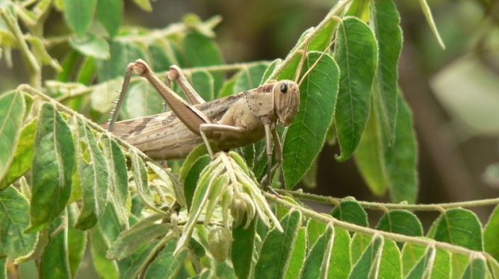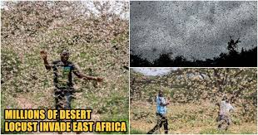
Kenya, Ethiopia, Somalia - Crops in danger
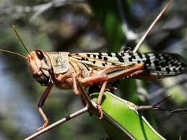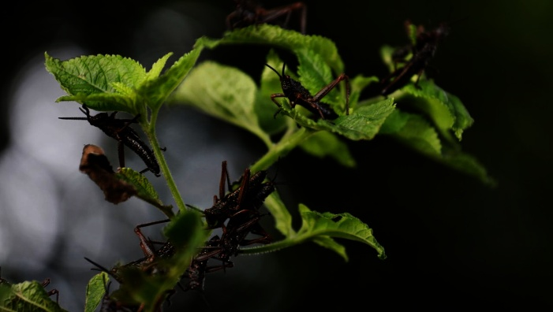
Pakistan Declares National Emergency – Crops in danger

Refer to: “Historic Locust Plague Threatens Famine in East Africa”

Exodus 10:1-20: “And יהוה said to Mosheh, `Go in to Pharaoh, for I have hardened his heart and the hearts of his servants, so that I show these signs of Mine before him, and that you relate in the hearing of your son and your son’s son what I have done in Mitsrayim, and My signs which I have done among them. And you shall know that I am יהוה.’ And Mosheh and Aharon came in to Pharaoh and said to him, “Thus said יהוה Elohim of the Heḇrews, ‘Till when shall you refuse to humble yourself before Me? Let My people go, so that they serve Me. ‘Or else, if you refuse to let My people go, see, tomorrow I am bringing locusts within your borders. ‘And they shall cover the surface of the land, so that no one is able to see the land. And they shall eat the rest of what has escaped, which remains to you from the hail, and they shall eat every tree which grows up for you out of the field. ‘And they shall fill your houses, and the houses of all your servants, and the houses of all the Mitsrites, which neither your fathers nor your fathers’ fathers have seen, since the day that they were on the earth to this day.’ Then he turned and went out from Pharaoh…And יהוה said to Mosheh, `Stretch out your hand over the

land of Mitsrayim for the locusts to come upon the land of Mitsrayim and eat
every plant of the land – all that the hail has left.’ And Mosheh stretched out his rod over the land of Mitsrayim, and יהוה brought an east wind on the land all that day and all that night. Morning came, and the east wind brought the locusts. And the locusts went up over all the land of Mitsrayim and settled within all the borders of Mitsrayim, very grievous. There had never been locusts like them before, nor would there again be like them. And they covered the surface of all the land, so that the land was darkened. And they ate every plant of the land and all the fruit of the trees which the hail had left, and no greenness was left on the trees or on the plants of the field, in all the land of Mitsrayim.
Pharaoh then called for Mosheh and Aharon in haste, and said, `I have sinned against יהוה your Elohim and against you. And now, please forgive my sin only this once, and pray to יהוה your Elohim, that He would only turn away this death from me.’ And he went out from Pharaoh and prayed to יהוה. And יהוה turned a very strong west wind, which took the locusts away and blew them into the Sea of Reeds. Not one locust was left within all the border of Mitsrayim. However, יהוה hardened the heart of Pharaoh, and he did not let the children of Yisra’ĕl go.”

Joel 2:1-11, 25-26: “`Blow a ram’s horn in Tsiyon, and sound an alarm in My set-apart mountain! Let all the inhabitants of the earth tremble, for the day of יהוה is coming, for it is near: a day of darkness and gloom, a day of clouds and thick darkness, like the morning clouds spread over the mountains – a people many and strong, the like of whom has never been, nor shall there ever be again after them, to the years of many generations. Ahead of them a fire has consumed, and behind them a flame burns. Before them the land is like the Garden of Ěḏen, and behind them a desert waste. And from them there is no escape. Their appearance is like the appearance of horses, and they run like steeds. As the noise of chariots they leap over mountaintops, as the noise of a flaming fire consuming stubble, as a mighty people set in battle array. Before them peoples are in anguish, all faces become flushed. They run like mighty men, they climb the wall like men of battle, everyone goes on his way, and they do not break ranks. And they do not press one another; everyone goes in his path. They fall among the weapons, but they do not stop. They rush on the city, they run on the wall. They climb into the houses, they enter at the windows like a thief. The earth shall tremble before them, the heavens shall shake. Sun and moon shall be darkened, and the stars withdraw their brightness. And יהוה shall give forth His voice before His army, for His camp is very great, for mighty is the doer of His word. For the day of יהוה is great and very awesome, and who does bear it? Then I shall repay you the years that the swarming locust has eaten, the crawling locust, and the consuming locust, and the gnawing locust, My great army which I sent among you. Then you shall eat – eat and be satisfied – and shall praise the Name of יהוה your Elohim, who has done with you so wondrously. And My people shall never be put to shame.’ ”
Yahuwah calls them “My army” because he uses the fallen ones to bring judgment on fallen humanity. This army is symbolize in mannerism as locusts, though it is obvious that they are hybrid entities of the fallen angels.

Revelation 6:7-8: “And when He opened the fourth seal, I heard the voice of the fourth living creature saying, “Come and see.” And I looked and saw a pale horse. And he who sat on it had the name Death, and the grave followed with him. And authority was given to them over a fourth of the earth, to kill with sword, and with famine, with death, and by the beasts of the earth.
In Joel 2 and Revelation 9, the “locusts” are supernatural mutant beings who rise out of the pit of the deep opened by the “star” wormwood – a mighty fallen angel. They are a supernatural army led by fallen angels, Nephilim, and Rephaim. This is the army that amasses at Megiddo in the Jezre’el Valley between Carmel in Haifa, and Bet Shean south of Tiberias – the greatest battlefield the world has ever known – Hebrew, “Har Megiddo,” Ar-megeddon, Greek, for their march towards Jerusalem to come against Messiah as He descends. (Revelation 16:13-14, 16; Zechariah 14:1-5) The “battle” of Armegeddon is also described in Revelation 19:19-20:3. So much for Hollywood hype!
Isaiah 13:3, Septuagint: “THE VISION WHICH ESAIAS SON OF AMOS SAW AGAINST BABYLON Lift up a standard on the mountain of the plain, exalt the voice to them, beckon with the hand--open the gates, ye rulers. I give command, and I bring them: giants are coming to fulfill my wrath, rejoicing at the same time and insulting. A voice of many nations on the mountains, even like to that of many nations; a voice of kings and nations gathered together: the Lord of hosts has given command to a war-like nation, to come from a land afar off, from the utmost foundation of heaven; the Lord and his warriors are coming to destroy all the world. Howl ye for the Day of the Lord is near and destruction from God shall arrive…”
The message of this historic locust invasion on both sides of the Red Sea, 2019-2020, is a message, an announcement, of the coming of this massive spiritual locust-like army that devours everything in its path. Before it is a “garden of Eden,” after it is a barren wilderness. The destruction of green things by locusts in the Middle East and the East African continent is a harbinger of the coming of the world ruler (Beast of Revelation 13/”antichrist”). They bring famine. Famine brings economic collapse. These conditions bring disease, and all attract the beasts of the earth. Thus we see the compacting of the 4 horsemen of Revelation 6!
By the time of his arrival the earth will be nearly destroyed in many ways. With the invasion of the demonic army of hybrids and mutants, the destruction of grain and vegetable crops, plants, trees, bushes, grass, fruit of trees – green things that produce oxygen and maintain health – most of humanity will be dead from war, starvation, disease, and “beasts” of the earth.
Messiah said that “if the days were not few, no flesh would be alive at His coming. KJV says “…if the days were not shortened…” They’re not “shortened,” they are few. In other word, He compacts the events tightly into a smaller space of time, so that the time of His people’s suffering will be less!
Therefore the translation of the Bridal remnant (Revelation 14:1-5), the “first fruits of the resurrection” must take place before 1) the green things are totally destroyed and 2) before the anti-messiah/Beast can kill them. Millions of martyrs will have eternal great rewards (Revelation 7:9-17)

KEY VERSES: TIMING RELATED TO THE DESTRUCTION OF GREEN THINGS
Did Yahuwah drag out the 10 plagues into a long period of time? NO! It was one right after the other, and they were out! Yahuwah is no sadist!!! He does not drag out the judgment and punishment. He compacts them into a short time, not 7-years, not 3½ years. The worst is only 10 days, from Yom Teruah to Yom Kippur.
[Refer to: “Days of Awe: Yamin Noraim – The Most Serious Ten Days of the Entire Year” [Podcast CXXXII, September 3, 2019] and “Yom Kippur, Day of Atonement – Leviticus 16 – Yom ha Din, Day of Judgment-Wrath, Day of Yahuwah”]
When the locust plague came on Egypt it was the 8th of 10 plagues. The 9th plague was darkness upon the land. The 10th plague was the death of the first-born sons of the Egyptians, followed by the “Passover” and the Exodus. (Exodus 12)
Joel 2:30-31; Zephaniah: 1:14-18; Revelation 16:10-22: Demons like locusts covering the land are followed by thick darkness. Then comes Messiah on the “Day of Yahuwah,” the day of His wrath, the Day of great darkness. Then comes the resurrection of the righteous dead. The translated Bridal remnant, “first fruits of the resurrection, and those in hiding in Petra who remaining alive during the last 10 days of Satan’s rampage of death, will be caught up to be with Yahushua as He descends (I Thessalonians 4:13-18; Revelation 14:1-5).

Revelation 7:1-3: “And after this I saw four messengers standing at the four corners of the earth, holding the four winds of the earth, that the wind should not blow on the earth, nor on the sea, nor on any tree. And I saw another messenger coming up from the rising of the sun, holding the seal of the living Elohim. And he cried with a loud voice to the four messengers to whom it was given to harm the earth and the sea, saying, “Do not harm the earth, nor the sea, nor the trees until we have sealed the servants of our Elohim upon their foreheads.”
Revelation 8:7: “And the seven messengers who held the seven trumpets prepared themselves to sound. And the first messenger sounded, and there came to be hail and fire mixed with blood, and they were thrown to the earth. And a third of the trees were burned up, and all green grass was burned up.”
Revelation 9:1-12: “And the fifth messenger sounded, and I saw a star from the heaven which had fallen to the earth. And the key to the pit of the deep was given to it. And he opened the pit of the deep, and smoke went up out of the pit like the smoke of a great furnace. And the sun was darkened, also the air, because of the smoke of the pit. And out of the smoke locusts came upon the earth, and authority was given to them as the scorpions of the earth possess authority, and it was said to them that they shall not harm the grass of the earth, or any green thing, or any tree, but only those men who do not have the seal of Elohim upon their foreheads. And it was given to them that they should not kill them, but to torture them for five months. And their torture was like the torture of a scorpion when it stings a man. And in those days men shall seek death and shall not find it. And they shall long to die, but death shall flee from them. And the locusts looked like horses prepared for battle, and on their heads were crowns like gold, and their faces were like the faces of men. And they had hair like women’s hair, and their teeth were like lions’ teeth. And they had breastplates like breastplates of iron, and the sound of their wings was like the sound of chariots of many horses running into battle. And they have tails like scorpions, and stings. And in their tails is their authority to harm men five months. And they have over them a king--the angel/messenger of the pit of the deep, whose name in Hebrew is Abaddon, but in Greek he has the name Apollyon. The first woe is past. See, two woes are still coming after this.”

1) This locust plague signals the soon release of demonic “locust” army that covers the earth and destroys what brings life to His creation.
2) Darkness due to the Revelation 8:6-10 asteroid that hits on earth releasing perhaps hundreds of volcanoes to erupt, causing darkness over the land as if it were night, and the moon to appear reddish. This is both natural darkness and supernatural darkness as the Beast begins to release the greatest of Satan’s power over the earth.
3) The King of the Kingdom of Light breaks through the darkness and brings with Him all those who have died in faith to receive their resurrection bodies, and bringing His Bridal remnant to ride behind Him as He descends. All of His faithful servants get a front-row seat as He descends!

The locust plague we’re seeing now is a harbinger of what is to come under the rule of the Beast, to whom Satan gives his authority, power, and throne. (Revelation 13:1-10)
Revelation 8:10-13; 9:1-4, 11: “And the third angel/messenger sounded, and a great star fell from the heaven, burning like a torch, and it fell on a third of the rivers and on the fountains of water, and the name of the star is called Wormwood. And a third of the waters became wormwood, and many men died from the waters, because they were made bitter. And the fourth messenger sounded, and a third of the sun was struck, and a third of the moon, and a third of the stars, so that a third of them were darkened. And a third of the day did not shine, and likewise the night. And I looked, and I heard an eagle flying in mid-heaven, crying with a loud voice, `Woe, woe, woe to those dwelling upon the earth, because of the remaining blasts of the trumpet of the three messengers who are about to sound.’ … And the fifth messenger sounded, and I saw a star from the heaven which had fallen to the earth. And the key to the pit of the deep was given to it. And he opened the pit of the deep, and smoke went up out of the pit like the smoke of a great furnace. And the sun was darkened, also the air, because of the smoke of the pit. And out of the smoke locusts came upon the earth, and authority was given to them as the scorpions of the earth possess authority. And it was said to them that they shall not harm the grass of the earth, or any green matter, or any tree, but only those men who do not have the seal of Elohim upon their foreheads…And they have over them a king, the messenger of the pit of the deep, whose name in Heḇrew is Abaddon, but in Greek he has the name Apollyon.”
(Beast/anti-messiah: Revelation 9:11, 11:7, 17:8, II Thessalonians 2:3 – Nimrod/Gilgamesh, Osiris, Horus, Apollo/Apollyon)
I repeated some here because I wanted you to see that this “star” in Revelation 8, “Wormwood,” which means “bitter,” is not an asteroid, as the two previous judgments showed. This is a “he.” This is the same “star,” fallen angel, who opens the bottomless pit in Revelation 9:1. He follows the devastation that is done by the asteroids.
It has been confirmed by theologians and scientists that the area of these three events takes place as the two asteroids hit into the deepest ocean trenches of the Pacific Ocean. They open the Pit of Hell, releasing the army of demonic entities/locusts upon the earth, as well as the “Leviathan” out of the sea, of Revelation 13:1-10.
Jonah chapter 2: Jonah descended below the floor of the Mediterranean Sea. He went into the Pit which is under the seas. Father brought him up from the Pit.
Isaiah 14:9-14, Revelation 20:3: An angel will throw Satan into the Pit. Yahuwah allows an angel to open the Pit to release Apollyon, too. It is possible that one of Yahuwah’s great angels is this “star,” bringing bitterness to earth and opening the Pit, because of Revelation 20:1-3. Since this is the 3rd trumpet judgment, it is possible that this “star” is one of Yahuwah’s “morning stars.” Remember Job 38:6-8! Yahuwah’s angels are called “morning stars.”
The 1/3rd that keeps repeating has to do with the area of Asia, where the greatest population of earth resides. The Pacific Ocean itself is now very contaminated with acidity, and soon to be filled with radio-active waste so that all sea life will die, and the trading ships will be destroyed by the impacts. The ash from the exploding asteroids will darken the sky for weeks.
It is from this point that the sealed remnant of Daniel 11:32 goes forth in the face of the anti-messiah and his forces, to bring Yahuwah’s message of judgment (Jeremiah 25:15-17, 27-33) and a final chance for salvation to the people of earth. But, most will not repent. (Revelation 9:20-21)
The star of Revelation 8:11 named “Wormwood” is most likely the same “star” that opens the pit to release the demon-army from the underworld. The Beast rises out of the sea, Revelation 13:1. He is “Leviathan” (Isaiah 27:1). He is the messiah of Kabbalah. He is the “Holy Serpent” Nachash, Metatron, the blood thirsty messiah who comes to take over the world for the Kabbalist Elite, the Shabbati-Frankists. This is what they proclaim. This is the goal of the new world order, the one world government.
Therefore, the sealing of the “144,000” of all tribes for the Daniel 11:32 remnant-exploits has to be before Revelation 9:4. It is the same with Ezekiel 9:4. The marked ones are spared; there are many martyrs at the same time. Those set-apart to Yahuwah, serving Him and “not touching the unclean thing” will at some point before the final 10 days of awe be translated as to not see death. These are the 10 days of Revelation 2:10, the days from Yom Teruah to Yom Kippur.

A Steve Quayle Alert
“NEVER IN HISTORY, HAS A LOCUST PLAGUE OF THIS SIZE, THAT IS BOTH MULTI COUNTRY AND CONTINENT TAKEN PLACE, WHICH WILL ACCELERATE GLOBAL FAMINE AND WAR”
1. THE 360 BILLION LOCUSTS HAVE EATEN THEIR WAY THROUGH EASTERN AFRICA AND ARE HEADING TO WESTERN AFRICA AND ALSO IN SAUDI ARABIA AND ON ACROSS THE WHOLE MIDDLE EAST BREEDING AS THEY ARE EATING EACH NEW GENERATION IS 20X BIGGER ACCORDING TO THE INSECT GURUS IN THE AREA.
2. THE LOCUSTS WILL BE DONE EATING THEIR WAY ACROSS PAKISTAN IN MAYBE 36 HOURS WRECKING THEIR CROPS AND HARVEST. THEN AS THEY MULTIPLY THEY WILL EAT THEIR WAY ACROSS INDIA AND ON TO THAILAND AND VIETNAM ETC. GETTING REALLY INTERESTING. LOCUST POPULATION IS ABOUT 600 BILLION NOW UP FROM 360 BILLION 30 HOURS AGO. THEY MULTIPLY VERY FAST.
3. THE WEATHER IN EUROPE IS TRASHING THE GROWING SEASON ( JUST LIKE THE USA). IN THE COMING HARVEST THERE WILL NOT BE ENOUGH FOOD TO FEED PEOPLE. ( RICH OR POOR)... AS THE NEW `NORMAL’ WEATHER PATTERNS HAVE CREATED THE PERFECT BREEDING SITUATION FOR THE INSECTS
“Exodus 10: The Plagues Continue” -
A. “The eighth plague: Locusts” – by David Guzik (February 6, 2020)
“What Pharaoh wanted is what many of us want in the flesh: a way to “give in” to God, without fully submitting to Him. Sometimes we look for a way to bargain with God as an equal, instead of submitting to Him as Creator and LORD.
iii. When Moses first came to Pharaoh, Pharaoh said: Who is the LORD, that I should obey His voice to let Israel go? (Exodus 5:2). The fact that Pharaoh still would not submit to the LORD showed that he didn’t know who the LORD was yet. This was despite the fact that the LORD God had made it clear that He was:
· Greater than the god Khnum (the guardian of the Nile).
· Greater than the god Hapi (the spirit of the Nile).
· Greater than the god Osiris (who had the Nile as his bloodstream).
· Greater than the goddess Heqt (the frog-goddess of fertility).
· Greater than the goddess Hathor (a cow-like mother goddess).
· Greater than the god Imhotep (the god of medicine).
· Greater than Nut (the sky goddess).
· Able to stop the whole worship of the Egyptian gods with loathsome lice and swarms of insects.
iv. Despite all this, Pharaoh showed he still did not know the LORD God. Therefore, God would show him more.
3. (Exodus 10:12-15) The plague of locusts comes.
Then the LORD said to Moses, “Stretch out your hand over the land of Egypt for the locusts, that they may come upon the land of Egypt, and eat every herb of the land—all that the hail has left.” So Moses stretched out his rod over the land of Egypt, and the LORD brought an east wind on the land all that day and all that night. When it was morning, the east wind brought the locusts. And the locusts went up over all the land of Egypt and rested on all the territory of Egypt. They were very severe; previously there had been no such locusts as they, nor shall there be such after them. For they covered the face of the whole earth, so that the land was darkened; and they ate every herb of the land and all the fruit of the trees which the hail had left. So there remained nothing green on the trees or on the plants of the field throughout all the land of Egypt.
a. They ate every herb of the land and all the fruit of the trees which the hail had left: Yahweh showed Himself greater than the Egyptian god Set, thought to be the protector of crops.
b. There remained nothing green on the trees or on the plants of the field: God did for Pharaoh what He will do in our lives – expose and topple every false god. When we trust in these gods it hurts to see them fall, but it is always best to have them exposed.
B. The ninth plague: Darkness.
Darkness which may even be felt: This was no normal darkness. It had a supernatural element to it that could be felt. Light is not only a physical property; it is an aspect of God’s character (God is light and in Him is no darkness at all, 1 John 1:5). In judgment, God can withdraw His presence so significantly that the void remaining is darkness which may even be felt.
i. Seemingly, God did not even allow artificial light sources to work. The Egyptians attempted to use candles and lamps but were unable to produce light. This was dramatic show of greatness over the prominent Egyptian god Ra, thought to be the sun god.
c. All the children of Israel had light in their dwellings: We don’t know if this was because God spared them the plague or because God granted them His unique presence, bringing a supernatural light.
To answer Pharaoh’s question, Who is the LORD? (Exodus 5:2). In the plagues, God showed Himself greater than any of the false gods of Egypt.
· To show the power of God through Moses (Exodus 9:16).
· To give a testimony to the children of Israel for future generations (Ex. 10:2).
· To judge the false gods – demons, really – of Egypt (Ex. 12:12; Numbers 33:4).
· To warn the nations – more than 400 years later, the Philistines remembered the LORD God of Israel as the one who plagued the Egyptians (1 Samuel 4:8).
· As a testimony of the greatness of God to Israel (Exodus 15:11; Deuteronomy 4:34).”
Locust Plague Pakistan and India
Steve Quayle: “THE FINANCIAL RAMIFICATIONS IN INDIA WILL TIP THE SCALES ON GLOBAL ECONOMIC UPHEAVAL SHOULD LOCUST PLAGUES HIT THEM HARD”
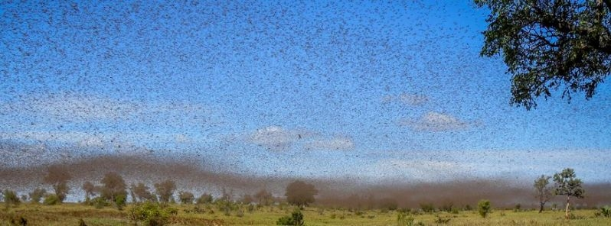
Pakistan
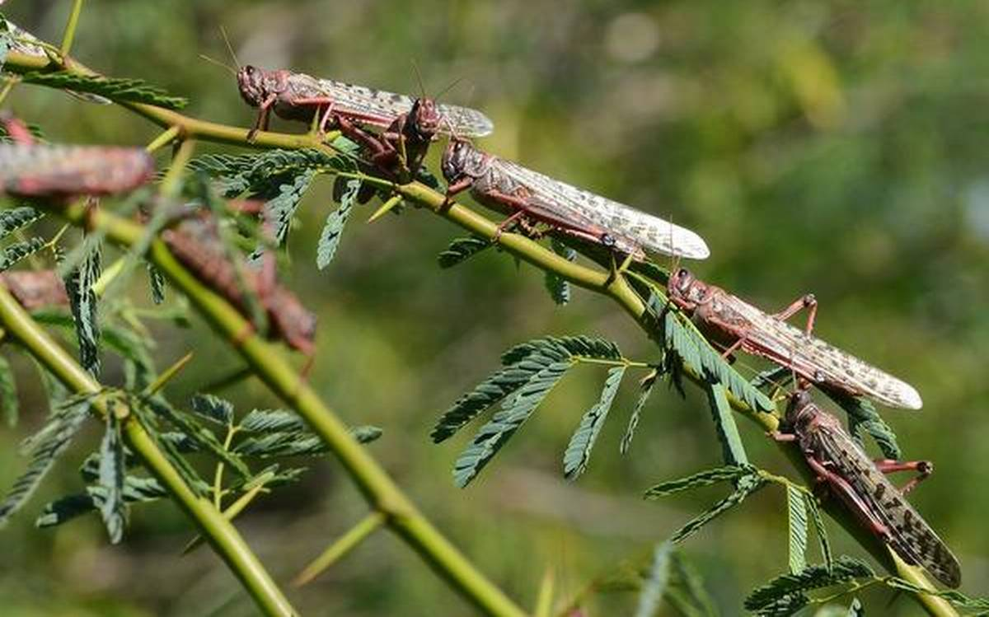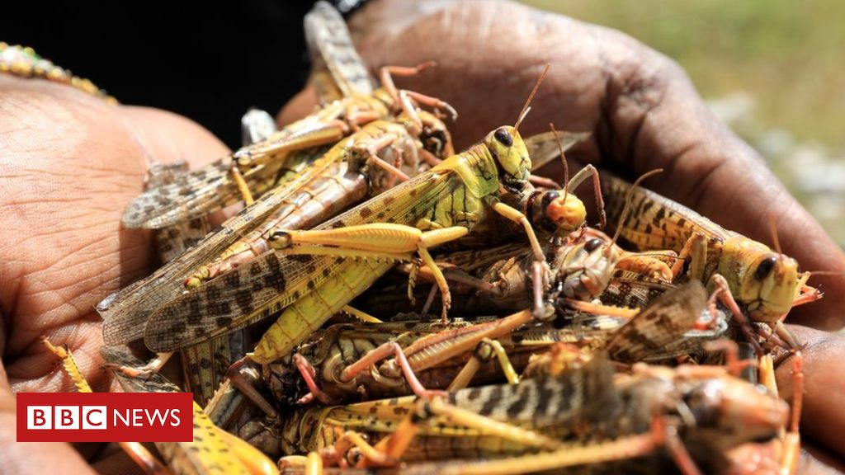
Punjab Region February 2020 Somalia February 2020

“Pakistan declares national emergency…” Posted by Julie Celestial on February 4, 2020 The Watchers
“The government of Pakistan declared a national emergency on Saturday, February 1, 2020, as the nation faces its worst locust plague in 27 years. The insects have been devastating crops on a large scale in Punjab province, the country's main region for agricultural production.
The decision to declare a national emergency was made during a meeting summoned by Prime Minister Imran Khan on Friday, January 31. The meeting was attended by federal ministers and senior officials of four provinces.
A national action plan was also approved to allocate a sum of 7.3 billion rupees (102 million dollars) to tackle the crisis.”
Watch the return of the Egyptian plagues reported in Revelation. Yahuwah wants to share with you what is on His mind and in His heart. He is once again judging the gods of this world. He wants to make sure we’re 100% on His side.
In Shalom and His love, Yedidah
February 10, 2020

