THE MANIFESTATION OF THE SONS OF ELOHIM
Romans 8:16-23

Romans 8:16-23, The Scriptures: 16 “The Spirit Himself bears witness with our spirit that we are children of Elohim, 17and if children, also heirs – truly heirs of Elohim, and co-heirs with Messiah, if indeed we suffer with Him, in order that we also be exalted together. 18For I reckon that the sufferings of this present time are not worth comparing with the esteem that is to be revealed in us. 19For the intense longing of the creation eagerly waits for the revealing of the sons of Elohim. 20For the creation was subjected to futility, not from choice, but because of Him who subjected it, in anticipation, 21that the creation itself also shall be delivered from the bondage to corruption into the esteemed freedom of the children of Elohim. 22For we know that all the creation groans together, and suffers the pains of childbirth together until now. 23And not only so, but even we ourselves who have the first-fruits of the Spirit, we ourselves also groan within ourselves, eagerly waiting for the adoption, the redemption of our body.”
Romans 8:19 KJV: “For the earnest expectation of the creature waiteth for the manifestation of the sons of God.” (“creature” referring to the whole of creation)

We are fast moving into the time when our expectation of final redemption of soul, spirit, and body, will be realized. It is at the end of our faith that receive final redemption, and our eternal rewards. (I Peter 1:9; I Thessalonians 5:23-24)
We are near the end--in the “latter days.” Preceding our redemption there must come the final raking of the “tribulum.” The raking of the tribulum over humanity is an act of the love of Yahuwah for His children. (See pictures at end of this article)
First of all the tribulum, from which we get the Latin word “tribulation,” is raked over the wheat to remove tares and chaff. That’s called “threshing.” The tribulum is also known as a “threshing sledge.” The spirit raking removes the evil, the imposters, the hypocrites and masked ones, represented by the tares/darnel, and also removes the chaff that binds the wheat from being gathered and used. (Matthew 13:24-50) Without the tribulum, there would be no preparatory justice before Messiah came, no testing of faith, no separation between Yahuwah’s children and the Satan’s children--separation between the seed of the woman and the seed of the serpent. Acts 14:22: “…it is through much tribulation that we must enter the Kingdom of Elohim.” (Philippians 1:29; I Peter 4:1-2, 12-14)
It’s time for “Gideon’s 300” to be separated unto the battle! There is a famous cliché that says, “A picture is worth a thousand words.” Very true! So, I encourage you to go to Derek’s website, thewelltroddenroad.org, and click on the video he made in August at the site where the Gideon 300 were chosen by Abba – at Ein Herod (Judges 7) It is an authentic Israeli site. I took the last part of the video, where Derek demonstrates how the 300 “lapped like a dog” in the water, and were chosen to be the conquerors. [Also refer to my article “Gideon’s 300”/Jan. 5, 2009]
It’s time for the FEW who have been walking on the narrow path that leads to the narrow gate that leads to life, to enter the gate and go forward. (Matthew 7:13-14)
It is time for His soldiers to stand firm in the power of His might, trained, and battle-ready, to obey the Captain’s every directive. It’s time for those who know the enemy and his plan to advance against him. The army of Yahuwah knows one direction – FORWARD.
Those who have forsaken all to obey His every command, who have learned from His Spirit, who have allowed Him to transform them into His nature, knowing His ways and thinking, are now standing. (Ephesians 6:10-18; II Corinthians 10:3-6; II Timothy 2:3-5) There are rewards and positions in the Kingdom to strive for!
Please know that I am not talking about the twisted thinking of the cultish “Manifested Sons of God Movement,” or the cultish “Kingdom Now Movement” of “Dominion Theology,”--both created by religious men who do not know Yahuwah.
I’m talking about Yahuwah’s Movement! No human can draw this end-time remnant together. This is a sovereign movement of the Spirit of Yahuwah! This army has been prepared by the Master Himself. These are believers who have laid down their will to pick up His and be obedient to it. Their loyalty is to their Captain only. They trust him explicitly. They know His faithfulness.
NO, I’m not talking about the army of Joel 2 either. That’s the destroying Nephilim army related to Revelation 16:13-21. [Refer to: “Ezekiel 38 and 39 – Directly Linked to the Return of Messiah/September 30, 2016]
The end-time army of Yahushua is “the army of the Lion – the unstoppable battalion that drives away the night.” (Chuck Girard Song “Soldiers of the Unstoppable Battalion” from the “Name Above All Names” album)
Yahuwah’s army is comprised of the end-time Bride of Messiah and the martyrs of Revelation chapter 7. His army has His nature and thinking. They know His ways of doing things, and they are full of His love. They fight only the enemy, not each other, for they are in perfect unity with the Captain of the Host.
A friend of mine asked me if the Bride wore combat boots under her wedding dress. I said “Yes.” As “she,” this bridal-hearted company, has prepared for her wedding, her loyalty to her Bridegroom is “off the charts.” He heart beats to the rhythm of His heart. She thinks of Him day and night. Her focus is: “How can I conform to what He expects of me?” She aligns to Him. She wears white – for she is pure. (Revelation 14:1-5)
Do you want to hear someone besides Yedidah talk about the difference between the soul and spirit, and about the Bride? I highly recommend that you go to the SkywatchTV.com home page, and click on the October 13th interview of Josh Peck with Michael Lake on “Into the Multiverse.” You can find it on YouTube also. Their topic is “Dimensional Doorways.” Dr. Michael Lake bottom-lines amazingly, so well that in this 20 minute interview I took six pages of notes. He is a Torah-guarding teacher of the Word who has opened the eyes of many Christians to the truth. In this interview he tells about how peace, and deer, come onto his property from Friday night to Saturday during Shabbat. He talks about the ancient Jewish wedding and about the Bridal remnant. He even mentions Daniel 11:32. I wonder if my readers think I am the only person who quotes that verse (smile). The Spirit teaches the same things to all who submit to His teaching! Dr. Lake has had one or two other interviews with Josh Peck on “Into the Multiverse” – all of them are good. “Into the Multiverse” is the program where I’ve been learning basic quantum physics which has clarified so many things in the Word; the Word is an extra-dimensional Book. In fact, being spiritual simply means you are extra-dimensional – you live through your spirit in the eternal realm of Yahuwah and Yahushua, as you go through the 3-dimensional time-space of our earth (i.e. Psalm 91:1). We are eternal beings because we have an eternal spirit within us. Dr. Lake confirms what I’ve been teaching on this for most of my life.
Here are a few notes from that interview: Lake said the church in America is the church of Laodicea—its “gospel” is watered down--lukewarm. He talked about Revelation 3:20. At the coming of Messiah, the Bridegroom goes to the door of His Bride and knocks. She opens the door and they go to the wedding Feast. The Father and the Bridegroom first lay out the conditions – the things that the Groom wants in his Bride. If she agrees, they drink a glass of wine together, and the covenant of the engagement is sealed. Then He goes away to prepare a house for her, part of His Father’s house. (John 14:1-6) Lake asks: “Who does she need to become in order to match that?” The engagement with us was cut on Mt. Sinai.
In other words, how can she match the conditions laid out for her by her fiancé in the engagement covenant? How can she please Him? The conditions are the spelled out in the Torah, encapsulated in the Ten Commandments, and expanded on by Yahushua Himself in the Messianic Writings. The Bridegroom wants an exclusive relationship. He is a jealous Bridegroom, Son of a Father who is jealous over His children. (Exodus 20 5-6; 34:14; Deuteronomy 4:24)
Yahushua doesn’t want to find His Bride’s heart focused on anyone else but Him. He wants all of her loyalty. He doesn’t want to find pictures of old boyfriends in her photo albums. He doesn’t want her doing laundry and shopping on their date-day (Shabbat). If you look the Ten Commandments as what the Bridegroom wants in His Bride, they take on a whole new aspect of meaning. He doesn’t want a woman who is dishonoring to her parents, who harms others, who steals from others, who lies, gossips, slanders, and is deceitful. He wants a pure and set-apart Bride who is exclusively His and loves like He does – one with His nature, His thinking, who is obedient to His ways, who loves His Word – His love-letters. We’re talking relationship here. There were those in the Tenach, like Enoch, Abraham, and Moses, who knew Yahuwah and lived in His Presence.
Romans 8:14: “Those that are led by the Spirit of Elohim – they are the sons of Elohim.” Those sons are now standing with their Abba in set-apartness, purity, with single focus on overcoming all to stand before the returning Yahushua without shame. (I Thessalonians 3:13; I John 2:28)
Daniel 11:32b describes the remnant of the House of Ya’cob, represented by all twelve tribes. They are strong because they know their Elohim personally. You can never know Him through man-made religious doctrines and teachings about Him. It takes interaction with a person to know them. In Chris Pinto’s DVD on the roots of America, “The New Atlantis,” a man was interviewed who had spent 33 years studying about Sir Francis Bacon. He knew everything there was to know about him, but, of course, he never met Sir Francis Bacon, so he never knew him. Unless a person personally knows someone, they might hear what is said about them by others that is false, and believe the lies. We have to know our Elohim personally and be taught by Him to keep from believing lies.
Yahuwah can only trust those He knows to do the exploits at a time when anyone guarding His Covenant and having the witness of Yahushua Messiah is a target for destruction by the enemy. (Revelation 12:7-17)
This remnant is the unstoppable battalion that moves forward at the command of the Captain of the Host. This is the overcoming remnant that prepares the way for Yahushua. [Refer to: “Soldiers of the Unstoppable Battalion”/January 31, 2014]
This army consists of “the few”--the “Bridal remnant” who will be translated before the resurrection at Messiah’s coming for their protection. It also includes martyrs who are faithful unto death (Revelation 7:9-17; 14:9-13)
Revelation 7:1-8 it speaks of the 144,000--a symbolic number of the tribes of the Bridal remnant. In Revelation 7:9-17 it speaks of the martyrs who were loyal unto death. Look at their reward! Revelation 14:12-13 also speaks of martyrs.
As Yahushua begins to descend, His Bride will arise to meet Him in the air and accompany Him to earth, along with all those righteous dead who are raised in the first resurrection (I Corinthians 15:51-58; Revelation 20:6). She comprises the main group of “those that remain.” (I Thessalonians 4:13-18) She is mentioned in Revelation 3:12; 7:1-8; 9:4; 14:1-5, and 22:3-5.
This battle is most unusual. The soldiers are disciplined; they advance only on the orders of their Captain. Their strategy is most unusual--as in Judges 7 and II Chronicles 20. Their weapons are not swords, spears, arrows, guns, bombs, or missiles. They are weapons of authority and power in the mouth of those the Creator has trusted to proclaim exactly what He wants said to break through the lives of the evil ones. It is the Word in our mouth backed by His authority that causes us to overcome all, and stand before the Master. [Refer to: “Authority Backing”/February 12, 2012]
I teach you only things I’ve learned that work--like in the 3-part Spiritual Warfare series of 2010, and the “Manifestations of the Set-Apart Spirit” in 2008. In Africa, 1996, I learned to multiply food--it was an amazing miracle. In my 20s I learned to command adverse weather when it got in my way of the Master’s business. (Mark 4:31-5:1) In my 20s, I also learned to work with the Master in deliverance, healings, miracles, and the baptism in the Spirit. I had been leading people into the new birth from age 6 already. That is on-going. Our education by the Spirit never ends! The Spirit of Yahuwah has been my teacher, and I’ve seen so many miracles and experience so many that what I tell you is deeply ingrained in my lifestyle. I’ve had very much experience in combat with the enemy--50 years this year to be exact--against demonic powers of all types. If you want to learn from my experiences through the hard disciplines of the Spirit, my autobiography is entitled Touching the Eternal, sold in paperback book form on Amazon, and on Amazon Kindle. I don’t tell give you life-advice/wisdom that I’ve not learned for myself from suffering, from experiences with Abba, and from His teaching.
The training of a soldier basically entails the preparation of wheat for use--the gathering process, the threshing process, the winnowing process, the crushing process, the grinding process, and the pressure-cooker process. After all that – we know what it means to be a servant and a soldier. I chuckle, but it is a fact!
Definitely! His ways are not our ways! (Isaiah 55:8-11) His thinking is not human thinking. He does what He has to do to get rid of our sin, rebellion, stubbornness, stiff-necked nature, and reduce to “yes Daddy” obedience. With a hard-headed person like me, stubborn to the max, He had to about kill me.
When the mind and emotions of the soul are overcome by fear and terror justifiably in battle, to protect itself, it often shuts down. In my autobiography, I tell how I almost died of malaria in Tanzania in 1997, and forgot my own name, but I heard Him speak in my spirit and was able to stay alive and even preach. I’ve written about “what happens when the mind shuts down.” There is technology out there now that can erase the mind, ruin it, take it over, and change its thinking to even eliminate “faith in God.” Some of that technology is on your TV. I wrote about that in “Beware Digital TV.”
Because the mind and emotions are so unstable, being related to the flesh and the world around us by the five senses, Yahuwah can only speak to us through our re-born spirit in the loins area of our body. If a person is filled with the Spirit, baptized into the Spirit by Yahushua, the spirit is a temple for Him to dwell in. If that portal of the re-born spirit stays open to His dimension He can give His orders directly to us, for He trusts those He knows and has personally trained to execute them exactly as given.
The true new birth transforms a person into an entirely new creation (II Corinthians 5:17-21). [Refer to: “The True New Birth”/July 2015]
In the true new birth, the Spirit does 40 things to transform us into a new creation, able to go forth under His direction to become like Adam and Eve before they sinned. A truly born again person has totally new desires. Even major glands of the body and DNA are changed. They hunger for the Word – it is our food, our life. Their driving compassion is to tell others about their salvation. It is a radical change that begins with repentance, with laying down our lives to follow the Master. It is different than anything taught in the Western churches. Those truly born again are in love. To lose that “first love” is to lose what we’ve gained, even eternal life (Revelation 3).
Messiah taught us that we must possess our eternal life, or else we will lose it.
Once again I promote Derek Townsend’s mini-book For the Love of Truth – Possessing Your Eternal Life, available from Amazon and through his website: thewelltroddenroad.org. He’s my son; I know his heart--he belongs 100% to Abba.
Yahuwah and Messiah Yahushua are not a religion. They hate religion, for the root of all religion is in sun god worship from Nimrod, Semaramis, and Tammuz, 5,000 years ago--the original “trinity.” [Refer to: “Exposing the Trinity Doctrine”/February 12, 2015]
Christianity boasts of 43,000+ denominations and organizations. Messiah did not die for that. He died to restore the Covenant of His Father with the “lost sheep of the House of Israel,” the ten northern tribes of Ya’cob, whom He had to divorce because of their incredible sin. He had to “divorce,” or break the engagement covenant, i.e. Matthew 1:18-20, speaking of Joseph thinking he’d have to divorce/”put away” Mary for fornication. So, because of His love, and His promises from the foundation of the world, Messiah died to break the covenant according to His own Word, and rose again to be able to remarry a remnant of the whole House of Ya’cob – from all twelve tribes. What kind of love is that! Love to live for, love to die for--love to lay down one’s life for!
This year, 2016, everything is being set up for the great end-game. The game itself won’t last very long, but the set up is rigorous for those who will participate. We’re in a life and death situation – its Forward march or perish. There will be a might army of the sons of Light who will stand against the darkness and overcome. We must anchor our soul and spirit, unite the mind with the mind of Messiah, so that when overwhelming terror comes, we won’t be moved, we won’t be shaken.
Psalm 125:1: “Those who trust in Yahuwah are like Mount Zion – it cannot be shaken, it remains forever.” We want to be like Mount Zion. But, this doesn’t happen unless we submit totally in faith to our Master. All “belief systems” will crumble when hard core reality hits. It is only if our spirit is anchored in His Presence that we will find His protection.
Because of sin, all of creation is oppressed and changed from what the Creators meant it to be. Because of sin animals suffer, birds, fish, insects, reptiles, and plants, trees, and food crops suffer. We suffer because of our own sin, and the sin of others. Life is full of hurt, bitterness, tragedy, and death. All of creation waits for the rising of the FEW, who will stand against the Serpent and overcome until the time of Messiah’s return when earth will be renewed.
Matthew 7:13-14, Messiah tells us who the FEW are: “Enter in through the narrow gate, for the gate is wide, and the way is broad, that leads to destruction, and there are many who enter in through it. Because the way is narrow and the way is hard pressed which leads to life, and there are few who find it.”
Even today, all creation knows who has the nature of Elohim and who does not.
I love the story told about Sadhu Sundar Singh. The village he was ministering in was being stalked by a huge cougar that was killing children and eating them. One night, an English minister-friend of his looked out the window of his house to see Sundar sitting outside in the dark praying. To his horror, at his feet was the huge cougar, asleep. Truly, “when a man’s ways please Yahuwah, even his enemies are at peace with him.”
At the fall of man, many types of animals, birds, reptiles, insects, even some varieties of plants, went from being peaceful to being dangerous – i.e. deadly, hunters, meat eaters, destroyers, poisonous. Disease entered. Microscopic mutated bacteria began to afflict human kind world over. Reptiles came to include snakes with poisonous venom. Nephilim who ruled earth created mutates of all types, like perhaps the T-Rex, for everything Yahuwah and Yahushua created was “GOOD.”
In the Kingdom of Messiah, there will be nothing that harms, i.e. Isaiah 11:9; chapter 35; and 65: 17-25.
All of creation is attracted to the peace of the sons of Elohim who exude the nature of the Creator. There is great power in one who has the nature of Elohim, who walks in the fruit of the re-born spirit, filled with the Spirit of Yahuwah, using the gifts of the Spirit, sharing the Word--speaking the Word, teaching the Word. These are the “sons of Elohim” who are led by the Spirit of Elohim (Romans 8:14).
The children of Light are given authority over all the ability of the enemy because they are set-apart in the Light (Luke 10:19).
We need the power of the Spirit and His gifts more now than ever before in our lives. The gifts of the Spirit, listed in I Corinthians 12:1-12, are part of our “weapons that are not carnal, but might to the pulling down of strongholds.” (II Corinthians 10:3-6; Ephesians 6:10-18)
Please go to the third mikvah on my website--the mikvah of the Spirit--and begin reading the articles. Without being empowered with His might and gifts, there is no way anyone will survive. Those that relegate the gifts of the Spirit to the devil are blaspheming the Spirit, who is Yahuwah. Whole denominations teach that the book of Acts is only history--thus they teach spiritual suicide. What will you do when your food runs out, your child is sick and there is no medicine, when your medicine runs out, etc., and you cannot get out of your house to buy anything?
My two youngest daughters did not go to a doctor until they had their first babies because I taught them about healing and miracles and they walked in the power of Elohim in America and Mexico, and the youngest also with me in Africa. I’ve seen Him work and tried to teach that to others, but most people won’t take hold of it until it is too late, for under terror faith is dead and Abba can’t help.
The earth cries out for the remnant that has the nature of the Creator. It is impossible to have His nature unless one is born again by the Spirit of Yahuwah, filled with the Spirit of Yahuwah, and dead to self-will – controlled only by the Spirit, transformed by the Spirit. No amount of religiosity can do that … man’s attempts at “sanctity” is all stale and moldy, a dead end.
World War III is in our face. It’s not a passing thing; it’s a real thing.
We’re facing all the horrors of the time before Messiah returns. Those who walk the narrow way, enter the narrow gate that leads to life. They are the ones who will be protected. This stalwart remnant that knows their Elohim, are strong, and do exploits in His Name – today’s Gideon 300.
Be challenged to let go all that hinders you and embrace the call of the Master.
Shabbat Shalom, in His love,
Yedidah, October 21, 2016

Examples of tribulum (threshing sledges) made of rocks or metal on a board that is raked over wheat to remove the tares and chaff (threshing). The “winnowing” process lifts up the wheat so that wind can blow away the loosed chaff, then the wheat is gathered into storage barns (Matthew 13)
The now manifesting sons and daughters of Elohim have been threshed and winnowed, and are preparing for being gathered at Yahushua’s return!
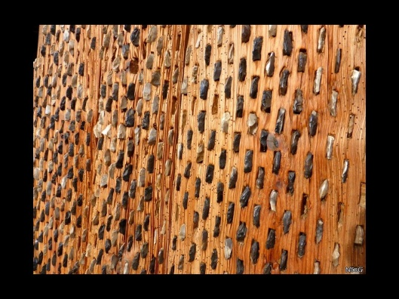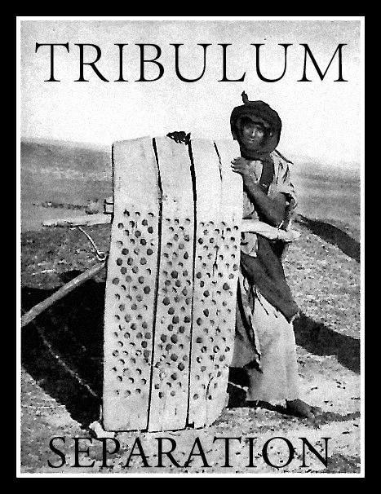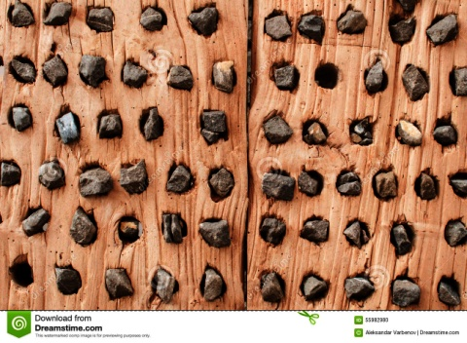

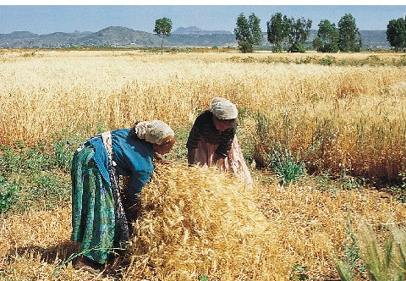
Left: Yedidah’s symbolic tribulum with rocks from Israel, used in intercession and proclamation, and my plumb line used as Abba directs (Amos 7:7-8)
Right: Wheat harvest in Israel
-----------------------------------------
PS: To find articles that I refer you to, go to comeenterthemikvah.com. Click on the “search” tab in the upper right hand corner of the main page. Put in the name of the article and it will draw from both my website, and from laydownlife.net, my archives site of a good friend for many years

