The rising OF Hades
from the Inner Earth

Isaiah 5:14: “Therefore, Hell has enlarged itself wide, and opened its mouth without measure. And, their splendor, their multitudes, their pomp, and he who is exalting within her, shall descend into it.”

From the 1920s, there has been talk about the earth being hollow. “Hollow earth” advocates are abounding more than ever now. I don’t believe the earth is hollow, or that there is a civilization living deep inside it. However, according to many Scriptures, the inner earth has great caverns within it.
Recently, the news reported that a cavern has been found under the ice in Antarctica: “World's largest canyon found beneath the Antarctic ice sheet: Mega chasm carved by flowing water is 'bigger than the UK' by Colin Fernandez for the Daily Mail - Published 13 January 2016. Deep below the thick ice that covers the Antarctic region, geologists have discovered the world's biggest canyon, measuring a staggering 621 miles long (1,000km). The previously unknown chasm is said to bigger than the UK--around half a mile (1km) deep in places. The previous record for the longest canyon in the world was achieved in 2013 - also below the ice - but in Greenland. That mega canyon is a mere 460miles (750km) long.”
There have been many theories that have fed the intellectual and religious fires of New Age occultists and mystics, scientists and explorers, that the inner core of the earth is hollow, and that deep within it is a paradise of pristine beauty, people who live in a peaceful culture, with even an inner “sun.” Even the aurora borealis has been attributed to reflections from the inner “sun” on the ice poles. Expeditions have gone to the North Pole to try to find the opening. The Nazis headed for the South Pole – Antarctica – at the close of World War II to set up an underground Base. But, other countries have also claimed part of this frozen region. Today, the speculations are growing, fueled by pictures from NASA of open holes at the north and south poles.
The diary of Admiral Richard E. Byrd, leader of “Operation High Jump,” a U.S. government expedition to Antarctica after the close of World War II to locate and capture Nazi defectors, describes his trip over the South Pole of Antarctica. He describes entering into a cavern that looked like the original creation, complete with a Wooly mammoth, gorgeous vegetation, a blue sky, and an inner light. During his fleet’s stay off the coast of Antarctica, Admiral Byrd and his Navy crew attest to seeing many Nazi flying saucers, some which attacked their ships, and killed some of his men.
Admiral Byrd and his team were called back to the U.S. in 1947. In a public speech, he alluded to a few things he saw, not coming right out and telling about saucers of an inner earth, but hinting at enough to cause him to be quietly taken out of the public eye. The Admiral’s diary fueled a lot of theories too, including the “hollow earth” theory.
1947 was a year of massive UFO activity worldwide, including the famous Roswell UFO incident in New Mexico, the year the Dead Sea Scrolls were discovered, and the year the U.N. partitioned Palestine to create a Jewish State (November 29, 1947).
The Nazis had “flying saucer” technology from 1922 onward. The supernatural components of Nazism were centered in the beliefs of the Vril Society. Members of the Nazi Vril Society learned the technology of how to build anti-gravity saucers from having “séances,” from contacting “spirits” of another dimension-- the dimension of “aliens,” gods and demi-gods, spirit-guides, the dimension of the fallen ones. Thus the Nazis were as much supernaturally inspired as they were militarily inspired. In fact, the Nazi were/are occultists, Luciferians/Satanists. Many of the World War II-era Nazi scientists tell of receiving instructions for military equipment and experiments on human beings, DNA manipulation, etc. from “spirit guides--“sky gods.” In the 1920s, Nicola Tesla also admitted to getting his extensive knowledge from these “gods.”
To learn invaluable and truthful information on this subject, I recommend Steve Quayle’s new book Empire Beneath the Ice – How the Nazis Won World War II, released November 2015.
Because of my past research, and personal experiences with the “supernatural” world, the realm of the fallen ones, I can envision possibilities beyond what appears to be openings into the earth at each pole. Steve Quayle sees the openings at the poles as portals into another dimension. Yes…and, it is possible that those entering into another dimension beneath the poles, which Admiral Byrd described as a paradise, could be seeing back into time and viewing the original “Paradise” that was once in the heart of the earth. In the eternal realm, there is no time, everything is now. In other words, perhaps the portal enters into the past, before Messiah’s ascension.
The realm of Paradise is mentioned in these Scriptures: Luke 16:19-31; Luke 23:39-42; I Corinthians 12:4; Revelation 2:7. Ground-level “Eden” of Genesis 2-3 was a symbolic reality of the gigantic area under the earth of “Paradise”-- the abode of the departed righteous before the ascension of Messiah. At His ascension, the reality of the abode of the righteous, “Paradise,” became a suburb, so to speak, of Elohim’s Eternal City--the New Jerusalem.
Revelation 2:7, letter to the assembly at Ephesus: “He who has an ear, let him hear what the Spirit says to the assemblies: `To him who overcomes, I will give to eat of the tree of life, which is in the midst of the Paradise of Elohim.”
In eternity, the “New Jerusalem” will descend as Yahuwah comes to rule the earth forever, His throne hovering over Mount Zion. (Revelation 21-22)
At His ascension, Yahushua “took captivity captive” those righteous ones of past who were buried on the Mount of Olives, who came out of their graves at His resurrection and appeared to many in Jerusalem--the “first fruits of His resurrection.” (Matthew 27:50-54; Ephesians 4:8-10)
Psalm 68:17-18: a prophecy of the ascension and return of Yahushua Yahuwah: “The chariots of Elohim are twenty thousand, thousands of thousands. Yahuwah came from Sinai into the Set-Apart place. You have ascended on high, you have led captivity captive. You have received gifts among men …”
I Kepha/Peter 2:18-20: “…Messiah once suffered for sin, the righteous for the unrighteous, to bring us to Elohim. Having been put to death in the flesh was made alive in the Spirit, during which He went and proclaimed to the spirits in prison, who were disobedient at one time when the patience of Elohim waited in the days of Noah…”
Revelation 1:17-18: “And when I saw Him, I fell as His feet as one dead. And He laid His right hand upon me, saying `Fear not! I am the first and the last; I am He that lives, and was dead, and behold I am alive forevermore, Amen, and I have the keys of death and hell.’ ”
Ephesians 4:8-10: “…When He went up on high He led captivity captive…and what does `He went up’ mean,’ except that He first went down into the lower parts of the earth? He who went down is also the One who went up above all the heavens…”
Luke 23: 39-42: “…Today you will be with Me in Paradise…” -- Yahushua speaking to a repentant dying thief, as He hung dying on the stake.
When Messiah died, He first descended and visited two realms beneath the earth: 1) Paradise, where all the righteous dead were waiting. What a glorious meeting that was! He let them know that in 3 days He would rise from the realm of the dead and they would rise with Him, for heaven’s gates would be opened to them, and 2) the realm of the damned, even Tartaros, where He proclaimed the judgment of the fallen ones, and took the keys of the gates of Hades from the king of the pit. He conquered!
Yahushua stripped authority from Satan, his fallen angels, and demons, over His people, and took away their ability to control those who would be born again by faith in Him. Because of Yahushua there would be a remnant who would not submit to their authority, but only submit to the authority of Yahuwah and Yahushua, their Creators.
I John 3:8b: “For this purpose was the Son of man manifested: To destroy the works of the Devil.” The Greek word “destroy” means to “undo, to loosen, to relieve of authority and power.”
Luke 10:17-20: “And the 70 returned with joy, saying `Master, even the demons are subject to us in Your Name.’ And He said to them, `I saw Satan falling out of heaven like lightning. See, I give you authority to trample on serpents and scorpions and over all the power of the enemy, and nothing shall by any means hurt you.”
Concerning our present time, all Scripture has to say about the heart of the earth is concerning Hades, Hell, Gehenna, Sheol, the Pit, Tartaros, and the “lake of fire.’
In the above introductory Scripture, beneath the title, Isaiah 5:14, the word “enlarged” is #7337 “rachab” Strong’s Concordance Hebrew Dictionary…means to “enlarge – to be large, or to grow large, to be made wide, to open wide.” The Hebrew letter “peh,” refers to “a mouth, jaws, edges, entrance, face, boasting--a mouth from one end to the other that receives things from without.”
This “mouth” is the rim of a giant cavern in the molten interior of earth--a giant prison, to which the damned are sent to await the Revelation 20 judgment. At this very time, this cavern is enlarging itself wider and wider as it anticipates a great intake of the damned. Like a giant cannibal it awaits its food. There is a great amount of activity going on under the earth, as we see in volcanic activity.
The word “descend”: #3381 “yarad,” means to descend. Many of the Scriptures listed below use the words “go down,” or “descend.”
Literally, Hell is enlarging, widened, itself, opening its mouth wide without measure, at the anticipation of the incredible intake of the damned that will come shortly, as the world turns against Yahuwah and His Messiah-Son, Yahushua, to identify with “the god of this world.”
There will be cut-off point, after which there will be no repentance granted, no second chance--nothing but to enter the mouth of Hell in eternal judgment. Hell will finally be thrown into the lake of fire. Revelation 20:14: “And death and hell were cast into the lake of fire. This is the second death.”
My words in this article, like in all of my articles, are warnings, exhortations, admonitions, encouragement, and caring wisdom from our loving Abba-Father Yahuwah to His people, and to those who are “lost”--without knowledge of His salvation through Messiah Yahushua. I write to warn the intellectual and prideful religious ones who deceive themselves into thinking they are “in” with God, but who do not know Him. I write to sincere of heart who have “lost their first love”--their love of sharing the joy of their salvation with others, their love for Yahushua, and the expectation of His return.
There will be no “gift of repentance” granted after a certain point (Revelation 9:20-21; 16:8-11). So, I also warn the dull, the lethargic, the apathetic, and the lazy ones who think they have a free ticket into heaven but don’t care if anyone else does. It is natural for human beings to share what is most precious to them. His true children share with the compulsion of the Spirit, in the hopes that others will also receive of His salvation before it is too late. (II Corinthians 5:17-21) If one doesn’t “possess” their eternal life, and increase what they have been given regarding it, they’ll lose it. [For the real “meat” of the Word regarding possessing your eternal life, refer to: For the Love of Truth – Possessing Your Eternal Life by Derek Townsend, Amazon Kindle, or on his website-- thewelltroddenroad.org]

Please look up and read each passage below, in context. This way the Spirit of Yahuwah can teach you, and you will be instructed personally.
UNDER the EARTH:
PARADISE:
*Luke 16:19-31
Luke 23:39-42
II Corinthians 12:4
Revelation 2:7

UNDER THE EARTH - These Scriptures taken from the King James Version
*Genesis 4:11 (Abel’s descent into Paradise)
*I Samuel 28:4, 6-20 (Samuel called up from Paradise)
*Jonah 2 (verse 6: Jonah descended past the bars/gates of Hades into the dark chasm of the damned) It is these “gates” that will not prevail against His true servants!
*Isaiah 5:14
*Isaiah 14:9-20
*Matthew 16:18-19 (“gates of Hades”/hell)
*Philippians 2:10 (9-19)
*Luke 24:1-7 with I Corinthians 15:1-8
*Ephesians 4:8-10 (Messiah first descended, then ascended)
*Revelation 1:18 (while in the pit of the earth, Yahushua took the keys of death and hell away from Satan)
*Revelation 20:13-14
The Apocrypha of Noah, found at the end of Enoch I (Enoch ascends from Paradise)

Hades, Hell, Gehenna (Valley of Hinnom), Sheol
The Earth opening up, descent into Hades, ascent from it…
These Scriptures taken from the King James Version
*Genesis 6:17
*Exodus 20:4 (carve no image of anything under the earth, OR in the waters that are under the earth)
*Numbers 16:20-35 (the Korah rebellion, the earth opened up to receive them)
Numbers 26:10
Deuteronomy 11:6
Deuteronomy 32:22 (“lowest hell,” “bottom of Sheol”)
*Isaiah 5:14
*Isaiah 14:9-20 (i.e. above) with Ezekiel 28
Isaiah 24:18
*Isaiah 26:14-15 (the fallen ones/Nephilim, “shades”)
*Isaiah 26:19-21 (the set-apart righteous)
Isaiah 28:18
*Isaiah 66:24-25
Ezekiel 31:16-17, 21 (KJV)
Ezekiel 32:27-28 (KJV)
Psalm 9:17
Psalm 16:9-10
Psalm 86:13 (“lowest hell”)
Psalm 106:17
Psalm 139:8
Proverbs 9:17-18
Proverbs 15:11, 24 (“grave” is the Hebrew word “Sheol”)
“The way of life is above to the wise that he may depart from hell beneath.”
Proverbs 27:20
*Job 26:5-14 (with Isaiah 26:14)
Job 26:6: “Hell is naked before Him, and destruction has no covering.”
Job 28:5
Matthew 10:28 with Luke 12:5 “fear Him”
Matthew 11:23-24
Matthew 23:33
Mark 9:45-46 “…the fire that shall never be quenched.”
Revelation 5:3, 13
Revelation 6:8 “…death and Hell followed him…”

the pit: King James Version
“Pit” #7585 Strong’s Hebrew Dictionary: “SHEOL”
Psalm 40:2
Psalm 69:13-15
Psalm 88:6 “…the lowest pit, in darkness, in the deep”
Psalm 140:10
Proverbs 22:14
Isaiah 14:9-19
II Peter 2:4 (Tartaros)
II Thessalonians 2:3 (the “son of perdition” – the Beast of Revelation 9:11)
Revelation 9 (the pit opening and what comes out)
Revelation 11:7, 17:8 (the beast of the pit)
Revelation 14:11 (torment ascending)
Revelation 20:1-3

THE LAKE OF FIRE
Revelation 19:20 “…lake of fire burning with sulfur”
Revelation 20:10, 14-15
Revelation 21:8

Revelation 9:1-2, 11, 18: “And the fifth angel sounded and I saw a star from heaven which had fallen to the earth. And the key to the bottomless pit was given to him. And he opened the pit of the deep and smoke went up out of the pit like the smoke of a furnace. And the sun was darkened, also the air, because of the smoke of the pit. And out of the smoke, locusts came up onto the earth and authority was given to them, as scorpions of the earth possess authority... And they have over them a king – the angel/messenger of the pit of the deep, whose name in Hebrew is Abaddon, but in Greek he has the name Apollyon (Apollo)” … “And a third of mankind was killed with these three plagues: by the fire, and the smoke, and the sulfur which came out of their mouths.”
These “locusts” will sting people. Joel 2: “the locusts” are a Nephilim/demon army. Surely this speaks of mighty fallen angels! They rise out of the interior of the earth, which has caverns filled with molten lava--fire, smoke, and sulfur gas--like what spews from a volcano mouth. These have been released from the “lowest” level of Hell. (II Peter 2:4)
Apollyon/Apollo, the destroyer, like Shiva of the Hindus, and other gods of destruction will enter the cloned body of Nimrod. These destroyers are imply other names for Nimrod, aka Gilgamesh or Osiris.
II Thessalonians 2:3: “Let no man deceive you in any way, because the apostasy (falling away) is to come first, and the man of lawlessness is to be revealed—the son of destruction.” The Greek word for “destruction” is “apolia,” from Apollo/Apollyon. [The two names are used interchangeably in modern Greece]

THE BARS OF THE PIT
Job 17:16, KJV: “They shall go down to the bars of the pit …”
Jonah 2:6, KJV: “I went down to the bottom of the mountains, the earth with her bars was about me forever, yet have You brought up my life from corruption, my Elohim.”
Strong’s “bars”: #905 “bad” in Hebrew, meaning “poles, separation”--to keep whoever is outside from entering inside, or to keep anyone inside from going outside … like prison bars. The “pit” is evidently a cavern that has boundary bars, with gates that are opened or shut by the king of the pit--a Nephilim, like the ancient gods Hades, Osiris, or Apollo/ Apollyon--one who had the authority to control the gates.
“The gates of Hades will not prevail against the set-apart ones…” In other words, they won’t open to snatch in the set-apart ones. The set-apart ones unto Yahuwah will be shielded from being dragged through those gates!!!!

“THE DRY PLACES” -- Where are they?
Matthew 12:43-45: “When the unclean spirit is gone out of a man, he walks through the dry places seeking, but finds none. Then he says, `I will return to my house from where I came.’ And when he comes, he finds it empty, swept and garnished (decorated). Then he goes and takes for himself seven other spirits more wicked than himself and they also enter in and dwell there. And the last state of that man is worse than the first. Even so shall it be also in this wicked generation.”
Evidently the “dry places” describe a dwelling region for disembodied Nephilim (demons)--a kind of “center” where they go if sent by one who has Yahuwah’s authority-backing. They legally know they have to obey the servants of Yahuwah who have His backing, authority, power, and privileges. They can do as they will with people who have no authority-backing from Yahuwah, as in the story in Acts 19:13-17.
“Demons” are Nephilim who once had a body. They are tormented if they cannot have a body to inhabit. They are driven to find a body--especially a human body. But, they’re not terribly choosy. They’ll go into an animal, like the pigs in Mark 5:12-13, or a reptile, bird of prey, disease-carrying insect, even an idol--whatever they can use to move among people to destroy the image of Yahuwah from the earth, dismantle faith, weaken and sicken people, and pry loose His people from His protective power!!!
The demons we read about in the Messianic Writings, and the ones we deal with in everyday life, have moved among mankind since after the Flood. They are not part of the original incursion who rise from Tartaros. Tartaros was the prison of the original 200 fallen angels of the first incursion before the Flood. (II Peter 2:4, 9) These began returning around 1896-1900, according to Enoch’s 70 generation prophecy--a real happening in real time.
Demons, and other authorities and powers of Satan’s realm, from low to high in rank, listed in Ephesians 6:12 and I Corinthian 10:3-6, have been active since after the Flood. They are disembodied spirits of post-Flood Nephilim, Rephaim, and of immortal hybrids from DNA mixing – what Scripture refer to as “shades.” But, today – they are not as disembodied as they were. They are taking bodies – cloned, or otherwise.
In Messiah’s day, the “dry places” that He mentioned must be referring to a place where they “hold up,” after being sent there—perhaps a planet, the moon, or some area under the earth where they can roam freely. “Dry places” indicate an uninhabited place – desert, or even a planet or burned out star--a place where there is no water. (i.e. Numbers 21:5)
However, Messiah could very well have been referring to Azazel. We hear of the name “Azazel” in Enoch I. This fallen angel was one of the 200 chief fallen angels who were in the 1st incursion before the Flood, the Genesis 6:2, 4 angels, who mated with human women and brought forth Nephilim-Rephaim (giants)--powerful mutates. But, also, we read in Leviticus 16 that on Yom Kippur, the High Priest first slaughtered a goat after laying his hands on its head to transfer the sins of the nation to the goat. A second goat also carried the sins of the nation on its head, but it was sent out into the wilderness—“to Azazel.” There it died with no food and water with the sins of the nation of Israel. (Leviticus 16:7-10, 21-22, 26)
Before the Flood, Yahuwah cast the original 200 fallen ones, and their hybrid offspring, who killed each other off early on, into Tartaros--the lowest pit of hell. (II Peter 2:4) Azazel was one who went into Tartaros. He also was one who ascended around 1886-1900--120 years ago from 2016, to bring back the technology of war and immorality that they brought to man in the “days of Jared,” before the Flood. Thus, it
has been suggested that the “mankind” spoken of in Genesis 6:3 are those of Genesis 6:2 and 4, their mates, and their offspring. That would mean that the Spirit of Yahuweh would give them a final 120 years – 1886-2016.
Remember that the human gene pool was totally corrupted by the time of the Flood, except for Noah, his wife, his 3 sons, and 2 of his daughter-in-laws. It has also been suggested that the 120 years are also “Jubilee years,” or 6,000 years--the time allotted to man. “6” is the number of man. I believe both are true. (It only took Noah 5 years to build the ark…smile) [Refer to: “The Amazing Message Behind the Numbers 3, 7, 50, 70 and 120”/January 15, 2016]
The power of the spoken Word by a trusted and submitted servant of Yahuwah may send them to the “dry places,” however, if the person who has been delivered does not immediately fill the void in their mind (soul) with the Word of Yahuwah, the demonic spirits have every right to return, and to bring seven others more to completely possess the lazy fool. Once a person is free of being inhabited by demonic spirits, to return back to their old ways of sin, to submission to the lusts of the flesh, is not only foolish, but idiotic! There are many waterless places under our earth, as well as close planets, where they might hide out--waiting for “the time” that they’ve feared would come – the “time” of their judgment. (Matthew 8:28-29)
As the book of Enoch I tells us, their time in the pit, 70 generations, or 4,900 years, was only until their release to do their work for Yahuwah of separating people into two camps. Then they will be incarcerated into the pit forever, along with their leader, Satan/Lucifer/Dragon/Devil, the anti-messiah, the false prophet, and those billions of fools they seduced.

WHAT IS THE “LAKE OF FIRE?”-- WHERE IS THE “LAKE OF FIRE?”
Revelation 19:20: “And the Beast was seized and the false prophet who worked signs in his presence, by which he led astray those who received the mark of the Beast and those who worshipped his image. The two were thrown alive into the lake of fire burning with sulfur.” (Sulfur is also known as “brimstone”)
Revelation 20:10: “And the devil who led them astray was thrown into the lake of fire and sulfur where the Beast and the false prophet are. And, they shall be tormented day and night forever and ever.”
Revelation 20:14-15: “And death and the grave were thrown into the lake of fire. This is the second death. And if anyone was not written in the Book of Life, he was thrown into the lake of fire.”
Revelation 21:8: “But, the cowardly, the fearful, the abominable, murderers and those who whore, drug sorcerers and all idolaters, and all the liars, shall have their part in the lake which burns with fire and sulfur – which is the second death.”
“Lake” is #3041, Strong’ Greek Dictionary, is “limne.” “Fire,” in Greek, is “pyros.”

“Sulfur,” or “brimstone,” is the Greek word “theon,” meaning sulfur
When a demon or a higher power of the demonic realm (principalities, powers, rulers of wickedness, rulers of darkness), manifests into the natural realm, they have a smell – sulfur! I’ve smelled them. It is a strong smell. Ex-Satanist Ken McBride smelled it before he saw the demon he was planning to incarnate. In “Gomorrah,” on the Dead Sea, there are still sulfur balls scattered over the area. To this day, they still have the smell of sulfur. While there, 2003, I took some of the ash in my hand from an ash pillar in Gomorrah and smelled it. It smelled strongly of sulfur. The sulfur balls can still be lit, producing a colorful flame and exuding sulfur gas.
Is sulfur present under the earth in molten lava that spews from volcanoes? From: volcanoes.usgs.gov/hazards/gas
“The volcanic gases that pose the greatest hazards to man, to plants and animals, are sulfur dioxide, carbon dioxide, and hydrogen fluoride…sulfur blowing from a volcano can locally lead to acid rain, but globally interject a huge amount of sulfur arousals into the stratosphere and even lead to the depletion of earth’s ozone layer. Sulfur is in the magna/lava that spews and flows out of a volcano. At high pressures deep below the earth’s surface, volcanic gases are dissolved in molten rock. Magna contains dissolved gasses that spew out of a volcano.”

Stunning Electric-Blue Flames Erupt From Volcanoes
Indonesia's Kawah Ijen and other craters emit rivers of light from burning sulfur.
By Brian Clark Howard, National Geographic - January 30, 2014
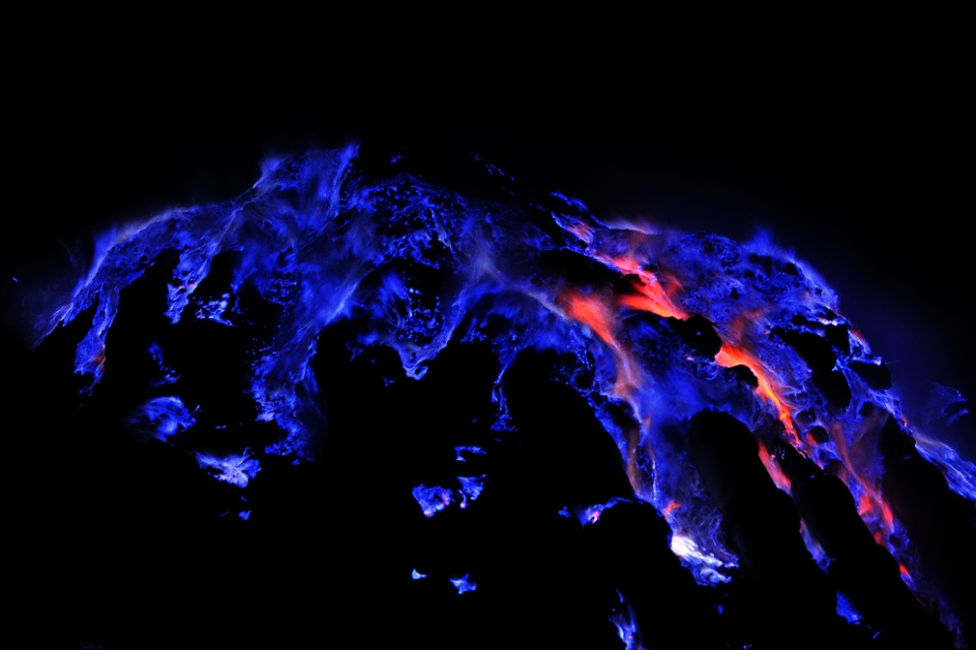
“Sulfur combusts on contact with air to create stunning blue lava-like rivers of light in the Kawah Ijen crater on the island of Java…This blue glow, unusual for a volcano, isn't, of course, lava, as unfortunately can be read on many websites," Grunewald told National Geographic in an email about Kawah Ijen, a volcano on the island of Java.
The glow is actually the light from the combustion of sulfuric gases, Grunewald explained. Those gases emerge from cracks in the volcano at high pressure and temperature—up to 1,112°F (600°C). When they come in contact with the air, they ignite, sending flames up to 16 feet (5 meters) high.
Werner noted that forest fires in Yellowstone National Park have caused similar "rivers," as heat from the blazes melted the sulfur around hydrothermal vents.
According to Werner, it's relatively common to find molten sulfur around volcanic fumaroles (hot vents). The mineral has a relatively low melting point of 239°F (115°C), and the temperature at the hot vents often exceeds that. Blue volcanic fire was described in antiquity in Italy on the south slope of Mount Vesuvius and on the island of Vulcano, Grunewald said. "Blue flames may also be observed at the base of the plume of erupting volcanoes, when ash explosions occur," he added.”
There are rivers of sulfur--sulfur that flows. But, once congregated into a central area, it becomes a “lake.”

What is the “lake of fire?”
A normal lake has moving water, with fish and other creatures that live in water and move about inside the lake. A lake of fire is a moving mass of fluid molten lava. Nothing on the surface of the earth can live in it. It is under the earth at deep levels, as in the base of a volcano or at the core of the earth. But it can be thrust to the surface of earth in a volcano eruption, where it runs down the sides of the volcano, burning everything in its path.
When the final judgment comes (Revelation 19- 20), before and after Messiah’s 1000-year reign, it will include the Beast and the False Prophet, human and fallen angels, and later Lucifer/Satan himself. A volcano serves as a portal into the realm of the damned. But, during times of shifting earth, i.e. earthquakes, its burning contents is violently thrust to the surface. No, the damned don’t come flying to the surface, but it is very possible that the eruptions of volcanoes are signs that the earth is greatly agitated at what is contained within it. When earth was first created, there was no cavern carved for the damned!
Volcanoes are portals into the interior of the earth! They are portals that lead to gates, or bars, deep inside the earth. Within these gates is contained eternal fire and sulfur, along with the damned. The ruler of the underworld has had many names--such as “Hades” and “Apollyon.” (Matthew 16:19; Revelation 9:11)

Indonesia has many active volcanoes. The Pacific Ring of Fire speaks of volcanoes that surround the Pacific Ocean, and is known for its volcanoes and earthquake activity. The Ring of Fire has a total of 452 volcanoes, and has 75% of the Earth's active and dormant volcanoes. Submarine Volcanoes: There is an estimate of 4,000 volcanoes per million square kilometers on the floor of the Pacific Ocean. There are volcanoes under the Atlantic Ocean, and in many other places on the earth and under the oceans.
Revelation 16:21: “And there fell upon man great hail out of heaven, every stone about the weight of a talent, and men blasphemed Elohim because of the plague of the hail, for the plague was exceedingly great.” It is estimated, using the “talent” weight that each hailstone would weigh about 100 pounds. Stones thrown into the air by volcanoes are called “hail stones.”
When Messiah returns in the wrath of His Father, the earth as a whole will experience the greatest earthquake since its creation. It will set off all the volcanoes. But, this could also happen during the time just before His entrance!
Fire has been seen on the tops of waves of the ocean in Indonesia. The fire is coming up from underneath the ocean. Where I am in Costa Rica, a country with lots of volcanoes, there is a volcano about 20 miles away which has become quite active in the past year.

Isaiah 66:23-24: Where do people look on the burning damned in the millennium of Messiah?
It has been surmised that the lake of fire might be off the earth, in a black hole. It is possible that when Yahuwah comes at the end of the 1000-year reign of Messiah, that all the damned will be removed off of the earth, perhaps to a planet, star, or black hole into another dimension. However, the dimension of the fallen ones now could very well be their eternal prison!
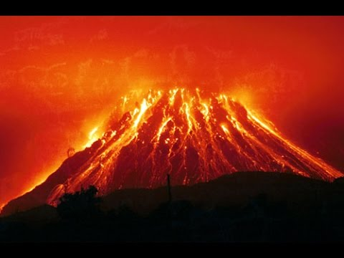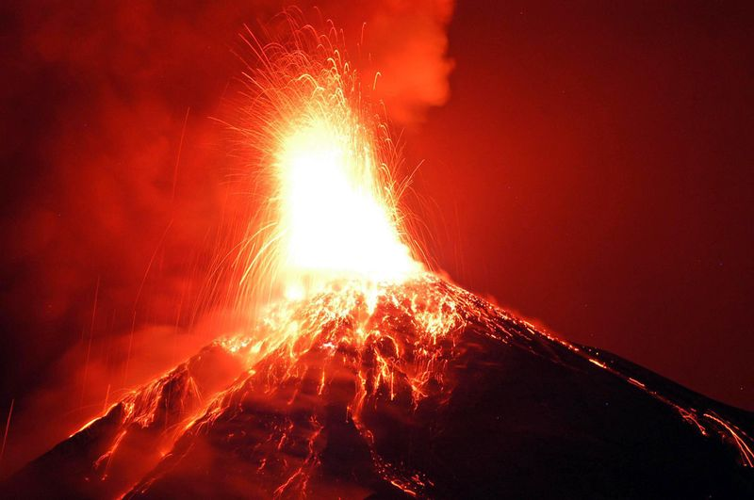
From the “ring of fire” around the Pacific Rim

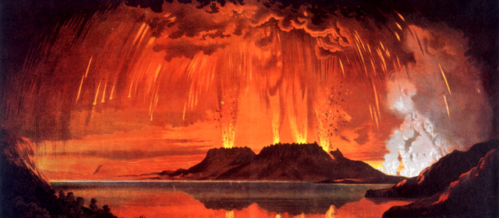
The world’s most dramatic volcanic eruption in 5,000 years occurred in New Zealand about 200 AD. The Taupō eruption devastated much of the central North Island, emptying Lake Taupō in the process…The volcano erupted again in June 1886 – it was the deadliest in the history of New Zealand settlement
Note: This gives the illusion of a lake of fire … Could the “lake of fire” be in the molten core of the earth, at least until Yahuwah comes? Yes, Scriptures indicates that.
1954 Kilauea Volcano
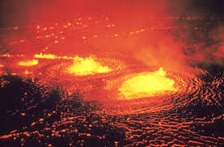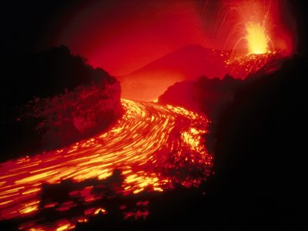
Water set on fire River of fire

THE FIRE OF YAHUWEH’S JUDGMENT (sample Scriptures)
Genesis 19:24
Isaiah 9:19
Isaiah 33:9-14
Ezekiel 21:31
Ezekiel 22:17-22
Ezekiel 38:19
Zephaniah 1:18
Malachi 2:17, 3:1-7
Psalm 21:9-10
Revelation 14:10

Genesis 9:11-13: After the Flood, Yahuwah promised Noah that He would not use water as a means of judging the earth anymore. The final judgment will be one of fire.
Abba Yahuwah has been impressing me lately that the fires of the pit are surfacing, and the words of Isaiah 5:14 are coming to pass.
The caverns of molten lava that burn forever and ever are widening, like a mouth ready to receive it’s intake. But, He has also impressed me that the words of Isaiah 14:9 are included. “Hell beneath is excited about you—to meet you at your coming. It stirs up the dead for you and all the chief ones of the earth…” Though verse is in context of prophecy about the final end of Hillel, Lucifer, it also speaks to those who identify with him in these last days by identifying with the first Beast of Revelation 13.
Revelation 14:9-11: “And the third angel followed them, saying with a loud voice, ‘IF anyone worships the Beast and his image and receives his mark upon his forehead or upon his hand, he shall drink of the wine of the wrath of Elohim, which is poured out undiluted in the cup of His wrath. And he shall be tortured with FIRE AND SULFUR before the set-apart angels and the Lamb. And the smoke of their torment goes up forever and ever…”
Hell is moving, like liquefied molten lava, from deep underneath the earth to greet the damned at their coming. From within the earth, the caverns assigned to the damned are expanding to contain more people…the masses of the 7 billion people who inhabit earth now. Only a small remnant will survive to enter the Kingdom, along with those resurrected. (I Thessalonians 4:13-18)
Messiah comes with the wrath of His Father against the wicked--that is clearly written throughout all of Scripture, i.e. Isaiah 63:1-6, Isaiah 34, Revelation 19. He comes to redeem the set-apart ones, but also Revelation 11:15-18.
As He returns the earth shakes nearly out of its orbit in the greatest earthquake known to earth. Mountains fall and valleys are raised up. Great volcanic activity happens during the final days before, and during, His return. Hell literally rises to receive the beast and false prophet, and the masses of the damned.
Messiah comes as a “refiner’s fire”: Malachi 3:2. “Who shall dwell with the devouring fire?” (Isaiah 33:9-14)

Yahuwah’s Purging Fire:
Luke 3:16-17: “Yochanan answered, saying to them all: `I indeed baptize you with water, but One mightier than I comes, whose sandal latches I am not worthy to unloose, He will baptize you with the Set-Apart Spirit and with fire. His fan is in His hand and He will thoroughly purge His threshing floor and will gather the wheat into His barns. But, the chaff He will burn with unquenchable fire.”
When asked, Messiah will immerse the truly born again ones into the Set-Apart (kodesh) Spirit of Yahuwah. Our re-born spirit then becomes a temple for Him to dwell in. He comes to purge out sin, and transform a person into the image of His Dear Son! Without repentance there is no salvation. He cannot do anything for a person who is not totally detached from the kingdom of darkness!
My story, 1997, Fort Worth, Texas: I was trying to sleep, but felt tormenting sprits all around me. I was doing spiritual warfare. Then, all of a sudden I saw about 4’ of white fire, like a fence, at my bedroom door. I called out: “fire of God surround me.” It quickly moved around me, and I immediately fell into a peaceful deep sleep. The next morning, I called my intercessor-friend Doris. I had barely said “hello,” when she said she had to tell me what happened last night. She said that she was in her prayer closet praying for me. All of a sudden her prayers turned into a wall of white fire and surrounded me. I was shocked. I told her what happened.
Abba’s fire has different effects, depending on His goals for it. Even in judgment is cleanses, purges, and burns up what emanates from the kingdom of darkness. But, for those who turn from Him, deny His Son, reject His salvation, and choose identification with the evil one, there is only the eternal lake of fire.
(Revelation 14:9-11)

THE INNER EARTH
There is an “inner earth” that contains activity that is controlled ONLY by Elyon, the Most High, Shaddai, the Almighty--Yahuwah! He has all the forces of darkness on a leash. Nothing happens in His universe without His approval!
The earth has many portals--some open downward, but most open upward into the dimensions of both Yahuwah, and the fallen angels. Nimrod was trying to open portals to return the Nephilim to earth, to their pre-Flood power, and also to go through into Yahuwah’s realm and destroy Him. Today, the more we learn, the more it is very probable that CERN is attempting to do what Nimrod failed to do! CERN not only talks about opening other dimensions in other solar systems, but also to open dimension under the earth.
Truly, as many know, volcano entrances are portals, gateways, into the interior of the earth. But, instead of it being a beautiful paradise, it is HELL, with a waiting lake of fire that will burst forth to receive its first occupants – the Beast and False Prophet, then Lucifer/Satan, then those not written in the Book of Life (Revelation 19-20)
There is a possibility that a portal reaches into the inner earth, revealing what Paradise was once like. Since in the eternal realm there is no time, seeing into the past, or the future, is not something mystical for a servant of Yahuwah. However, more than likely, Paradise was taken up and made a part of the heavenly realm of Yahuwah at the ascension of Yahushua. It is a place where the spirits of the righteous have gone ever since His ascension to wait for His return—i.e. Ecclesiastes 12:7.
The Scriptures have much to say about what is in the inner earth. When Messiah comes, the earth will be returned to its pristine condition from the original creation. He comes to destroy those who have been destroying the earth (Revelation 11:15-18).
May we walk in set-apartness to a radical extent, so that no deception can touch our mind, by closing our mind to anything that does not agree with His whole Word – which has been taught by Him exclusively to us, in line with His nature, ways, and thinking.
The earth groans as it waits for the coming of Messiah and the transformation of the set-apart ones who have His nature. (Romans 8:19-22)

II Peter 3:9: “Yahuwah is not slack as some men count slackness, but is long suffering towards us-- not willing that any should perish but that all should come to repentance. But, the day of Yahuwah comes as a thief in the night, in which the heavens shall pass away with great noise and the elements shall melt with fervent heat, the earth also, and the works that are in it shall be burned up. Seeing, then, that all these things shall be dissolved, what manner of person ought you to be in set-apart conversation and righteousness, ...?”

Titus 2:11-14: “For the saving Gift of Elohim has appeared to all men, instructing us to renounce wickedness and worldly lusts, and to live sensibly, righteously, and reverently in this present age—looking for the BLESSED HOPE, the esteemed appearance of the great Elohim and our Savior Yahushua Messiah, who gave Himself for us to redeem us from all lawlessness and to cleanse for Himself a people for His own possession, ardent for good works.”

I write, as always, with His love and shalom,
Yedidah,
January 28, 2016

