WARNING FROM YAHUWAH THIS MORNING - CONFIRMED THIS EVENING
Monday, August 30, 2021
As I began shopping at H-E-B Grocery Store this morning, I was pushing my buggy past the produce, and I began to feel in my spirit that something was wrong – very wrong. Something was happening, or in the works that was very serious. I know how Yahuwah speaks into the spirit area within us, sometimes it’s just strong impression, and we can feel His emotions. The mind has to wait until He reveals what it is He is warning us about. It’s His gift of discerning of spirits coupled with the gift of knowledge, and of wisdom as to how to use that knowledge. (I Corinthians 12:1-11).
The feel of warning increased as I walked in the very large store. It was like a black cloud was moving over. I could see it in the spirit realm. I began thanking Father for the privilege of being able to walk in a large and lovely supermarket with stocked shelves.
Either September 8th or 9th, depending on the sighting of the new moon from Jerusalem to determine the 7th month of Tishre, is not far away. Elul, which month we’re in now, is our month of preparation for the last three Festivals to do with Messiah’s return. Tishre 1 begins the 10 “days of awe,” which you can read about under the Mikvah of the Covenant. These are the ten days between the Festivals/Feasts of Yom Teruah and Yom Kippur. Daniel 12 tells us that the blessed ones make it through the final 45 days from Elul 1 to Yom Kippur - days of the final 7-year cycle of Abba before Messiah comes.
Right now, human beings are not in control of the world anymore. The fallen angels and their Nephilim offspring are in control, not just of governments and militaries, but of finances, commerce, trade, religion, wars, and violent destruction of believers.
One horrifying fact: The 500 Christians, most all women, whom the State Department ordered turned back at the airport… The CIA has been negotiating with the Taliban for Biden. These 500 are “offerings” to the Taliban for doing as Biden wants from them. That report from top-level sources to Steve Quayle. The greatest evil ever done to children and babies is being done now as human sacrifice is not just throwing them into the arms of Moloch, as in ancient times, to be burned alive, but includes the most horrible of torture, mutilation, rape, and death - cannibalism following. Yet, the lies go forth: “all is well,” “America will rebound, and nothing will happen to us.”
At H-E-B, I was not thinking of these things. I was trying to find “Street Corn Dip” in the deli section. Here I was in a huge Texas grocery store, with shelves shocked full, and produce in abundance, and thanking Abba, because in many major cities, the shelves are empty. Thank Yahuwah for fresh water, for food, for the privilege of driving your car, for the privilege of meeting at your assembly to worship Yahuwah and Yahushua – for it will end soon. Many believers are feeling this in their spirit!
The truckers in Australia are taking their stand against their draconian lockdown rules, and not taking food to the stores. Now the American truck drivers are considering the same things. But there is a major shortage of food in most states already.
So, when Abba’s Spirit continued with me up and down the aisles with His heaviness, as He has done for about 2 weeks, He urged me to prepare more than I already have. When the first lockdown happened, even H-E-B was completely wiped out of food.
There is no news of lockdown in Texas. So, why His impression to prepare more? Why the impression to be very thankful for my being able to push a buggy around H-E-B?
He knows things we don’t! John 16!
Last night, I noticed that Steve Quayle had posted another one of his “Alerts.” His information for 50 years has been Spirit-led. He is known as the “father of the Prep-Movement.” He is a “called by Yahuwah” watchmen to prepare His people in all ways with knowledge, exhortation, and wisdom. He is sending regular “Alerts” to his subscribers, and I often pass them on to you.
He has spoken recently in his video briefings of the possibility of military takeover of the western states because of what is coming there related to the drought. He has said that false flags would be coming – and the dates of “something’s up” are 9/11 through 11/11. You who know “dark kingdom code” know how symbolic the 11s are, or 22, 33, 44, etc. multiples of 11.
We read in Revelation 9:11 about the Beast coming up out of the Pit – his spirit to rejoin his “cloned” body. That’s happened and he waits. I’ve written and podcasted some of that for you. Yes, his body, along with his burial treasures, was found in 2003 in Iraq, unearthed, and brought to the U.S., turned over to DARPA scientists. Steven ben Nun, also an insider, having been in the C.I.A. for several years, made the bold statement that the reason for Gulf War II was to exhume the body of Nimrod/Gilgamesh from Iraq, and get the plans for opening the Pit to give to C.E.R.N. It was overseen by U.S. soldiers, unearthed by German archeologists just as the war began.
The greatest false flag in history was the 9/11/2001 planned, executed, and used event in New York City to launch the plans for the new world order/new world government. Today this information is exposed in detail in such amazing books as David Icke’s The Trigger. That event united the nation in agreement that we go into Afghanistan after Osama bin Laden, and also to go into Iraq to get the body of Nimrod/Gilgamesh from his tomb, and the plans for the tower, which were plans to open extra dimensional portals, stargates, doorways, into the cosmos, and even unto the throne of Yahuwah to “kill” Him and His Son.
In Genesis 11, Yahuwah and Yahushua “came down” to investigate, and Their decree was that basically, “if this is not stopped, mankind can do whatever they want to do – totally unrestricted.” Yahuwah was talking about opening dimensional gates even to His throne room, which He knew was Nimrod’s plan. Nimrod wants to rule earth as God-after getting rid of Yahuwah and Yahushua. He’s back to attempt it.
The plans for the attempt were found in 2003, as the U.S. army with German archeologists, uncovered the tomb of Nimrod. Among the gold treasures found in the tomb were found the plans for the tower. What did America do with the plans? They gave them to what we know today as C.E.R.N. – with its Hadron Super Collider. What is the professed goal of C.E.R.N.? - To open the portals of other dimensions in the heavenlies/cosmos and to the underworld. Who is the king of the underworld – Revelation 9:11 – “Apollyon,” or “Abbadon,” who is simply Nimrod by his name in Greece – Apollo – the destroyer of worlds.” And what is the name of C.E.R.N.’s mascot, the Hindu god, Shiva, who is also known as “the destroyer of worlds.”
My opinion, but I don’t believe for one second that the proven-to-be false flag in New York City just happened by coincidence to be on the date of the Scripture reference in Revelation – Revelation 9:11! That date was not pulled out of the hat by those that did it – who were not anyone from the Muslim world! It had not anything to do with Osama bin Laden. He died shortly afterwards of kidney failure, or early murder.
Today, with the world in control of the fallen angels and their human organizations loyal to them – the Illuminati hierarchy, the Jesuits, the Scottish-Rite Freemason hierarchy, the Ultra Zionists – i.e. the “Shabbtai Tzvi-Jacob Frank hierarchy that literally rules all else. The Ultra Zionists have nothing to do with the tribes of Israel – only to do with those who claim to be “Jews but are not.”
Let’s look at those scriptures a little closer:
Revelation 2:9, Messiah’s words to the assembly at Smyrna, representing the martyred believers: “I know your works and tribulation, and poverty – yet you are rich – and the blasphemy of those who say they are Jews and are not, but are a congregation of Satan.”
Revelation 3:9, Messiah’s message to the assembly of Philadelphia, “See, I am giving those of the congregation of Satan, who say they are Jews but are not, but lie. See, I am making them come and worship before your feet - to know that I have loved you.”
“Philadelphia” is the remnant that, in Revelation is the 144,000 Bridal remnant.
The starvation of the American people, the elimination of the Christian true believers, the starting of annihilation-war, the take over and destruction of end-time Babylon – America – described so well in Scripture – is happening.
The four major judgments of Yahuwah on an apostate nation are: 1) famine 2) war, 3) pestilence/disease and 4) “beasts of the earth,” as in hungry animals, yes, but mainly it refers to the microscopic beasts – “beasts” which attack the body and destroy from within – i.e. created viruses, and the death in DNA-changing “vaccines.”
Please read Ezekiel 14! I will be using it in the next podcast.
So, back to Steve Quayle and the evening of my strong impression of something very wrong – having to do with grocery stores evidently, for when I left H-E-B the warnings in my spirit left and have not returned to date.
Last night, following my experience at H-E-B that morning, I saw that Steve Quayle had posted one of his Alerts. It was an alert about the soon inability of getting to grocery stores. In the Alert, he wrote about the stand of the Australian truckers. Then he wrote to us in America: “STOCK UP NOW BEFORE IT IS TOO LATE.”
“As a draconian lockdown and a call for vaccine passports was enacted against the Australian people, truckers are now making a statement: “We’re not going to take it any more.”
Quayle said: “A trucker’s strike like in Australia now, would bring the U.S. to a standstill in 2 weeks.” “That is coming here.”
I felt thankful for the freedom I had this morning to push the buggy along aisles that were stocked with food. But I know that famine has been “planned” to come here. I’ve been following the “plans” for about 3 years and reporting on it to you in articles.
The man-made weather warfare of flooding crops just before harvest, weird blizzards, tornadoes, hail – all weather warfare of man’s doing to manipulate weather began around 2004. I began following the pattern in other countries.
Actually, man’s “weather warfare” has been going on since the 1940s. Look what was done to Texas this last February - the evil pilots executing the evil will of the fallen ones actually moved the polar vortex, which cannot be righted, in order to turn Texas into a Freezer – to destroy crops, cattle, and people. Why? Our governor and cabinet agreed to stand on the rights of Texas to succeed from a corrupt federal government.
Bill Gates bought up almost all the major farms in the U.S., and did not plant. The W.H.O. and C.D.C. told ranchers to euthanize, poison to death, their cattle, pigs, chickens, and turkeys. Millions died. In California, the evil governor Newsom has diverted the water from the farms into the Ocean, while the reservoirs are so low that soon water will have to be rationed. So, the ranchers and farmers have not had enough water for their crops and animals. Great storms were created over the mid-west about 2 years ago and tens of thousands of chickens drowned, crops were destroyed. I remember decades ago when the wheat crop was so great that the government ordered the bulk of the wheat to be dumped into the ocean – to keep the price of wheat high.
This evil is leading to what is not planned – famine and dehydration from lack of clean drinking water. Get a good water filter than will remove contaminents – like Big Burkey. Let us thank Abba every day for what we still have – and for the ability to go to a store and buy food.
The wise have stocked up on food, water, medicines, and anything NEEDED for the sustaining of life. America is surrounded by foreign troops outside America, on our borders, off our coasts in submarines, with nuclear weapons pointed right at us from Venezuela (Iran with Russian weapons), foreign troops within by the tens of thousands, sitting on all borders.
Now Biden is opening the borders to tens of thousands – 200,000 for a start – of criminals, drug cartels, those from other nations of Africa and the Middle East, putting them up in hotels, homes. According to Executive Orders, the government has the right to confiscate homes and give them to “migrant families” if need be.
Inside the U.S. is also ISIS, Al Qaeda, Iranian sleeper cells, Chinese and Russian by the tens of thousands each. The U.S. is already a done deal. Yet, the people go on as if tomorrow is going to be better. Mindless fools – yes. Tragically this apathy and complacency and “all is well” mentality will give the fallen ones the result they want – Isaiah 13! Jeremiah 50-51! Revelation 18!
It is past time to act! Wisdom acts on wisdom! Remember: Lentils plus grain breads equal protein. It’s not expensive things you need – but what will fill the stomach and give nutrition too. Freeze dried food is best for long life.
Remember the foremost words on the Georgia Guidestones:
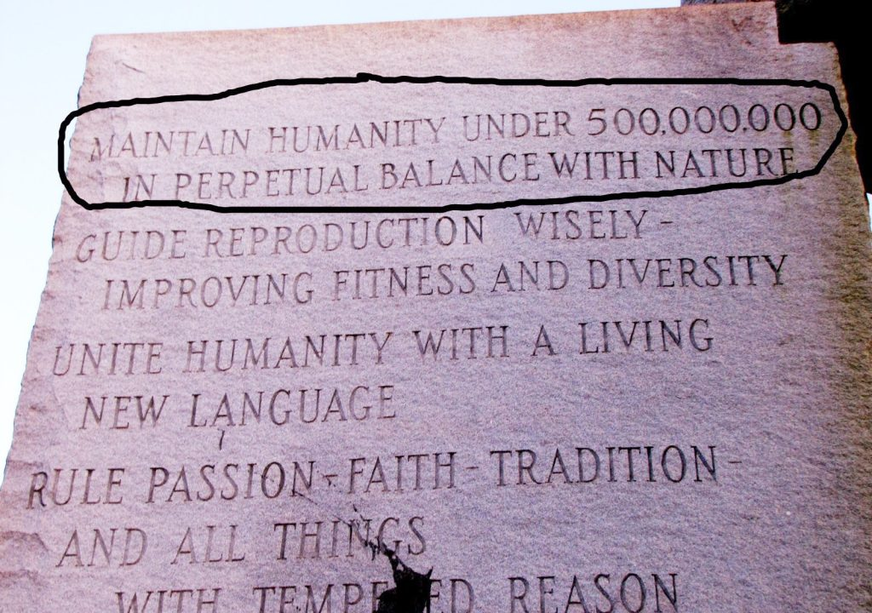
These New World Order principles are being put into effect! The annihilation of human fertility is also happening - no babies, no humans to grow up. Daniel 11:32: By shalom, wage warfare and act – blessings, Yedidah – August 31, 2021

