WALKING

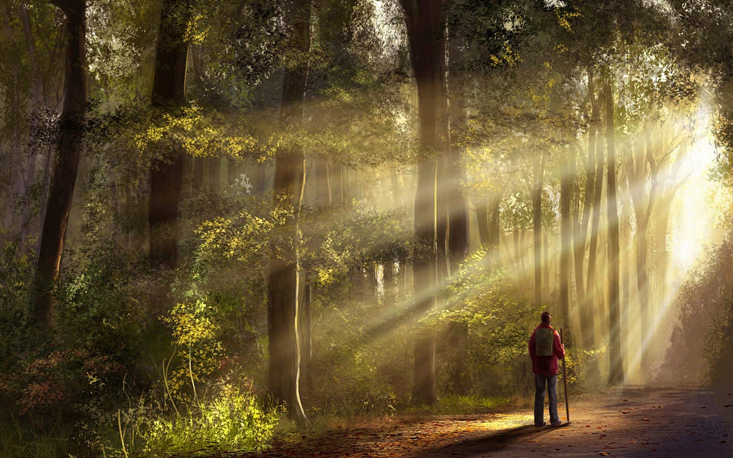

II Corinthians 11:2-3: “For I am jealous for you with a jealousy according to Elohim, for I gave you in marriage to one husband, to present you as an innocent maiden to Messiah. But I am afraid, lest as the serpent deceived Eve by his trickery, so your minds should be corrupted from the simplicity that is in Messiah.”

Genesis 3:8: “And they heard the sound of Yahuwah walking around in the Garden in the cool of the day. And Adam and his wife hid themselves from the Presence of Yahuwah Elohim among the trees of the Garden. And Yahuwah called unto Adam and said to him, `Where are you?’ ”

Genesis 5:24: “Then Enoch walked with Elohim, and he was no more because Elohim took him.”
Hebrews 11:5-6: “By faith, Enoch was translated so as to not see death, and was not found because Elohim had translated him. For before his translation he obtained witness that he pleased Elohim. For without faith it is impossible to please Him, for he who comes to Elohim has to believe that He is, and that He is a rewarder of those that diligently seek Him.”

Genesis 6:8-9, 22: “Noah found favor in the eyes of Yahuwah. Noah was a righteous man, perfect in his generation. Noah walked with Elohim…And Noah did all that Elohim commanded him.”
Hebrew 11:7: “By faith Noah, being warned of what was yet unseen, having feared, prepared an ark to save his house by which he condemned the world and became an heir of the righteousness which is by faith.

Genesis 17:1-2a: “And it came to pass that when Abraham was ninety nine years old that Yahuwah appeared to Abraham and said to him, `I am El Shaddai; walk before Me and be perfect. And I give My covenant between Me and you…”
Hebrews 11:8-10: “By faith Abraham obeyed when he was called to go out to the place which he was about to receive as an inheritance. And he went out, not knowing where he was going. By faith he sojourned in the land of promise as a stranger, dwelling in tents with Yitzak and Ya’cob, the heirs with him of the same promise, for he was looking for a city having foundation, whose builder and maker is Elohim.”
Hebrews 13:14, KJV: “Here on earth we have no continuing place, but we seek one to come.”

Yahuwah is Spirit. He dwells between the Cherubim (Psalm 99:1). He doesn’t walk like a man in a Garden, or anywhere else. So, who is this mystery-man who walked in the Garden of Eden, with whom Enoch walked, who shut the door of the ark before the Flood, who visited Abraham before the destruction of Sodom, who wrestled with Ya’cob, who talked with Daniel and Ezekiel, who walked before Moses, and talked with him face to face (Deuteronomy 34:10), who appeared Joshua as the Captain of the Host, who appeared to and spoke with the parents of Sampson, who appeared to and spoke with Gideon, and on and on into our present day? He is also known in Scripture as “the arm of Yahuwah,” and “the right hand of Yahuwah.” He is Yahushua! Whether in His pre-incarnate state or after His incarnation, He wants to walk with us in a personal way. In Luke 24:13-47, we find Him walking with two men on the road to Emmaus.
To walk with the Creator in simplicity and love – what greater privilege can any human being be given!
Yet, for the sake of satiating the flesh with what it desires, attaining personal agendas, or acquiring material possessions, most are throwing all these blessings away. Talk about the low-life! He is calling us today: “Walk with Me.” He wants us to walk with Him as His friends, as He once walked with Adam and Eve.
Notice the attributes of those who had His favor. They obeyed, they walked by faith, they feared Him as the Almighty, and they were righteous and set-apart unto Him in loyalty and love. They walked with Him. And as they walked with Him, the Spirit of Yahuwah transformed them so that their nature became like His. They thought like He did. They acted like He would act. They became “echad.” Enoch walked with Him so closely that one day he just walked into eternity with Him. Enoch lived 5000 years ago. Look what mankind as a whole has lost. But, there are the tiny remnant few--Daniel 11:32: “Those that know their …” There is the Matthew 7:13-14 remnant that will enter the narrow gate that leads to life.
Psalm 91:1: “They that dwell in the secret place of the Most High, abides under the shadow of the Almighty.”
Dwelling in His Presence, abiding in His shadow – that’s really close knit fellowship isn’t it? Eternal life begins with our abiding, staying, dwelling--living in His Presence--walking with Him now! Being so in love with Him that His slightest request is obeyed instantly--that’s bridal love. This one knows He is Elohim, and they are not. They are dependent on Him for everything, giving Him their full attention. He doesn’t just fill their thoughts on Saturday, or Sunday, a midrash, a convention or seminar. He fills their thoughts every day, every night. Their spirit is in constant communion with Yahuwah, and with the Master Yahushua.
Walking!
More than ever, we must fine-tune and prioritize our life to put Yahuwah and Yahushua of first importance. While the shallow who live for the world and what satisfies their mind and emotions, live to please themselves, there are those who know what it means to sit with Him in heavenly places – they are extra-dimensional-focused, like Enoch was. The world holds no fascination--the world is, in fact, boring to them. Don’t you know modern western civilization and all that it offers would be disgusting to Enoch? He’s seen it before, so it would be horrifying to him--for we are “in the days of Noah” once again, and final Judgment looms near.
These who dwell with Them (Yahuwah and Yahushua – Father and Son), walk with Them, and are already living in the Kingdom through their re-born spirit. No religion – just relationship. We become extra-dimensional beings through the “true new birth.” The Word and Their Presence are their passion and focus of the set-apart ones. They are aligned in loyalty to Elohim. The things of this world have no attraction to them. These few are prepared for the coming days of darkness and death, so that, like Mount Zion, they cannot be moved (Psalm 125).
Where are you with Them? Are you walking beside the Master?
On December 25, 2003, as I sat alone in Benbrook, Texas, Abba opened up Revelation 9:1-11 to me, explaining that the war in Iraq was a cover-up for what was unearthed at its beginning of the war in Babylon. I was in Jordan during the initial Iraq war. I saw and heard things the news media would never tell, and exposed some of it in articles. What He showed me on December 25, 2003 was confirmed in 2015 by personal experience of Tom Horn and reporting by Steve Quayle. What has come from 2008-2016 began in late March/early April of 2003 at the ancient ruins of Babylon. Later Rob Skiba also wrote about what Abba showed me in his book Babylon Rising. Abba always confirms what He shows us! Thus, loyalty to stand with Yahuwah against the world, the flesh, and the devil, has great, and eternal, rewards!
As we go into 2017 on the Gregorian world calendar – we face dreadful unknowns, but as children of light who walk in the light as He is in the light, Yahushua walks beside us.
Psalm 23:4: “Though I walk through the valley of the shadow of death, I will fear no evil, for You are with me.”
In His love and shalom,
Yedidah
December 25, 2016

