WE CAN’T JUSTIFY OUR SIN
A Personal Testimony

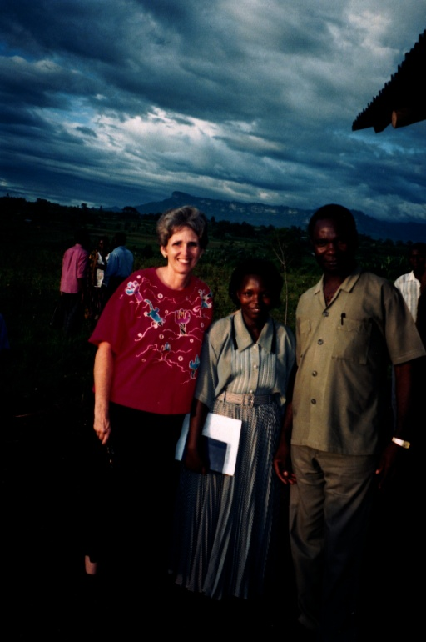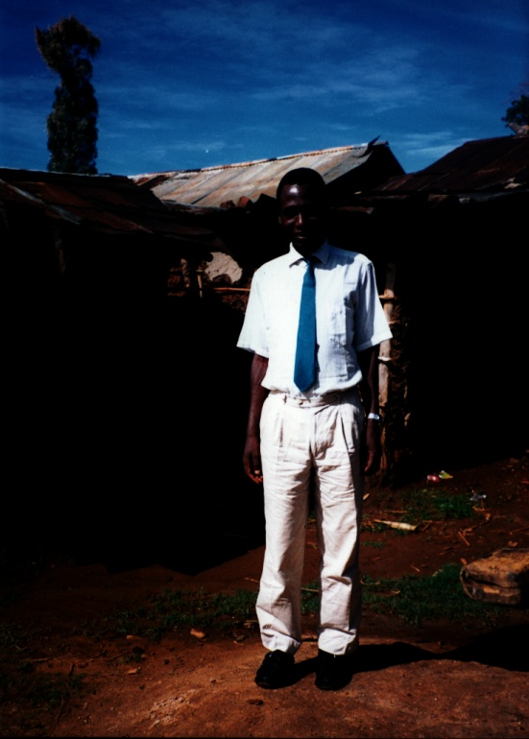
Left: Yedidah with Doctor Stephen and his wife Mary high in the mountains near Lawakhaka, Uganda 1999
Right: My African Director for many years: Vincent Wanyoni Wabuki

Doctor Stephen was not just the head of the only Clinic in the village of Lawahaka, near the Kenya border, but he also was pastor of a church near his house high up on the mountain where this picture was taken.
I was ministering in his church one morning, and praying for people to receive the baptism into the Spirit. Many were receiving the Spirit. As usual, Vincent was ministering to the people individually. He was not only my student in Charis Bible College in Kissumu, Kenya, but the Pastor of his own church near Bungoma, Kenya. He also worked for the Water Department in Kissumu. Kissumu sits on Lake Victoria. Vincent and I made a good team. I loved his family, and stayed at his home many times.
Near the end of the meeting at Dr. Stephen’s church, I began praying for those who were still stammering and had yet come through with a clear prayer language. One woman in particular was crying and stammering. I laid my hands on her spirit-area, her mid-section of our body, and to my surprise her pregnant belly was as hard as a rock. I did something I’d never done before or sense. I told her to stop stammering. I told her to repeat after me. Then I gave the first sentence of my foundational prayer language. Vincent was ministering near me, and Dr. Stephen was standing behind me. As soon as the lady repeated what I said from my prayer language, she burst into flowing with the identical language as mine. Vincent was shocked.
Later, Dr. Stephen told me that she had been pregnant for twelve months and the baby was still not ready to come. He was her doctor. After she broke into the prayer language, I laid my hands on her belly and commanded that the baby come out soon, healthy and peacefully. Then I went from there to stay with a family near Lawakhaka.
The next morning, a runner came up from a lower mountain with a message for me that this lady had her baby the following night after I prayed for her, and named her “Deanne,” after me.
Note: I had a “Director” whom I traveled with in Africa, because at that time I was an ordained “Reverend” and had my own nonprofit 501C corporation in Texas-- Word Fellowship International. I also founded an orphanage in Kissumu, Kenya, with its own elementary school and a church pastured by John Alos. I taught in Charis Bible College in Kissumu, an extension of Andrew Womack’s Bible College in Colorado.
It was while staying in the home of Dr. Stephen and Mary the night before the above-mentioned meeting in his church, that I had a life-changing experience. Abba’s timing can sometimes be really weird!
Because of deep anger, bitterness, and hurt for many years due to severe, traumatic, and abusive marriage, plus hurt at my parents, and hurt from friends, I had what psychologists call a “psychological reversal.” I turned totally against what I was, to become what I became – a total opposite. I went into an extremely defiant stage to get back at God who I felt had failed me. My hate grew so much that I purposely did everything I could to show my hate for God. I was the little girl in the poem: “There was a little girl who had a little curl right in the middle of her forehead, and when she was good she was very, very good, but when she was bad, she was horrid.” I never walked a middle road!
I delighted in sinning – the worse the better as far as I was concerned. But, in the ensuing years, even though restored miraculous to faith and deep love for my Abba and my Savior, there was that little section in me that could not let go of justifying my former sin because of the evil done to me.
Since He had restored me to fellowship with Him in 1985, it led to my going to the nations to teach and proclaim the Good News, conduct Pastor’s Seminars, teach in a Bible College, and do many forms of ministry in various nations. Abba was with me, and miracles came, people were saved, healed, delivered, baptized in the Spirit, and taught the Word. I had an exciting life.
Yet, there was something hidden deep inside of me that I did not think about, but it was there. It had not been dealt with before the throne of Yahuwah! There were times later on that it surfaced and I remembered what I’d suffered, and I still felt justified in my sinning. After all, I was hurt – I acted in hurt, but I felt no conviction of it being damning. After all, I was sure God understood. Then I’d forget again. It was not a conscious thing. I didn’t dwell on my hurts. It was just not dealt with! I had not put it on the altar before THE Righteous Judge. Even though I had repented when I returned to the Master in 1985, I did not get rid of my justifying the sin – the making excuses for why I did it! We make excuses for attitudes we know are wrong, but because we were hurt, we think these carnal attitudes are justified. “Surely, God knows my heart!” Yes, He does!
Read Jeremiah 17:5-10. “The heart is deceitful above all things, and desperately wicked.” In Hebrew “the heart” is the soul – the mind and emotions of the carnal self. It is often at war with the re-born spirit.
So, back to my story: I was sleeping well at Dr. Stephen’s house. About 3:00 AM, I woke up. I sat straight up in bed, and Abba flashed a picture of me in my sin. He put within me what I’ve come to know as “the gift of repentance.” It came down all over me, and within me. I was baptized in the spirit of repentance. All of a sudden the horror of MY sin was presented to me! I cried and cried and told Abba how sorry I was. I knew I was NOT justified for holding onto those memories, or holding onto justifying my hurt over them. I went back to sleep. A gigantic burden had fallen off of me. It never returned.
In 2003, as I’ve told many times, the day before First Fruits I was in East Jerusalem, walking around the walls of the Old City with a young lady who absolutely hated me out of jealousy, so she later admitted. She said she hated me because I heard from God and she didn’t. I know that sounds crazy, but I’ve had several women hate me viciously, lie and slander me, for the same reason – some in foreign countries.
I was walking with her because I’d never walked around the Old City, and she had several times. I asked her if we could go into the St. Stephen’s Gate at the north end of the Temple Mount and visit the Church of St. Anne, where the ruins of ancient Bethesda were – John 5. After 38 years a man there was healed by Yahushua. As we entered the grounds, the lady I was with went on to the entrance of the ruins. I stopped in the garden area because Yahushua spoke to me. He simply said: “After 38 years.” I knew what He meant. I calculated 1965 and 2003, and yes, that was a 38-year period. In 1965, because of great discouragement, I made a decision that ruined my life for the next 30 years. I burst out crying, sobbing very hard. I walked to where the lady was waiting for me at the entrance of the Pools of Bethesda. As I approached the entrance area, all of a sudden I was staring into the face of Yahushua. All I could think of was that He looked the same age as my son. The sweetness of His Presence held me spell-bound. He smiled, and then He bent over with a gracious sweep of His left hand towards the entrance, as in “welcome.” I began crying so hard I was shaking. The young woman was disgusted. I walked around the ruins by myself, and the peace came over me that “passes all understanding.” As I left, He said to me what He said to that man so long ago: “Go and sin no more.”
That day, He removed from me all the mental and emotional pain that I had all those years, and set me free. If I had not repented at Dr. Stephen’s house in 1998, I may not have received such a powerful deliverance.
There is no justification for holding anger, bitterness, hate, vengeful thoughts, or for holding onto memories of hurts done to us that provoke deep and often hostile emotions. I was not holding onto negative emotions. I was freed by Abba to be His servant. It’s just that Yahushua was probing deeper. The whole thing had not been totally dealt with in his sight. He’s after purification and blamelessness! Through the years if something triggered the memories, which was rare, the anger would rise. But, after being confronted by Yahushua Himself, there is no more anger, no more anything but praise for Him who died to free me!
So many people hold others in a cage in their heart. Whenever they feel hurt, they bring out the cage, pull out the person or persons whom they put in the cage out of hurt, anger, bitterness, vengeance, etc., and beat them up again in their mind, spew venom about them to others, or just talk out loud to themselves. Then they put them back into the cage in their heart for the next time of beating. We must let Abba destroy the cage and we must free all who have wounded us. We must remember that we are sinner also who deserve death and hell. If it were not for Yahushua, where would we be? The only thing that stands between us and damnation is the blood of Yahushua!
There at Bethesda, I had no cage in my heart that I knew of, but as a human I had memories that were sometimes provoked and my reaction was not good – so the cage may have been buried so deep I did not know it was there, or else the hurt from the cage once being there was something I could still feel. We can be quite complex at times as humans!
The healing of the memories and emotions is not something we can do. It takes a sovereign act of Elohim’s Spirit to do it within us. It takes our repentance, then our submission to Yahuwah to remove it from us.
Other’s try to put us in a box and control us to our harm, or gleefully harm us to make themselves feel in control, and good about themselves. But, we must not put ourselves in a box, or anyone else. If we do, all we are doing is destroying our own life. And, no one can know or receive Abba’s love, or be used to share His love, if they live in a box of “I’m hurt.”
I understand a wounded spirit. Proverbs 18:14 KJV: “The spirit of a man will sustain his infirmity, but a wounded spirit, who can bear?” A wounded spirit is very, very deep, and often hides. But, that night at Dr. Steven’s Abba granted me the “spirit of repentance” to let go of my justifying my sin. He did it sovereignly because I could not do it for myself!
Yes, I was sinned against, but then, aren’t we all. John 16:33: “…In this world you will have tribulation, but be of good cheer, I have overcome the world,” so said Messiah to His disciples.
It took three things for me to be totally free: 1) true heart-crying repentance for my sin (1985/North Carolina) 2) True repentance for justifying in (1999/ Uganda), and 3) the 2003 experience in Jerusalem that completely healed me inside both my soul and my spirit.
I talk about the “gift of repentance.” Do you remember from Hebrews 12:16-17 that Esau sought repentance with tears but repentance was not granted to him by Yahuwah?
Many think they can repent on their death bed and go to heaven. Many attend evangelistic meetings and feel the Spirit of Yahuwah calling them to go to the altar and be born again, but they hold back for their own reasons, thinking “I’ll do it later.” No! There is no guarantee that there is a “later.” I’ve heard stories of those who felt strongly to go to the altar and get “right with God,” and even cried, yet did not submit to the Spirit. I remember hearing of one who had been convicted to be saved yet he went out of that meeting unsaved and was killed in a car accident on his way home.
Only after complete repentance for our own sin, and submission to the Master, can He remove the pain that we’ve held inside. Only by complete repentance and submission of our self-life totally to the Master can we even be born again. Refer to: “The True New Birth” under the Mikvah of Eternal Salvation on comeenterthemikvah.com.
It’s not a game of “pray this prayer to receive Jesus,” then go to church, tithe, be moral, die, and go to heaven. That’s not His journey!
He wants us free! Messiah said: “He who the Son sets free is free indeed!” The dark kingdom and man’s kingdoms want us bound and submitted to them. Think straight! How can we enter the Kingdom of Light if our nature is that of the Devil and his angels? We can’t! “Carnality”--living with the lusts of the flesh and motivated by the sin nature--will not be allowed to enter the Kingdom of Light.
Here is just a sampling of Scriptures that describe those who do not enter the Kingdom of Light: I Samuel 15:23; II Kings 9:22; Isaiah 33:14-17; Psalm 15; Psalm 24:3-5; II Chronicles 33:5-7; Matthew 5:20; Matthew 7:21-23; Mark 8:38; John 3:3, 5; Romans 1:28-21; I Corinthians 6:8-11; Galatians 5:19-21; Ephesians 5:3-7; II Timothy 3:1-8; Revelation chapters 2 and 3; Revelation 21:8, 27.
“God is not mocked, whatsoever we sow, that shall we also reap.” (Galatians 5:7-9) We can “fool most of the people most of the time,” but we cannot fool the Judge of the universe. And, we’re about to face Him!
In my life I’ve found many times that the ones others consider to be the most saintly and righteous people, have been the most Satanic people in their true nature. They fool religious people, but not those who are their victims, or the discerning. One of my deepest hurts has been seeing and experiencing the ability of the demonized to transform themselves into an angel of light before others, yet to me they reveal their true nature. We are known by our real nature, not as we appear to others, but as we appear to the Judge of the universe. We cannot fool Him! He sees us naked! (Hebrews 4:12-13)
I pray that you make sure you are free from negative emotions that may be controlling your life in some way because of harboring justification for sin. Yes, bitterness, negative anger, hate, vengeance, nurturing and fueling a wounded spirit, a wounded mind and emotions, is sin--sin that will keep you out of the Kingdom. Is holding onto negative feelings and thoughts that are foreign to the nature of Yahuwah worth losing your eternal life for?
As always, I write to prepare you for the coming of the Messiah and His Kingdom!
In His love,
Yedidah
October 6, 2018

