HEALING -Part V
We’ve been robbed!

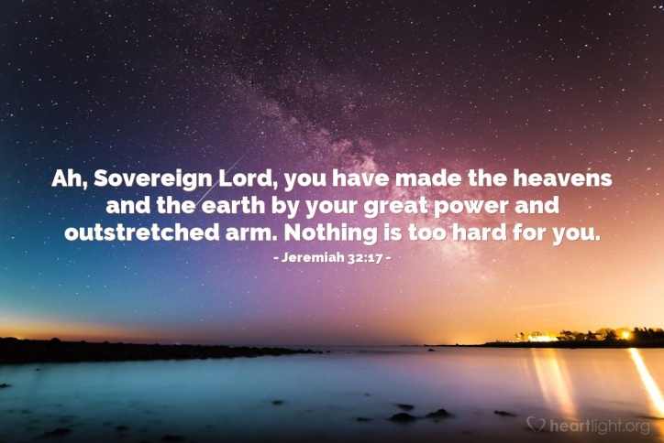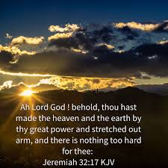
Not only have we been told the book of Acts is not for us today, we’ve been told that there are some things God doesn’t do for His people now. We’ve been told that what our pastors teach is the truth, and we need to listen to them. Wow, have we been lied to!

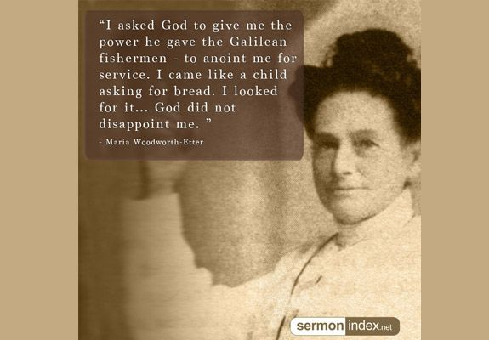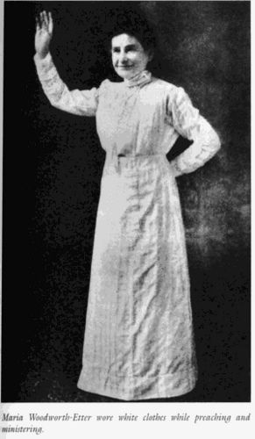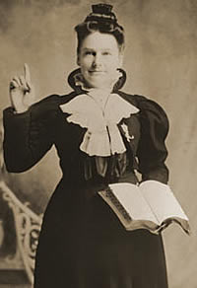
Pointing people toward heaven …
Maria Woodworth was a quiet and unassuming lady. She had eight children by Mr. Woodworth. In the 1800s, a married woman was supposed to have babies, clean the house, and keep her husband happy. She certainly was not allowed to preach – that was a man’s job.
However, just as Messiah defended women and enjoyed flaunting His exaltation of righteous woman to the anger of the Pharisees, Maria was called by Abba to preach. [Refer to my study: “Women in Ministry”]
Maria kept telling Him that she was a woman and she was not allowed to preach. One by one, her little children died, leaving one daughter and a husband who opposed any idea of her preaching. Finally, Abba got through to her, that He had called her and she had to obey Him. She began tent meetings. The opposition from male ministers was incredible, from intellectuals, from “Infidels,” and from Christians who were lukewarm and religious. But, Abba anointed Maria with His

power and His message, putting within her a passion for the lost.
In the first year of her preaching/evangelism, He told her she had a healing ministry to accompany her preaching. She had never laid hands on the sick, or cast out demons, though she believed the book of Acts never ended, but is for us now. She also believed in the baptism into the Spirit BEFORE the 1906 revival on Azusa Street in Los Angeles that sparked the great Pentecostal renewal of Acts 2. Because she was anointed by His Spirit, people coming to the meetings out of curiosity, or contention, religious arrogance, with mockery, and with intent to tear down her meetings, ended up being born again and filled with the Spirit. Even Charles Finny, after having the baptism into the Spirit, did not know what really happened to him until later, because the great Welsh Revival of 1904 had not happened yet. He called his experience a baptism of love. In the 1904 revival under Evan Roberts, Yahuwah restored the empowerment of believers by His Spirit, as in the book of Acts. Oh how we need this empowerment, this anointing – the oil of His Presence! Oh how we need to see His mighty works again. Without it, we will not be able to stand in the days ahead, but will be overcome and defeated. No human will be able to stand who is not empowered by Yahuwah! Right now Yahuwah is gathering a remnant in small groups to unite His set-apart ones in His love, as in John 17, and empowering them to go forth in these last days with the coming two witnesses – the Daniel 11:32 company, the Joel 2:28-29 company, the Eliyahu/Elijah company – Revelation 7:1-8; 14:1-5. “They that know their Elohim will be strong and will take action to do exploits” in His Name.
In this article I give you quotes from Maria’s reporting on the meetings from 1885-1889, from her book The Acts of the Holy Ghost. I urge you to get her autobiography A Diary of Signs and Wonders. She was a forerunner. She remained in humility, yet Yahuwah powerfully anointed her. Like the Apostle Sha’ul/Paul everywhere she went she met with opposition, yet the power of Yahuwah’s Spirit brought tens of thousands to salvation. The Spirit’s methodology is often mocked today, but the results cannot be argued with! Everything she preached and did had foundation in the whole of Scripture.
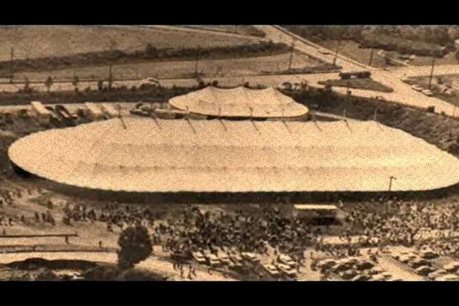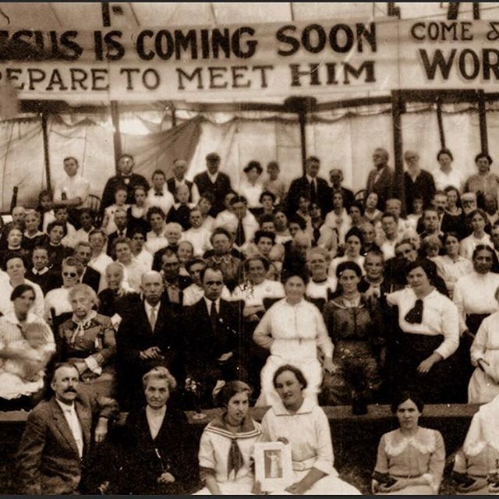
Charlevoix, Michigan 1915 tent revival

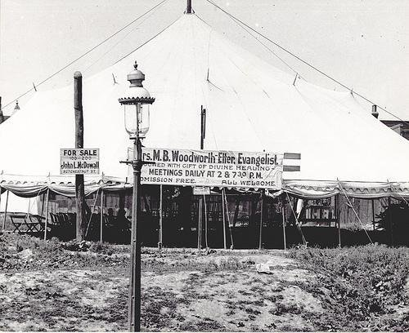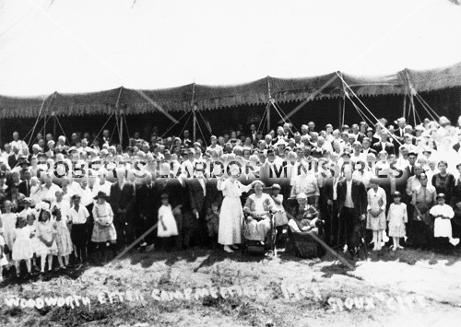
They believed that Jesus was coming soon, and that the great outpouring of Hosea 6:1-3 was happening. Yes, it was the beginning of the Hosea 6:1-3 latter rain in our day, the Acts outpouring of the Spirit. That latter rain will once again be poured out, perhaps for as little as six months, for the latter rains begin at Passover, but that will be mankind’s last outpouring until Messiah comes.
Abba has His timing in each nation. He poured out His Spirit through Messiah for the first time for all flesh who would receive Yahushua by faith as Savior and Master who died for them, in their place, on the stake, and rose again to give them eternal life. Salvation begins with “repent, for the kingdom of heaven is at hand.”
The Kingdom comes within us as we allow the Spirit to prepare our spirit as a temple for His dwelling, and then we must ask Him to come and dwell with us. It is the pattern of I Kings 8. He is simply received by child-like faith in an all-powerful Father.
He began in Jerusalem, the epicenter of all good things for His people, and His dwelling place forever. (Psalm 132:13-14; Acts 1-2) This great outpouring moved to other nations, one at a time, or one region at a time. The resurgence of this outpouring began in 1904, in the coal mining area of Wales, the Rhondda area, under a humble man named Evan Roberts. This outpouring continued in the UK, and then across western Europe, at the same time coming into America, beginning at Azusa Street, Los Angeles, in 1906. This great outpouring came into Germany around 1906 also. The leaders of the Lutheran Church, like the Pharisees of old, gathered and reasoned that this movement would not be good for their power over the people. So, in 1909, they drew up the Berlin Pact, saying that this teaching was banned from the churches in Germany, and no Christian was to go to any such meetings, for they were of the devil. That is what Messiah called “blasphemy” against the Spirit. That same spirit rose up in America in the formal churches. But, way before 1906, Abba began preparing the way.
In the mid-1800s, men like Charles Spurgeon began preaching a simple gospel of the new birth, and calling people to repentance and set-apartness, to the Word, and to Elohim/God of the Bible. By the early 1880s, because of the teachings of Charles Darwin, and the occult “spiritism” movement, there were many intellectuals and mockers, scoffers, agnostics, and “Infidels,” like Robert Ingersoll and Voltaire. College professors were turning students away from faith in God even back then. But, at the same time, Father Yahuwah raised up simple child-like faith evangelists and restored to us the gifts of the Spirit (I Corinthians 12:1-12), primarily healing, deliverance from demons, the power of the Spirit, the trances/visions/”falling under the power” of the Spirit, which all led to people being born again and gloriously saved.
Abba sent Maria to some very hard areas where other evangelists would not go, and the power of the Spirit fell. She was then told by Him to add healing to her meetings. She had never laid hands on anyone for healing, but when she did, at His command, miracles began to happen. He backed her 100%. Her life was a life of signs, wonders, and miracles. I’ve seen my share of miracles, since my baptism into the Spirit in November of 1966. You can read some of my testimony under the Mikvah of the Spirit, on comeenterthemikvah.com. My baptism into the Spirit was dramatic, followed by signs and wonders. Signs follow them that believe – leading others to the stake/cross, thus to eternal life. (Mark 16:17-18, 20)
I have been an evangelist since age 6, and a missionary from age 9. In November of 1966, I was 22. I’ve seen the miraculous happen all over the world in response to child-like faith. What are you doing with the power that Yahuwah gives us – i.e. Luke 10:19?
Intellectualism has to file-cabinet everything – and Yahuwah just won’t be filed!
He often does things that shock the human mind, but out of it people are saved.
Here I want to share just a tiny few quotes she wrote of her adventures in the early years (1888-1890). I’m only about 1/4th through her book The Acts of the Holy Spirit, which is a 700+ page sequel to her 700+ page autobiography, A Diary of Signs and Wonders. But, there’s not a boring paragraph in any of her writings!
A young woman named Mrs. Aimee Semple met with Maria Etter to tell her of her passion to win souls for Jesus. Maria counseled her and prayed over her to receive the anointing to be an evangelist, to heal the sick, and cast out demons. That young woman went on to found the Foursquare Church, and to reach millions with the Good News of salvation. She also founded Life Bible College.
It was two students from Life Bible College who came up to me while I was preaching on the streets of Los Angeles, and asked me the question Sh’aul asked in Acts 19 “Did you receive the Set-Apart Spirit when you believed?” I said “No, but I sure would like to.” I went to their apartment a few nights later and the awesome life-changing story is told under the Mikvah of the Spirit. I went on to attend Angelus Temple, founded by Aimee, and saw the work that she started still going on through her children by Rolf McPherson – the book of Acts is alive and well.
Later, following Maria, came Charles Finney, Smith Wigglesworth, John G. Lake, Lester Sumrall, and others in the great healing movement of the 1920s, 30s, and 40s. Dallas became a center of the healing movement in the 1940s. Yet, today, in America and other affluent western nations, hardly anyone receives the true baptism into the Spirit. Few know how to hear from the Spirit, to be taught by Him, how to be led by Him, convicted by Him, and shown things to come by Him (John 14, 15, 16, 17). Few know how to receive from Him by simple child-like faith! This is why we don’t see the great manifestations of the Spirit – the principles of faith are for those with child-like purity, who receive from One they know and love. Today, self-sufficiency and intellectualism rule the mind, and the spirit is neglected.
Today, there are more than 43,000 Christian denominations and organizations around our world, all with a different bent, all following the theology of their founders. Very few believers are Spirit-taught.
In March 2018, Abba led me to Fort Worth to a small growing congregation where the leaders are Spirit-taught, and move in the powerful gifts of the Spirit.
Oh how awesome to be with those who move with the Spirit without wasting time on opinions, theology, doctrines of men and demons, rules of organizations and denominations! We have no formality, no man-made file-cabinet structure. We flow with the Spirit, and the teaching of the Word is powerful also.
Few today understand what a child understood in the days of the great revivals. Today’s children and teens extol the powers of Batman, Superman, Captain America, the “Justice League,” and Spiderman, virtual reality technology, smart phones, computers, the latest rock music, and the stars on TV. Back then, there were those like little Moses, whom I wrote about in “Healing – Part IV.” “A little child shall lead them,” was common-place in the great revivals of the restorations.
Acts 3:19-21: “Repent therefore and turn back, for the blotting out of your sins, in order that the times of refreshing might come from the presence of the Master, and that He sends Yahushua Messiah, pre-appointed for you, whom heaven needs to receive until the times of restoration of all things, of which Elohim spoke through the mouth of all of His set-apart prophets since of old.”
First salvation in its simple form by faith was restored in the 1800s, then the baptism into the Spirit, then the gifts of the Spirit, i.e. healings, deliverance from demons, prophecy, miracles, tongues, interpretation of tongues, miracle-working faith, word of knowledge, word of wisdom. (I Corinthians 12:1-11) His power often overtakes His servants. However He manifests it is always for our redemption! Never be guilty of “limiting the Set-Apart One of Israel!”
By the 1950s, and especially from the mid-1990s, the restoration of the Torah was sent by the Spirit. The enemy moved in, just like he did in the early 1900s, to turn the people to Phariseeism, to following messianic rabbis, and teachers of theology – thus killing the work of the Set-Apart Spirit, making people proud of their knowledge - turning many away from Messiah to their eternal damnation, i.e. Hebrews 6:4-6.
I had a dream in the late 1960s, in which I was living in a single-wide trailer out on a lonely lot. I had a dresser full of real jewelry, and other things that were priceless to me from my parents, my childhood, in my archeology collection, etc. I had everything in a five-drawer dresser. I came home late one night, and saw that my trailer door was open. I went in and saw nothing missing. I went to my dresser to check there. To my shock, every drawer had costume jewelry in it, set in perfect little sections - beautiful, but all fake gems, fake gold, fake silver, fake everything. I was devastated. I went over the window that looked out on an open field. It was dark and I saw nothing out there, but in my heart, I was totally wiped out, everything I treasured in this life was gone, replaced by beautiful, but fake jewelry.
That described most of my real life after that. I was robbed. I first of all was robbed by the lies told by my Baptist Church – the Old Testament is not for today; the book of Acts is not for today. And in the place of the genuine they substituted fake costume jewelry. I stood on principle. One weekend, the youth director at the church showed the Alfred Hitchcock movie The Birds, in order to attract young people to the church. I boycotted it and stayed home. The same youth director mocked the belief in a 1000-year reign of Messiah, saying “I am a pan-millennialist - it will all pan out in the end.” I was angry at that. He was a typical Seminary graduate. Today, few Christians in America even believe that the Bible is the Word of God, that Satan is real, and that there is a Holy Spirit.
That is the religion of man my friend! The genuine has been removed, and lovely fakes given to us, thus we’re empty in mind, emotions, and spirit. Nothing of the fakes can give us what we need from Abba, for we’ve been robbed of what is real! Powerful testimony huh!
The tragedy is, that most in the western world of affluence has any idea that they’ve been robbed. They think the fake is real. They go to church, or congregation, and while enjoying it, the genuine is not there. We’ve had His power and Person removed by listening to the deceit of man’s religious ideas.
Don’t you long for the days where we see the power of God, not via millionaire charlatans who make healing an entertainment theater, but for real? It’s coming. If you want to be a part of it, you have to pay the price – total submission to the Master, Yahushua Messiah, obedience to His, and our, Father, and abandonment to do Their corporate, united will.

Quotes from early chapters (1888-1890) of The Acts of the Holy Spirit
I could only find this book on Amazon Kindle, but if you go online, like on Amazon/books, you can find A Diary of Signs and Wonders, her autobiography, for sale at a reasonable price for a used book.
These quotes will give you an idea of how badly we’ve been robbed. Spring 1985-1889: Quotes from many meetings in several cities in several states, like Ohio, Missouri, Michigan, Pennsylvania, Illinois, California, Kentucky, etc. Later, after the 1906 revival began, she set up her tent in Dallas, Texas. It was to Dallas that people came from all over America and all over the world to be saved, healed, delivered, to find reality of what is written in His Word. It overflowed to Fort Worth, Texas, and it will begin again with a small remnant in various places.
From Marie’s writings: “These outpourings of the Holy Ghost were always followed by hundreds coming to Christ. The Lord has backed up His Word, as I preached it on the apostolic line, with signs and wonders and demonstrations of the Spirit.”
“No place is too hard for the God of Israel. I expected the mighty God of Jacob to fight for me. Jesus is a Mighty Conqueror. He never lost a battle.”
“Jesus said it would be so, `people should wax worse and worse.’ There should be a falling away in the churches. ‘False teachers should arise having the form of godliness but denying the power, from such turn away.’ How many hundred preachers there are today who preach the letter but deny the power and the Spirit”…blind leaders leading the blind. Oh that the churches would arise from the sleep of death and call upon God, that He may give them light.”
“I never saw such manifestation of the power of God before or since. The house was full of the glory of God. It was like a mist. People fell down in their seats all over the house, overpowered with the glory of God. Sinners came out crying for mercy.”
“Many of our churches are more like a theater than the sanctuary of the Lord. They are decorated with everything to lead the mind off the sermon into another channel. No wonder so many of our best men and women are becoming skeptical. They say there is nothing in it. … Jesus told of these days when the churches would leave the old paths, teach false doctrines, and lead the people away…”
“Divers operations of the Spirit were seen. The displays of the power of God continued to increase till we closed the meetings, which lasted about five weeks. The power of the Lord, like the wind, swept all over the city, up one street and down another, sweeping the places of businesses, the workshops, saloons, and dives, arresting sinners of all classes. The Scriptures were fulfilled…Men, women, and children were struck down in their homes, in their places of business, on the highways, and lay a dead. They had wonderful visions and rose converted, giving glory to God. When they told what they had seen their faces shone as angels. The fear of God fell upon the city. The police said they never saw such a change; that they had nothing to do. They said they made no arrests; and that the power of God seemed to preserve the city. I held the people still. A spirit of love rested all over the city. There was no fighting, no swearing on the streets; that the people moved softly and that there seemed to be a spirit of love and kindness among all classes, as if they felt they were in the presence of God.”
Let me insert here from the ministry of Charles Finney after he was baptized in the Spirit. Wherever he went to hold meetings, the bars closed, the houses of “ill repute” closed, swearing stopped, and people were crying out for mercy, repenting, getting born again, in their homes, their shops, the street, the horse stables, and in factories. One day, Finney went to visit a man who owned a large clothing factory with the intent of leading him to salvation. As he entered, just near the man’s office, there were many workers using sewing machines to make clothes. Without knowing who he was, all of them, all of a sudden, began weeping. They got down on their knees and cried out to God for mercy, and cried out to Jesus to save them. This is called “the anointing,” where we are so filled with the power of the Spirit of Yahuwah, that people feel it, not knowing where it is coming from. But, when we speak, they know that, like Moses, we have been in the Presence of the Almighty One.
The late 1800s, early 1900s, were known as the time of the “great missionary movement” from England and America to foreign nations. A man named Jonathan Goforth (yes that was his real last name) was called to go to China. He and his wife went to preach the Good News. He struggled because the people were not receiving the Good News to be born again, but rather said they believed just to get free food – thus the expression “rice-Christians.” He was greatly discouraged. He heard of the baptism into the Spirit in the life of Charles Finney. Jonathan told his wife that he was going to stay in his room until he got the empowerment of the Spirit. It was not too long after that, that he came out of his room, face glowing, telling his wife that he had received the Acts outpouring. He went to preach. The places of his preaching could not hold the crowds. They came to be saved, weeping and crying out for God’s mercy to save them. He had a powerful ministry. The Spirit was poured out wherever He went, for the salvation of souls, the baptism into the Spirit, healing and deliverance. We are baptized in the Spirit to minister to others, as well as to build up our own life!
John 14:12-13a: “Truly, truly, I say to you, he who believes in Me, the works that I do shall he do also, and greater works than these he shall do, because I go to My Father. And if you ask whatever in My Name, I will do it.”
With the knowledge now that we have of the whole Word, the name Yahushua, the gifts of the Spirit, and so much more, His people today have no power to do anything but to try to convert someone’s head to their particular religious philosophy. Oh how we have been robbed!

Back to Maria: “One night there was a party seventeen miles from the city. Some of the young ladies thought they would have some fun; they began to mimic and act out the trance. The Lord struck some of them down. They lay there as if they had been shot. Their fun-making was soon turned to a prayer meeting, and cries for mercy were heard.”… “…before the meeting closed all who had been making fun were struck down by the power of God and lay like dead people…scoffers and mockers were struck down in all parts of the house.” …“Not less than five hundred were saved in one week, and hundreds after the meetings closed, as the result.”
“The Holy Spirit fell upon me. God made them to see the life-boat on the ocean of eternity, and them drifting away into darkness and despair, down to an awful hell. I led in prayer. When I arose, the silence of death reigned over the house. They were trembling under conviction. While I was preaching, God sent every word like arrows, dipped in the blood of Jesus, to their hearts. After preaching, I called for sinners to come forward. There was a rush for the altar. It was soon crowded.”
“Some of the scoffers who were struck down by the power of God had awful visions of hell and judgments of God on the ungodly. God showed them the road to heaven and told them to make a choice…They came out shouting with that awful look of horror all gone and their faces shining with brightness. When the people saw the changes in these men (former mockers), they said, `It is the work of God.’ ”
“The seats were taken out to make standing room. The whole house was a mourner’s bench. Many of the worst men in the town and country were saved, and lived earnest Christian lives. Many were saved at home, all around the country, in nearly every house. Some died praising God. Several went on to preaching the Gospel. Hundreds have been brought to Christ by their labors.”
[This reminds me of four-five young men who came to mock in one of my meetings in Uganda, and ended up in tears, receiving the Savior, and also of the ex-Hells Angels, ex-pimps, x-prostitutes, and x-criminals from jails, in my Bible class at Community Chapel, Long Beach, California, who went on to be pastors, evangelists, and church leaders]
Maria: “The holy fire went into all the churches and spread for miles. Hundreds of lost souls were brought to Christ after I had gone to other fields.”
“It was indeed a battle against the powers of darkness and the hosts of hell. Conviction rested over all the city. Hundreds became pilgrims said they had started for heaven, seeking `a city out of sight that hath foundations, whose builder and maker is God.’ ”
“The Lord showed me while here that I had the gift of healing, and of laying hands for the recovery of the sick. I had been working day and night for many months and had no strength only as God gave me each meeting. It would be two o’clock often before I would get to sleep. When God began to show me I must preach divine healing, I could not understand that I was the Spirit of God leading me. For three nights when I was most dead for rest, I lay awake. God was teaching me a lesson I could not, or would not learn. I said, `Lord, you know I started out to win souls for heaven, and I have been busy all the time. I have tried to be faithful in everything you have given me to do. I am so exhausted with constant labor that I have to be helped many times to rise from my bed.
I thought if I would preach divine healing they would bring all the cripples from the country and I would neglect the salvation of souls. Te Lord showed me He would take care of the work. I told the Lord if he wanted me to pray for the sick to send them to the meetings, and show me He wanted me to pray for them and I would. When I made this promise I had perfect rest of mind and soul. At this time God began to lead me to teach divine healing and pray for the sick. It is now nine years since, and God has healed thousands of all manners of disease. Thousands have been brought to Christ by seeing the people healed.” [her “Test of Iyob”]
“The people thought that I would not be able to preach, but I arose, and stood before a packed congregation. The power of the Holy Ghost was like a cloud on the
people. I saw the three men that I had seen in my vision coming from the train…
They were angry at first, and said they were going to another city, but something got hold of them, and they had to get off the train. They saw the crowd going to the church, so they came too. Praise the Lord they were all saved that night. One told me that he was going right back home, twelve hundred miles, to tell his mother the good news…From that meeting the revival swept over the country, and thousands were rejoicing in a Savior’s love.”
[Somewhere around 1991, I came in a little late to a morning Bible meeting at Calvary Cathedral in Fort Worth. I saw the cloud covering the people like a foggy mist. I walked down to get a seat, and when I entered the cloud, the “glory cloud,” I had to grab onto the back of a pew in order not to fall over. Oh how the people today are so ignorant of the power of the Spirit, and how tangible He is, nor do they know that He is Yahuwah Himself just as the cloud was with the children of Ya’cob. People baptized in the Spirit today, often think it is a badge of religious superiority, but do not know Yahuwah and Yahushua, or walk in Their nature]

Maria: “We went from the court house to the skating rink, the largest building in the city. About one hundred were baptized. It was said about twenty thousand witnessed this solemn and wonderful scene.”
“Many were stricken down as Saul (Sha’ul/Paul). The power of God was felt for fifty miles around. Thousands of souls were brought into the light of God. The Sabbath was closed, and God gave us a Pentecost. The Holy Ghost fell on the multitude that had crowded in the rink and around the door. The power of God had been poured out in all the meetings and signs and wonders followed and rested upon the people. The Holy Ghost sat upon the blood-washed sons and daughters of the Lord Almighty.”
“The great revival at Cornelius’ house was all brought about by two men in trances--one a sinner, the other a saint--though they were miles apart at the time.”
“A blind girl was healed. Her sight came like a flash. It seemed as though she could never stop shouting and praising God.”
[Tanzania, believers told me how they went to preach in villages ruled by witchdoctors, the blind were healed and whole villages turned to the Savior, witchdoctors included - 1997]
Maria: “Elder S. met us at the station, and I think it looked the hardest and most discouraging place I had ever pitched battle in. It was five miles into the country. I was so weak after hard labor at Cleveland that I could not walk without assistance. I shouted the victory, and the power of God came as a cyclone. Sinners fell at their places of business and in their homes under the mighty power of Elijah’s God, and came to the church and told of their visions and wonderful conversions.”
“The power of God came until it filled the whole house, and hardened sinners said on entering the building they could feel a strange power come over them. Men were smitten down in their seats…man were entranced and saw visions…strong men cried for mercy. …Wives and husband crying `Oh let me in the kingdom!’
The place was noted for infidels (made so by dead, cold professors). Both these classes were made to yield.”
“`The wicked flee when no man pursueth, while the righteous are as bold as a lion.’ ” Professor R had been a skeptic. The Lord talked with him in the silent hours of the night as friend to friend, and he was brightly converted. His friends heard of his wonderful experience and came to see his shining face and hear him tell of the love of God…”
“Almost every person in that community belonged to a church, hence it seemed their hearts were `bomb proof.’ God save the church members…! This battle carried to the very doors of the enemy. It was not a battle about doctrines, such a ordinances, but a real battle to tear down the citadel of the soul; a hand to hand conflict with the powers of hell. There was no wishy-washy palaver about Mr. Satan, Esq., and the place of Hades or Gehenna. It was a battle in which Satan was called the devil, and his habitation was called hell. And dear people began to believe there was such a being, and a place called hell. One feature of this meeting was the presence of Jesus to heal bodily disease.”
“A preacher came to the meeting who was dying of consumption and as healed in the presence of thousands, while we were praying for him. He went out to preach the gospel.”
“The first night, while I was leading in prayer, the power swept over the multitude in waves. The people could not stand God’s mighty power; some ran from the tent saying they would never come back. What will they do in the awful judgment day?”
“Brother D., sixty years old, who had been lame for twelve years, had to walk with a cane or crutch…Several of us kneeled and prayed with him, laying our hand on him. The Holy Ghost fell on him, and the pain left him, the swelling went down, and the calloused parts disappeared. He leaped to his feet shouting `Glory to God, I am healed.’ …He threw his crutch away. It is now about nine years since he was healed; he has testified before thousands…” [Like the delivered man at Gadera – when we’re touched by Abba, we can’t be quiet about it]
“The power came like a cyclone. The multitude swayed to and fro. Sinners were converted on their feet. God’s servants were so filled with the glory of God, they could not minister, as the priests of old (I Kings 8). Some of their faces shone like Stephen’s when he was brought before false witnesses (Acts 7).”
“In the afternoon, at two o’clock, I preached from the words, `Behold, ye despisers, and wonder, and perish; for I work a work in your days, a work which ye shall in no wise believe, though a man declare it unto you.” (Habakkuk 1) Many said there were ten thousand people within the hearing of my voice.”
“The Lord brought down the electric power of the Holy Ghost, one shock after another, until the `dry bones’ began to rattle for miles away. Men and women fell as dead at these meetings. Sinners were frightened at the wonderful presence of God and ran from the camp-ground, but were brought back by the power of God, and many there were that ran to the loving arms of Jesus. Many were healed of various diseases, and thousands were made to feel the power of Elijah’s God.”
“The ministers of the city stood and looked on, but God sent many from other places to help me. Several elders and ministers from other states came and took part…Thousands were brought out in the light of God. Men and women were struck down in their homes in the city; and for miles around revivals started in all directions.”
“While I was sitting in the station at Anderson, waiting for the train to take me to Farmland, I was surprised to see one of the evangelists sitting there that I had sent to Farmland. She said she was discouraged, and could not do anything there; the people were so hard and spiritually dead. She said she had a vision and saw them all in coffins…The other evangelist was a man. I depended more on him than on all the others, but he was a worse coward than the woman…He said there could be nothing done there, and they could not hire him to stay…I was without help. It was now time for the afternoon meeting. Hundreds were coming in every direction. I broke down weeping…God alone knows what a dark hour that was for me. I either had to play the coward like the other of God must work a miracle in giving me strength and courage. I had no thought of running. In the strength of God I arise, was helped to the pulpit. I stood there trembling and began to sing. The power came on me… soon shouts of new-born sons and daughters of the Lord were heard over the camp. The altar was crowded day and night… The whole community was stirred, and hundreds under deep conviction …Is there anything impossible with God? No!”
“There were thousands on the camp ground every day. The power of the Holy Ghost came as a cyclone and many times the multitude were swaying as the growing grain in the wind storm. There were shouts gong up all over the congregation…Lawyers, doctors, and infidels were brought to Christ…Numbers of church members who had been in the church for years came and found all their sins pardoned …there were thousands of conversions. They came in all sorts of conveyances, on the cars, in the wagons in buggies, on horseback and on foot, numbers walked four and five miles to attend the meetings by day and night.”
“While hundreds were stepping into the life boat, and starting for glory, many bright men and women were almost persuaded, yet they would not surrender. I was very much concerned about them. I felt it as now, or never with them. The Lord impressed me to say it was the last call, and to ask all who believed in prayer to fall on their knees and raise faces and hands to God and to ask Him to shake the earth; to send an earthquake, if necessary. The people, five hundred or more, knelt in prayer with hands raised to heaven, and what a wonderful sight it was! All expected the Lord to come near in some wonderful way. The power of God fell in the congregation and all at once the earth began to shake. There was an earthquake, and it was felt all over the city. It was the time that Charlestown, South Carolina was destroyed, and it reached to Anderson, Indiana. The prayer of faith will be answered if the Lord has to bring heaven down. The earth had been shaken at many places so that the multitude swayed and fell.”
“The ministers and old people said there never had been such a revival in that part of the country; that there had never been such an outpouring of the Holy Ghost; never such signs and wonders followed; never such an ingathering of souls. Many of the converts were baptized in the White River. Thousands crowded the banks to witness the solemn scene.”
In another city: “God was present in mighty power, and hundreds were brought to the Savior’s loving arms. Many aged ones were brought to Christ and scores were healed of various disease. Muncie was noted for infidels and scoffers…They had made their boast many times saying I would never come to Muncie; that I was afraid of them. After hearing so much loud talk, I was determined to go and let them know what God could do. In the fourteen year I have been on God’s battlefield, He had given me such courage that I have never seen man or devil that I was afraid to meet in the Name of the Lord. Many of these infidels were the first to all under the slaying power of God. Other trembled so they could not stand, and fell on their faces and cried to God for mercy. The meeting continued four weeks. Every day the crowds were larger and the power of God was greater…my heart and mind were constantly going out after the unsaved…The power of God was displayed in a wonderful manner at this meeting in healing man of bodily afflictions as well as the disease of the soul.” [My article: “Give Me Souls Or I Die”]
“The powers of darkness were all in battle array against us, but in the midst of all the trying circumstances and fiery darts thrust at us on all sides by the enemy, we continually looked to Jesus, and though the battle was long and hard, we had gained victory through Him who rules the world.”
“Nearly all the people had their minds on Christmas, and their time was taken up in some way. Many were trying to make others happy. I could see multitudes of souls all around, rushing down to an awful hell…In the Name of the Lord Jesus we put the foe to flight; we will have victory through the blood of the Lamb…”
Mrs. C. was brought from St. Louis, Missouri, in a sleeper (train), in a dying condition having been given up to die by the most eminent physicians of St. Louis and elsewhere. She was starving to death, her trouble being cancer of the stomach… I laid hands on her. I prayed that she might be healed and filled with the Holy Ghost It as done. The pain and soreness left. The power of God filled and thrilled her whole being. She arose shouting with a loud voice praises to God….It is now seven years since she was healed, and she is still an earnest worker, rescuing lost souls.”
“Greensburg, Indiana…Here as at other places, we found true Christianity at a discount, and dear reader, do not be surprised when I tell you that the first night when I asked those who were on the Lord’s side to stand up, no one in the large crowd acknowledged that he belonged to Jesus. This was the start at Greensburg, but before many days, scores were on their feet at once, only too glad for an opportunity to tell that they were on the Lord’s side.”
Urbana, Illinois: “We found this place no exception to many others where the people are living in an easy hope `we’ll be saved’ fashion. The crowds were not large at first … Before many days however many were asking for mercy, the Gospel Sword having cut right and left. People came for miles around to witness the scene that week daily transpiring at the meeting…Frequently there were half a dozen on their feet at one time, telling of the love of Jesus. As we looked over the many happy faces in that vast assembly, we thought God had moved in a mysterious way to bring us to this place, His wonders to perform. To Him, not to us, be the glory.”
“I baptized a number of converts, assisted by Elder S., in a beautiful stream of water near the camp-ground. The ceremony was witnessed by several thousand persons.”
“The altar was crowded at the first meeting with seekers, some for the healing of disease of the body, and many for the healing of the soul and body.”
“Ephesians 3:20-21: `Now unto Him that is able to do exceedingly abundantly above all that we ask or think, according to the power working in us, unto Him be glory in the church by Christ Jesus, throughout all ages, world without end. Amen.’”
“He gives His children power to call down fire from heaven. This is the fire of the Holy Ghost that comes in answer to prayer…”
[Sound radical? I Kings 18! Jeremiah 23:29; Luke 3:16-17; Hebrews 12:25-29 It was during this time that the world’s people were getting into counterfeit manifestations, as the demonic realm was mocking the true manifestations, people were believing the counterfeits in séances, and appearances of demons, that was a precursor to the Vril Society, the Nazi religion, and trances given by demons on the astral-plane level. The enemy can only counterfeit, and he sure fools most everyone because so few know the genuine, the real power of the Spirit. Thus the dream I had of the beautiful, but fake jewelry replacing the genuine in the late 1960s. I was robbed of the genuine, while the fake was left for me to see.]
Maria: “From Hannibal, Missouri, we went to Warrensburg, Illinois and began meetings in the Church of God, Bethel. The weather was very cold and stormy. The hearts of the people were a hard as iron and colder than the weather. We battled on through the storm until the Holy Ghost fire came. The ice began to melt and the cold hearts began to catch fire. The holy fire spread from one to another, until the country for miles around was shaken by the mighty power of God. People were converted on the roads, and some in their homes…One night the power of God came over the congregation so that everyone seemed as solemn as if death was in our midst. Sinners came rushing to the altar crying for mercy. Men, women, and children bowed side by side, and with tears running down their faces, looked to heaven and asked Jesus, who died for them, to come and save them and fill their hearts with His glory.”
“We took the train for Philadelphia, Pennsylvania, where we held meetings in the Church of God, Bethel. We had been sent for by the church and the minister. The minister was running the church on cold form and style; I had no liberty. The Lord closed my mouth. We stayed a few days only, and then went to Chambersburg, Pennsylvania and commenced meeting n the United Brethren Church.”
Maria and her team went to Springfield, Illinois. Not one minister volunteered to help set up the tent or do anything to help: “The voice of God said, `Go, and I will be with you.’ We lived in our tents, hired a cook, paid all expenses, trusting God to provide all needful help. The first few days the weather was very wet and everything was against us. Although there were but eighteen persons present the first night, we shouted the victory and told them that God was going to shake the city. The interest increase until there were thousands present. The altar was crowded day and night. They came from different states to be healed of all manner of diseases. They were brought on beds, on the cars, in chairs, on crutches and in cabs, hundreds being healed and converted…”
“We were awakened one night hearing someone praying. An old man came to the meeting the next day and said that he had been a sinner all his life, and became so convicted that he got down on his knees in the woods and cried aloud to God for mercy. God heard his cry and delivered him from that horrible pit and gave him a wonderful vision.”
“A little girl was carried into the meetings in her mother’s arms. She was as helpless as a babe two days old. She had spinal meningitis, and was paralyzed all over, her brain was impaired, her head dropped on her breast and she had no use of her back and limbs. She had been sick for six months. For four months she had eaten nothing but a little milk. I laid hands on her and commanded the unclean spirit to come out of her. In five minutes she could sit up straight and raises her arms above her head. In five minutes she could talk and arose upon her feet, stepped up on the high altar and walked with her mother to the street cars; went home, and could eat anything she wanted. The next morning she was the first one up, running from house to house, telling what God had done for her. It shook the whole neighborhood…Several children were wonderfully healed and also several infants. One little boy was healed of dropsy, stomach and bowel trouble. His clothes could not be buttoned because he was so badly swollen. The swelling went down at once, his mother fastened ever button on his vest and clothes and stood him on the platform where everyone could see what God had done. The little fellows said in a clear, ringing voice, that God had made him well.”
“I could mention scores of wonderful cures of cancers, tumors, blindness, deafness, lameness, and all manner of diseases and infirmities that God healed and made every whit whole. There is nothing too hard for the Lord!”
The only thing that blocks Him today is a lack of child-like faith, and persistence in seeking Him. People analyze, they reason, they wrangle in their minds, they live in fear, they live trying to control their lives and the lives of others, so when it comes time to receive healing, they can’t reach out beyond the prison house of their reasoning, and so real faith is non-existent. Many believe “about God,” but do not know Him well enough to depend on Him. Sometimes, it takes casting out of a demon for healing, but few today even believe in demons, or the “Holy Ghost.”
In one of Smith Wigglesworth’s meetings, he was brought a little boy who had never walked. Under the anointing of “special faith,” as in I Corinthians 12:1-11, he threw the little boy a few feet ahead of him on the stage. When the little boy’s feet hit the stage, he took off running. They brought him a man who had a heart attack and had died right there in the meeting. Smith took his fist, hit him below the heart, and the man sat up healed. Signs and wonders of Yahuwah! But, the true new birth, the true salvation, cannot be counterfeited by the devil. People truly anointed only do as Yahuwah directs – no formulas, no methodology, no theology, just obedience to the leading of the Spirit!
Hundreds of thousands were healed in the great evangelistic movements of the 1800s and early 1900s, and healing was a part of this outpouring of the Spirit.
John G. Lake ministered to hundreds of thousands in the U.S., Britain, but also in India and other places. In India, he went to leper colonies to preach and heal. Doctors there were afraid he’d get leprosy, for he touched the lepers. He told them to get a microscope, and put some live virus of leprosy in his hand. They were afraid to do it, but he insisted. He put his hand under the microscope, and to their utter amazement, the virus died in his hand. It is better to be so filled with the Spirit, so filled with the anointing oil of His Presence, that disease does not even touch us!
For forty years, the children of Israel/the tribes of Ya’cob/Jacob wandered in the wilderness because of their unbelief in His power, too scared to face the Anakim (Numbers 13 and 14). Yet, their shoes never wore out, they got no diseases, they had food, water, shelter, and none was feeble among them until they all died out and Joshua took their children into the Land. If that kind of anointing was with those who grumbled, complained, and rebelled against Yahuwah in the wilderness, what about us today who are believers in His Son?
Maria: “The number of conversions were in the thousands. We formed a union band of the converts and Christian workers. They met several times a week for the salvation of sinners.” So many who were born again, did what was normal – they gave their lives to leading others to salvation.
Maria told of a man who was the teacher of the famed infidel Robert Ingersoll. This man taught Ingersoll infidelity, atheism, and disgust for God. In one of Maria’s meetings, he came to mock, but the power of God struck him down, and he lay in a trance, like Peter did on the housetop, for a long time. He had a vision of hell, and another one of heaven. Little by little, the Spirit wore him down. His intellectual rebellion finally died. He came to salvation like a little child. He wrote to Robert Ingersoll about his faith, to tell him that all the things he had taught him was a lie-- God is real; Jesus is real; salvation is real. This man had studied and taught infidelity for twenty-two years, making God out to be a liar. But, in the end, God made him out to be the liar.
Today people mock the God of the Bible because His people are just like the world’s people, or they are prideful religious and the properly pious, their lives shining like the fake jewelry, yet fake on the inside. The power of God is what brings people to reality. Where is it today? It is in places like China among the persecuted, in North Vietnam, in North Korea, in Indonesia, in Africa -- in places where people are persecuted, yet stand strong. I’ve been among them- I know.
In St. Louis, Missouri, they had no help from the churches, so Maria and her team camped out in the cold for days, knowing they were to be there. Finally, they got help. But, they found that the church people were so stuffy and proper and dead of spirit, and so prejudiced against the black people, that they blocked the anointing of the Spirit. Maria loved the black people, and many were being saved. Yet, the white people even in coming to the altar to pray kept to one side, and the black people on the other side. Maria said they knew how to “endure hardness as a good soldier of Jesus Christ,” as Paul said in II Timothy 2.
“Everything was against us; nothing for us but God…The white people said that if the colored were permitted to come, they would stay away. Ministers and professing Christians said the same…I told them that God made the whole human family of one blood. Christ died for all…Can we obey God and drive the hungry souls away? …Sister F., a colored evangelist whom I had heard of …was highly esteemed by the people of the east…God bless her. She is a firebrand for God. Hundreds of colored people were saved in these meetings, and many bodies healed. Some had wonderful vision. Many, both male and female felt that god had called them to go and lead sinners to Christ. We organized a colored mission, and they have done a good work for the Master…We stayed in the city for three months, the interest increasing all the time…the blind went away seeing, the sick were brought on beds healed and picked up their beds and walked off with them…Many hardened sinners were pricked to the heart with conviction….
In 1889, she went back to Springfield. “Hundreds of souls were saved and many remarkable class of the worst disease and infirmities were healed by the laying on of hands and prayer. All classes had been reached--infidels, skeptics, gamblers, harlots, drunkards, dead church members, and moral men…The ministers of the city met and tried to crush me and the work. They brought history, doctor’s books and the devil’s works, to prove that the power of God had been taken from the church.”
She was challenged to a debate with the spokesman, Doctor B. She hesitated at first, but then addressed it in front of thousands of people in a meeting. During her presentation to these skeptics, and the audience who was with her in faith, people were weeping in all parts of the house. She met all the arguments and proved them false. She went strictly by Scripture. People stood up to testify of their salvation. People stood up to testify they’d been healed- about 50 testified. She wrote “I met all his arguments on the Bible and did not go outside of it. I proved him to be wrong on every point…Not one minister stood by me, but united in opposing and trying to crush me. Notwithstanding, with all this power of darkness that was arrayed against me, the interest increased daily…and from all over the city saying I had gained such a victory over Doctor B and all the opposition of the true doctrine of Christ.”
Louisville, Kentucky: “One little child a year old had been overpowered in one of the meetings and while in that condition looked up, its little hand pointing the people to heaven. God used that infant to bring its parents and many others to Christ.”
Shawnee, Ohio, a mining town: “Nearly all the nations under heaven were represented in our meeting. Sometimes eight or ten different languages were at the altar, all praying at once to the God of heaven who is no respecter of person… God bless the laboring classes who are so often despised by those who call themselves Christians. `The common people heard Him gladly…’ But, others sat in the seat of the scornful and stood in the way of sinners and criticized and mocked the plain gospel of Christ and denied the power of the Holy Ghost…”
“One saloon keeper, who had been in the business nearly all of his life, was lifted from the gutter and stood up before the people and praised God for saving a poor wretched sinner like him…”
“One of the biggest talented men in Shawnee--an infidel--was led to the altar by a little girl eight years old. He was brightly converted the next day and went into a trance and had a vision of hell. He had a great influence over the people there, and did all he could to lead them to Christ.”
“Our tent could not hold the crowds. Thousands stand around do the outside with their hats off, listening to every word, from the millionaire down to the beggar, from judges and lawyers and doctors, down to those who could not spell their own name. People came from different states. The classes bowed side by side at the same altar, asking Jesus for salvation….When God gets hold of a sinner, he comes down from his lofty height like a little child, he feels that those around him, are his brethren, no matter what their condition in life, made of the same blood, and one is as precious as another in the sight of the Lord, and he is ready to make them heirs of God and joint-heirs with the Lord Jesus Christ.”
I’ll stop here with quotes. There are hundreds more, but you get the idea – we’ve been robbed by those same types like Doctor B and his prideful mocking skepticism. But the child-like continued to receive, and be transformed by the true new birth, during which, following repentance, the Spirit does 40 things to change a person from a hell-bound sinner into a totally new creation. (II Corinthians 5:17)
In Wales in 1904, under the anointing of Evan Roberts, great revival broke out in the Rhondda area, the coal mining area. Bars shut down, houses of “ill repute” shut down, people began calling out for salvation in the streets, as the power of God began moving over the land. In 1906, this power of the Spirit broke loose at Azusa Street in Los Angles, and the Pentecostal movement was born, with the baptism in the Spirit restored. It was led by a poor black man.
Long gone are the days of such powerful anointing. Gone are the days of Hudson Taylor, Adoniram Judson, William Cary, George Mueller, Lotty Moon, and Gladys Alyward. The earth is now prepared to receive an antichrist. The salt of the earth has lost its savor. The restrainers are removed, or being held back. Daniel 12:1: Michael the archangel is standing back, aloof, to allow judgment to fall on Israel.
I am thankful that I was born in 1944. I saw a different America, where sit-com families ate together for dinner and the father prayed over the meal, the children were respectful, and the marriages peaceful. Today the white male particularly is emasculated, made to be a buffoon to be mocked. America has a 60% or higher divorce rate. The majority of women are jezebels who boss their husband. The children are haughty and rebellious and openly put down their dads. The children and the wife look down on the husband, and society as a whole openly wants to rid the earth of the white race, even college professors calling for the end of the white race. The birth count among white Americans is now so low, it cannot sustain the white race for long. At the same time, Muslims and migrants, criminals, and drug gangs, are glorified and supported by American tax-payer money.
Everywhere we see the lies, deceit, treachery, and manipulation by Globalists and hybrid beings who are nearing their goal of a one world government under the rule of Nephilim, fallen angels, and a returned Nimrod/Osiris/Apollo.
I Corinthians 2:4, KJV, Apostle Sha’ul said, “…my speech and my preaching was not with enticing words of man’s wisdom, but in demonstration of the Spirit, and of power.” Without the demonstration of the Spirit, and His power, all we have is words to convert the mind, which brings salvation to no one.
Ephesians 3:20, KJV: “Now unto Him who is able to do exceedingly above all that we ask or think, according to the power that works in us, unto Him be glory in the church by Christ Jesus throughout all ages, world without end, Amen.”
One day I was in Sky City in Murphy, North Carolina - a type of mini-Walmart. They were having a sale on cold and flu relief products, like Nyquil and cough expectorants, etc. I thought, how wonderful. My children got colds every summer and winter. I should stock up on these products. I reached out my hand to get some Nyquil and the Spirit spoke to me very plainly: “YOU BUY IT YOU GET IT.”
I jerked my hand back, and softly said to Him, “do you mean that if I buy these products my youngest two daughters at home will use them, because they will get colds in the summer and winter, but if I do not buy them they won’t get sick--You will take care of them? The answer back was “yes.” I did not buy any of these products. The pattern of the enemy was broken. They never got colds again, or flu, or any other malady in any pattern. It was years before they ever got a cold again.
Note: WE PREPARE FOR WHAT WE PUT FAITH IN!
If we believe in what the devil will do, then we get what the devil will do. If we believe what Yahushua can do, then we get what Yahushua can do. We prepare for whatever we believe in. If you believe Messiah is returning, you prepare. If you believe that it is wise to stock up because of imminent danger, you prepare. It is presumptuous not to prepare for what He says is coming. But, often our preparing is out of fear. Let us prepare “intentionally,” by faith to do what we need to do to help ourselves, at the same time hearing from the Spirit and avoid wasting time and money on what we do not need to prepare for. BOTTOM LINE: Only do what He tells you to do. He is telling His people to store food and water, and whatever we need to get to survive. Only buy what He tells you to buy in the quantities He tells you to get. HEAR HIM AND OBEY HIM!
Messiah was not taken by surprise when 5,000 men, plus women and children, were hungry and in a lonely place without food. And, He did not stock a cave with food, as some skeptics imagine. He had the power to multiply food. But, for us, He tells us to prepare by storing food and water. If supplies are nearly gone, we can multiply food. But, you have to have something to multiply.
One thing we must never do is presume upon God as if He were our servant, our Santa Claus, our Fairy Godmother, or our Prince Charming either ladies. He is not our servant. We do all we can, and we obey what He says. He’s not going to do magic tricks for the lazy and apathetic who presume – flippant “faith” that is no more than a mockery of His dignity. He has to be the Master and we the servants!
HEAR ME! I worked for Forest Lawn Mortuaries – Hollywood Hills and Cypress Parks – for years. While working in the Hollywood Hills facilities, during the time of the Viet Nam War, many bodies of soldiers came to line the walls of the embalming room. But, I arranged one funeral that should never have happened, a funeral for a 2-year old boy. His father was a doctor. They were on the rich side of life. They lived in a big house with a big swimming pool in the back yard. Friends and family told them to put a fence around the pool because their little boy liked walking outside by the pool, and he might fall in. The boys mom and dad were “name it and claim it”-style Christians. They laughed at the warnings. They said “God will take care of him.” One day, the little boy decided to get into the pool. He drowned. The parents were devastated of course. But, arrogance, presuming on God, a God they did not know, to do what they should have done, led to the death of their son, their only child.
There are things we have to do, and things He says for us not to do. Listening to the Spirit and quickly obeying saves a lot of hell on earth! He tells me what to buy and what not to buy. I serve a Master. The lazy, apathetic, seekers of the good life, the arrogantly religious, will pay the price for their treating Yahuwah as their servant, their man with the magic-wand.
We must never use the Word of Elohim as a magic potion, a magic wand, an “abracadabra.” This is the great fallacy of what became the charismatic movement – pride and false faith. Most are not Word-grounded, so they presume on a God they do not know, then get mad at God because He doesn’t perform like they think He should.
Shaddai must never be treated with disrespect. “The fear of Yahuwah is the beginning of wisdom.” He is the Almighty, the Most High. We must acknowledge that He is Elyon, the Most High, and we are not. Have you noticed that religion either carries a superiority attitude, or an “I’m a lowly worm” attitude? Both are really bad attitudes. Humility is simply honest acknowledgment about ourselves – our good and our need to improve.
WE’VE BEEN ROBBED! But, worse, WE’VE LET OURSELVES BE ROBBED!”
Close all doors to the Thief! Messiah said: “The thief comes not except to steal, kill, and destroy, but I have come that you might have life--life more abundantly.”
We’ve been robbed of the healing of our mind, our emotions, our past memories, our wounds of the spirit, and healing of our body, by preachers and theologians who tell us that these things are not for today, i.e. “go to a doctor; go to a psychiatrist, go to man – they’ll help you, come to church, pay your tithes, but healing is not for today.” LIES!
A small remnant is being gathered, who will be empowered to go forth n the days before Messiah returns. The greatest ingathering and the greatest apostasy is yet ahead. The enemy is fighting by inserting thoughts into the mind that are leading His people into false doctrines. Many new spirits are entering the earth now.
Within the Christian and Messianic Movement, there are many false teachers who have hypnotic spirits of seducing and beguiling, serpent spirits. I knew one such Messianic man who went around the Tiberias area, the Poriyya area, to get people to deny that Messiah was Deity, to get them to believe he was a created being. Of course, he used Scripture, out of context – don’t they all? He had spirits that seduced unstable women to fall in love with him, even though he was 50ish and not good looking at all. He had the spirit of the whore of Proverbs 7. Many false teachers have the same spirit. Barack Obama sure did! Women were fainting in his presence, swooning.
One day this Messianic man held a meeting in the home of a friend of mine. He began railing against Messiah. But, the women there were swooning, even the wife of the man of the house. One lady said that her mother used the name “Jesus,” to which he said “your mother is going to hell if she keeps saying `Jesus.’ ” But, still the woman was swooning over his charm. The man of the house, a good Mexican Sephardic Jew, rose up and yelled at the man to “get out.” He ran the man out. Yeah! But the charm of this wicked man, demonic charm, the charm of a warlock (male witch) as I lived with for nearly 30 years, made everyone believe what he said, except the man of the house. It is a hypnotic spirit. People follow them without thinking, without questioning.
We desperately need to use the gift of the discernment of spirits, to discern demonic spirits, man’s spirit, or the Spirit of Yahuwah. Making a mistake on what spirit is in operation could cost people their eternal life! There are many charlatan out there who are deceivers, as the book of Jude tells us.
***I’m sure you know the story of the man who went to work for the Treasury Department. He had to learn how to detect counterfeits. He went to their school to learn. A friend asked him: “I’m sure you saw a lot of counterfeit bills in your training, didn’t you.” To which the man responded: “NO, I did not see one counterfeit bill. I had to learn to discern the genuine bills so well that if I ever saw a counterfeit it would be easy to detect.”
The beguiling-seducing spirit will accompany the anti-messiah/antichrist. If you are Word-illiterate, and do not know personally the nature of Abba and our Savior, you can easily fall under the power of this spirit. This is the spirit of the Nachash/the Serpent of the Garden of Eden. Eve fell for him, but so did Adam.
You must know the nature of Yahuwah by the Word, but more-so by experience in walking with Him, and seeing Him be Himself with you. STUDY THE GENUINE SO WELL THAT YOU CAN EASILY DETECT THE COUNTERFEIT!
I hope you’ve learned a lot about His nature in healing in these five articles, and soon to be five podcasts.
I recommend that you read these books to show you how much you’ve been robbed, or have allowed yourself to be robbed
1) A Diary of Signs and Wonders by Maria Woodworth-Etter
2) The Autobiography of Charles G. Finney (Thrift book $3.79)
3) The Autobiography of George Mueller
4) The biography of Smith Wigglesworth (Stanley Frodsham, the editor of the Pentecostal Evangel, wrote a best-selling biography, Smith Wigglesworth: Apostle of Faith, 1948).
5) The biography of John G. Lake
6) The autobiography of Lester Sumrall (Autobiography: The Life Story of Lester Sumrall – The Man - The Ministry - The Vision by Lester Sumrall)
7) Matthew, Mark, Luke, John, Acts
In His love and shalom,
Yedidah
January 30, 2019

