MOSES’ SMALL SECRET FOR A GREAT VICTORY!
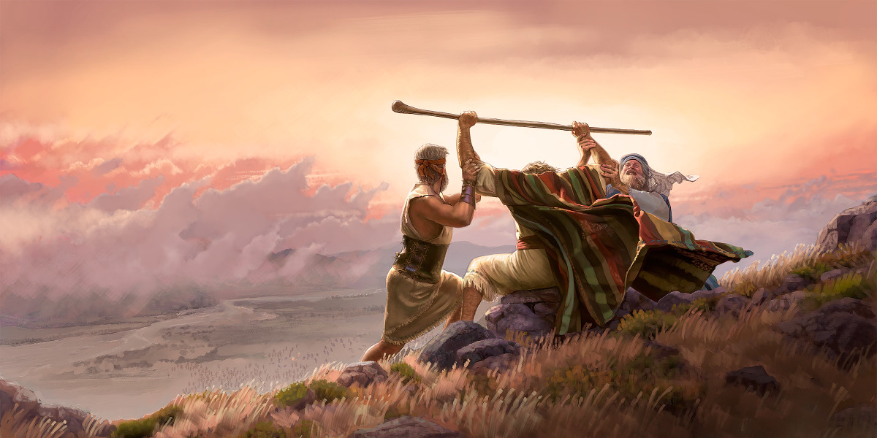
Exodus 17:8-16
“And Amalĕq came and fought with Yisra’ĕl in Rephiḏim. 9And Mosheh said to Yehoshua, `Choose for us men and go out, fight with Amalĕq. Tomorrow I am stationing myself on the top of the hill with the rod of Elohim in my hand.’ 10And Yehoshua did as Mosheh said to him, to fight with Amalĕq. And Mosheh, Aharon, and Ḥur went up to the top of the hill. 11And it came to be, when Mosheh held up his hand, that Yisra’ĕl prevailed. And when he let down his hand, Amalĕq prevailed.
12But Mosheh’s hands were heavy, so they took a stone and put it under him, and he sat on it. And Aharon and Ḥur supported his hands, one on one side, and the other on the other side. And his hands were steady until the going down of the sun.
13And Yehoshua defeated Amalĕq and his people with the edge of the sword.
14And יהוה said to Mosheh, `Write this for a remembrance in the book and recite it in the hearing of Yehoshua, that I shall completely blot out the remembrance of Amalĕq from under the heavens.’ 15And Mosheh built an altar and called its name, יהוה Nissi,16for he said, `Because a hand is on the throne of Yah, יהוה is to fight against Amalĕq, from generation to generation.’”

“Yahuwah Nissi”: Strong’s 5251: “Yahuwah is our victory-banner!”
When He is with us, we win, when He is not, we lose.
“Nissi” also means a banner, a sign, a signal, a standard, a flag pole, a rallying point, also an identifying “mark.” It is also a warning and a signal for war. Yahuwah is our banner – It is under Him that we fight. He is our sign to the enemy to back off as we go into battle under His banner.
As we saw in our learning about the “hand and forehead” applications of Revelation 13:15-18 regarding the “mark of the Beast,” in Hebrew cultural understanding, the “hand” is from the tips of the fingers to the top of the shoulder. It is one unit with multiple uses.
Psalm 63:3-4: “Because Your favor is better than life, my lips will praise You. So I will bless You as long as I live; I will lift up my hands in Your name.”
Let’s look at what Moses did that brought the victory for Yehoshua/Joshua on the battlefield. Talk about the working together of the children of Yahuwah and Yahushua in these last days. Joshua and the army of Israel was fighting against a deadly enemy, determined to wipe them all out.
Moses knew that his “rod” was symbolic of his authority, his position as shepherd-leader of the children of Israel. He knew that holding out that rod was what He had to do for Yahuwah to part the Red Sea in Exodus 14. He took his rod and lifted it up with both hands. In doing so, he symbolically said to Yahuwah and to all: “I submit to Yahuwah; He will bring the victory.”
Today, we, the children of Yahuwah by faith in Yahushua our Savior, lift up our hands in His Name – in praise, showing our submission to Him as our Shepherd, our Master, or leader, and our Supreme and only Shaddai – Almighty One.
However, in western-culture churches, and/or Messianic congregations that I’ve been in for most of my life, when praising, most people turn the palms of their hands up, and keep their arms by their sides, or they lift the palms of their hands up a little. Few actually, lower their head, or raise their head, and lift their hands totally straight up in the air and hold them there for a while.
I have been giving you revelation knowledge from Yahuwah that He has been giving me for a long time, but now – He is increasing it almost every night. He is speaking to His children personally, but also giving messages to share with all in their sphere of influence.
Let me relate one thing especially I began doing regularly back in October 2018, when I arrived in Fort Worth to start a whole new life with a whole new congregation of brothers and sisters. My son was sent by his company to Iraq a few days before I arrived. That was very hard for me. Not long after arriving, I got word that my son was experiencing some difficulty with his company who wanted him to stay months past their promised exit date. That would have caused problems in several areas of his life back in the U.S. His dear wife and I did much praying and sharing. One night I realized that unless Yahuwah did something through the Iraqi government, he would not be coming back for months, because his company was insistent that he stay.
Upon going to bed, and every time I’d wake up during the night, I would lie on my back and raise both hands into the air, stretching them as far up as I could, and proclaim the greatness of Abba. I would pound the air as I spoke, as if I was pounding a desk. I wrote an article on that, if some of you remember – a very passionate article. I would passionately cry out to Him: “You are Shaddai.” “You are Elyon.” “No one is more powerful than You.” “My son is Your servant – Move mightily to bring him home.”
The more serious it got, the more I lifted my hands and took the authority, my spiritual rod I received when baptized into the Spirit in 1966, and lifted it up Yahuwah to make proclamations of victory. I spoke to Yahuwah as Yahuwah Nissi.
Then my daughter-in-law and I got word that the Iraqi government said they did not need him to teach their Air Force military anymore – his assignment was over as far as they were concerned. He, and three others on the same base, were told to go home. We celebrated, but I kept my hands raised up as high as I could when addressing Abba Shaddai, ElYon, making my proclamations to Him mostly during the night, which was morning in Iraq.
One morning early, they flew him out to the civilian airport, and he came home. However, just before they flew him out that morning, the other 3 were told they could not go. Only my son was allowed to leave.
We keep the hands up until the battle is won – not when we think it is won – but when there is proof that it is won. We have authority over the enemy given to us in a true new birth, - as one of the 40 things that the Spirit does when He transforms us into an entirely new creation. Messiah said that He gave us authority over all the powers of the enemy… i.e. Luke 10:19.
Who is this “Holy Spirit?” The Word tells us that He is Yahuwah Himself who is spirit, who is THE Spirit. To reject “the Holy Spirit,” the “Ruach ha Kodesh,” the “Set-Apart Spirit,” is to reject Yahuwah Himself. In Isaiah 6, we see the seraphim flying around the throne crying out “Kodesh, Kodesh, Kodesh is Yahuwah ElYon.”
That authority comes when He is asked to dwell over our “ark” in our re-born spirit. Messiah then baptizes/immerses us into the Spirit of Yahuwah. It’s the same as with Solomon dedicating the Temple. The Ark was down the hill about a city block and a half under a tent, where it had been for 40 years under the reign of King David. Solomon asked the priests to bring it up and put it in the new temple. They did – they brought it UP from Mount Zion, the “City of David,” to Mount Moriah, the “temple mount.” Then Solomon prayed a prayer to ask the Spirit, Yahuwah, to come and dwell over the Ark. When He did, His power was so great that the priests could not stand up. (I Kings 8)
Yahushua is our High Priest, “after the Order of Melechizekok.” He is the One who baptizes us in the Spirit – as we call for Him to come. When He enters us, He comes in with “gifts” that He gives us, by which to live – I Corinthians 12:1-11. The one we personally need more than any other right now is the “discernment of spirits,” so that we can discern the human spirit, the spirit of the Nephilim, the spirits of the fallen angels, the spirits of man, good and bad, and the working of the Spirit of Yahuwah. We just can’t get those mixed up!!!!!
Other gifts we must have, as in Mark 13:9-13, are the gifts of knowledge and wisdom. These gifts are invaluable for us to enter the Kingdom in victory.
Mark 13:9-13 is near! Death by starvation, dehydration, radiation, bullets, bombs, disease, all very near for all mankind. We are at war (Ephesians 6:10-18)
Mark 13:9-13 NAS: “Be on your guard; for they will hand you over to the
courts, and you will be flogged in the synagogues, and you will stand before
governors and kings for My sake, as a testimony to them. 10And the gospel must
first be preached to all the nations. 11And when they arrest you and hand you over, do not worry beforehand about what you are to say, but say whatever is given you at that time; for you are not the ones speaking, but it is the Holy Spirit. 12And brother will betray brother to death, and a father his child; and children will rise up against parents and [h]have them put to death. 13And you will be hated by everyone because of My name, but it is the one who has endured to the end who will be saved.”
We’ve entered this time period. How will the Good News be preached all over the world as a witness? Revelation 12:11: “And they overcame him (Satan) by the blood of the Lamb, the word of their testimony, and they loved not their lives, even unto death.” Mark 13:11-12. It will be the testimony of the martyrs.
If a person is in fear, they will lose all faith and give in to do whatever they have to do to save their lives, or the lives of their family. Fear is the greatest enemy for it works on the side of the enemy against us. If the Spirit is in control, then He rules, and we remain in peace, and with controlled boldness, not afraid to witness of our salvation to executioners.

THE SECRET THAT MOSES HAD WHICH CAUSED HIS BOLDNESS WAS IN HIS UNDERSTANDING OF THE ROD AND THE RAISED HANDS!
Psalm 118:16: “The strong right arm of the LORD is raised in triumph. The strong right arm of the LORD has done glorious things!”
For many years, I’ve had to do spiritual warfare over myself just to get a peaceful night’s sleep. Before turning off the light, I go through a ritual of proclaiming NO curses, projections, rituals of witches, warlock, religious people, voodoo, or involvement with demons/disembodied Nephilim are allowed. The patterns of the witches and voodoo priests, etc. are very recognizable. They begin at midnight to pray, sending curses, doing chants, using voodoo dolls, etc. to torment a person so that they cannot sleep, i.e. they become nervous, mentally tormented, physically filled with anxiety, emotionally overwhelmed with bad memories, fear, fretting, etc. At 3:00 AM they release demons to take these curses to the people. This is what they do every night, with few exceptions.
I spent years of warring nightly, and I still do some. Yet I learned a secret – the secret of proclamation and raised hands! First, before turning out the light, I make my proclamations of what will not be done by them. I proclaim a peaceful night’s sleep. Second, if I do wake up and their pattern starts, I raise both hands as high as I can, and pound the air as in pounding an invisible desk, as I make proclamations of praise to Yahuwah and to Yahushua. It doesn’t take long.
You can actually change a lot of tormenting things in your life by “nipping the attack in the bud.” Just throw your arms straight up from your shoulders and hold them there, the proclamations of the Word being your “rod” of authority. I don’t yell. I barely make a sound. But, the fervor, and the Names – well, “they” know.
I cannot emphasize enough the importance of being 100% submitted to the Spirit within. Enoch heard from Abba, Noah, Abraham, Moses, and on and on. Eliyahu and Elisha raised the dead and performed many miracles, even the multiplication of food. Where is that today? It’s not in the western world. The book of Acts for today is rejected by most. However, in places where faith is child-like, and the people understand that death to self and death as a martyr are just part of being loyal to Elohim in a world controlled by Satan, they see lots of miracles.
We see it over and over in Scripture, that Yahuwah’s right hand and right arm are raised up – to bring victory. Please refer to: “The Right Hand and the Right Arm of Yahuwah is Yahushua”/Mikvah of the Covenant.
Please this Elul, go over these Scriptures and see that the hand-arm of Yahuwah is Yahushua ha Machiach, and He fights for us! The stretching out of the two arms upwards so that the fingers are pointed upward is an ancient one – the symbolic reaching towards Yahuwah for help.
Psalm 28:2: “Hear my cry for mercy when I call to You for help, when I lift up my hands toward Your holy sanctuary.” A Prayer of King David
The throwing of the fingers up with arms stretched out is an ancient crying out for His mercy. It is also an ancient way to praise Him, as a little child reaches up like that for Daddy to lift them up. It gets rid of fear! It maintains peace!
Yes, as a little child reaches up for Daddy, we reach up for Yahuwah to help us, or send us help from among His helpers.
Psalm 118:6-7: “Yahuwah is on my side; I do not fear what man does to me! Yahuwah is for me among those helping me.”
We see that Aaron and Hur came with a “chair” for Moses. But they didn’t just give him a “chair.” One got on one side, and the other got on the other side, and they lifted up his arms until the victory was won.
Dear children of Yahuwah, we must hold up the hands of those who are laying down their lives to warn, teach, instruct, prepare, and pray for His children who are in great battle. We are a family! We must allow Yahuwah from within to transform us so that we are what He is – and think like He thinks – and act like He acts.
“Yahuwah is Love.” (I John 4:8) Those wasting their time mocking, slandering, gossiping about others and doing nothing to lift up the wounded and help them heal, are void of His nature. Moses knew to hold up his hands – a sign of intense, with all my heart, prayer, worship, and faith. If you want to win the battle, that’s the secret of Moses: He held up his hands. He held up his “rod.” Our rod, our authority, is within our re-born spirit! Use it, and raise your hands!
Moses took the authority given to him by Yahuwah, and without fighting, he held it up with intense prayer for victory. Victory comes if you keep your hands high, daily praising Him as often as He moves upon you.
In His love, Yedidah - August 11, 20201
Recent Revelatory faith-building articles and podcasts:
1) “Tell the Children of Israel to Go Forward – It’s Now Time To Cross the Jordan”
2) “Transcript of the Book of Genesis Chapters 12 and 13”

